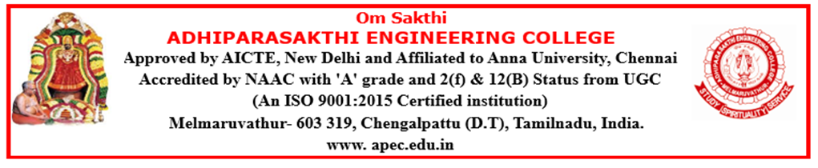

DEPARTMENT OF COMPUTER SCIENCE AND ENGINEERING
ACADEMIC YEAR (2026-2027) ODD SEMESTER

NEWS LETTER
The Times of Neural APEC
2026-2027
SEPTEMBER

APEC INTERNAL HACKATHON 2026

The Department of Computer Science and Engineering, Adhiparasakthi Engineering College, organized the APEC Internal Hackathon 2026 on 2nd September 2026 as part of Smart India Hackathon (SIH) 2026. The event encouraged students to showcase their innovation, creativity, teamwork, and problem-solving skills through technology-based solutions.
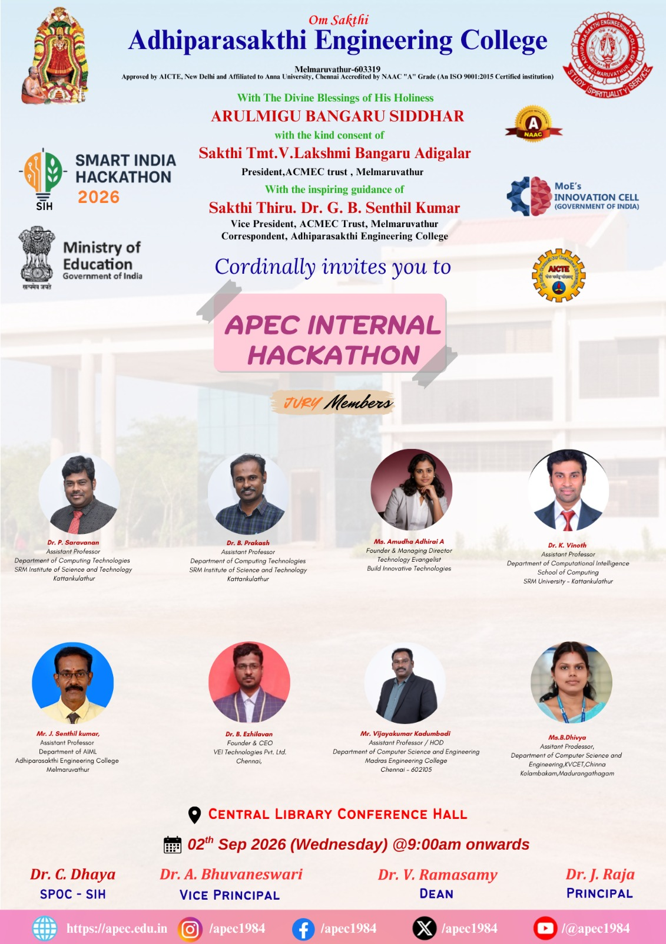

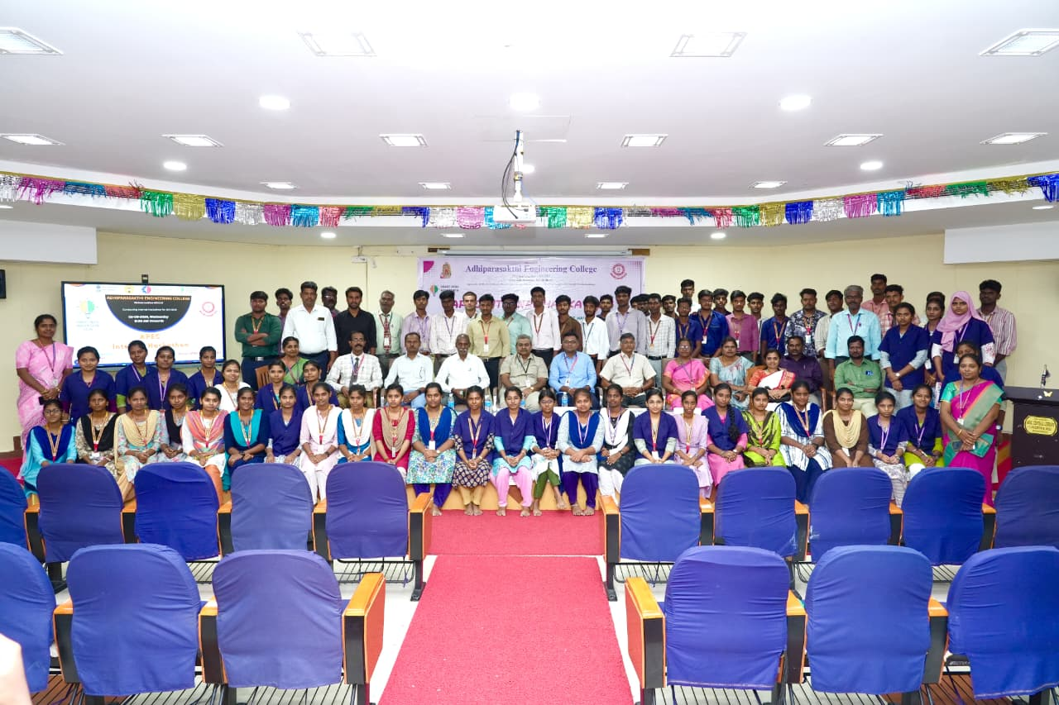

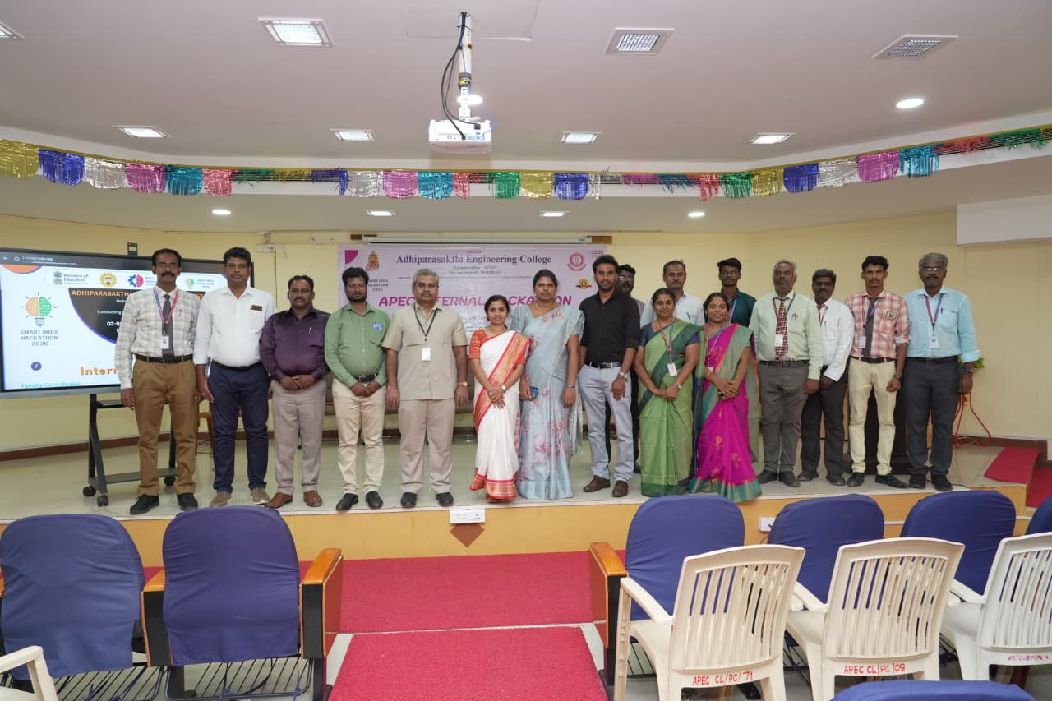

STUDENTS SHINE TECHNICAL & NON-TECHNICAL EVENTS

Our II Year students attended Technical Events at UCET, Tindivanam, on 11 September 2026. A valuable opportunity to showcase their technical skills, knowledge, and teamwork.
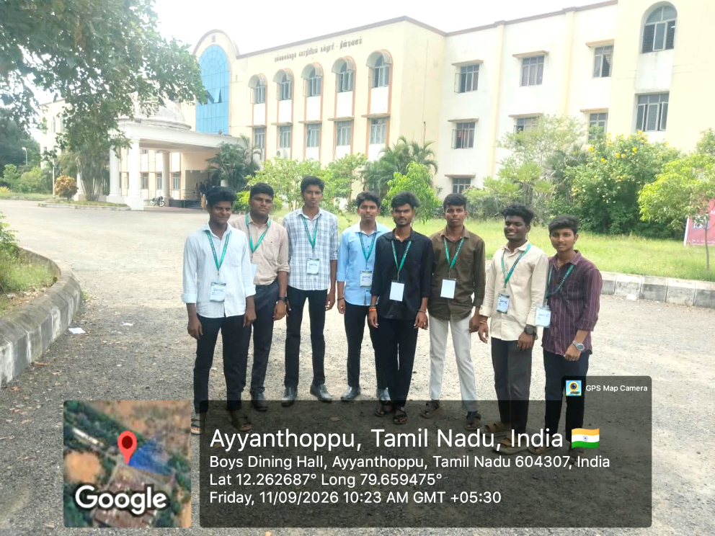

On 11.09.2026, our students Shyambalaji S, Pradeep S, Seenuvasan A & Gnanasekaran V secured 2nd Place with Cash Prize in the Technical Event “Idea Sphere” and 1st Place with Cash Prize in the Non-Technical Event “Rhythm Pick” at UCET, Tindivanam.
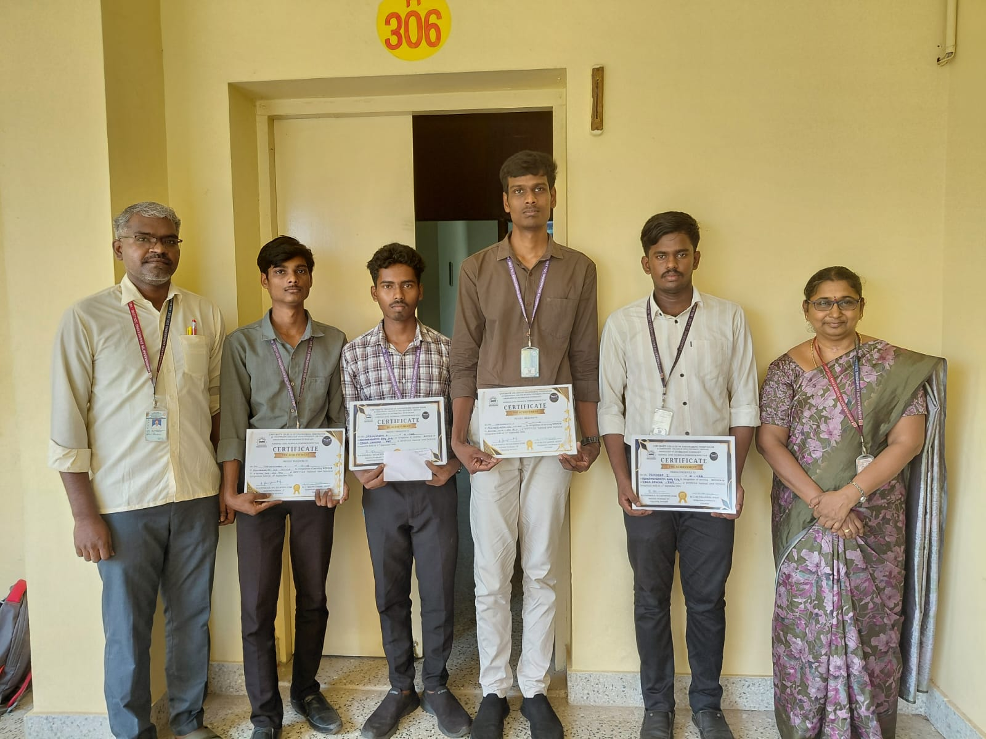

SATURDAY ACTIVITY

The Department of CSE, in association with the CSI Students Chapter, conducted engaging technical and non-technical activities on Saturday, 12.09.2026, for II, III and IV Year students, fostering knowledge, creativity, problem-solving and teamwork.
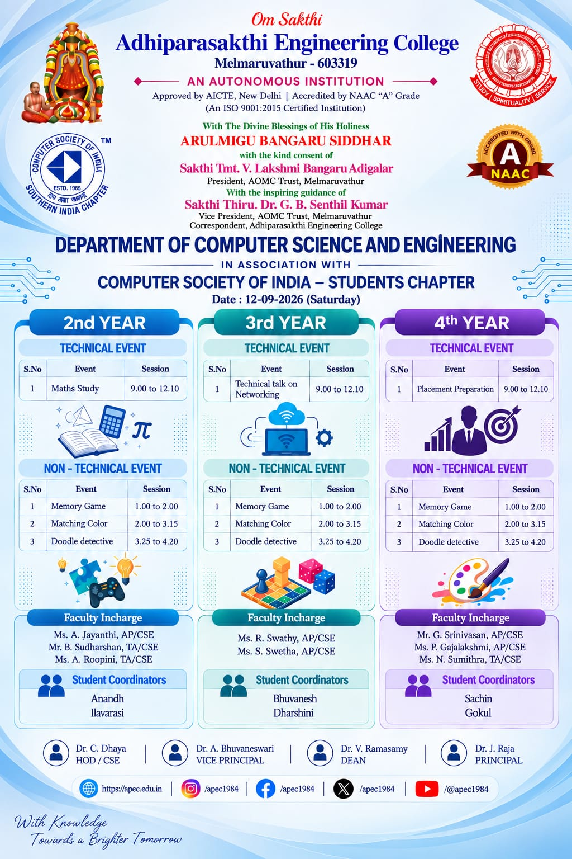

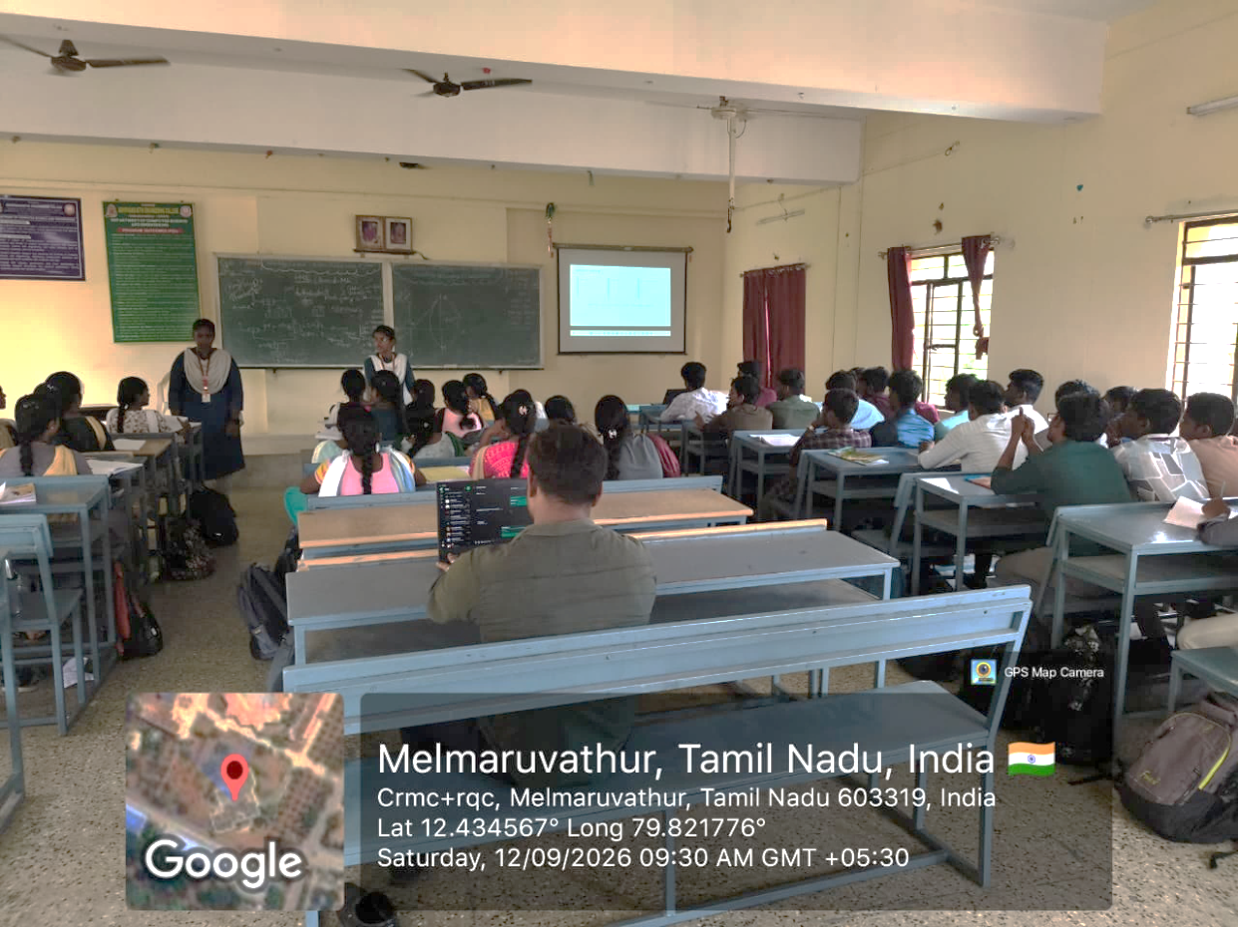

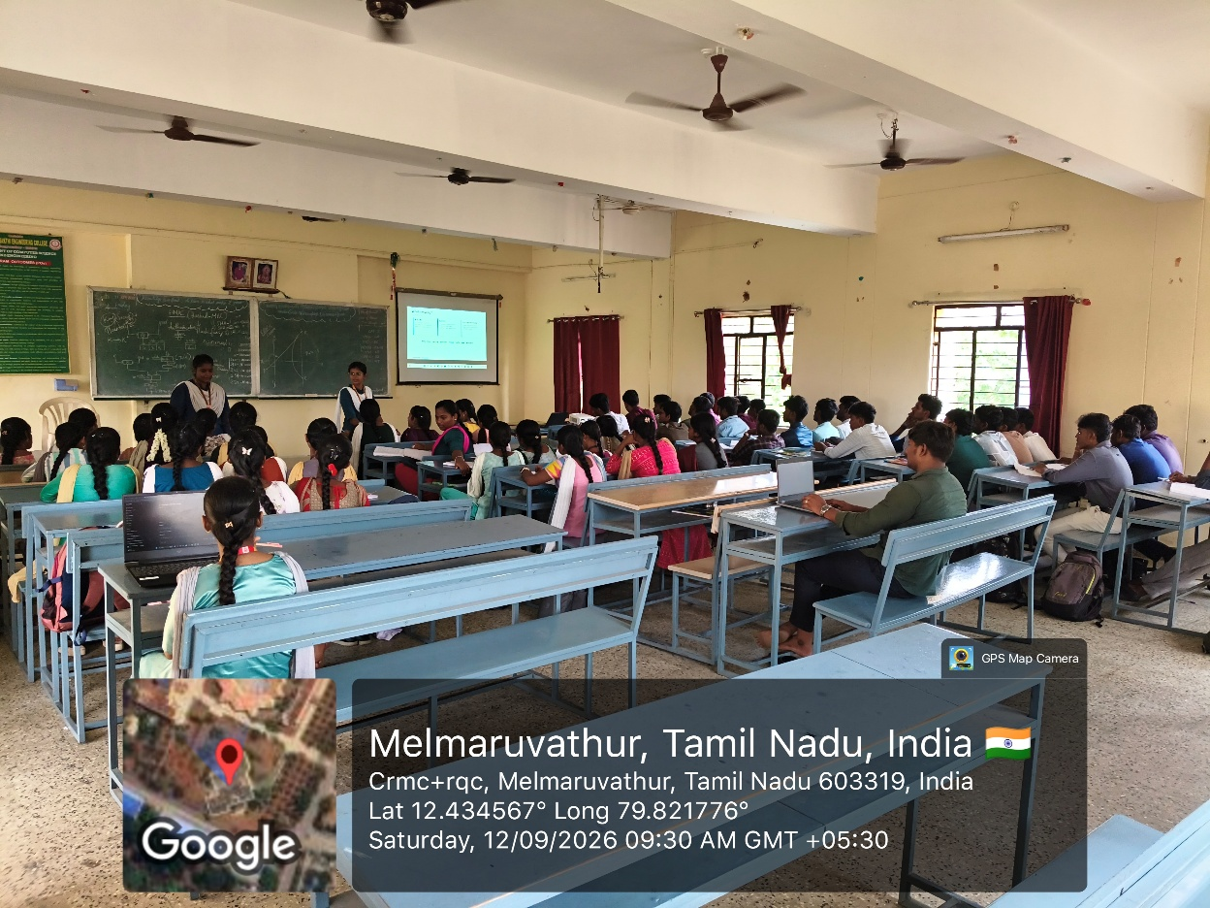

Saturday Activity – Introduction to Quantum Computing

The Department of CSE, in association with the CSI Students Chapter, organized an “Introduction to Quantum Computing” session on 19.09.2026 at the H-Block Auditorium, featuring Mr. Vellor Pavan as the resource person. The session provided students with an introduction to the emerging field of Quantum Computing and its technological potential.
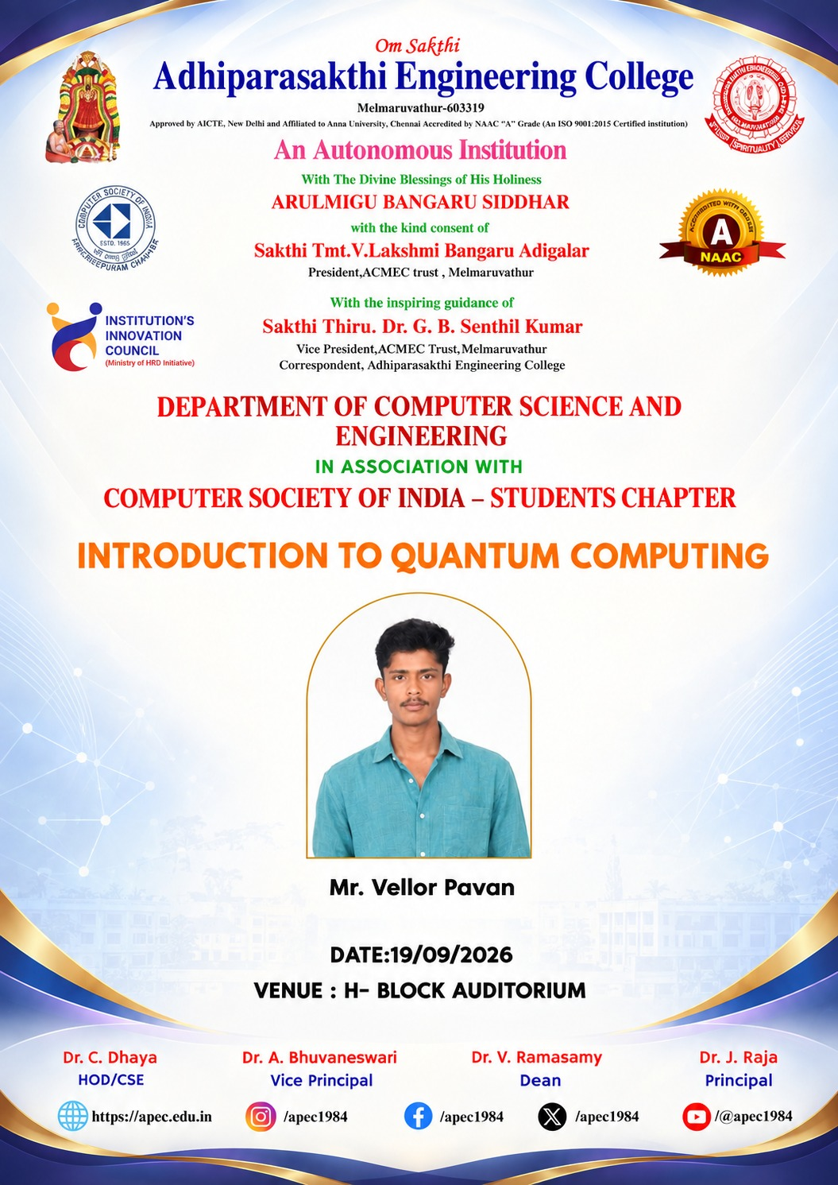

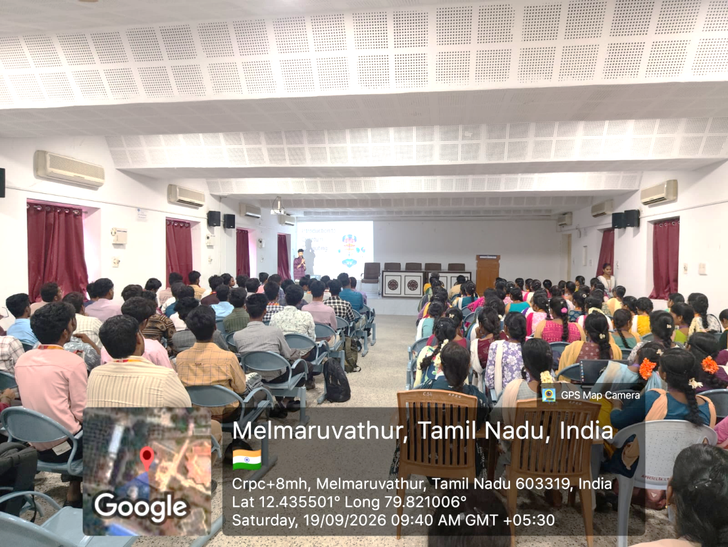

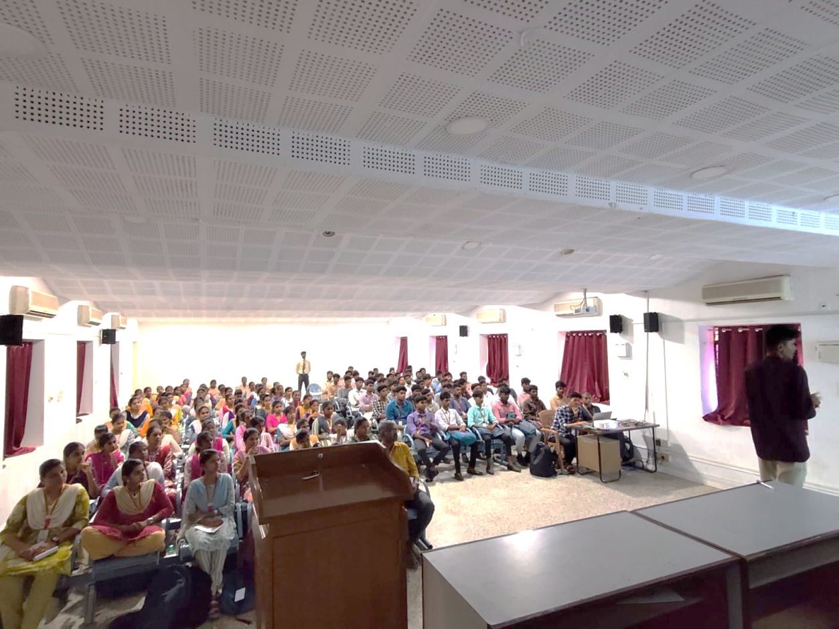

Saturday Activity Highlights[26.09.2026]
The Department of Computer Science and Engineering organized a Saturday Activity on “Video Creation and Editing” for II Year CSE students. The activity provided students with hands-on experience in video creation, editing techniques, transitions, effects, and creative presentation. Students actively participated in the session and enhanced their technical, creative, and digital media skills.


