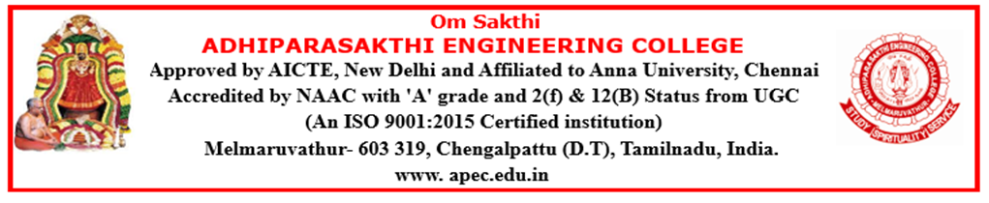

DEPARTMENT OF COMPUTER SCIENCE AND ENGINEERING
ACADEMIC YEAR (2026-2027) ODD SEMESTER

NEWS LETTER
The Times of Neural APEC
2026-2027
AUGUST

DEPARTMENT ACTIVITIES
AGENTIC AI ENGINEERING TRAINING PROGRAM
A five-day Agentic AI Engineering training program was successfully conducted for IV Year CSE students from 03 August 2026 to 07 August 2026, providing hands-on exposure to agentic AI concepts, tools, and real-world applications.
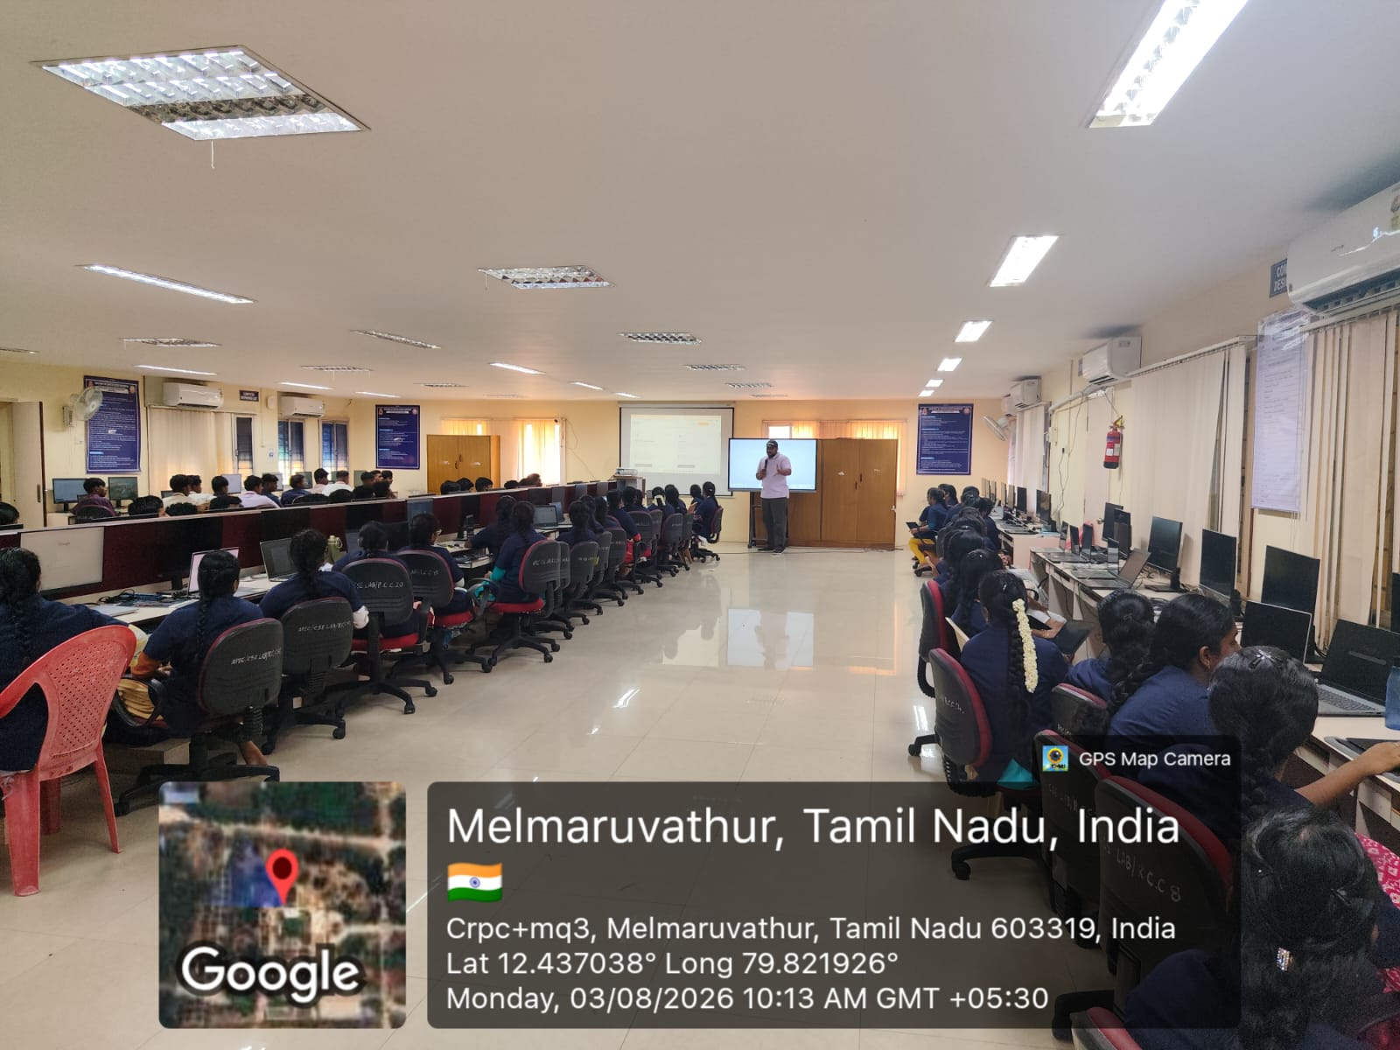

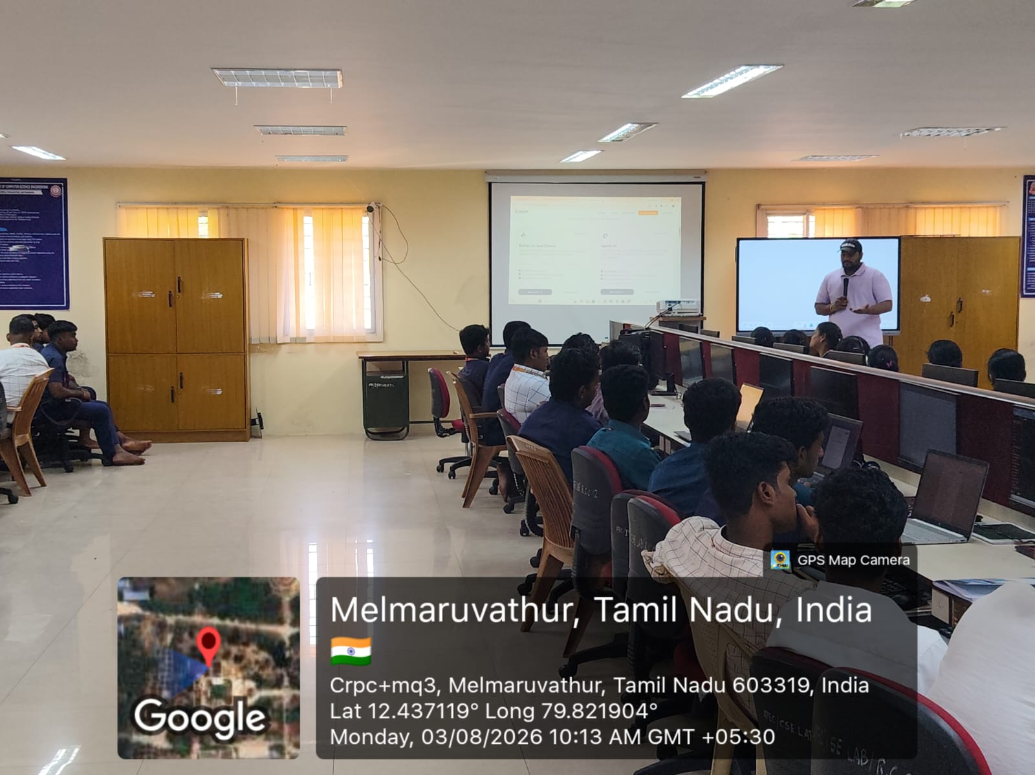
PARENTS MEETING
A Parents’ Meeting for III Year students was successfully conducted on 8 August 2026, providing an opportunity to discuss students’ academic progress, attendance, and overall development with parents.
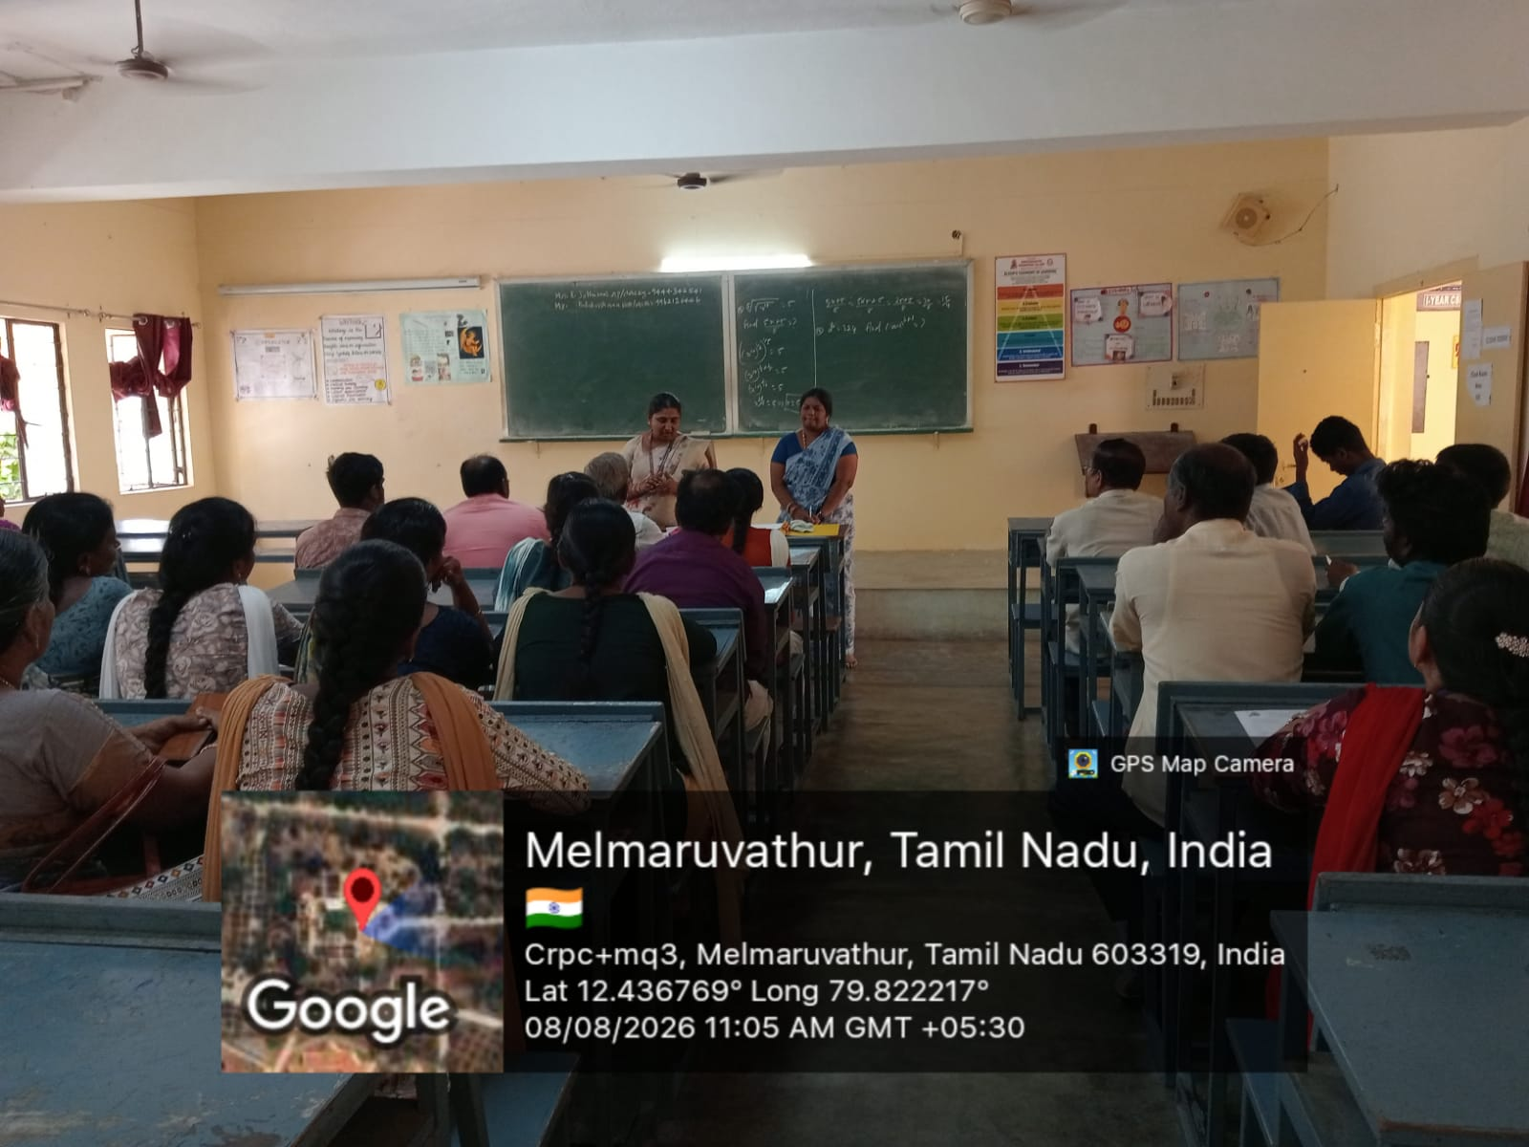

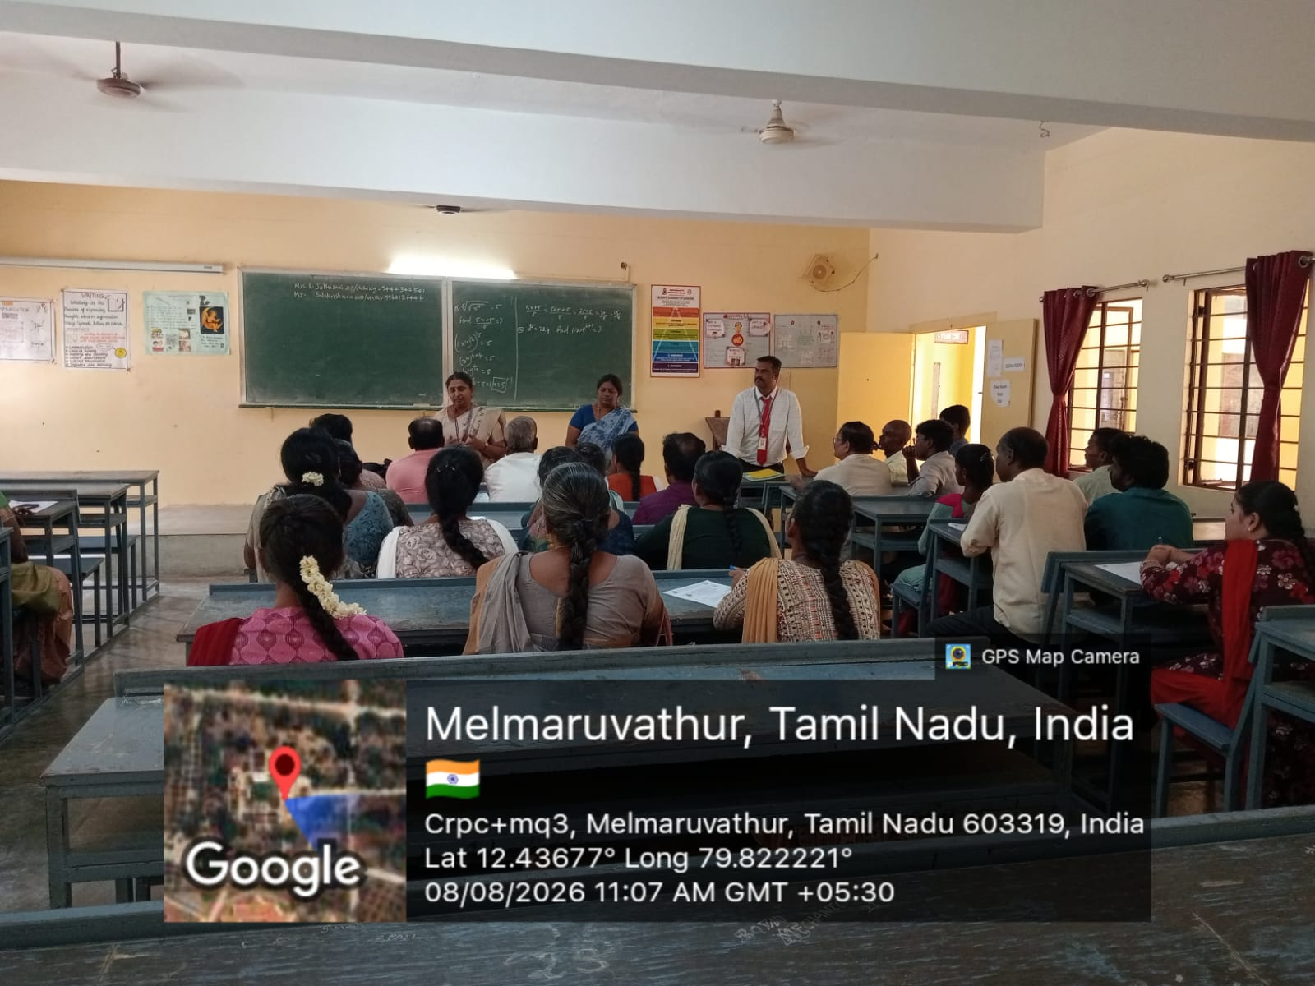

HANDS-ON TRAINING: “LET’S BUILD A GPT MODEL FROM SCRATCH”
A hands-on training workshop titled “Let’s Build a GPT Model from Scratch” was conducted on 8 August 2026 by the Department of Computer Science and Engineering in association with the Computer Society of India (CSI) – Kancheepuram Chapter, providing participants with practical exposure to GPT architecture, self-attention, transformer blocks, model training, and text generation using Python and PyTorch.

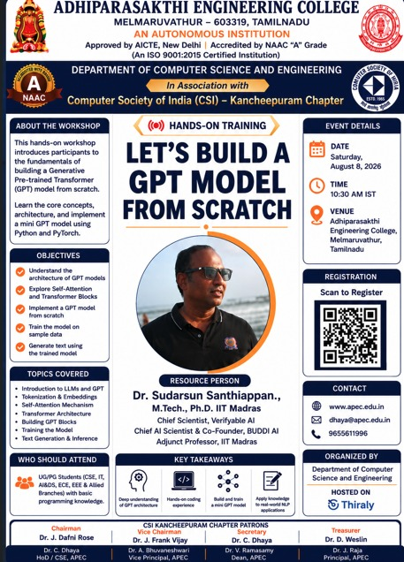

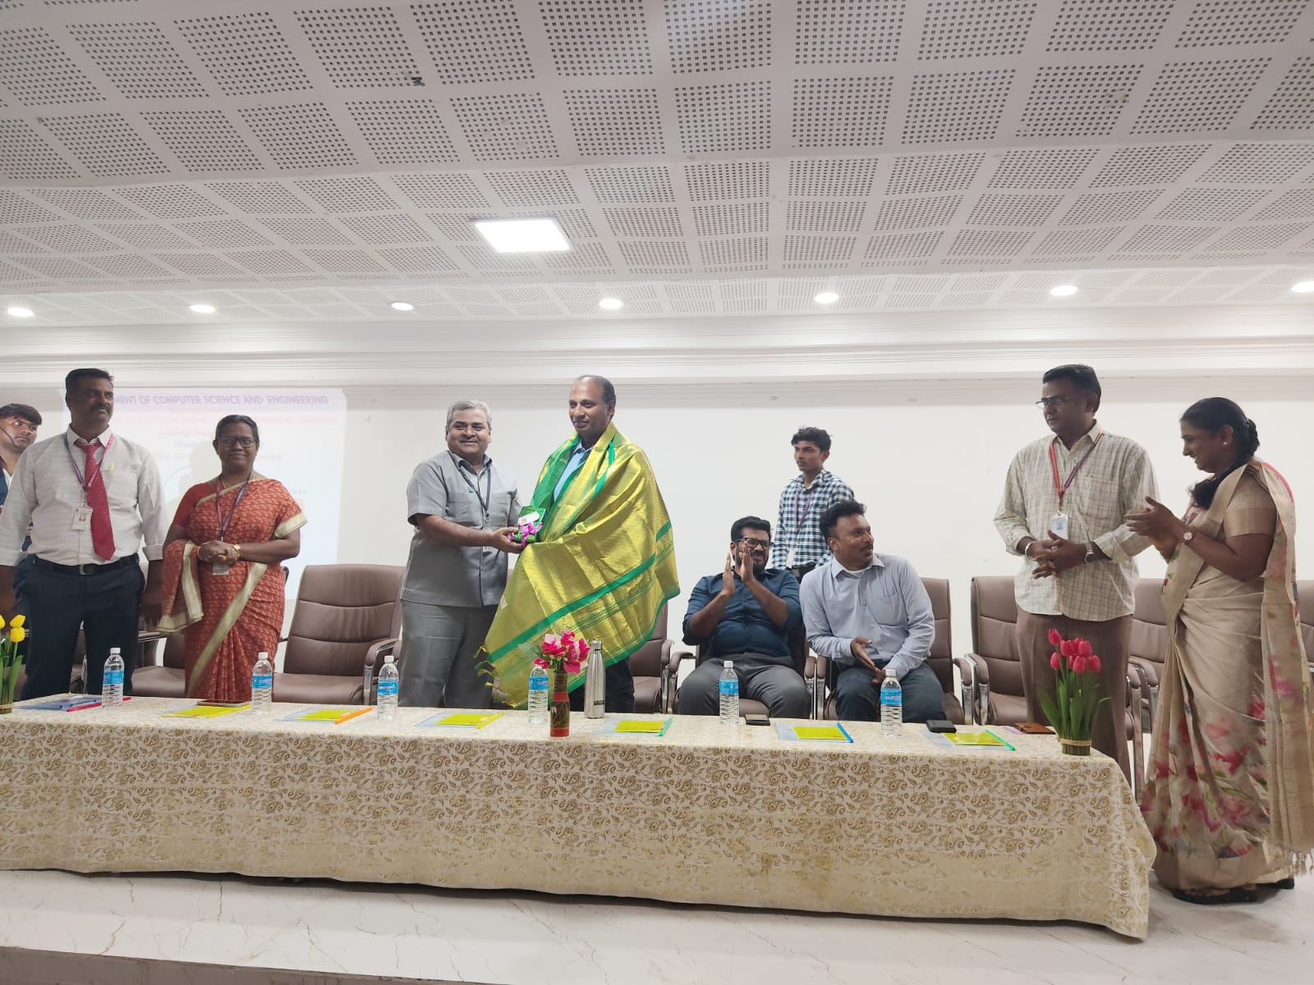

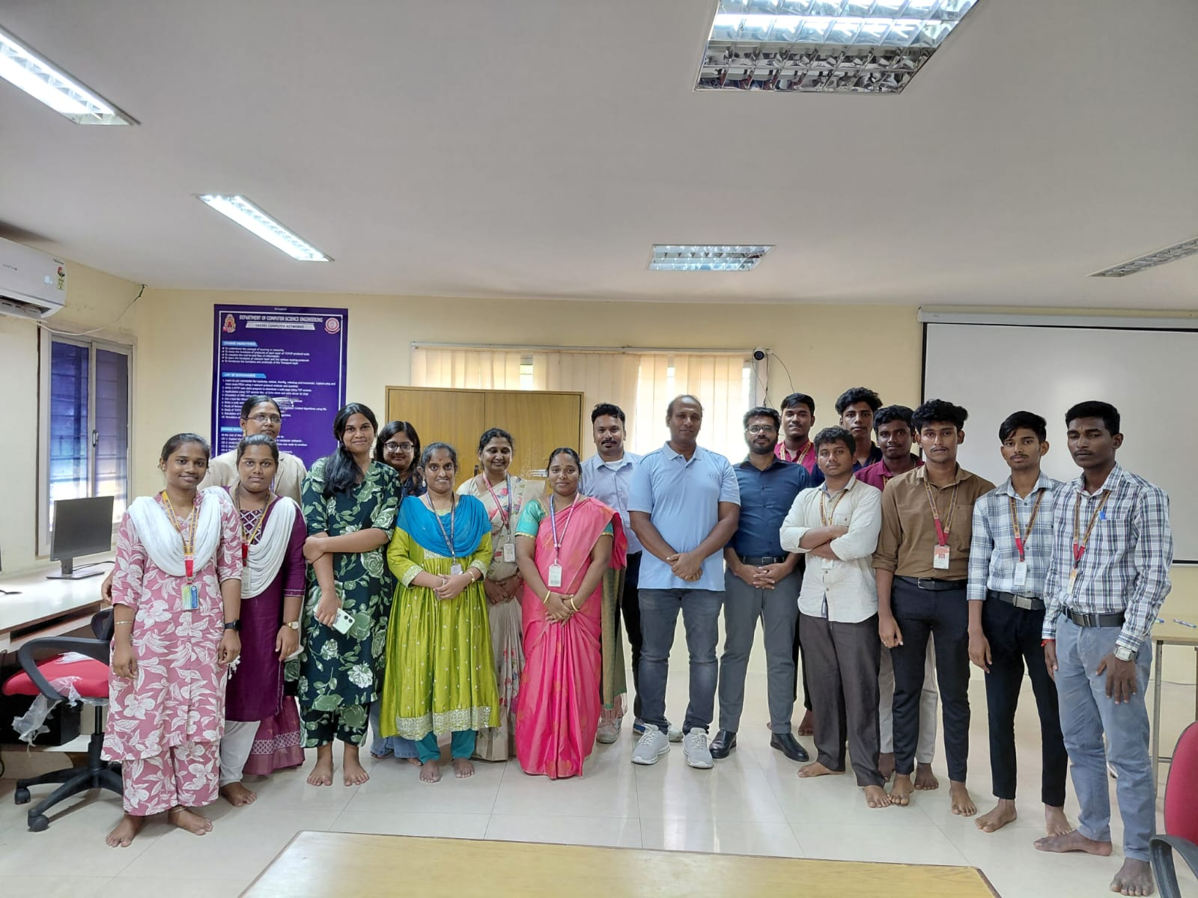

STUDENTS TAKE UP LEADERSHIP ROLES IN CSI KANCHEEPURAM CHAPTER – REGION VII

Our Department proudly joined the CSI Kancheepuram Chapter – Region VII, where our students assumed various office bearer positions, showcasing their leadership, commitment, and active involvement in professional activities.

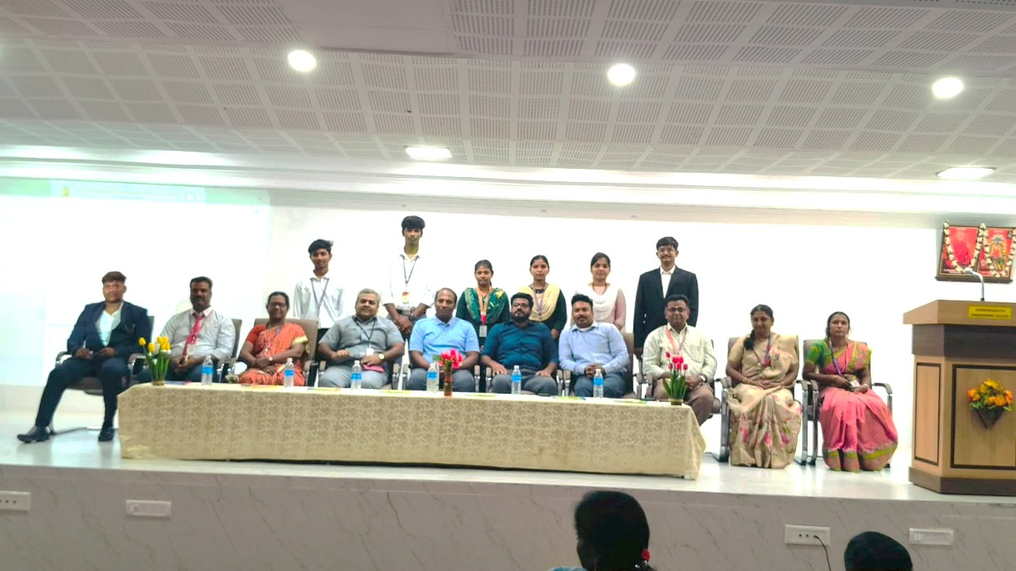

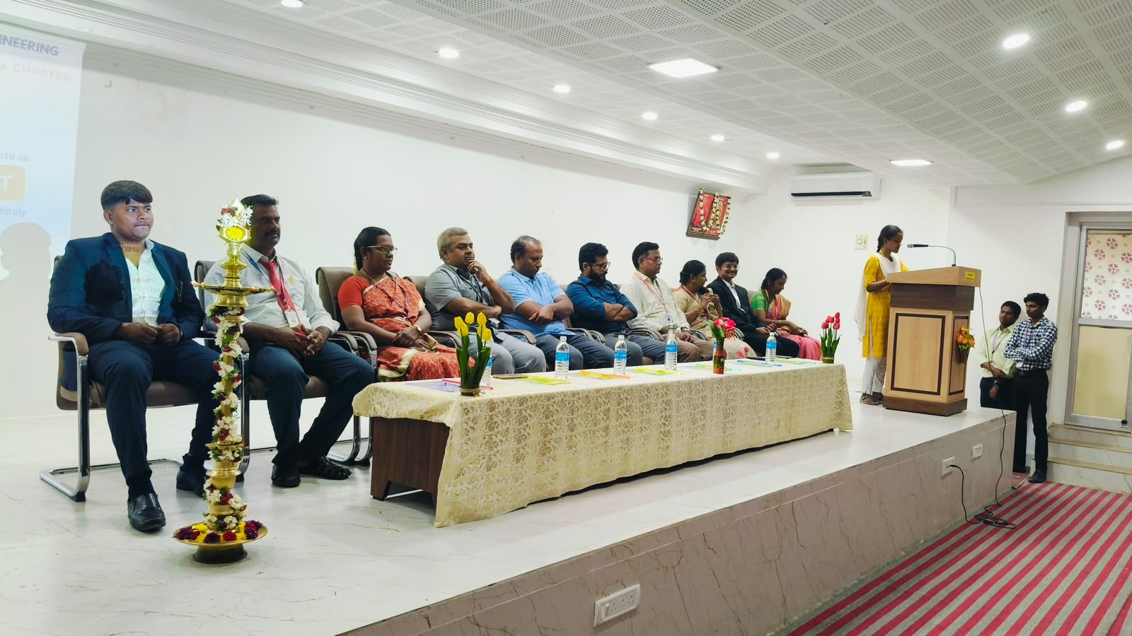

SATURDAY ACTIVITY HIGHLIGHTS [08.08.2026]
Saturday activities were conducted for the II, III, and Final Year students as part of the No-Book Day initiative. The sessions featured engaging technical development games and skill-based activities designed to enhance students’ technical knowledge, problem-solving abilities, creativity, teamwork, and active learning.
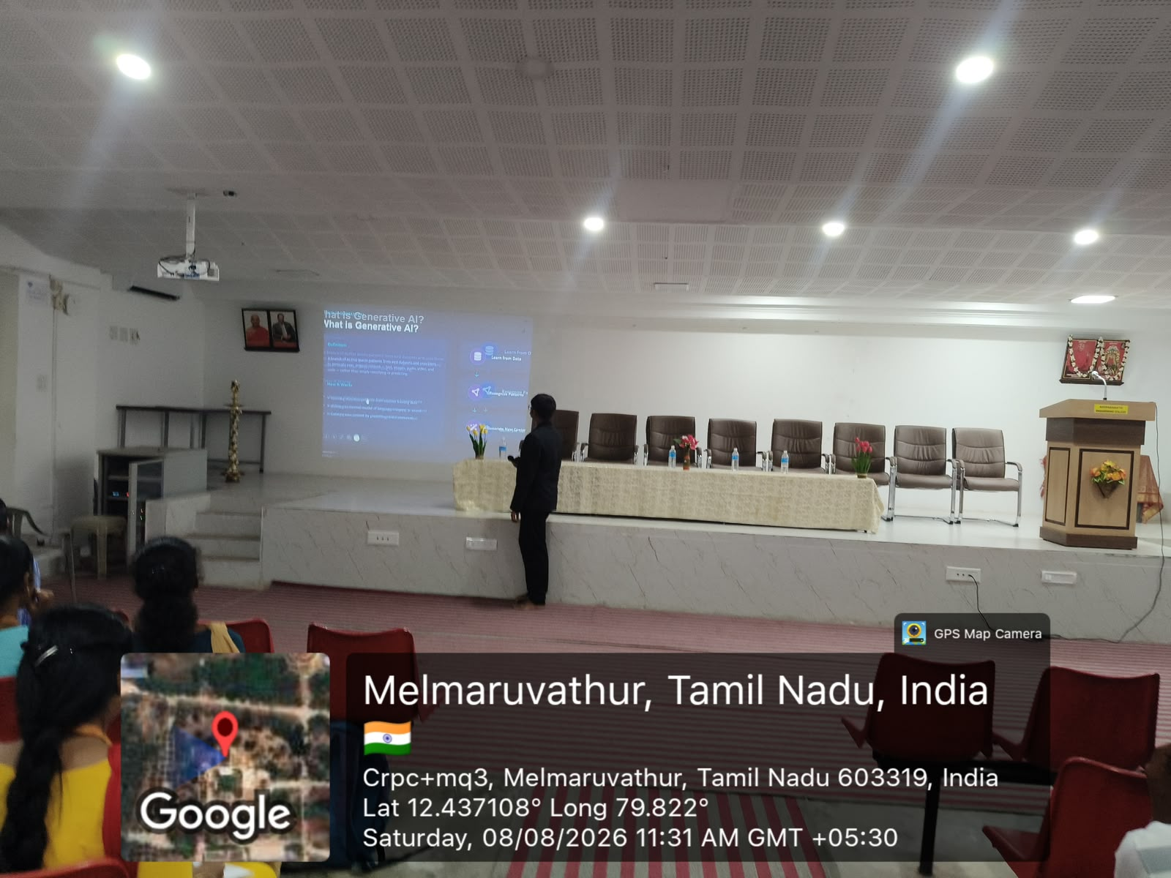

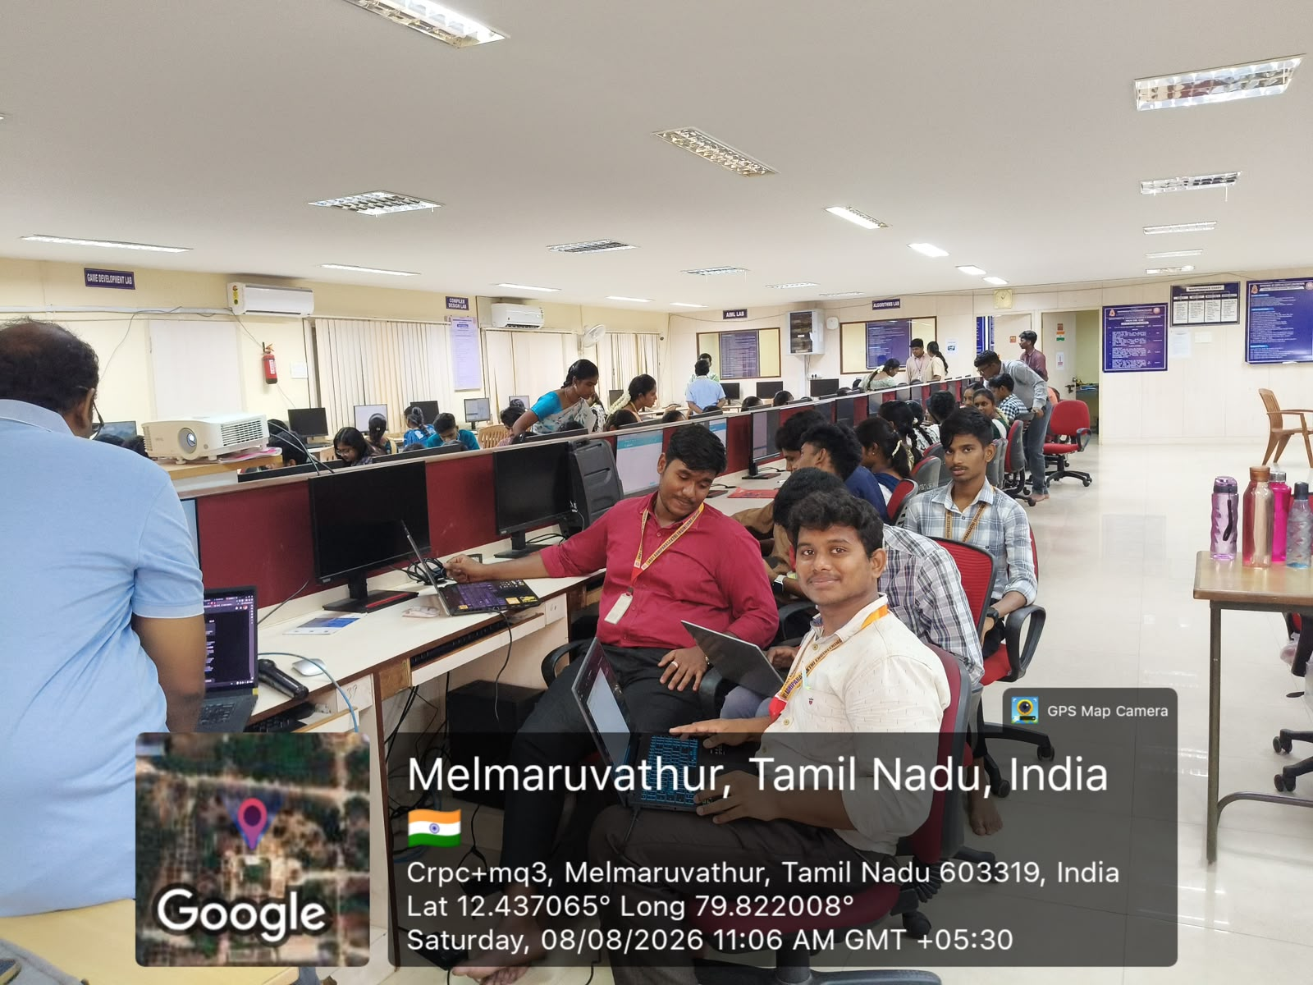

TCS ION ORIENTATION PROGRAMME FOR FINAL-YEAR STUDENTS

The TCS iON Orientation Programme was conducted for final-year students on 13.08.2026 to provide valuable insights into career opportunities and industry-oriented learning, thereby strengthening their career readiness and employability.
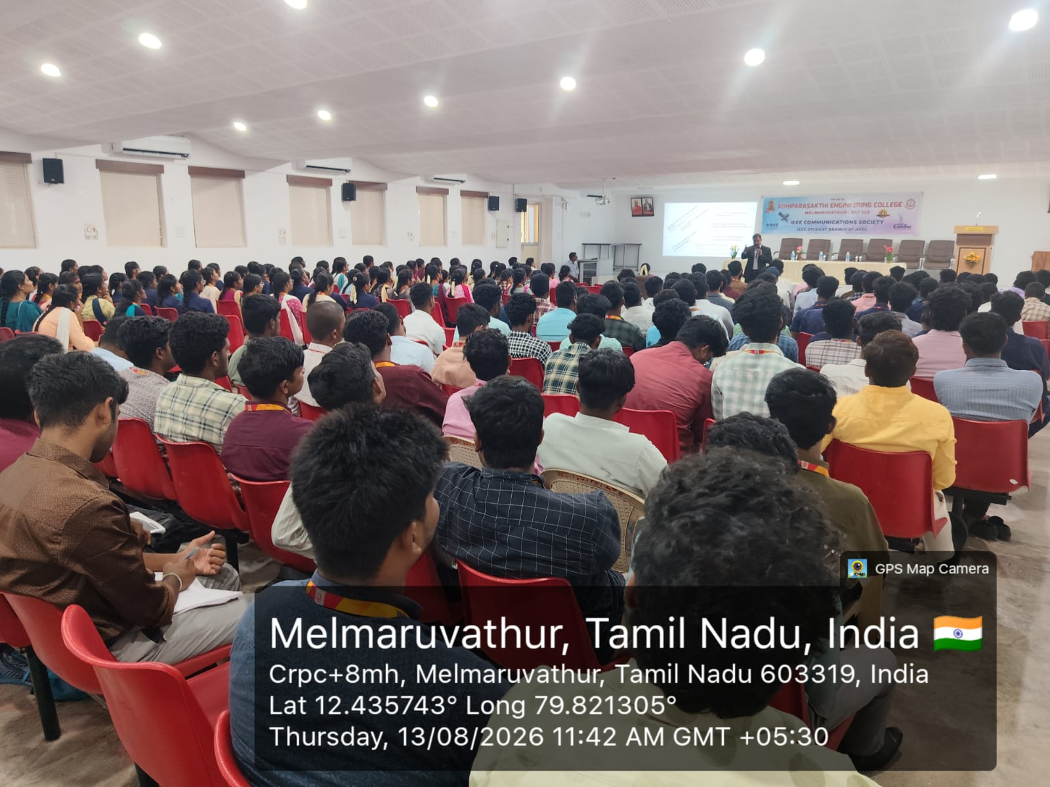

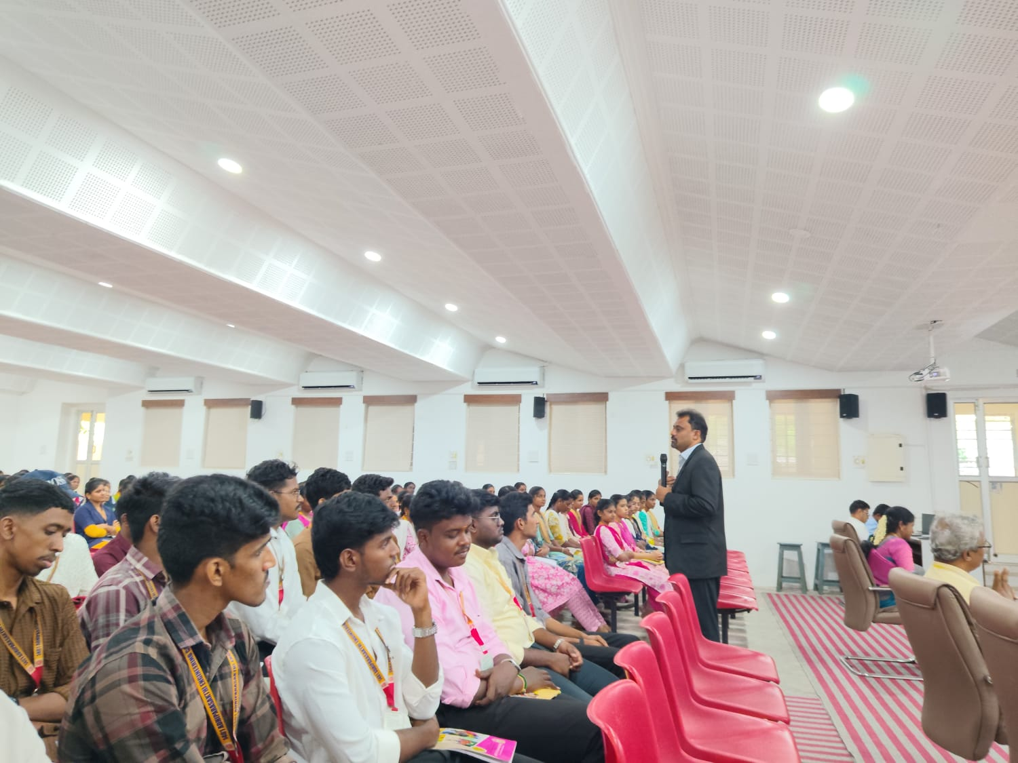

INDUSTRY EXPOSURE: VISIT TO IIITDM
Second-year students undertook an Industrial Visit to the Indian Institute of Information Technology, Design and Manufacturing (IIITDM), Kancheepuram, Tamil Nadu, on 12 and 13 August 2026, gaining valuable exposure to advanced technologies, innovative practices, and real-world applications.
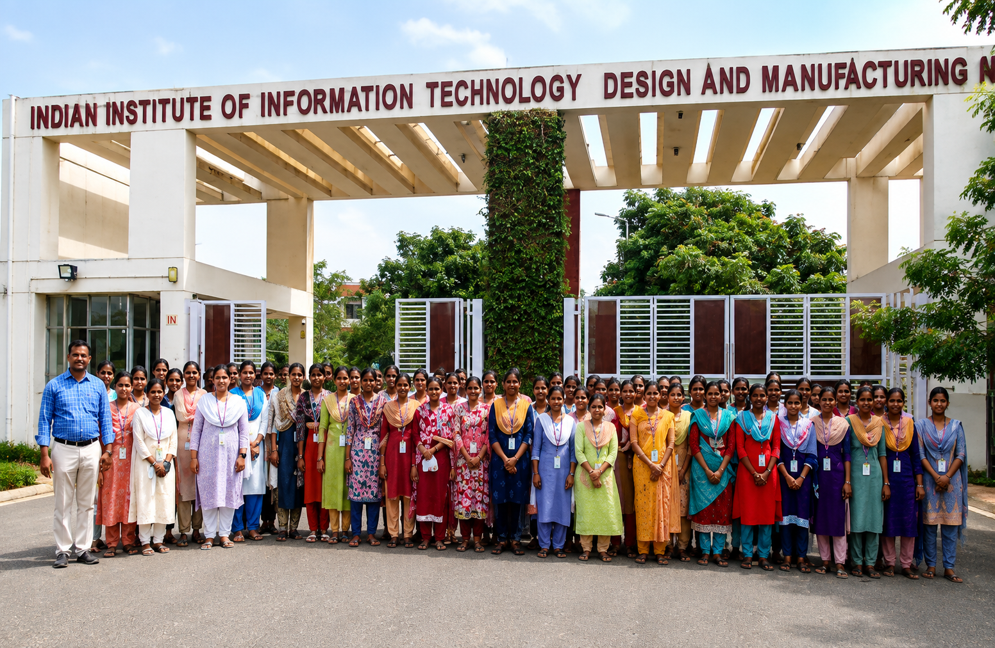
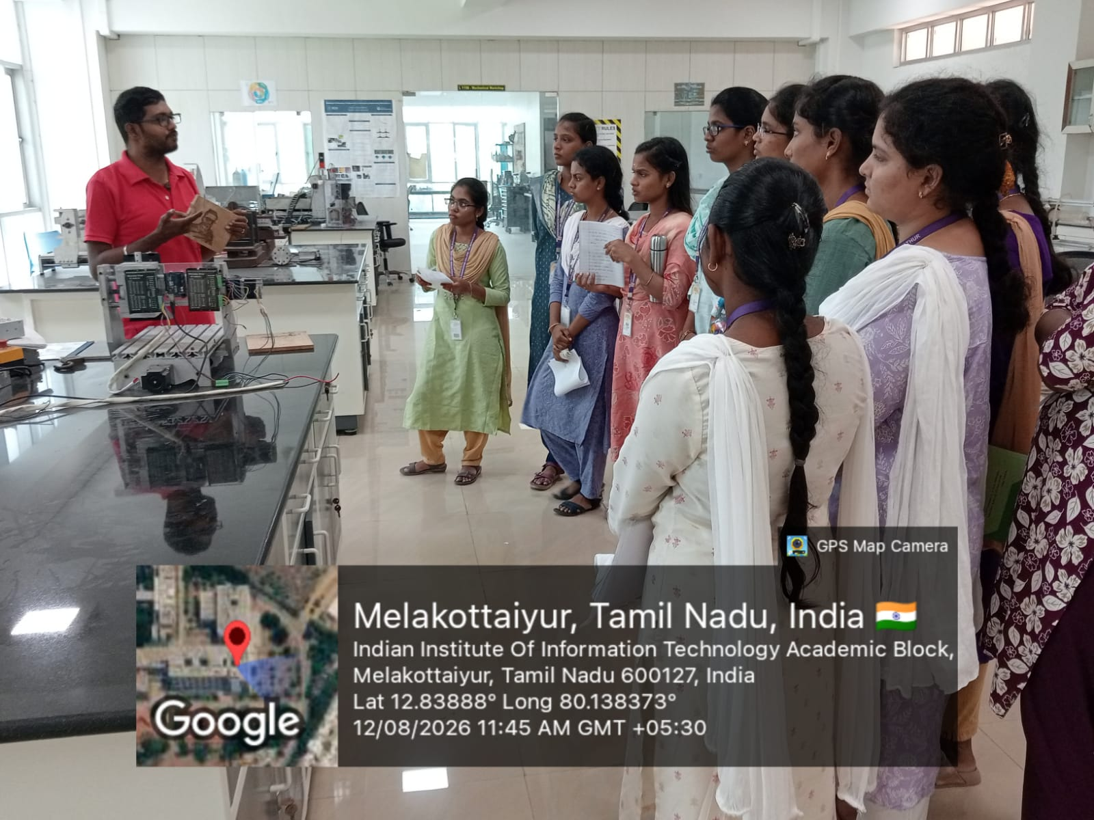

CCELEBRATING EXCELLENCE: ACADEMIC ACHIEVERS & UNIVERSITY RANKER
The Department of Computer Science and Engineering proudly celebrates the outstanding academic achievements of its students during the Academic Year 2026–2027. The Semester Toppers from II, III, and IV CSE have demonstrated remarkable academic performance, securing top positions with excellent GPAs. The department also proudly congratulates Ms. Swathika A, who secured the 9th University Rank in CSE for the 2021–2025 batch. These accomplishments reflect the students’ dedication, discipline, perseverance, and commitment to academic excellence.
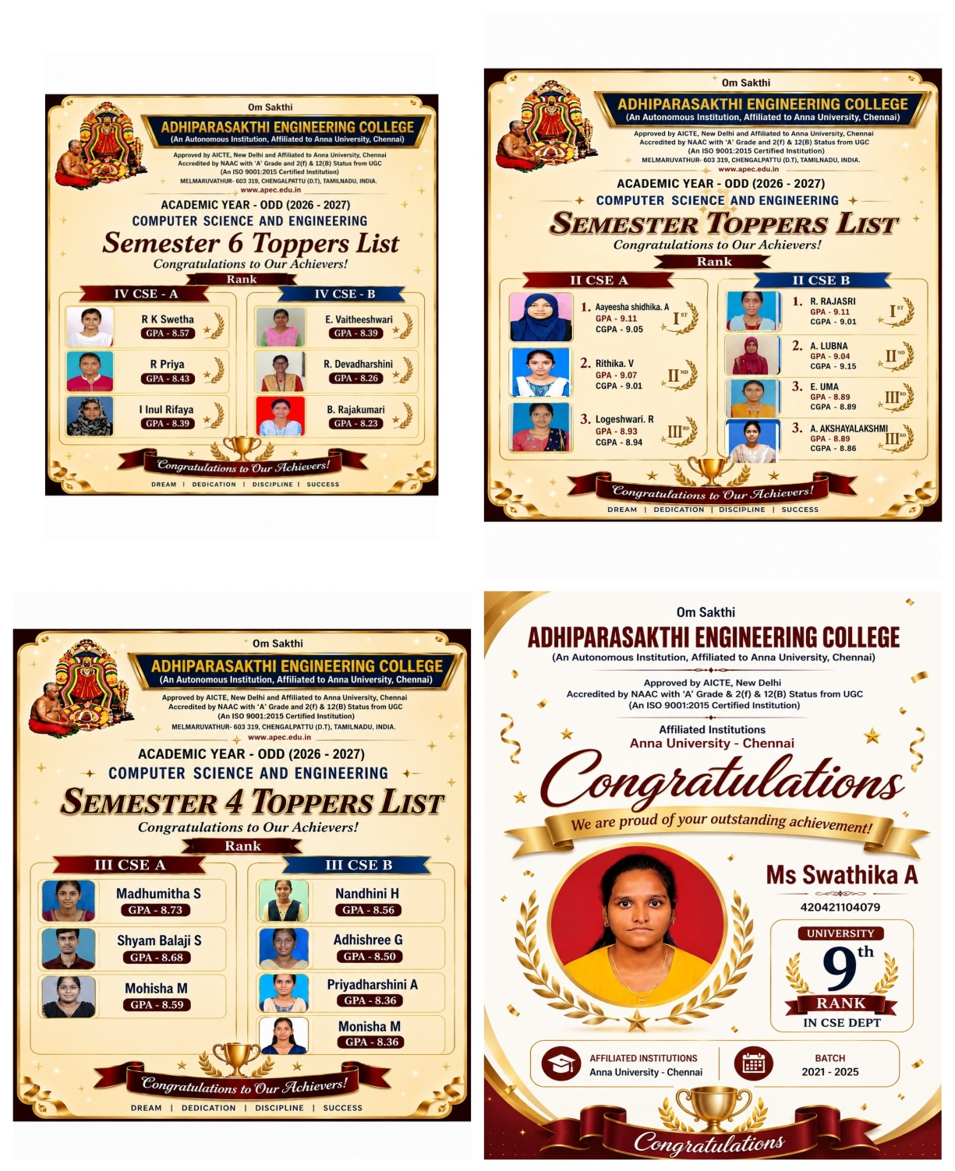

CSE DEPARTMENT AT SMART INDIA HACKATHON 2026

The Department of CSE proudly participated in the official launch of SIH 2026 problem statements on 21 August 2026, inspiring students to innovate and develop solutions for real-world challenges.
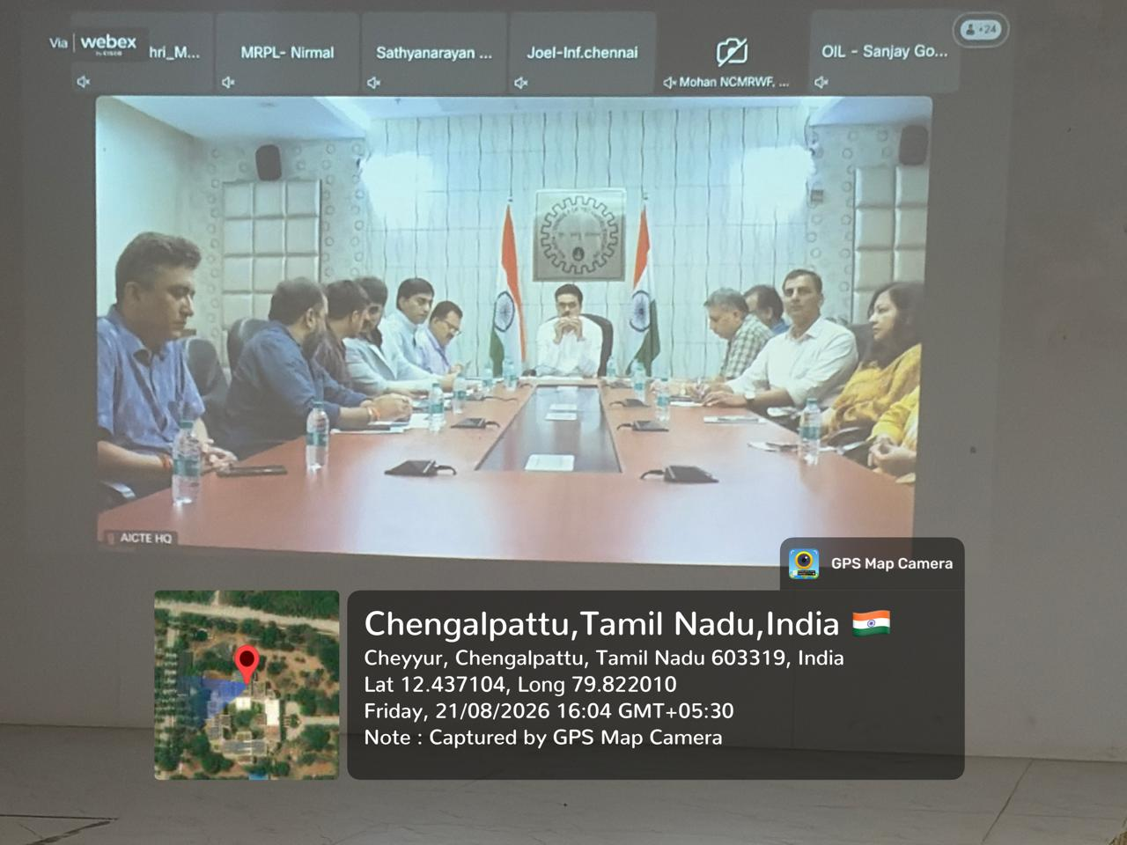

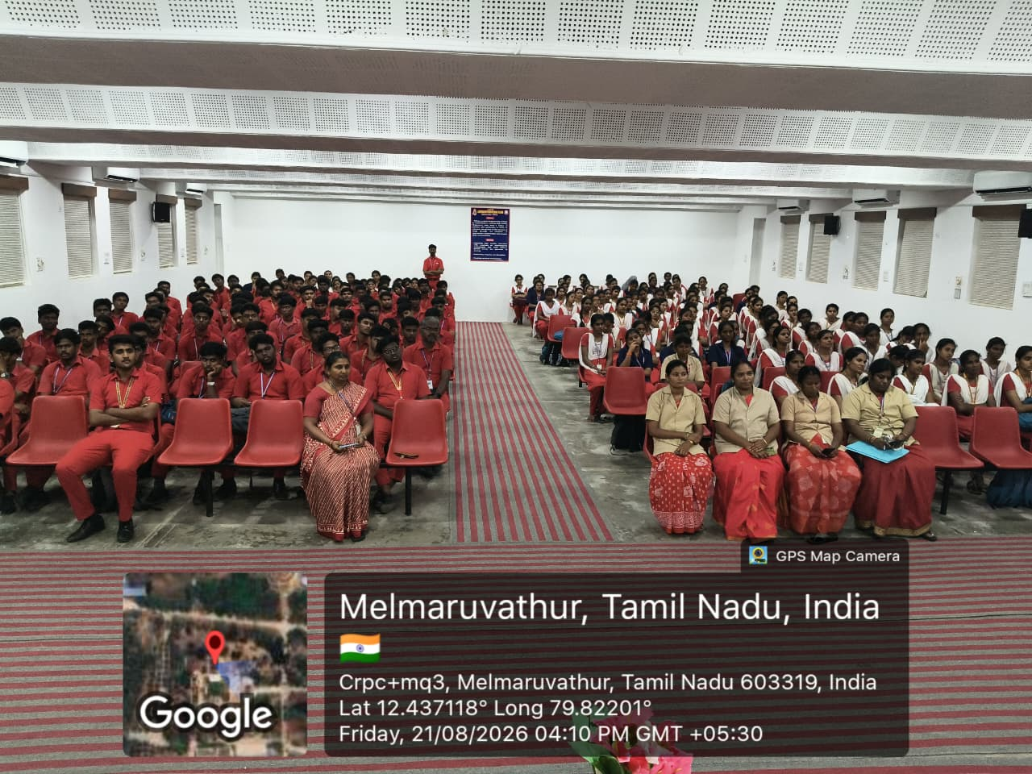

SATURDAY ACTIVITY HIGHLIGHTS [22.08.2026]
A hands-on workshop on AI Video Generation was conducted for the second-year students as part of the Saturday Activity – No Bag Day, providing students with practical exposure to emerging AI tools and creative video-generation techniques.
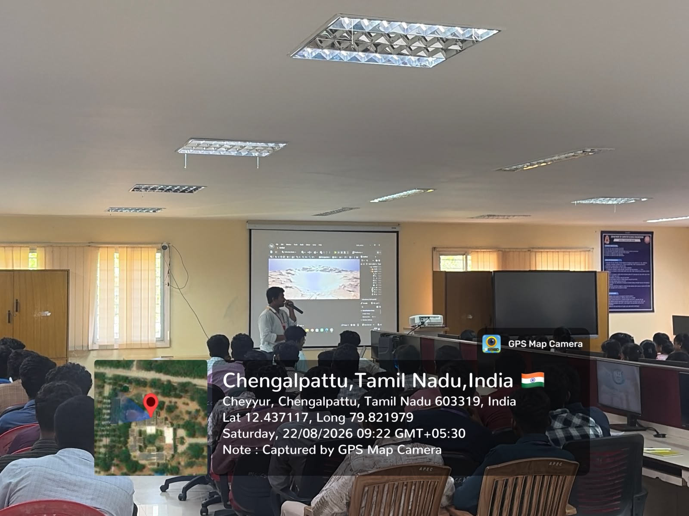

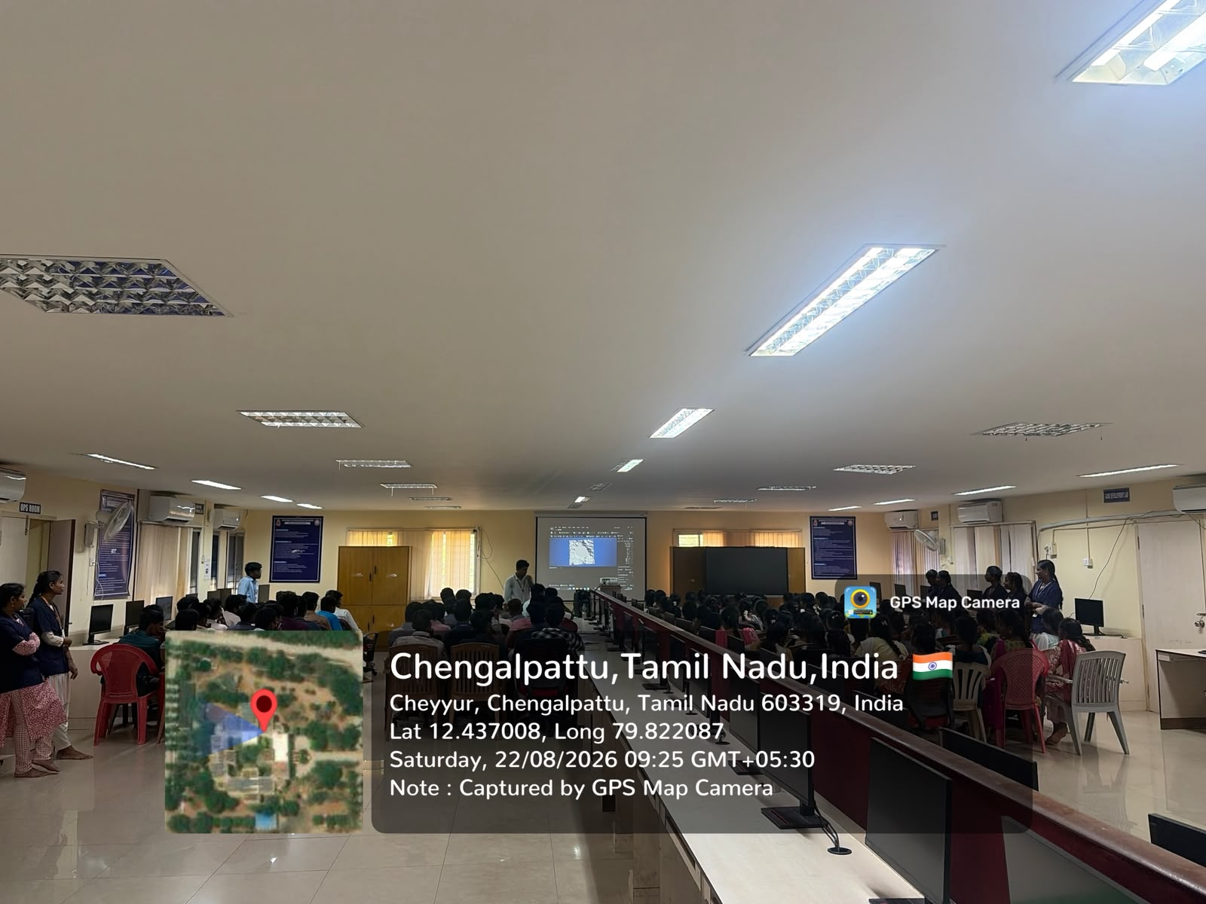

A Startup Pitching Session was conducted for the III Year students as part of the Saturday Activity – No Bag Day, providing them with an opportunity to present their innovative ideas and develop their entrepreneurial and communication skills.
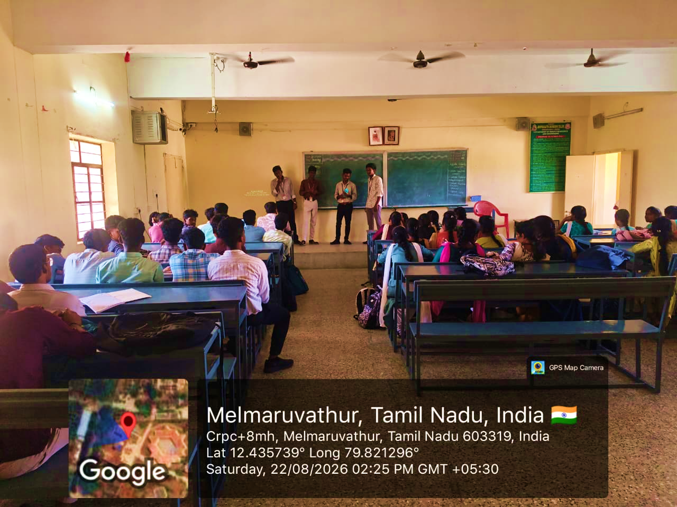
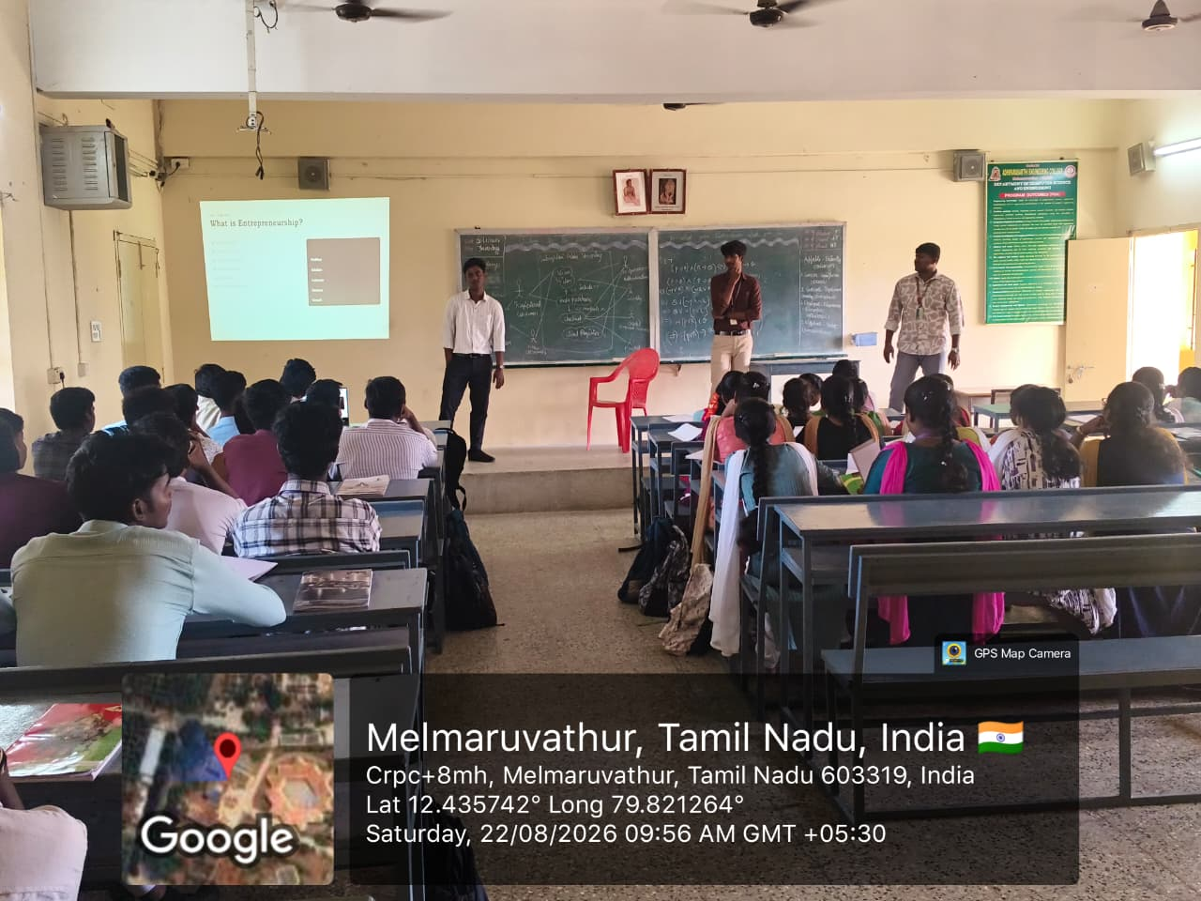

A Workshop on AI Engineering by Infomind AI was conducted for the Final Year students, providing them with practical exposure to AI engineering concepts, tools, and industry-oriented applications.
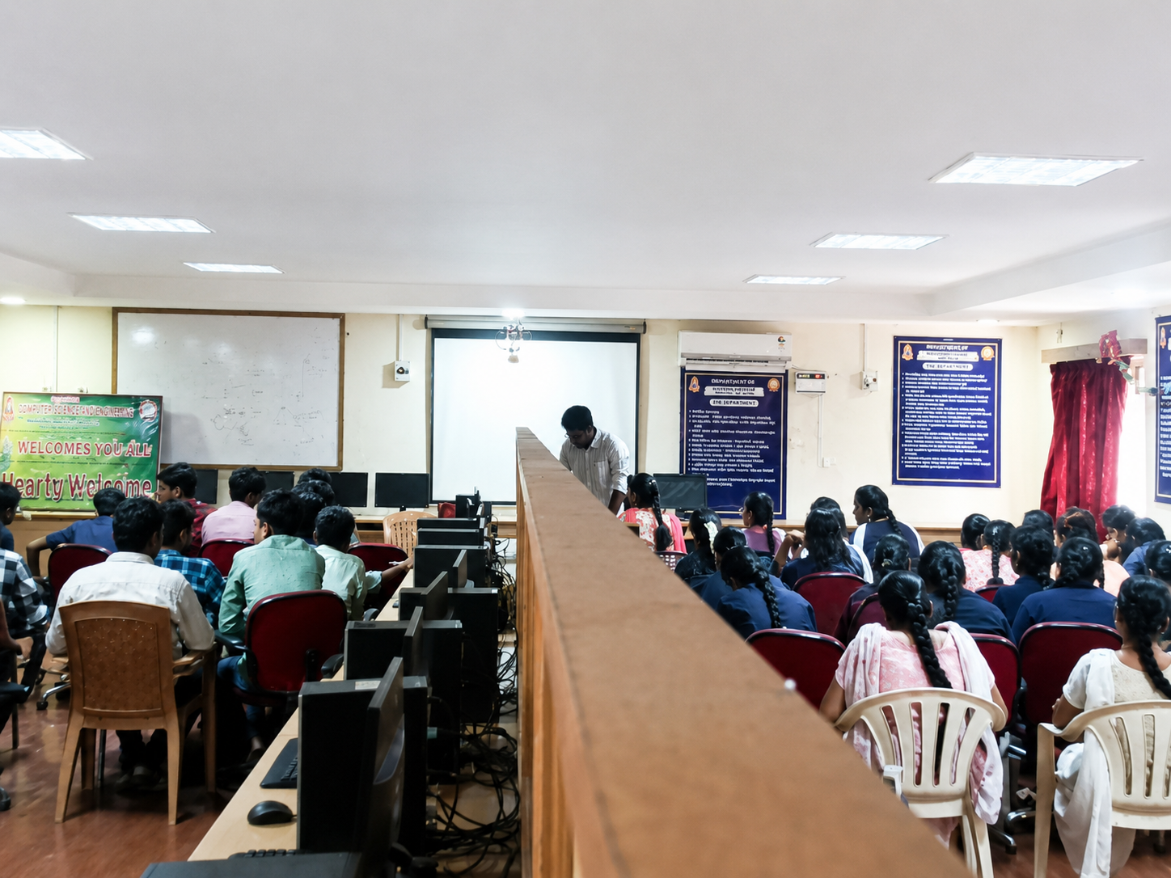
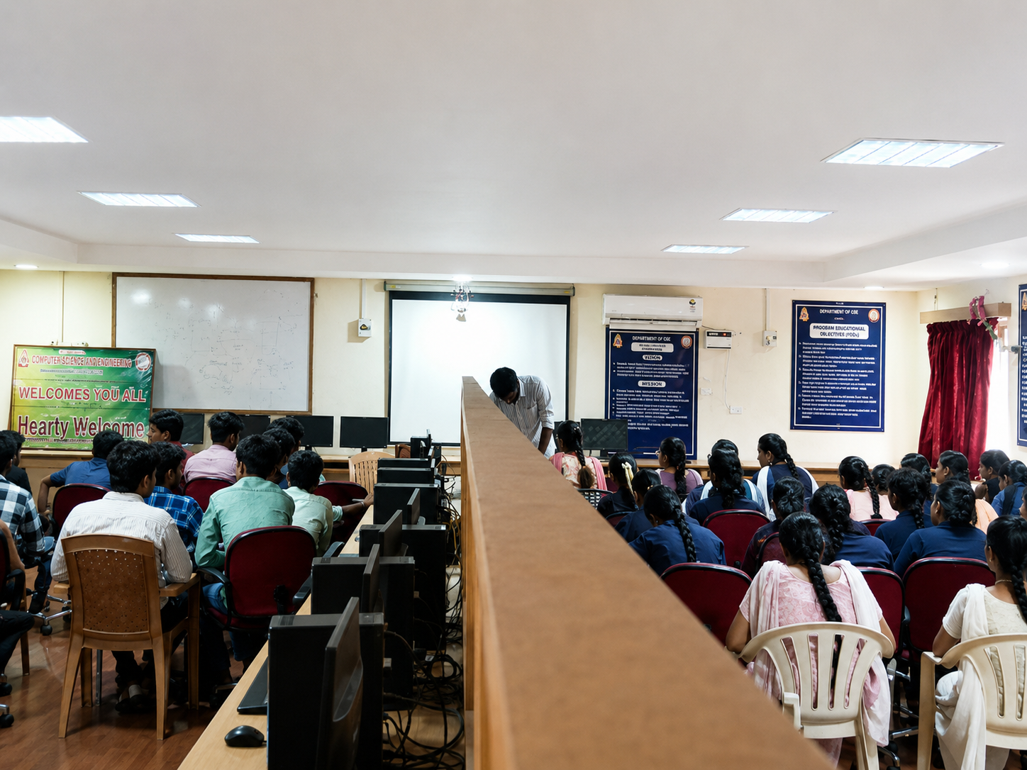

SOFT SKILLS TRAINING PROGRAMME FOR FINAL-YEAR STUDENTS

A Soft Skills Training Programme was conducted for the Final-Year Students on 24 August 2026. The session focused on enhancing students’ communication skills, interpersonal skills, confidence, teamwork, leadership qualities, and interview readiness. Through interactive activities and practical exercises, students were encouraged to improve their professional behaviour and develop the essential soft skills required for placements and career success.
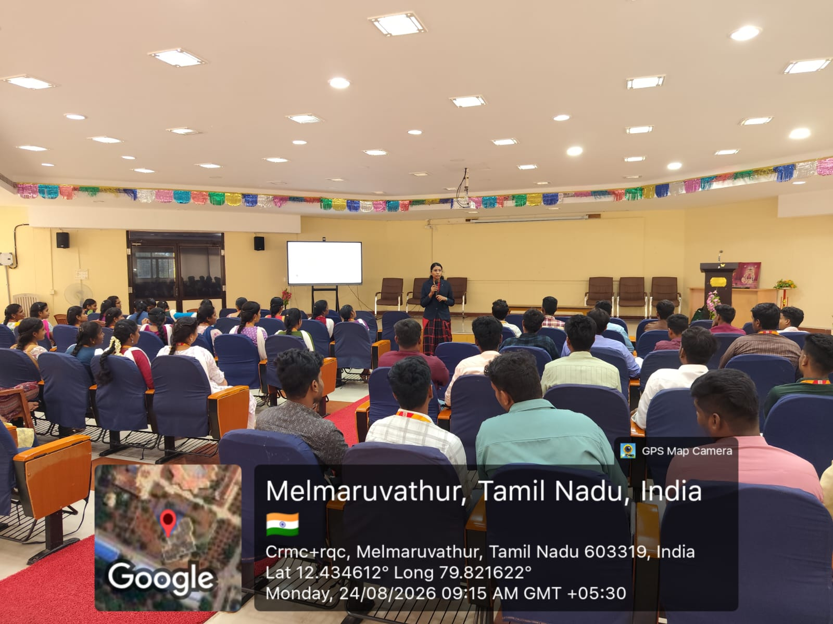

IBM SKILLBUILD – ARTIFICIAL INTELLIGENCE TRAINING WORKSHOP

The Department of Computer Science and Engineering, in association with the CSI Students Chapter, conducted a Workshop on IBM SkillBuild – Artificial Intelligence Training Programme on 25 and 27 August 2026. The session was led by Mr. Vignesh Mathiyalagan, Master Trainer, Edunet Foundation, focusing on AI concepts, practical skills, and industry-oriented learning.
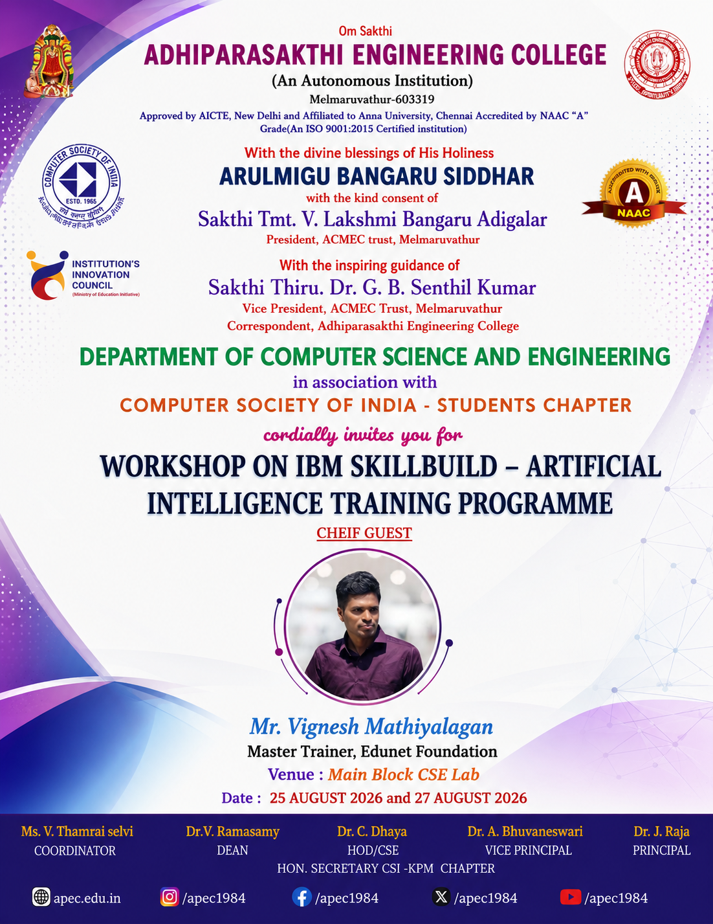

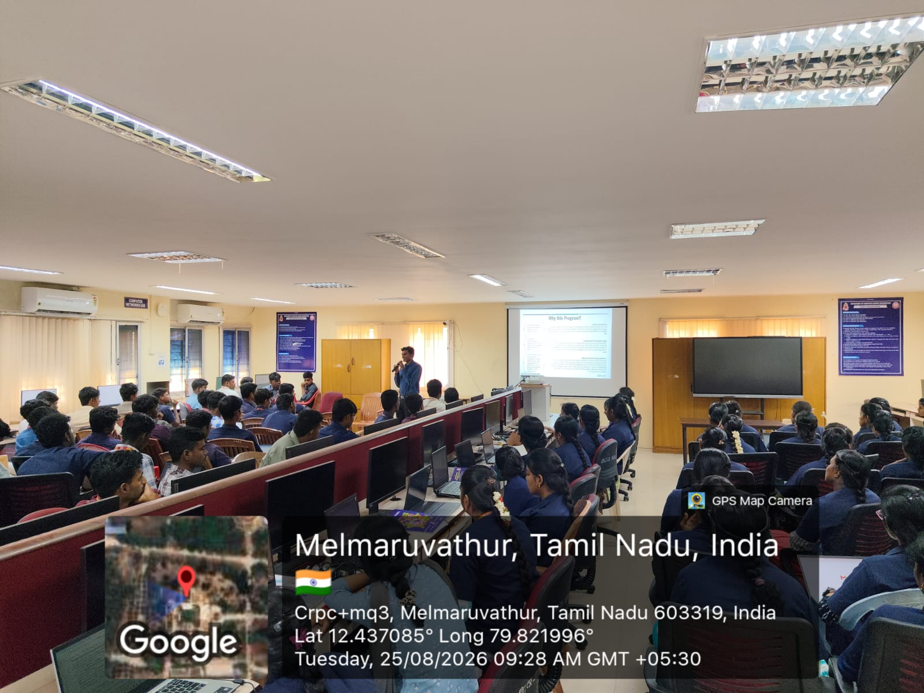
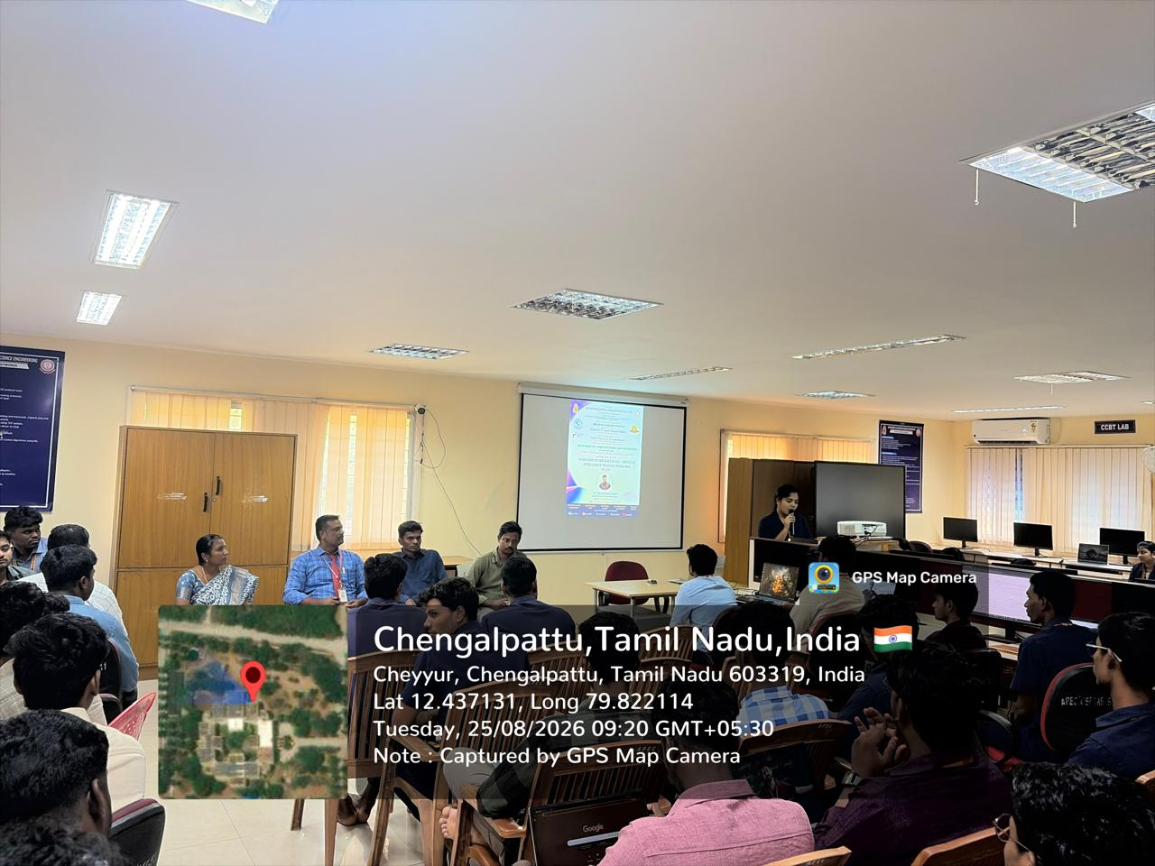

LEARNING BEYOND THE CLASSROOM: III YEAR GIRLS AT SRM

III Year girl students participated in an industry-oriented workshop at SRM, gaining valuable exposure to emerging technologies through interactive sessions and hands-on learning.
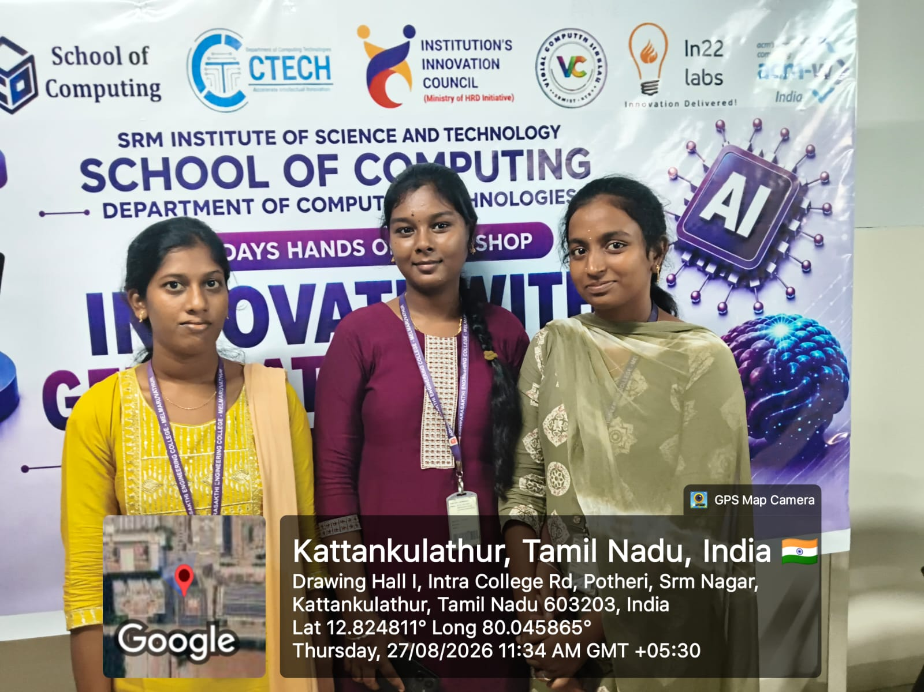

STRENGTHENING ACADEMIC SUCCESS THROUGH PARENT–FACULTY INTERACTION
A special meeting was conducted for II and III Year students with university arrears to review their academic progress and discuss measures for improving their performance.


