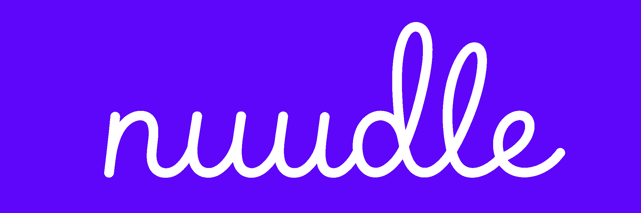
Brand Guidelines
Noodle · nuudle
Version 2.1 — single-line script logo
Own your outreach.
Outreach that sounds like you — not a robot.

1. Brand at a glance
Noodle is the warm, smart way to reach out. It finds the right people, researches them, and writes an email that actually sounds like you — not a robot.
The logo carries the whole strategy in one stroke. The wordmark is a single unbroken handwritten line spelling nuudle, in electric violet:
- One continuous line = connection. The strand never lifts — it threads through every letter, linking them, the same way the product links you to the right people. It is the noodle and the network in one mark.
- Handwritten = personal. A human hand wrote this — the promise of the product: outreach in your voice, not a generic template.
- Electric violet = intelligent and modern. It reads AI-forward and energetic, not grey-corporate.
Tagline: Own your outreach.
What it means: outreach that sounds like you — not a robot. You own the voice, the angle, and the relationship. The tool does the legwork, but the result is unmistakably yours.

2. Name & spelling
Use | Form | Notes
Spoken / in sentences | Noodle | Friendly and readable. Capitalised as a proper noun.
Wordmark / logo | nuudle | Lowercase, single-line script. The hero asset.
Domain / handles | nuudle.ai | The “uu” spelling makes the domain and trademark easy to secure.

The name carries three on-strategy meanings — use them deliberately: connection (strands that link), “use your noodle” (the idiom for think it through — the product does the thinking), and warmth (human, not spammy).

3. Positioning & personality
Positioning. The warm, human alternative to cold outreach. Where other tools blast generic templates, Noodle sends a few genuinely personal emails in your own voice.
Personality, in priority order:
- Human — it feels like a person wrote it (the handwritten mark says this out loud).
- Smart — it researches, finds the angle, and writes well.
- Energetic — modern, quick, confident; the violet brings the spark.
- Lightly playful — one wink, never a whole circus.
The brand is not: loud, jargon-heavy, salesy, cutesy, or corporate-grey.

4. Logo & mark
Primary asset. The nuudle wordmark — a single continuous handwritten line in electric violet. This unbroken stroke is the most important thing about the logo. Protect it.

Construction rules
- Never break the line. Don’t split, segment, or redraw letters individually. The connection concept dies the moment the stroke lifts.
- Don’t re-letter it in a different font. The specific hand is the logo.
- Keep the loops and the consistent stroke weight intact — don’t thin, thicken, or distort them.

Lockups & icon
The wordmark is long and horizontal, so for square spaces (app icon, favicon, avatar) derive a monogram from a single continuous loop drawn in the same hand — for example a lowercase n loop or a small knotted strand mark. Keep it one stroke, same weight, same violet. Don’t cram the whole word into a square.

Clear space, size & inverse
- Clear space: keep empty space around the wordmark equal to the cap height of the “d” on all sides.
- Minimum size: wordmark no smaller than 22px tall; icon no smaller than 24px.
- Inverse: electric violet on light backgrounds; white or lavender on violet / dark backgrounds.

Don’t
- Don’t break, recolour mid-word, or add a second colour to the stroke.
- Don’t add a drop shadow, gradient, outline, or glow.
- Don’t rotate, stretch, condense, or skew.
- Don’t place it on a busy photo or a low-contrast / similar-violet background.

5. Colour
Electric violet leads; a small set of violet-tinted neutrals supports it. Restraint keeps it credible.
Swatch / Hex | Name | Use
#5E06F9 | Electric violet | Logo, primary buttons, links, key accents
#8B5CF6 | Violet 400 (soft) | Hover, tints, secondary accents, charts
#17082E | Ink violet | Body text, headings, high-contrast UI
#6B6580 | Slate | Subtitles, captions, muted labels
#F3EFFE | Lavender mist | Cards, section backgrounds, highlights
#FBFAFD | Off-white | Page background
#E7E1F5 | Border | Dividers, card borders
#FF7A5C | Coral (optional) | Warm counterpoint — use ≤5%, highlights only

Usage ratio (60 / 30 / 10): ~60% off-white / white, ~30% ink + neutrals, ~10% electric violet. The optional coral is a garnish on top of that 10%, never a base. The violet is loud on its own — a little goes a long way.
Accessibility: use ink violet for small body text; white on electric violet is high-contrast and ideal for primary buttons.

6. Typography
The logo is script; everything else is a clean sans. The handwriting stays special precisely because it is used only in the logo.
- Logo: the single-line handwritten script (locked asset — never reused for other text).
- Headings & UI: a clean geometric grotesque — Geist or Inter (free, web-ready), Medium (500).
- Body: the same sans, Regular (400).
Rules: two weights maximum; sentence case everywhere (never ALL CAPS); generous body line height (≈1.6); never set headings or body in a script font — that space belongs to the logo alone.

7. Voice & tone
Write the way the product writes: like a thoughtful person, not a marketing department.
Do: short, confident sentences; warm and direct; contractions are good; lead with the benefit; use the food / connection metaphor occasionally as a wink.
Don’t: no buzzwords (synergy, leverage, game-changing); no exclamation spam or emoji in product UI; don’t over-explain — if a sentence can be cut, cut it.
Taglines, in priority order:
- Own your outreach. (primary — the brand line)
- Outreach that sounds like you — not a robot. (the explainer)
- Find your people. Sound like yourself.
- Use your noodle. (the wink — short form, app store, swag)
- Cold outreach, served warm.
Voice example — an in-brand outreach email:
Subject: quick one on your logistics SaaS portfolio

Hi Sam,
Saw you backed two freight-tech teams this year — we’re building in the same space and cutting onboarding time by 40%. Thought it might be worth a quick chat before we open our round.
Free for 15 minutes next week?

Cheers,
Ammad

8. Product feature naming
Name the product’s parts in-world so the app feels cohesive and on-brand:
Generic name | Branded name | Why
Voice Profile | Secret Sauce | Sells the differentiator in two words — the flavour that makes emails taste like you.
A batch / run of matches | a bowl | “You’ve got a fresh bowl of 12 matches.”
The search step | finding your people | Plain, warm, human.

Lowercase in running UI (“your secret sauce”); capitalised as a menu label.

9. Application notes
- Loading state — animate the wordmark drawing itself as one continuous stroke, left to right, while matches stream in. The single-line logo is built for this; it turns a wait into a signature brand moment.
- App icon — a single-loop monogram, electric violet on off-white, or white on violet.
- Empty state — honest and warm: “No strong matches this time — try widening the search.” Never pad results.
- Buttons — electric-violet fill with white text for the primary action; one primary action per screen; outline-only for secondary.
- Email compliance footer — sender identity + opt-out line, slate, small, always present on send.

Keep this document the single source of truth and version it (2.0, 2.1…) as the brand evolves.

