2. Process Management: The main responsibilities for the operating system when managing processes are sending resources to multiple processes, suspending and resuming processes, synchronizing processes for CPU time, inter-process communication, and reclaiming resources when processes are finished.
Memory Management: The OS is responsible for keeping track of what parts of memory are being used by what processes, decide what processes to move into and out of memory, caching, allocate and de-allocate memory as needed. This is management is needed to improve resource utilization as multiple processes are usually kept in memory.
Mass Storage Device Management: For convenience the Linux operating system abstracts the storage device into units called files. This is to make it easier for user and applications to work with the data. The OS allows for creating and deleting of files, mapping files to memory on the device, and backing up the device. It also allows for managing free space, storage allocation, and disk scheduling.
I/O Management: The OS manages I/O to hide the peculiarities of specific devices making it easier to do I/O with any device. The OS also abstracts devices as file systems. The OS uses drivers to learn how to talk to specific devices and manages data buffering, caching, and spooling.
Protection and Security: The OS protection controls the access of users and processes to the system resources. This is focused on the internal environment of the system. Security is focused on defending the OS against external threats such as malware. While security and protection definitions vary they often work together.
3. You should set up a bare-metal hypervisor, because this means that you would have direct access to hardware resources resulting in better performance and stability. If you went with the hosted hypervisor you would have to download and install an OS that then would create another layer between the user and the hardware creating more overhead and degrade overall performance.

4. Real-time systems are where tasks must be completed within a defined time constraint. These systems are usually embedded systems, systems that are dedicated to specific tasks. They are mission critical applications that cannot miss a deadline regardless of system load, such as car brakes and weapon systems.

5.
1. R to T: Is possible, because the process can go from a running state to stopped phase caused by control signal or it being traced.
2. T to R: Is possible, because the process can go from a stopped state to a running state by being woken up (fg cmd).
3. R to S: Is possible, because the process can go from a running state to an interruptible sleep state because the process can be waiting for an event to complete.
4. S to T: Is not possible, for the process to go from an interruptible sleep to a stopped state it must go a state of running(R).
5. D to R: Is possible, because the process can go from an uninterruptible sleep to a running state by completing I/O operations.

6.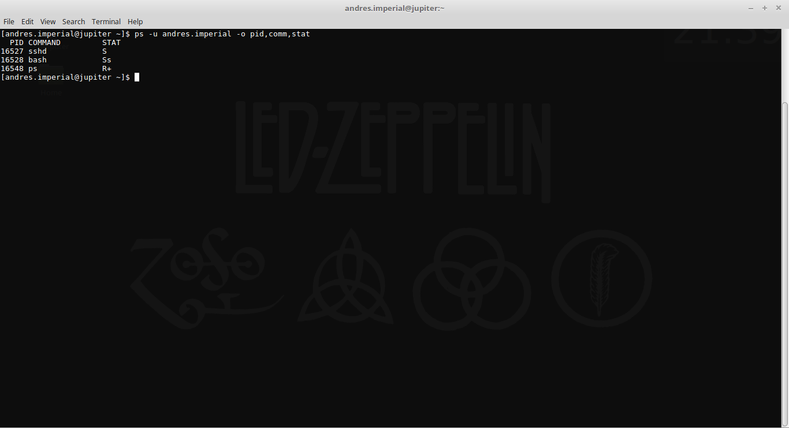
a. We have one processes in the running queue. PID: 16548 CMD: ps State: R+
b.We have two processes that are in an interruptible sleep.
PID: 16527 CMD: sshd State: S
PID: 16528 CMD: bash State: Ss
c. We have no processes that are in an interruptible sleep, if we did their state would be D.
d. We have no processes that are stopped by the job control, if we did their state would be T.
7. 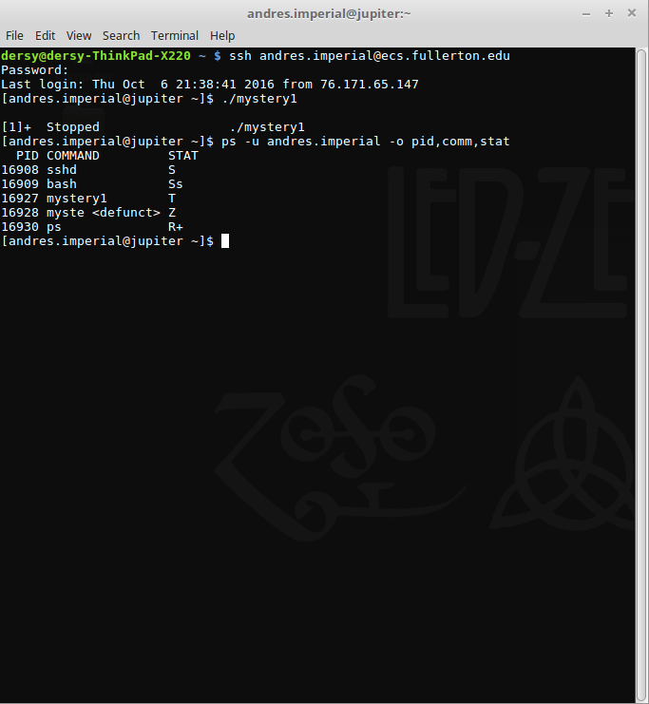
a. We have one processes in the running queue. PID: 16843 CMD: ps State: R+
b.We have two processes that are in an interruptible sleep.
PID: 16527 CMD: sshd State: S
PID: 16528 CMD: bash State: Ss
c. We have no processes that are in an interruptible sleep, if we did their state would be D.
d. We now have a process called mystery1 that is in a state stopped by job control(T).
We do have a difference though after the execution of mystery1 with a mystery1 process that is now in state T and also another mystery1 process that is in a zombie state.
8. a. I see that the mystery was told to stop and is in a T state, but also another mystery is there. So the parent mystery must have had a child and then that child must have died without having its PCB released making it a zombie.
