

**Project Title:** Complaint Logging and Tracking System

**Section:** W1

**Group Members:**

Um Ul Baneen Zahra F2019065072

Ammar F2019065033

M. Ayub Anwar F2019065010

Usama Masood F2019065040

**Submitted to:**

Mr. Arslan Asif

**UNIVERSITY OF MANAGEMENT AND TECHNOLOGY, LAHORE**

**Design (Complaint Logging and Tracking System)**

**Diagrams**

1. **Use Case Diagram**
2. **Class Diagram**
3. **ERD**
4. **Sequence Diagram**

**Use Case Diagram**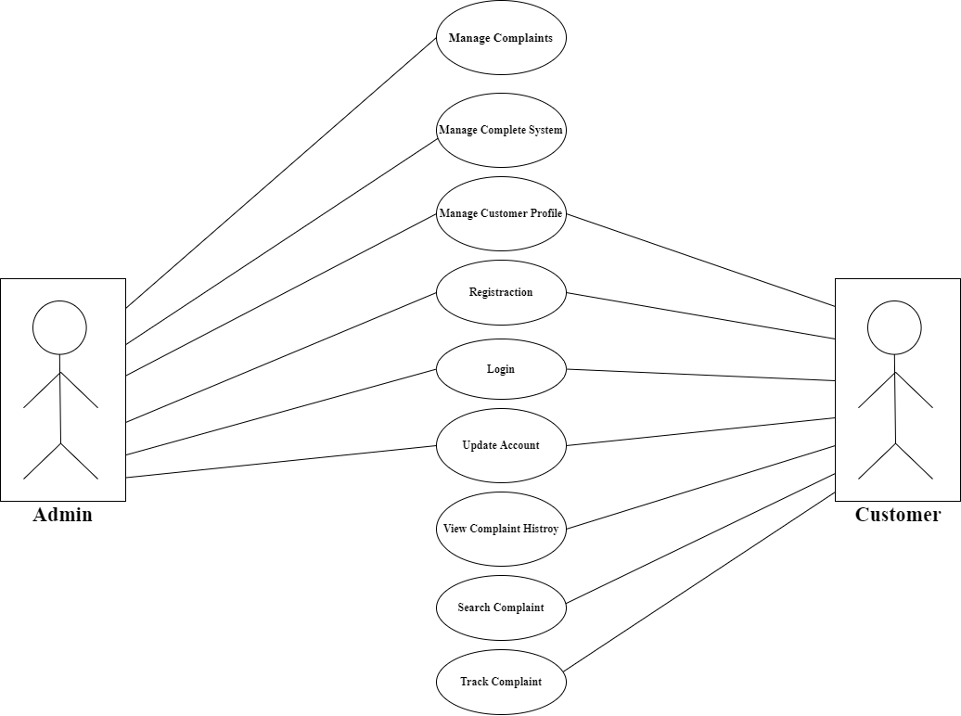

**Class Diagram**

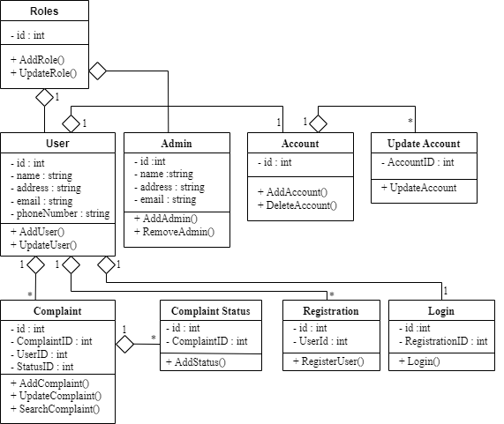

* **ERD**

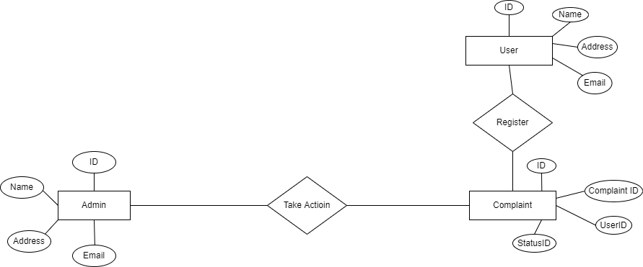

* **Sequence Diagram**

