SMART IT

CUSTOMER SUPPORT ANALYST
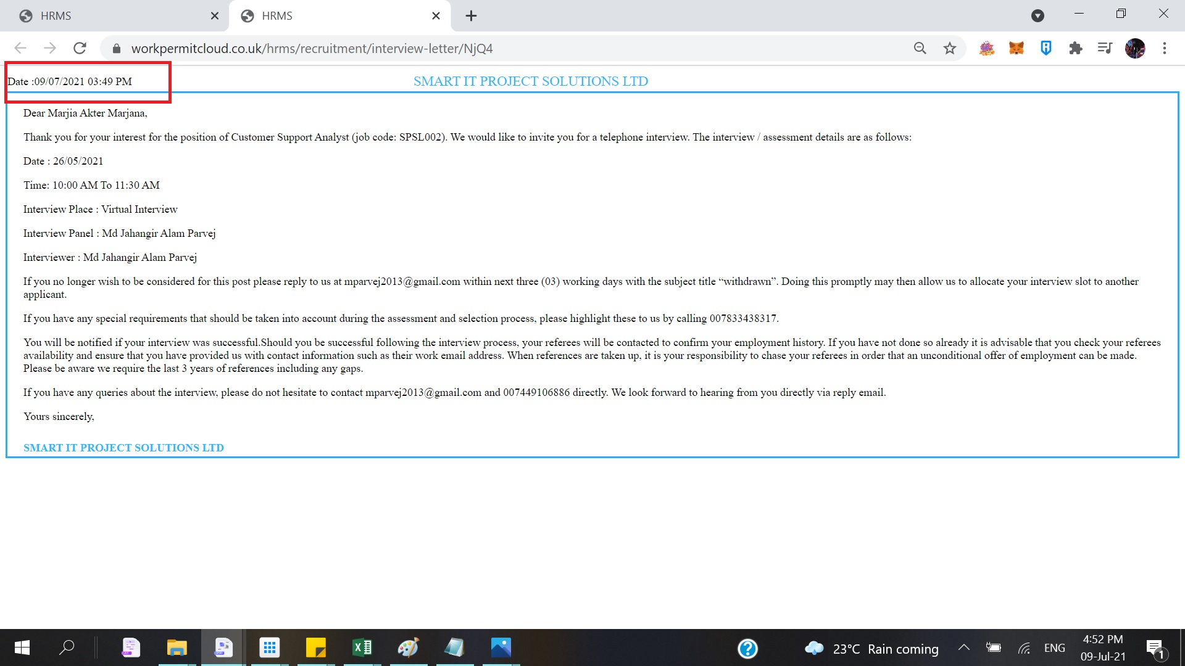
INTERVIEW EMAIL INVITATION, PLEASE CHANGE DATE FROM
09/07/2021 TO 21/05/2021

