SUPER ADMIN > BILLING >CANDIDATE> MAXI DINE LTD

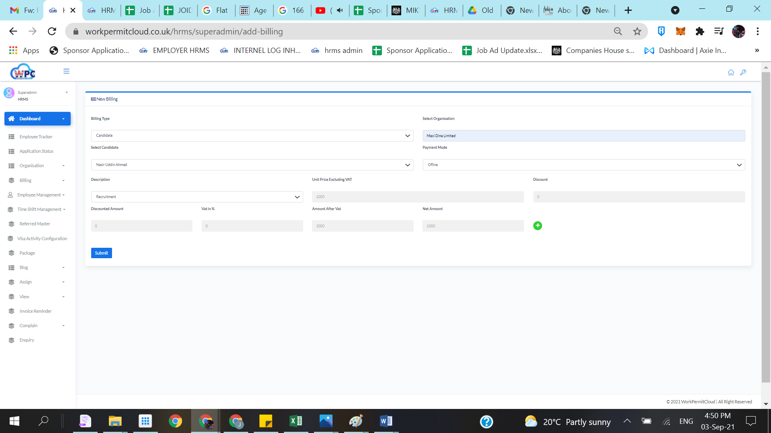

AFTER SUBMITTING ITS ERROR

