WE CREATE PACKAGE #6, BUT WE DISABLE IT

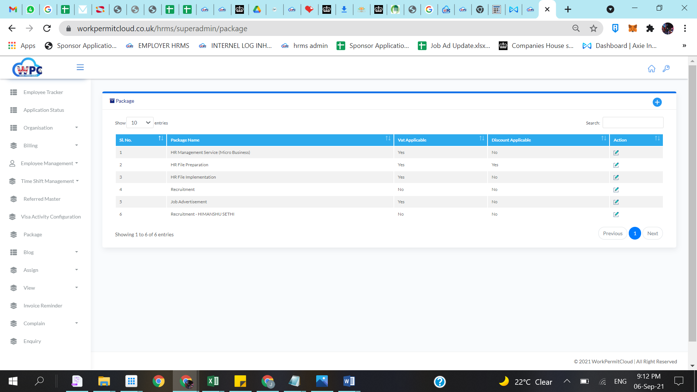

BUT EVERYTIME WE CREATE INVOICE IN ANY COMPANY IT APPEARS RECRUITMENT – HIMANSHU SETHI

EVEN WE DIDN’T CHOOSE THAT

