**AC VOLTAGE CONTROL USING TRIAC**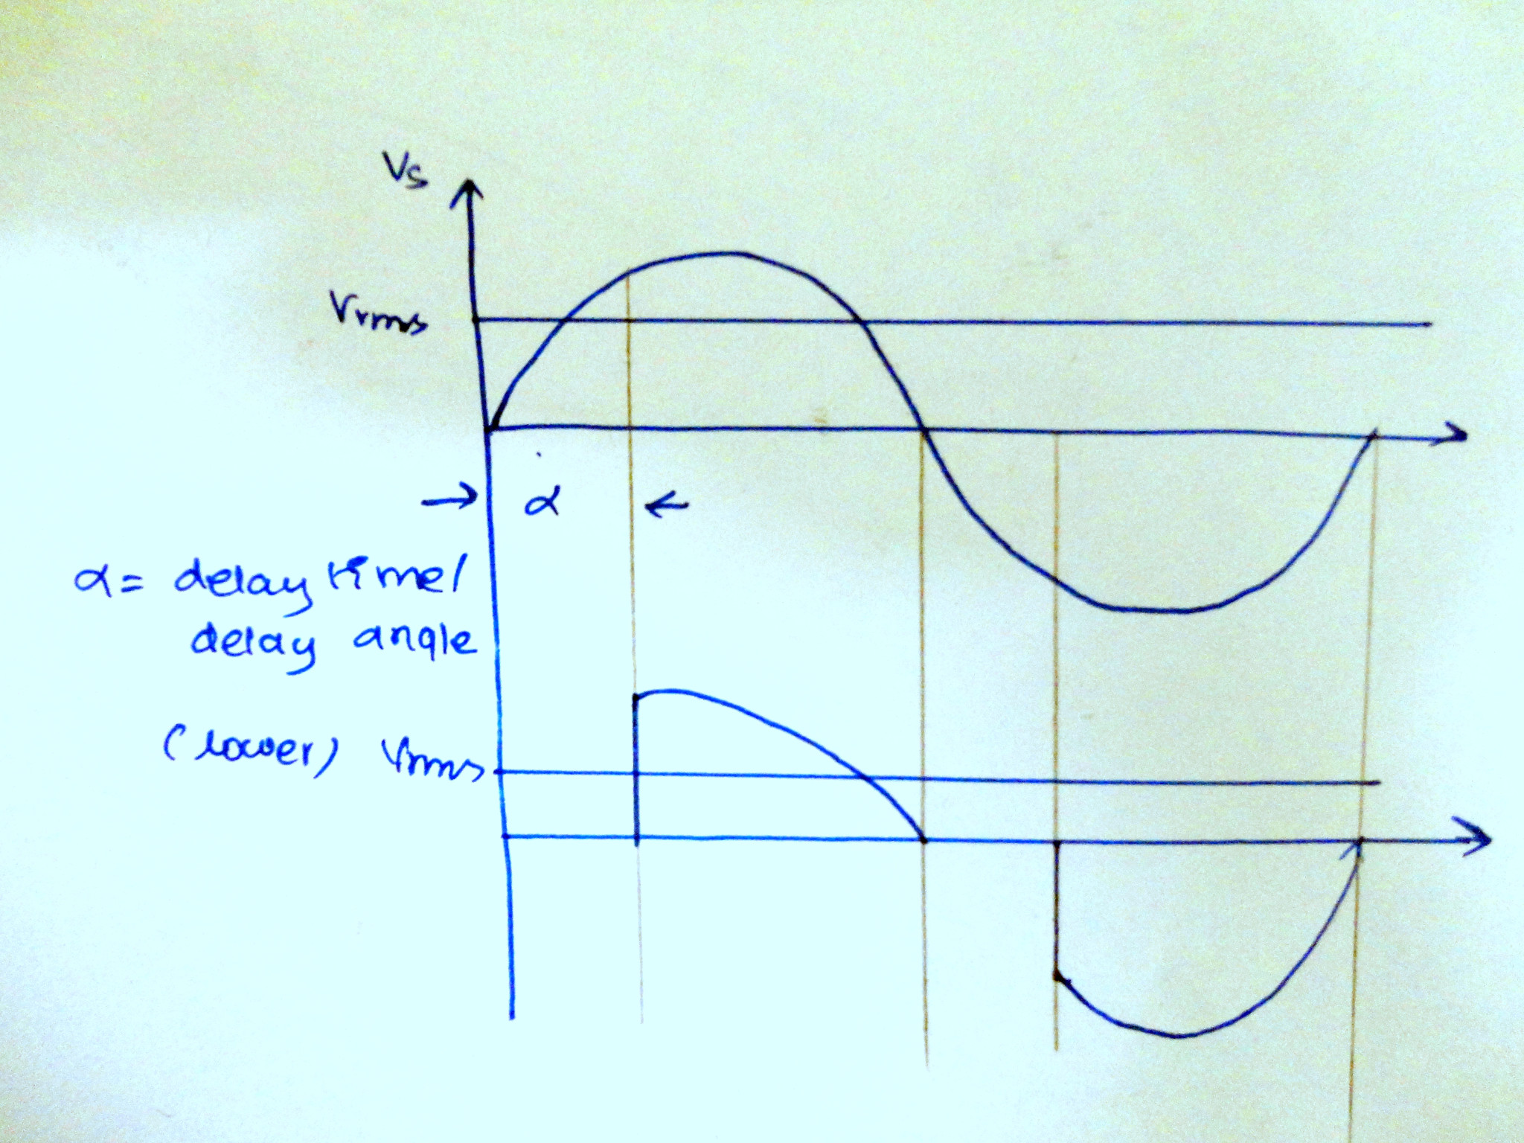

In this tutorial we are going to see how to control the phase voltage of AC wave using Arduino. The method which we are going to use is Phase control firing method which means chopping the AC waveform inorder to bring down RMS voltage of AC. This AC waveform is given to incandescent bulb. Since the light output of the bulb is proportional to the AC voltage(It is said that Light Intensity is proportional to V3.4  :-)) the brightness of the lamp can be controlled based on the delay angle at which AC wave is chopped.

The Method which we gonna use has 3 major steps/blocks, they are,

* Zero Crossing Detection
* Logic Part(Arduino)
* Triac Triggering

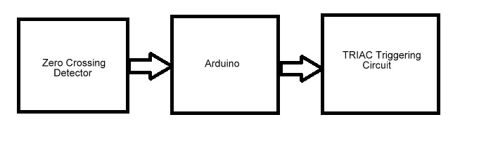

**So this is what actually happens:**

* The Output of the zero crossing detector is given to interrupt pin of the Arduino.
* When the Interrupt is triggered, after certain predetermined delay(in microseconds) the TRIAC is triggered.
* A Small pulse of digital signal is given to TRIAC driving IC (MOC3021) inorder to trigger it.

**Zero Crossing Detector:**

This circuit detects zero crossing attained by AC wave. The components which we gonna use for zero crossing detection is ,

|  |  |  |
| --- | --- | --- |
|  | 1 | Screw Terminals used to carry AC voltage |
|  | 2 | 220k ¼ watt resistor |
|  | 1 | 1nF capacitor  (B32922) |
|  | 5 | 1N4148 Diodes |
|  | 1 | 10uF capacitor(we used 50v) |
|  | 1 | 22k resistor ¼ watts |
|  | 1 | 1K resistor ¼ watts |
|  | 1 | 2N3904 Transistor |
|  | 1 | 4N35 optocoupler |

The circuit diagram explaining connections is given below:

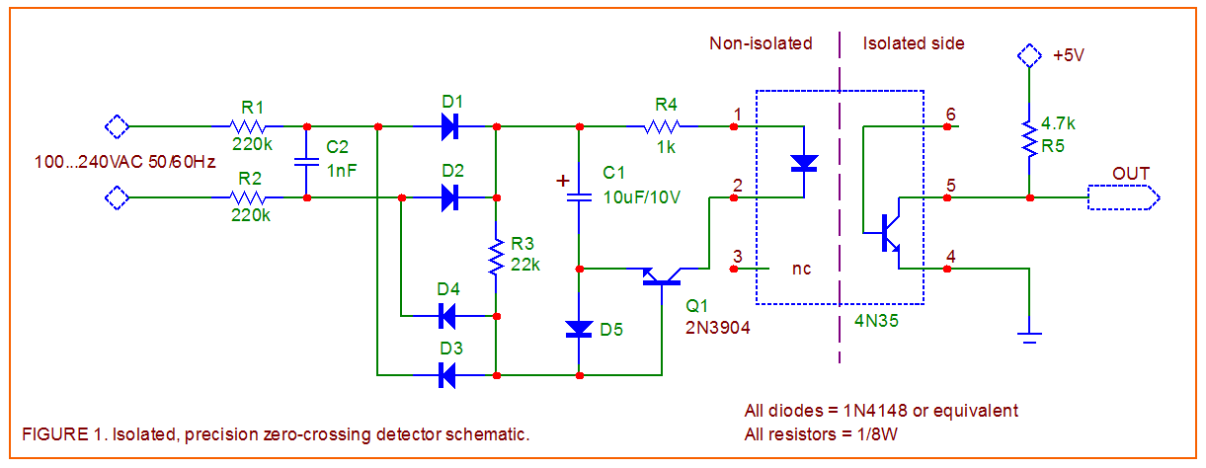

The Output of the Zero Crossing detector is given to Interrupt pin of the Arduino.

**Logic Part(Arduino):**

The Zero Crossing signal is given to Arduino, It takes that as reference point, now based on the brightness required/ VRMS required the delay period is introduced and TRIAC is triggered after the delay period,therby decreasing the effective voltage.

**TRIAC Triggering:**

Following components are required for Triggering TRIAC,

|  |  |  |
| --- | --- | --- |
|  | 1 | Screw Terminals |
|  | 1 | 100 ohm one watt resistor |
|  | 1 | BT 136 TRIAC |
|  | 1 | MOC 3021 TRIAC Firing IC |
|  | 1 | Transistor |

**Pin Mapping for TRIAC:**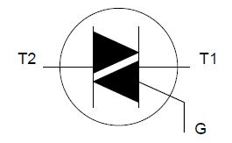

**TRIAC Triggering Circuit Diagram:**

