## horizontal line



Print & Mail Center (PMC) Campaign

12.06.18

MGMT 271, Fall 2018

Edmonds Community College

|  |  |  |
| --- | --- | --- |
| Aimee Stevens | Kaleena Devine | Susan Kelley-Morse |
| George Pavlakos | Mark Nefedov | Tammy Botham |
| Hieu Nguyen | Michele Rinaldi | Theresa Norris |
| Jason Nash | Shannon Rider |  |

# 

**Background and Introduction** **3**

**Objective** **3**

**Project Requirements** **3**

**Business Case** **4**

**Scope** **5**

**Constraints** **5**

Time 5

Cost 5

Quality 5

**Stakeholders** **6**

**Project Team** **7**

Aimee Stevens 7

Michele Rinaldi 7

George Pavlakos 7

Shannon Rider 7

Hieu Nguyen 7

Susan Kelley-Morse 7

Jason Nash 7

Tammy Botham 7

Kaleena Devine 7

Theresa Norris 7

Mark Nefedov 7

**Communication Plan** **8**

**Work Breakdown Structure (WBS)** **9**

**Project Schedule** **11**

**Risk Management** **13**

**PMC Recommendations** **18**

**Project Findings** **18**

Completely Remediable 18

Partially Remediable 18

**Analyzing Survey Results** **19**

**Recommended Solutions** **19**

For Completely Remediable Issues 19

For Partially Remediable Issues 20

**Final thoughts** **20**

**Post Mortem** **21**

**Project Team Lessons Learned** **22**

Meetings 22

Communication 23

Project Plans 23

Stakeholders 23

**Surveys** **29**

**Snapshot of Survey Results** **34**

**Marketing Materials** **35**

Postcard flyer 35

Instructional Presentation 36

# 

Charter

# Background and Introduction

The Edmonds Community College (EdCC) Print & Mail Center (PMC) supports the printing needs for faculty and staff. Over the past five years, the use of the PMC has declined as the use of local department copiers has escalated. This has resulted in an increased cost for printing and threatens to eliminate the PMC.

In 2012, EdCC introduced its new core values to include Responsibility and Accountability (<https://www.edcc.edu/about/mission.html>). It is the obligation of faculty and staff to be accountable for upholding the mission of EdCC. They are challenged to be good stewards of the college resources “with efficiency and integrity to ensure the long-term health of the college.” It’s with this value that faculty and staff should be aware of how their copy and print practices impact the future of the college.

In an effort to change the printing practices of EdCC faculty and staff, Kelvin Nesvog, Director of Auxiliary Services, who operates the PMC, requested that the Management (MGMT) 271 Fall 2018 class create and launch an initiative to increase use of the more cost effective PMC copiers and decrease the need to maintain more costly, remote departmental copiers.

# Objective

On December 6th, 2018, the MGMT 271 class has implemented the PMC Campaign educating EdCC faculty and staff on the costs of printing thus encouraging them to increase their usage of the Print & Mail Center (PMC) instead of their departmental copiers. To assess the overall increase of usage, the number of copies generated at the PMC copiers from the last week of November 2017 will be analyzed in comparison to the same week in 2018.

# Project Requirements

## The project has a clear message in all documentation

All marketing materials and messages must be approved by EdCC’s Marketing Department.

## Marketing & education materials have physical presence on EdCC campus

Postcards are sent to faculty and staff mailboxes and posters are hung by departmental copiers.

## The project includes participation from Kelvin Nesvog

An email is sent prior to finals week to all faculty, staff, and administration encouraging usage of the PMC to copy all instructional documents, like handouts and exams.

## The project has support from divisional deans and administrative assistants via participation.

Participation includes sending emails to their department faculty and staff as reminders to use the PMC.

## Recommendations are provided to Kelvin Nesvog to improve the PMC

A list of recommendations will be based on the data provided from the faculty & staff surveys - what they prefer, what they would like to see changed, etc.

## Sustainable practices are put into place

Kelvin will have the materials he needs in order to continue to promote the PMC: an instructional powerpoint of how to request a print job, statistics on pricing vs. usage, and recommendations to improve the center.

# Business Case

The program serves to challenge EdCC faculty and staff to print their finals and large projects through the PMC over their local departmental copiers to maximize departmental funds and saving the livelihood of the PMC. We intend to shift business to the PMC by reminding faculty and staff about the college’s “responsibility and accountability” value and providing recommendations on how they can improve their usage of the PMC. We will educate them on how much they can save for their departmental budgets as well as how to use the PMC.

# Scope

Class MGMT 271 will divide into three teams to: complete research on current usage of PMC and departmental copiers; send surveys to identify and solve the underlying cause of limited utilization of the PMC; as well as create and present the PMC Campaignto EdCC faculty and staff. This will include a total of two (2) surveys to EdCC staff, and the creation of printable marketing material.

# Constraints

## Time:

* 1. The project completion date is limited to the end of Fall quarter, 12/6/2018.
  2. Many project team members work during the day when most faculty and staff are available.
  3. Project team members are learning and applying their new knowledge to this project. Additional time may be required for ‘rework’ as lessons are learned.
  4. Coordination with partners, such as the Green Team, Marketing Department, and administrative staff must occur before the prep of finals week.

## Cost:

* 1. There are no allocated funds for this project.
  2. Marketing material cost is limited to what MGMT 271 students are willing to pay out of pocket if marketing department is unwilling or unable to help.
  3. This project relies on unpaid labor by students.

## Quality:

* 1. Since the students in MGMT 271 are not Subject Matter Experts (SME), there is a lack of extensive knowledge for this project.
  2. Due to lack of funding and experience, quality of educational materials may be compromised.

# 

# Stakeholders

|  |  |  |
| --- | --- | --- |
| **Stakeholders** | **Role** | **Goals & Motivations** |
| Dr. Amit Singh, EdCC President | Top Management | * Reduce costs for the budget to save money for the college |
| Kelvin Nesvog, Director of Auxiliary Services | Functional Management/SME Customer | * Educate faculty on the benefits of using the PMC to generate more business |
| Claudia Levi, Instructor | Sponsor | * Be the liaison between the MGMT 271 class and the faculty & staff * Help students be successful in project management |
| MGMT 271 Students | Project Team | * Create awareness to encourage increased use of the PMC * Further educational goals in project management |
| EdCC Administrative Managers & Division Deans | Consumer | * Maximize departmental budgets by saving on printing * Free up time spent on printing and copying |
| EdCC Faculty/Staff | Consumer | * Have easy and convenient ways to print and copy |
| Marketing Department | Team Members/SME | * Provide marketing assistance to faculty, staff, & students to communicate events happening at the college |
| Ben Church, PMC | Team Member/SME | * Generate more business at the PMC * Educate faculty on how to use the PMC website |
| Stewart Sinning, Green Team | Team Member/SME | * Actively pursue green solutions that can benefit students, staff, and the community |

# 

# Project Team

|  |  |  |
| --- | --- | --- |
| Aimee Stevens Created and analyzed surveys, wrote PMC recommendations and lessons learned, and compiled all deliverables. |  | Michele Rinaldi Primary contact with EdCC marketing department, designed marketing materials, helped create Risk Assessment, helped create WBS, and gave input on survey questions. |
| George Pavlakos Drafted charter introduction, designed marketing materials, and helped draft emails to stakeholders. |  | Shannon Rider Helped create Risk Assessment, designed marketing materials, helped draft emails to stakeholders. |
| Hieu Nguyen Created program schedule, helped design marketing materials, helped draft emails to stakeholders, and helped create Risk Assessment. |  | Susan Kelley-Morse Class project manager, kept class minutes, helped create surveys, drafted emails for all key stakeholders and coordinated meetings with Print & Mail Center, EdCC Green Team, and EdCC marketing team. |
| Jason Nash Was primary contact with EdCC Green Team, helped with surveys, initiated dialog with EdCC marketing department, and created WBS. |  | Tammy Botham Primary contact with Print & Mail Center, attended EdCC Green Team outreach event, attended all meetings, and helped create WBS. |
| Kaleena Devine Created Print & Mail Center instructional slides, created communication plan, and took meeting notes. |  | Theresa Norris Created post-mortem and introduction, helped create survey questions and recommendations, provided input to work products and took notes at some meetings. |
| Mark Nefedov Designed marketing materials, helped create WBS, and helped draft emails to stakeholders. |  |  |

# Communication Plan

|  |  |  |
| --- | --- | --- |
| **Name** | **Methods of Communication** | **Frequency** |
| Hieu Nguyen  Michele Rinaldi  Shannon Rider | Email, Google Docs, and Canvas Class Group | Weekly meetings, email and Canvas group for inbetween communications |
| Aimee Stevens  Jason Nash  Susan Kelley-Morse  Theresa Norris | Email, Google Hangouts, and Canvas Class Group | Weekly meetings, email and Canvas group for inbetween communications. Google Hangouts for real time and high urgency communications. |
| George Pavlakos  Kaleena Devine  Mark Nefedov  Tammy Botham | Texting, Canvas Team Group, and Canvas Class Group | Weekly meetings, email and Canvas group for inbetween communications. Texting for high urgency communications. |
| Kelvin Nesvog  Ben Church  Stewart Sinning | Email, Phone Call, and Meetings | As needed, emphasis on email, calls for more time sensitive issues. In person meetings to check milestones |
| Marketing Team | Email, Phone, and Meetings | As needed, emphasis on email, calls for time sensitive issues. In person meetings to check milestones and discuss deliverables. |
| Deans | Email | Email with deliverables and follow-up communication. |
| Claudia Levi | Email, Office Appointment, and in Class | As needed |

# 

# 

# Work Breakdown Structure (WBS)

1. **Research**
   1. Interview Kelvin Nesvog
      1. Received Usage Data on all Departmental Copiers
         1. Compiled Number of Copy Machines
         2. Compiled Number of Copies Made
      2. Received Data on Copies made at PMC
      3. Received Budget Information
         1. Evaluate Cost at Departmental Machines
         2. Evaluate Cost at the PMC
   2. Research Project Environment of EdCC
      1. Evaluate Guiding Principles, Values, & Strategic plan
      2. Study the PMC Webpage’s Product, Process, & Language
      3. Identify Campus Marketing, Website Management, & Fund Resources
   3. Acquire Green Team Endorsement
      1. Attend Campus Sustainability Event
      2. Meet with Stewart at Green Team meeting
      3. Present Project Outline & Marketing Materials
   4. Survey
      1. Create Surveys for Admin Staff and Faculty
      2. Send Google Survey
         1. Email 1 Survey to Faculty
         2. Email 1 Survey to Administrative Managers
      3. Analyze Survey Results
      4. Generate Recommendations For PMC
   5. Acquire Marketing Team Assistance
      1. Meet with Marisa & Max
      2. Assess Marketing Level of Involvement
2. **Create Marketing Material**
   1. Create Website Instructions with Google Powerpoint
   2. Submit Marketing Draft to Max
   3. Review/Revise Marketing Proof
   4. Submit Revision to Max
   5. Obtain approval from Kelvin
   6. Obtain Approval From Green Team
   7. Send Final to PMC for Print
   8. Draft Marketing Email to Kelvin & the Deans
3. **Execute Educational Campaign**
   1. Send Campaign Emails to Kelvin & the Deans
   2. Distribute Posters and Mailers
      1. Ben Distributes Postcards
      2. Kelvin Places Poster by Copiers
   3. Kelvin Sends Email to Faculty & Staff
4. **Follow​-​Up**
   1. Email to Kelvin for Print Results
   2. Document Results in Charter
   3. 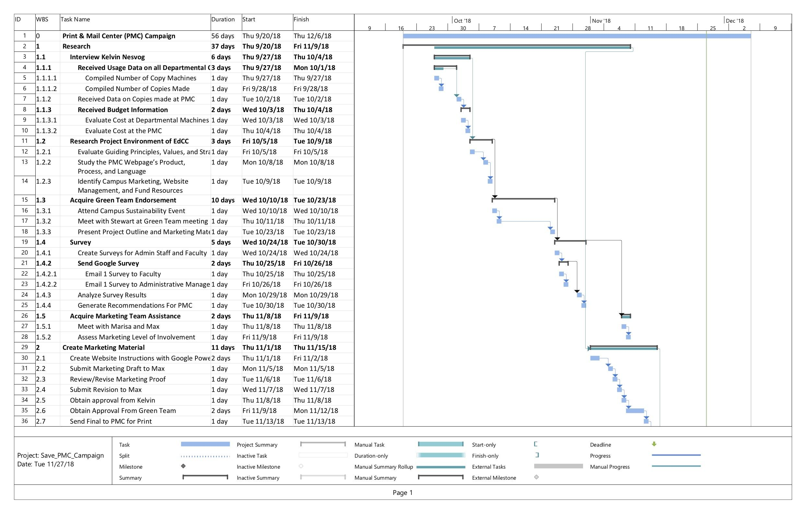Provide Recommendations
   4. Celebrate!

# 

# Project Schedule

# Risk Management

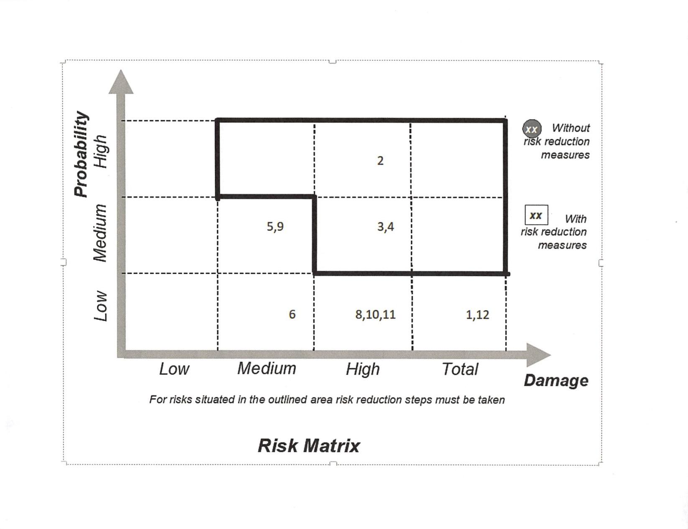

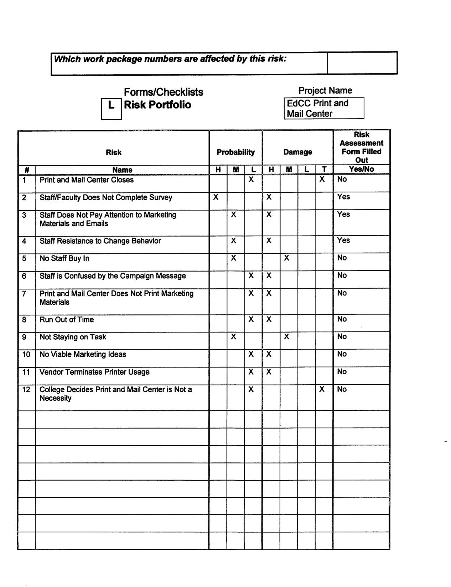

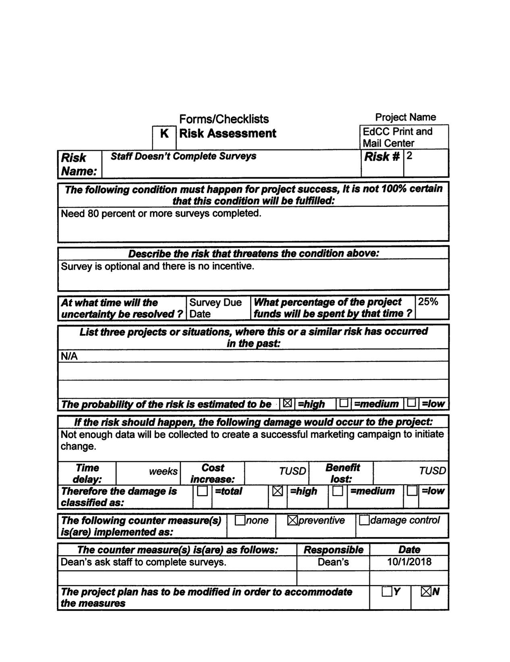

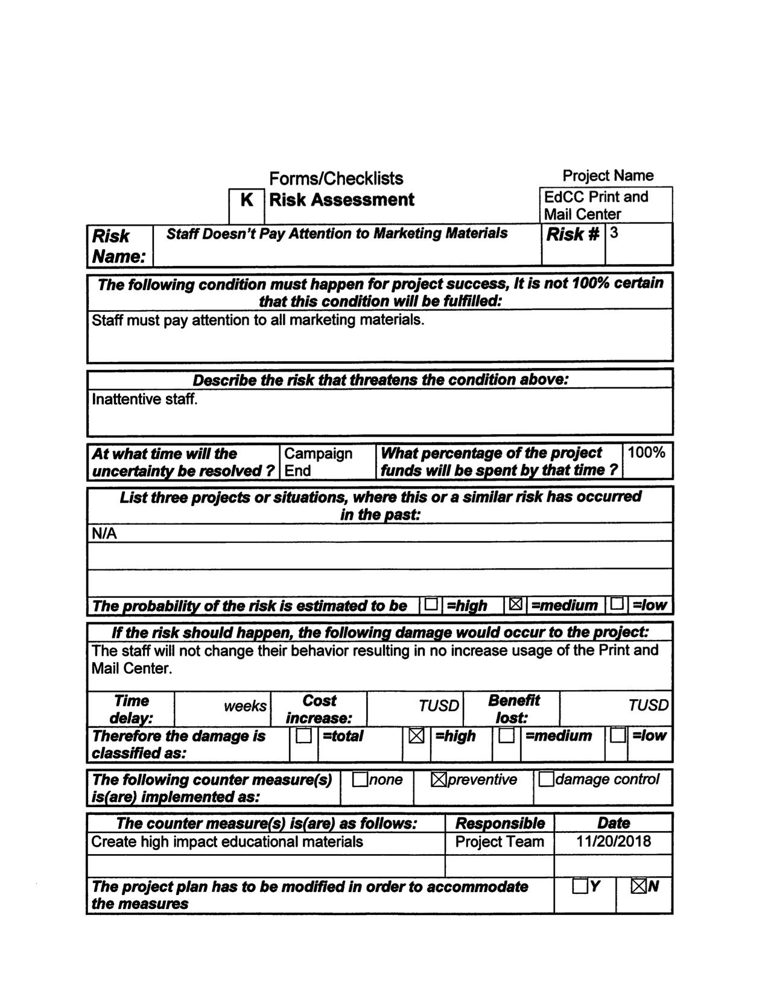

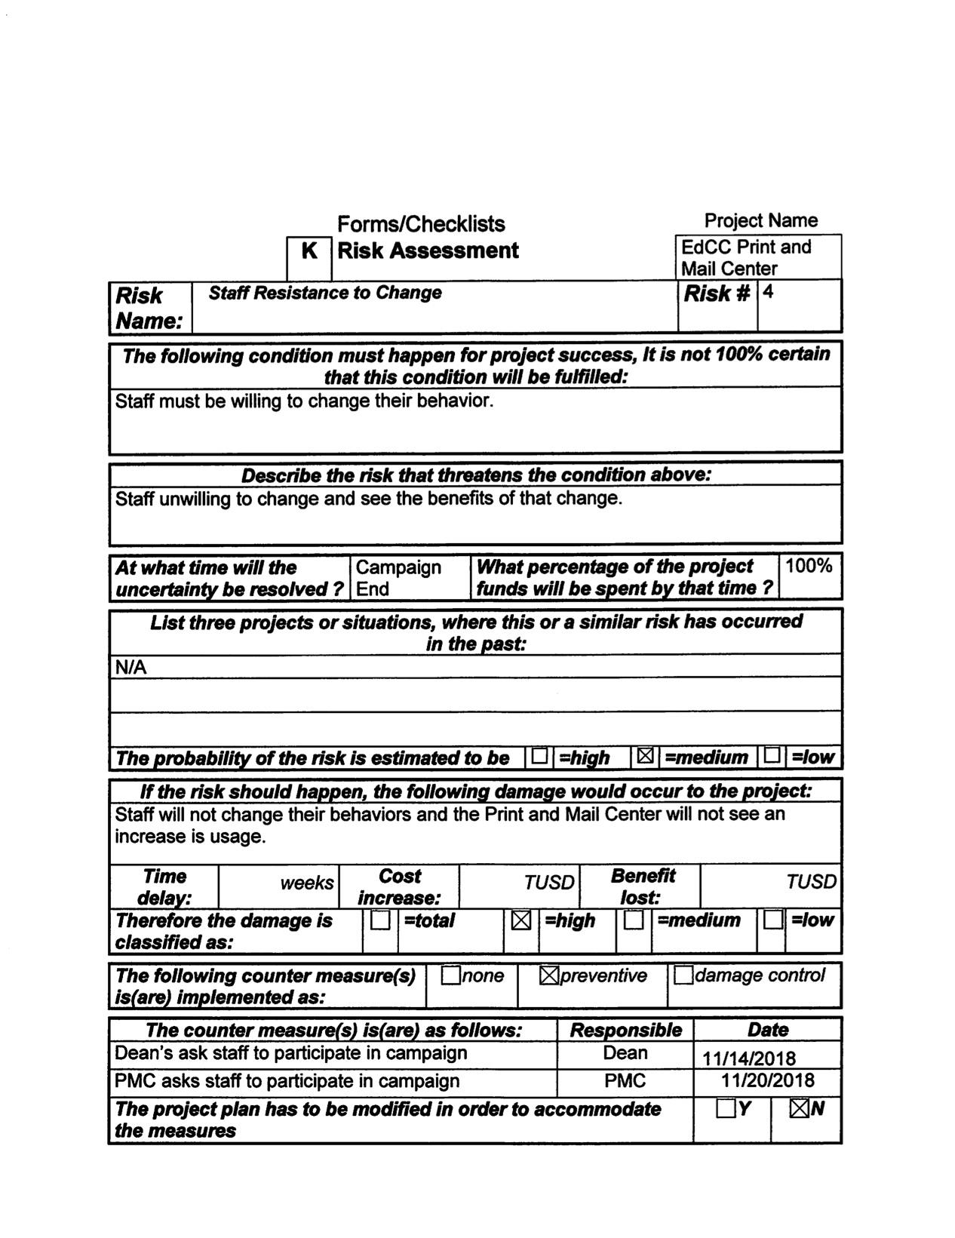

# PMC Recommendations

# Project Findings

Class MGMT 271 gathered data of printing habits of Edmonds Community College (EdCC) faculty and staff via a survey (using google forms). Survey answers may be seen using this link: <https://goo.gl/3poBhs>. With these results, class MGMT was able to analyze and identify underlying issues that are preventing faculty and staff from actively choosing the Print & Mail Center (PMC). The following list includes issues that are both changeable and not.

## Completely Remediable:

* The PMC website is not known
* The online job request form is difficult to navigate
* There have been mistakes in printing at the PMC
  + This could be a formatting issue from Google Docs
  + It could be related to the problems users find with the submission form

## Partially Remediable

* The location of the PMC is too far from workspace
* The PMC hours of operation are not accommodating for early or evening classes
  + This could be due to some faculty work hours being before/after the PMC is closed or lack of planning appropriately.
* The lead time to print is too long
  + Teachers finalize plans to print last minute
  + Filling out the form or navigating site takes too long

# 

# Analyzing Survey Results

|  |  |
| --- | --- |
| **Completely Remediable Problem** | **Why it matters** |
| The PMC website is not known | Faculty & staff that are unaware of the PMC website are less likely to use the services. |
| The online job request form is difficult to navigate | If it takes them longer to navigate the site than it does to print at the local copiers, they'll use the local copiers. Another point is not receiving confirmation that the print job was accepted and lack of project tracking information. This means faculty & staff are unsure if their projects are ontime. This puts into question the reliability of the PMC |
| There have been mistakes in printing at the PMC | Another concern regarding the PMC reliability. The time it takes to send and receive print jobs is already a concern. The project printing incorrectly may cause disruption to assignments. |

|  |  |
| --- | --- |
| **Partially Remediable Problem** | **Why it matters** |
| The location of the PMC is too far | Faculty & staff on the other side of campus may not have time to pick up their projects. Some may have the time but prefer not to. This makes local copiers more appealing |
| The hours of operation are not accommodating for early morning or evening classes | This only affects the outlier classes beginning at 7:30am and earlier or 6pm or later. This also makes local copiers more appealing because they have access during their working hours. |
| The lead time to print is too long | Many faculty members finalize their printables day of or day before the class it's intended for- this means needing to requested "well in advance" is inconvenient. |

# Recommended Solutions

## For Completely Remediable Issues:

Class MGMT 271 has addressed some of these issues directly through the “Print and Save With the PMC” project. Posters have been created for the education program and emails have been sent, both of which have detailed instructions of how to find the PMC site and fill out the print job request forms. Posters will be displayed by all local copiers. Additional recommendations for the future are as follows:

* At the beginning of the quarter and 2-3 weeks before finals, send reminder emails with links to the instructional powerpoint providing clear instructions on how to fill out request forms
* Work with Ben and Stewart (Green team) to create an instructional video to distribute online for video & audio learners
* Have blank hard copies of print request forms available in division offices
* Update the website to have clear instructions and expectations on the front page of PMC website.
  + Change the “hero slideshow” on the front page to be 5 seconds longer to allow users enough time to read information regarding hours, location etc.

## For Partially Remediable Issues:

These issues are harder to change but not impossible to improve. Following is a list of recommendations

* Implement a delivery system. This individual(s) could deliver daily to each department. If student led, projects must be in sealed envelope. Paid or volunteer based
* Implement a pop-up or email to confirm that a print job request has been accepted.
* Add a status bar for faculty and staff to have updates on their project. This keeps faculty and staff informed of the status of their projects so they can plan for pick up or expected delivery.
* Install (or use existing) lock boxes in the mail center where users can access their print jobs after PMC business hours.

# Final thoughts

For this change to be sustainable, create a dashboard with ongoing information about printing costs and potential for savings; add an introduction to PMC for new employee orientation to include cost and efficiencies.

Determine how the campus personnel engage with green and sustainability initiatives and find a way to include printing efficiency to their agendas. Use the instructions that were developed by this team - make them easily available and update them as required for future changes. Working with Stewart from the Green Team may be to the benefit of both parties.

Adding the PMC to the campus directory with simpler access would be a suitable addition.

Closing Documents

# Post Mortem

Overall, the Print and Save with PMC project was a success. Using the week before Fall Quarter final exams as a measurement period, 51% of printing was sent to PMC in 2018, compared to 45% in 2017. Percentages are used as a comparison, rather than numbers of copies as overall printing also declined during this period.

In a post-project meeting with Kelvin Nesvog, he expressed his satisfaction with the communication prepared by the Project Management class and the response he received from faculty. Faculty appreciated learning about the budget implication of their printing choices and confirmed that, prior to receiving the message, they were unaware. Kelvin enjoyed interacting with the students and stated that communication with the project group was positive and helpful. He did not experience pushback from his customers, as can sometimes be expected when asking people to change behaviors.

During the first weeks of the project, the class was divided into groups. Each group worked on the initiation phase of the project, from their own perspective; agreed upon meeting times and methods for sharing work and communicating with one another. Eventually, the groups combined and work was redistributed. One difficulty at this phase of the project was managing information as there were several different methods and platforms in use. It became more challenging to find times to meet that accommodated work and school schedules for the larger group. Once this was sorted out, and individuals took on parts of the project, things moved forward in a more organized fashion.

The survey to PMC customers was successful as there was a high participation rate and clearly stated needs and concerns. This information was used to prepare recommendations for PMC staff and communication materials for the awareness campaign.

The materials used for the awareness campaign were successful as the PMC staff received feedback from their customers indicating that they appreciated the information and the data comparing printing during finals week indicated an increased use of the PMC.

The class received support from the Green Team and the Marketing Team at EdCC. Both of these groups helped move the project forward by providing endorsement and work product. The Green Team expressed willingness to be the successor owner for maintaining the awareness campaign going forward and working with PMC to facilitate further communications.

This was a positive learning experience for all students who participated in the project. Each person came with different experiences, background, talents and ideas. Each person had the opportunity to hone their accountability, communication, critical thinking and project management skills. Not only did we learn from the project, the instructor, and the class materials, we learned from one another.

|  |  |  |  |  |
| --- | --- | --- | --- | --- |
| **Period** | **Local Copy** | **PMC Copy** | **Local Printer** | **Total Copy** |
| 11/24/17 - 11/30/17 | 46,650 | 57,942 | 24,319 | 128,911 |
| **11/25/18 - 12/2/18** | **44,039** | **75,506** | **29,679** | **149,224** |

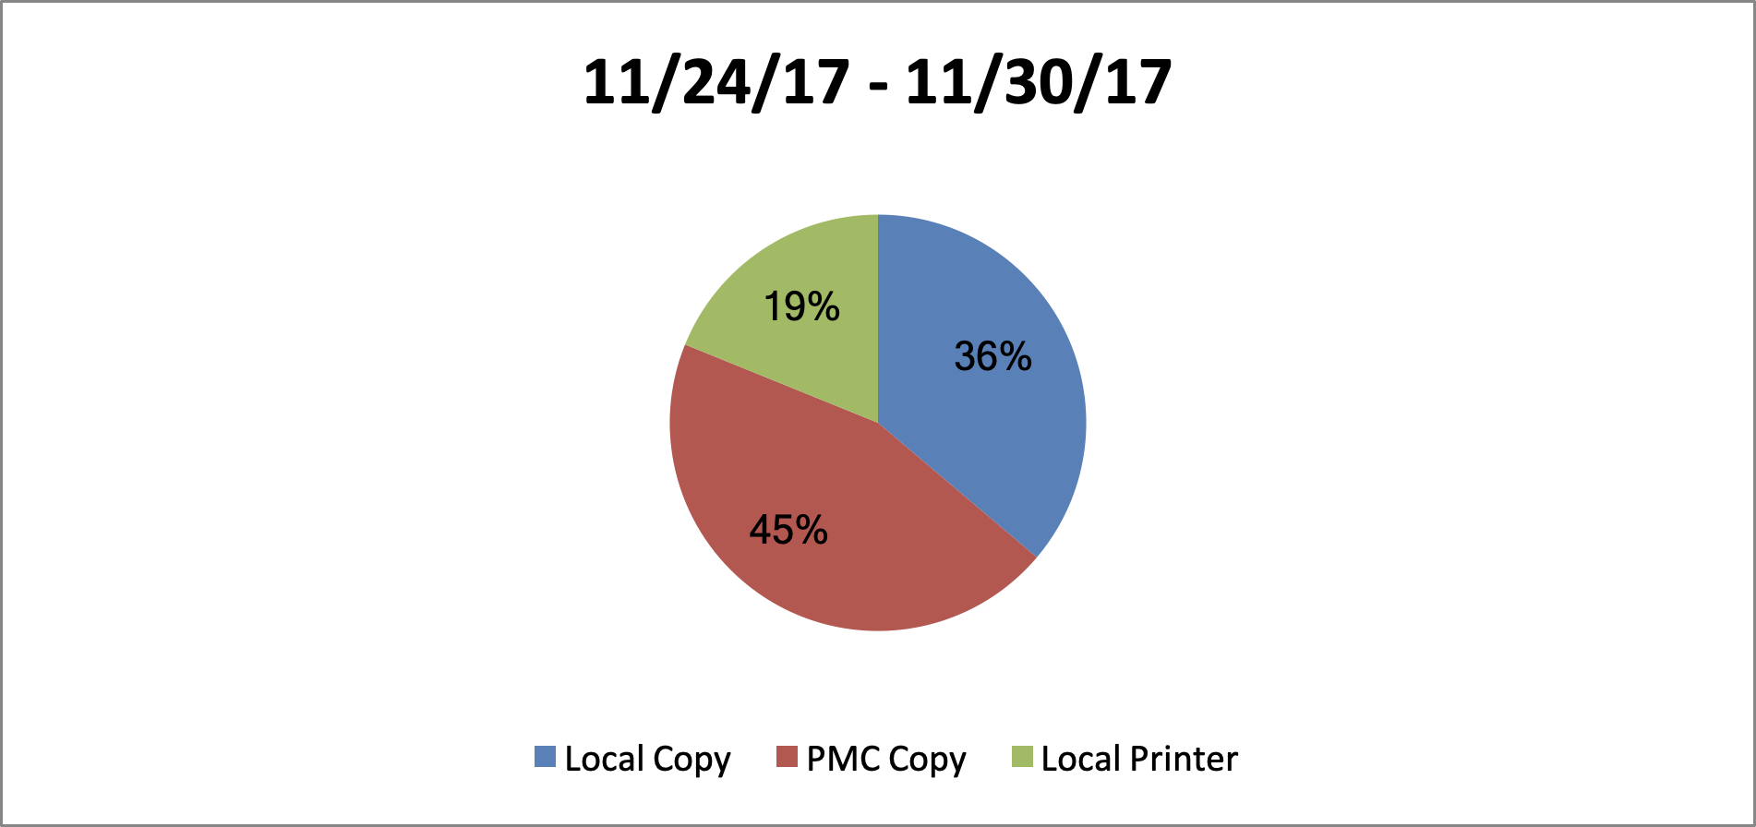 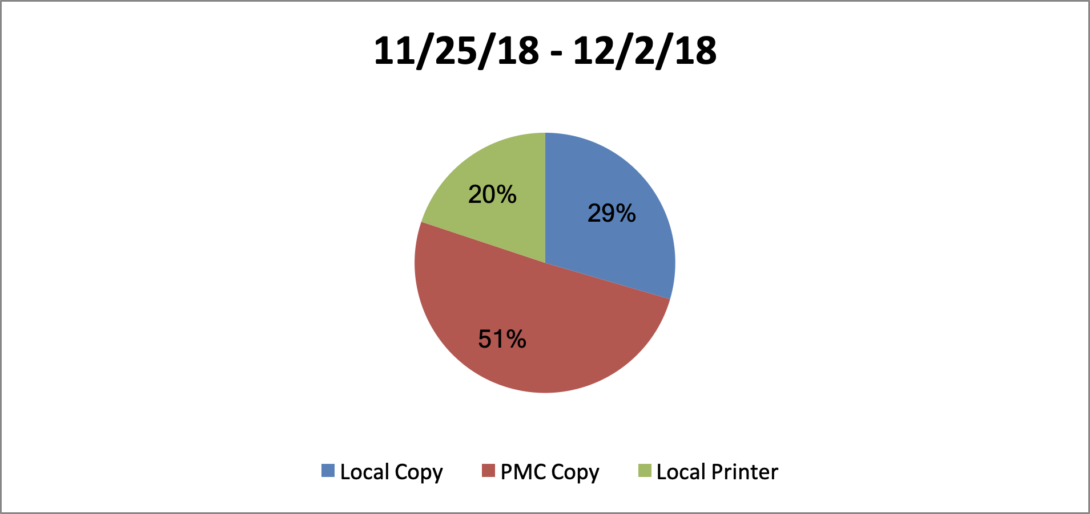

# Project Team Lessons Learned

## Meetings

Set consistent weekly team meetings (stand-ups) early on for each group as well as a weekly or bi-weekly meeting for the group (all class members). This allows time for the group(s) to address the project plans, progress, risks, and results.

Because all groups did not start meeting till week 5, the class scrambled to combine project plans and have since been rushed to get back on schedule. Meetings have been set but are inconsistent. Luckily, there were a few people who were available during the day to hold day-time meetings with stakeholders. This was extremely important as some Q&A was better done in person than over email or phone.

## Communication

Establish communication plans for each team and one for the group. Identify team contact and designated stakeholder for each team to avoid broken communication. Team contact must be responsive and reliable as they are in charge of relaying info to and from their team in a timely and effective manner.

Communication plans were established for each team but were not shared with the group nor was a plan created for the group until week 6. A Canvas group was created thus allowing for us to hold online discussions and share ideas when in person meetings were not happening. Emails pertaining to important info and updates were sent and referenced said discussion boards. Certain stakeholders such as the EDCC marketing team need lead time to create or implement projects thus speaking to them late put the project at risk for being late.

## Project Plans

Create a group charter to establish scope, WBS/project schedule, and expectations that are agreed upon by all group members early on. This helps to better execute the project such as mitigating risks, meeting deadlines, requesting appropriate information from stakeholders and having adequate time to change plans if necessary.

The group was confused on what was expected for the class- three separate charters or one group charter. Each team made its own but did not share with other teams. Ideas and expectations were not aligned thus adding to the confusion. A WBS would have been useful to help plan necessary tasks. We were able to recuperate over-all though plans did have to change due to late planning.

## Stakeholders

Identify stakeholders and assign to team. Team contact is responsible for communications between stakeholder, team and group. Establish stakeholder communication plan.

Stakeholders were given to each team however, due to lack of an official project plan, teams were unable to get appropriate and timely information from stakeholders until further progress on group project plan was established. Example: knowing what the group needed from the EdCC marketing team was not finalized until week nine and they will be asked to do a project with limited time. Knowing what we need from a stakeholder is crucial to the project and has set us back though we have gotten back on track.

Appendix

**Work Breakdown Chart**

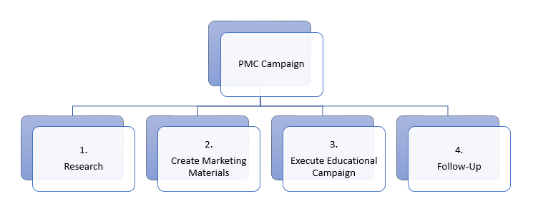

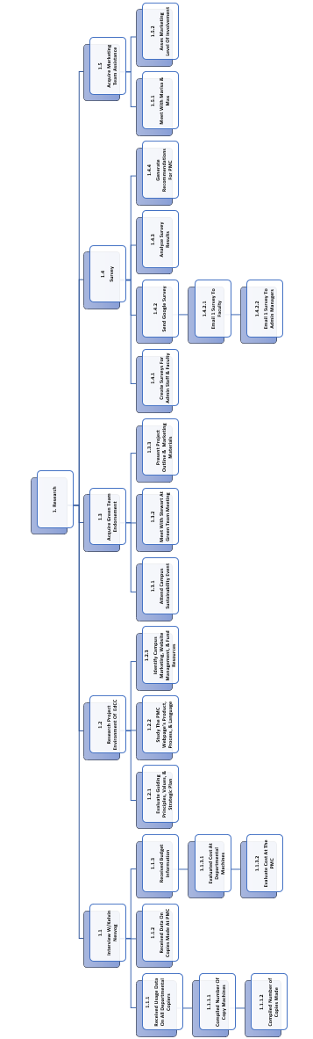

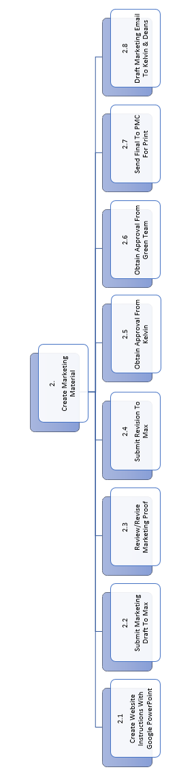

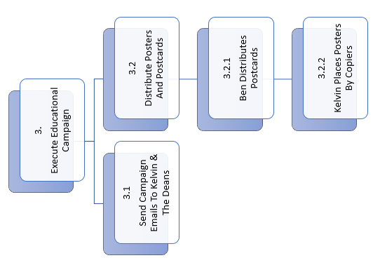

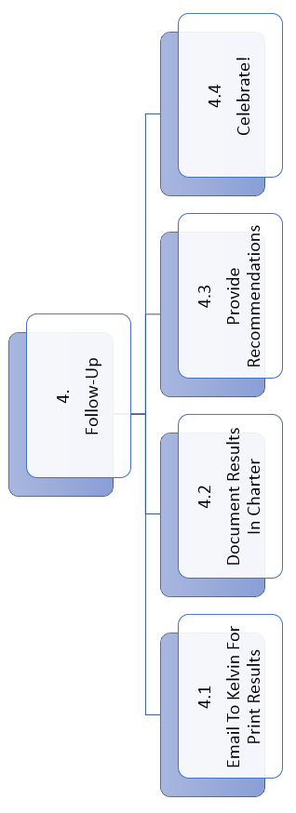

# Surveys

## 

## 

## 

## 

## 

## 

# Snapshot of Survey Results

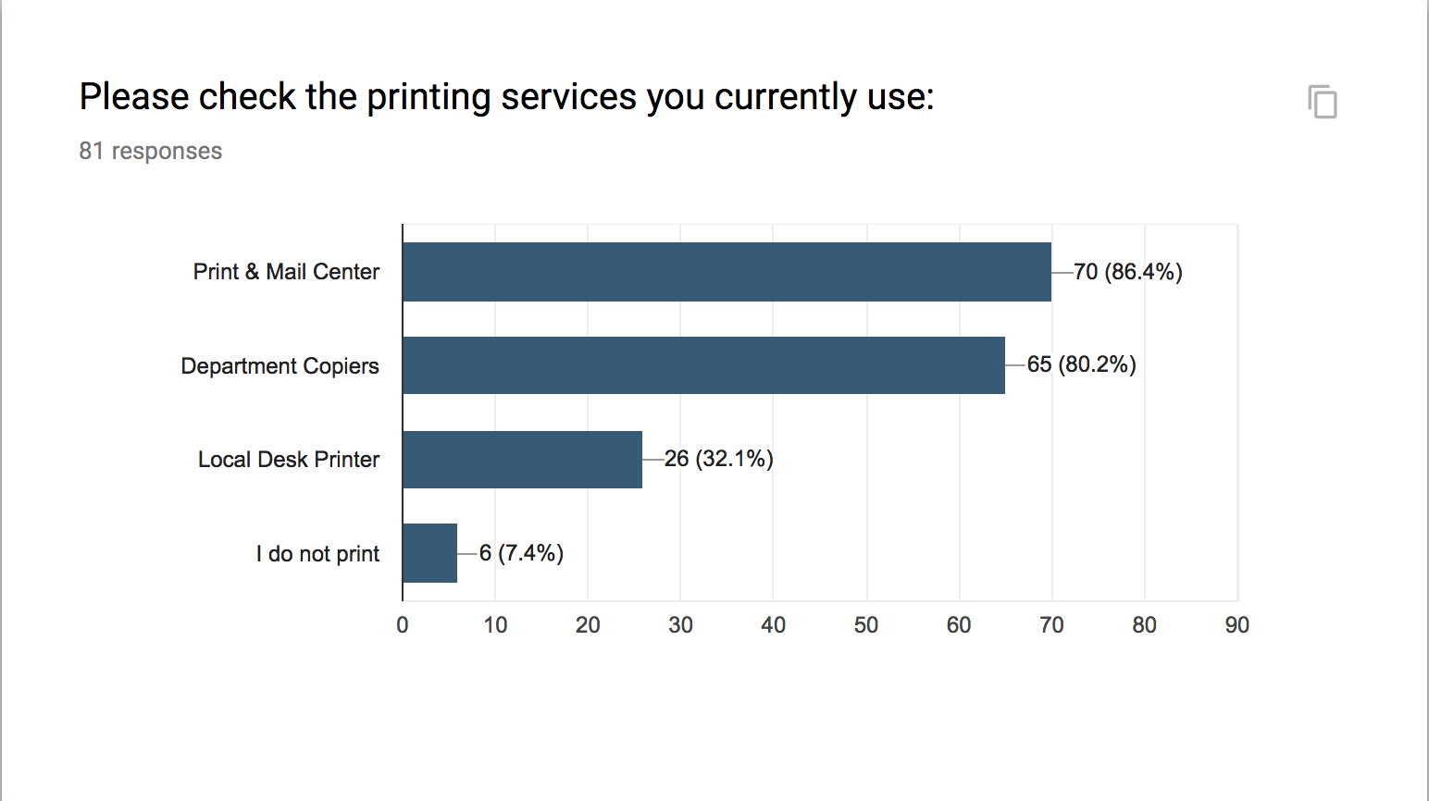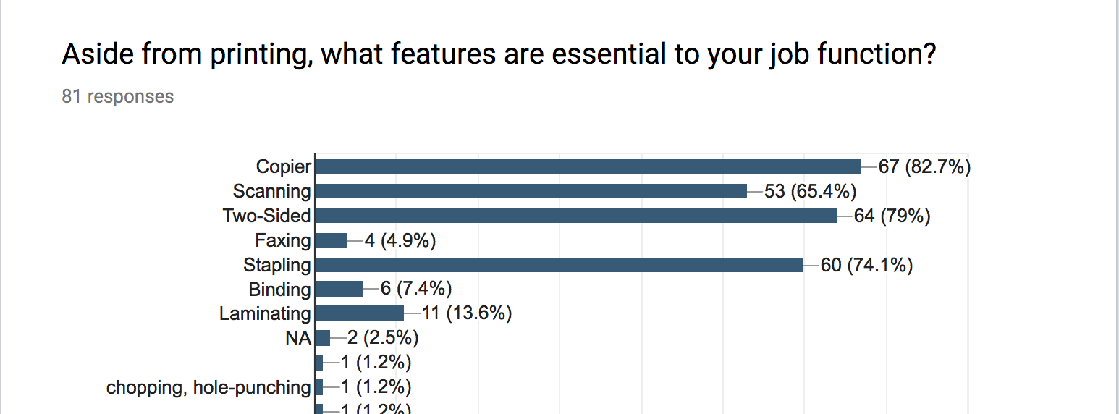

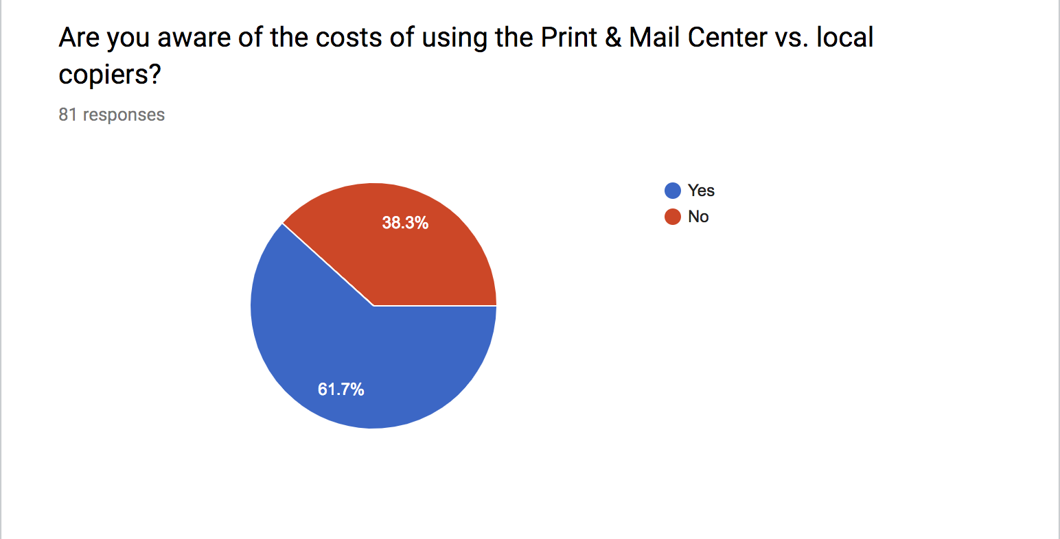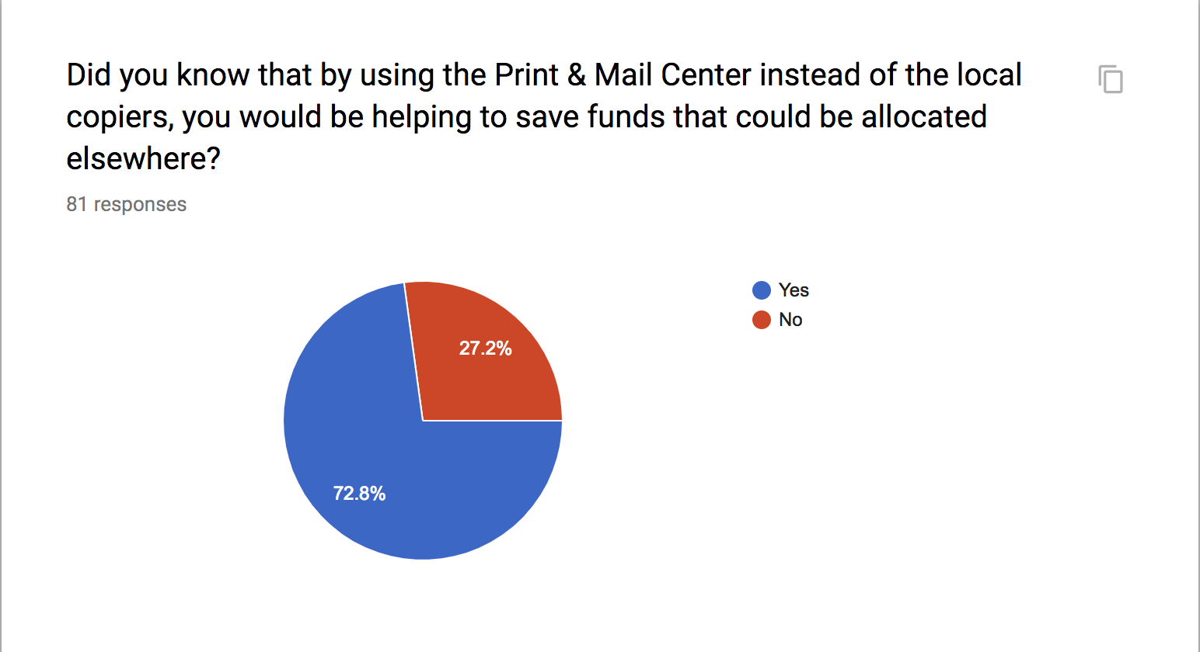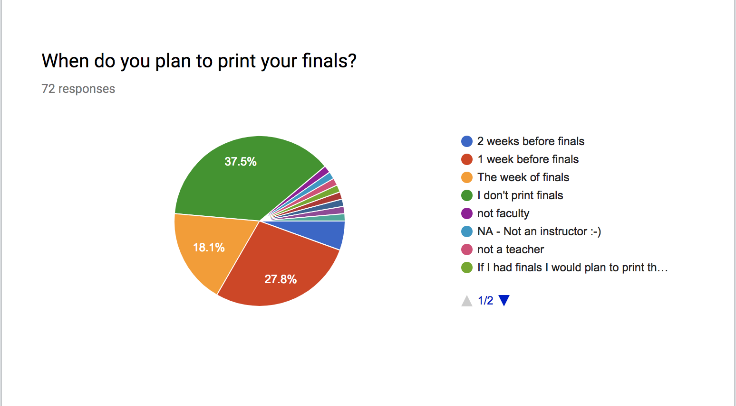

# Marketing Materials

## Postcard flyer

## Instructional Presentation

A “How to” Google presentation sent to faculty & staff to educate them on how to properly request a print job

View Here:

<https://docs.google.com/presentation/d/1Y97Ib0Q5gmlvmqnrCRFTKq1A_-2l8p_BpphAGMzZP90/edit?usp=sharing>

