Must Vs Have to
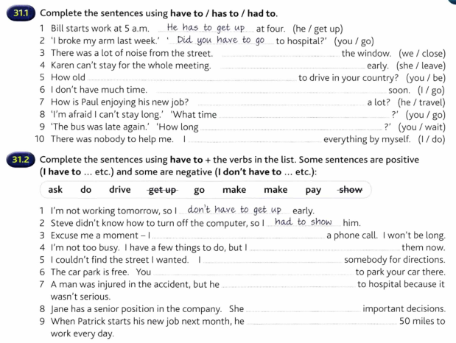
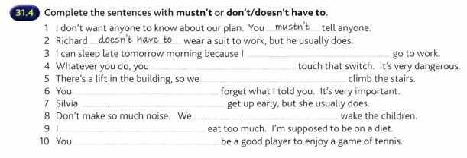
Must Vs Can’t
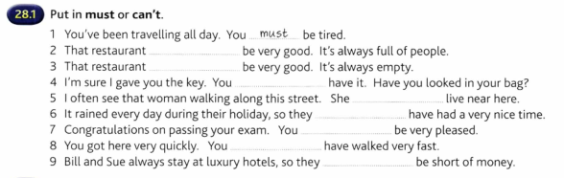
Can, Could and be able to
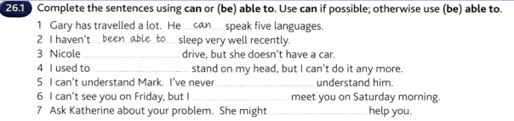
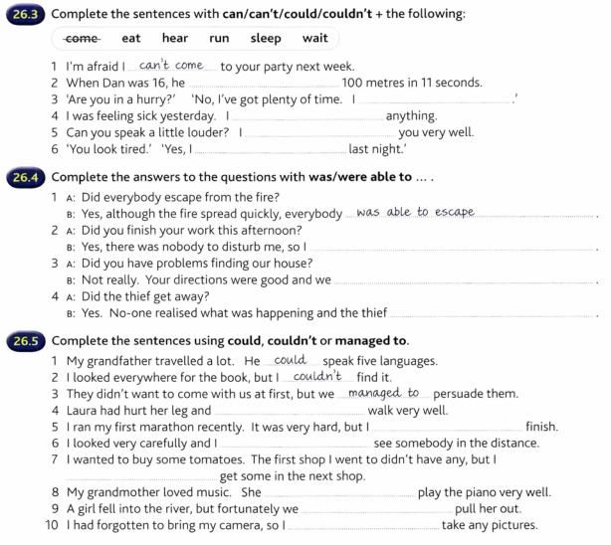 QUESTIONS:
1. We have to design a new _____________________ for our website.
part
section
area
2. I don't have a lot of experience in _____________-oriented programming languages like Java.
code
subject
object
3. Most of my experience is in back-_____________________ programming.
side
end
to-back
4. SQL is pronounced _____________________.
sequel
scale
school
5. C# is pronounced _____________________.
see sharp
see pound
see number
6. I've written 100 lines of _____________________.
program
coding
code
7. I'm not really familiar with that programming _____________________.
language
tongue
lingo
8. I _____________________ to work properly.
can't get this
can't make this
can't fix this
9. ASP.NET is a much more _____________________ language than classic ASP.
strong
powerful
power
10. This is a password generator _______________________ that I have written.
scripting
inscription
script

h/a
must or have to
1.1 _______be at the meeting by 10:00.1 will probably take a taxi if I want to be on time.
2. You ____________ submit the application if it has not been completely filled out. Check that the name, address, and background information are correct. If the form is not accurate and complete, you will be rejected and you will _____ reapply at a later date.
3. You __________forget to pay the rent tomorrow. The landlord is very strict about paying on time.
4. You ______be so rude! Why don't you try saying "please" once in a while.
5. If you are over 18 in California, you _________take a driver training course to get a driver's license. You can have a friend or a family member teach you instead. But remember, you still____get your permit before you start practicing.
6. You ___ be rich to be a success. Some of the most successful people I know haven't got a penny to their name.
7. While hiking in Alaska, you ____keep an eye out for bears. If you see one, you ____approach it.
8.I ____go to work tomorrow because it is Memorial Day. The best thing about a day off from work is that I _____get up at 6:00; I can sleep in till noon if I want to.
9. Yesterday, I ____ study all day for my French final. I didn't get to sleep until after midnight.
10. Ingrid received a scholarship to Yale University which will cover 100% of the tuition. She ______ worry at all about the increasing cost of education.

