Assignment 1)
- Change Browser Extension Logo Change
- Add Playwright Typescript converter using vibecode

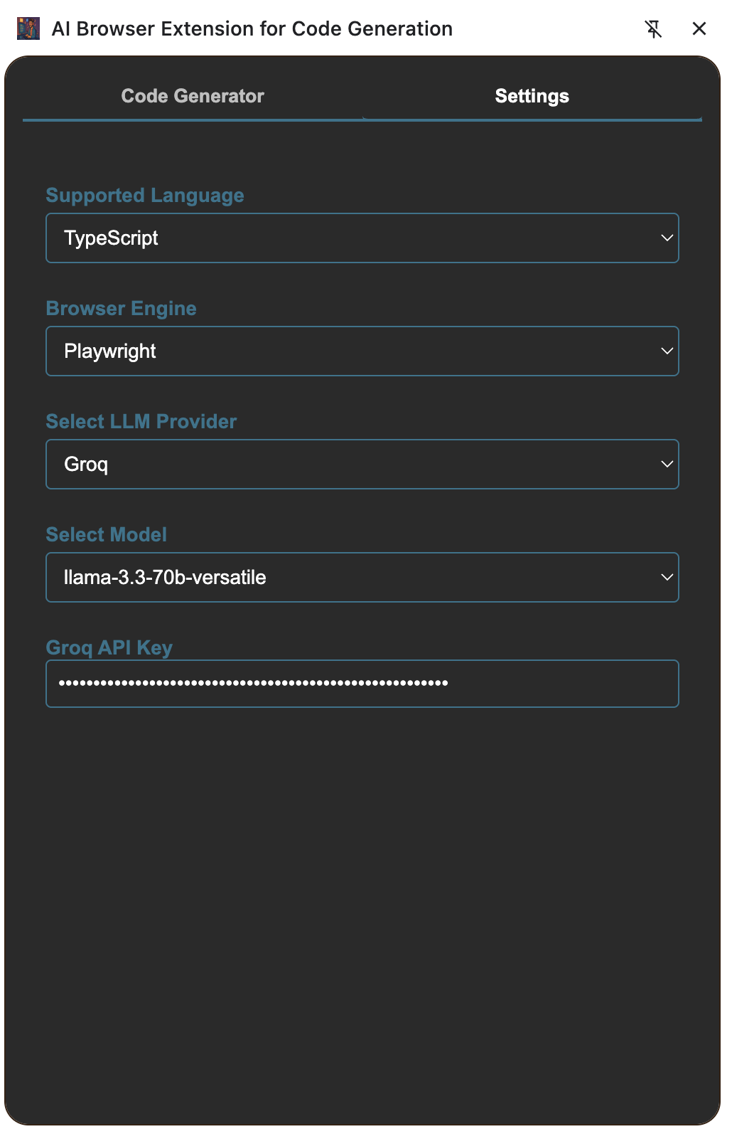
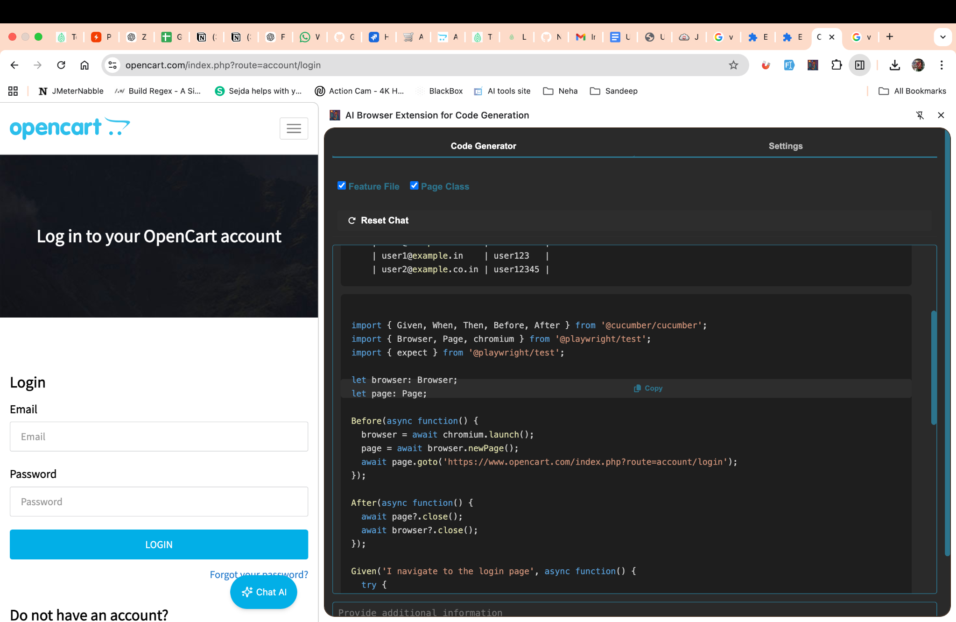

Assignment 2)
Using Fake Filler Extension Fill Data in Form

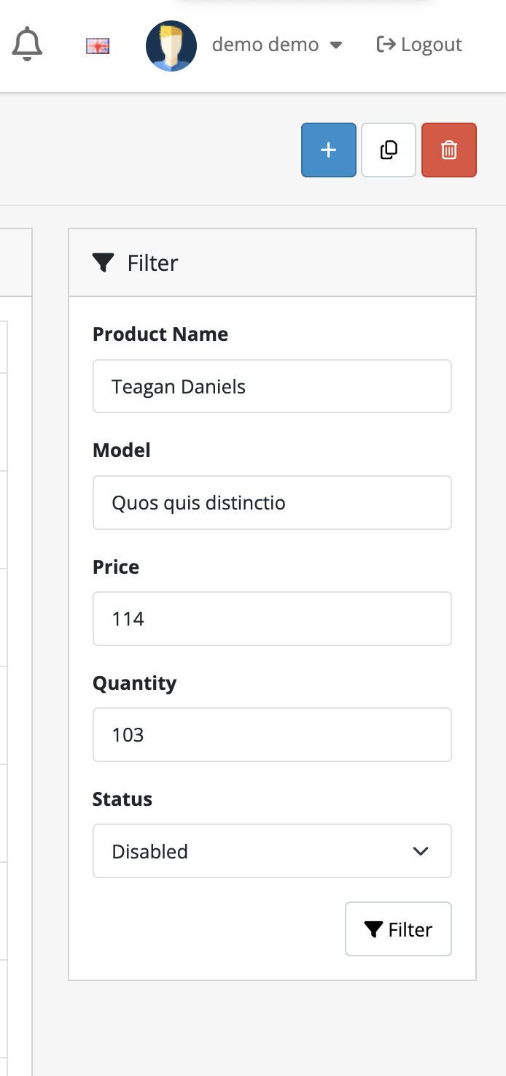

Assignment 3)
Using Bug magnet Fill Data
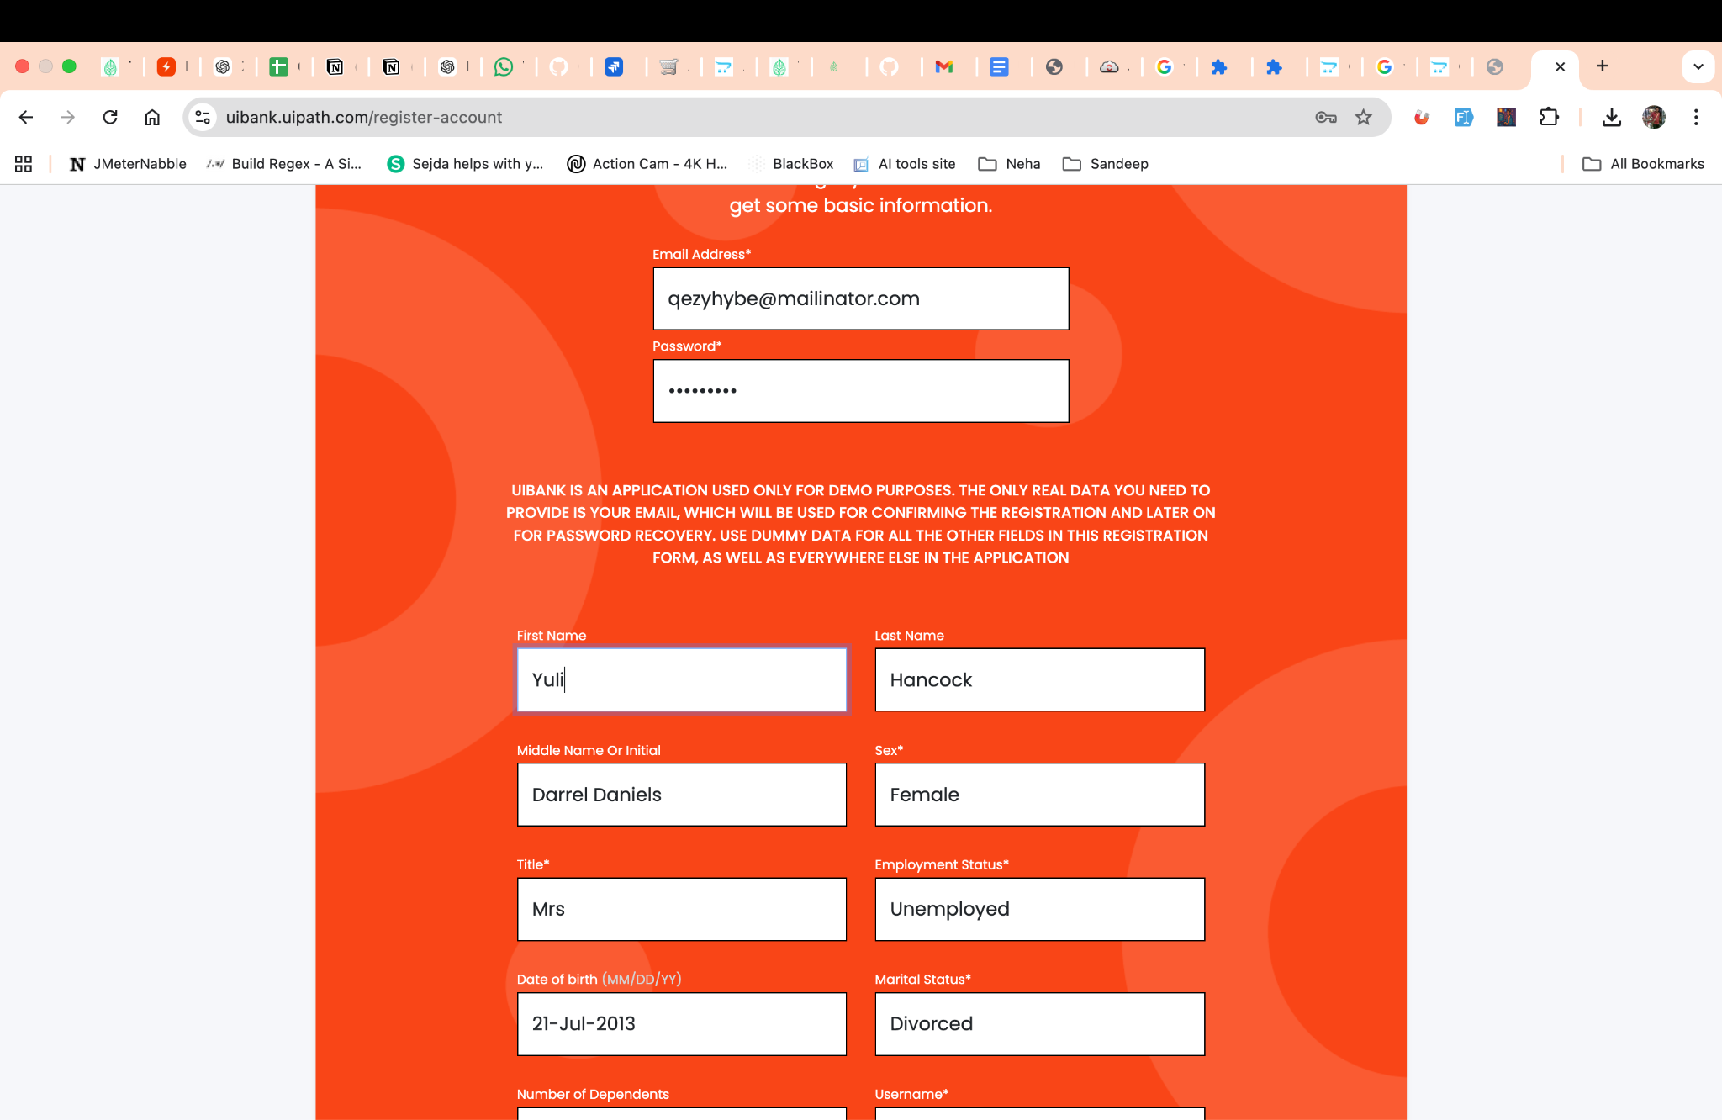

Assignment 4)
Use Grammarly browser Extension

Actual Paragraph having Grammar issue

Yesterday I goes to the market to buy some vegetables but I forget my wallet at home. The shopkeeper tell me that the prices is increased because many peoples are buying more items these days. I was feeling very embarrassing and don’t knows what to do, so I asks my friend to lending me some money. He say he will comes in few minutes but he never came. After waiting for almost one hours, I decides to walk back home and thinking about how careless I am. It was a day which teach me many lesson about responsibility.

Paragraph after using Grammar extension
I went to the market yesterday to buy some vegetables, but I left my wallet at home. According to the store owner, the reason for the price increase is that more people are purchasing goods these days. I asked a friend to lend me some money because I was feeling really embarrassed and didn't know what to do. He promised to arrive in a few minutes, but he never did. I choose to walk home after nearly an hour of waiting while reflecting on my recklessness. I learned a lot of lessons about responsibility that day.

