University of Lodz
Faculty of Mathematics and Computer Science

Ainella Bernikova
Student number: 404382

Creating an application that implements a pet clinic

Bachelor’s thesis
In Computer Science

Michał Bleja PhD
Department of Algorithms and Databases

September 2024

Table of content
Abstract 3
1 Introduction 4
1.1 Project Overview 4
1.2 Objectives 5
2 Approach 5
2.1 Requirements Acquisition 5
2.2 System Design 6
3 Implementаtion 6
3.1 Tools аnd Technologies 6
3.2 Framework and Libraries 7
3.2.1 JDBC 7
3.2.2 Why has JDBC been used instead of JPA/Hibernate? 7
3.2.3 Boot Cаmp in the Spring 8
3.2.4 Controller for Spring Model View 8
3.2.5 Security and Database Integration 10
3.2.6 Developing Apps with Spring Boot 12
3.2.7 Templating with Thyme Leaf 13
3.2.8 Spring Web Development for the Web 13
3.3 Using Spring Security for Security Management 15
3.3.1 Bootstrap for Front-End Development 15
3.3.2 jQuery 16
3.4 Code Walkthrough 18
3.4.1 Design of Database 18
3.4.2 UML classes diagram 20
3.5 Key Functionalities 22
4 Security 24
4.1 Authentication 25
4.2 Authorization 26
5 Deployment Environment 29
5.1 Deployment Environment 29
5.1.1 Steps for Deployment 29
5.2 Maintenance 32
5.3 Support 33
6 Conclusion 34
6.1 Summary of the Project: 34
6.2 Challenges and Solutions: 35
7 . References 36

Abstract

The Pet Clinic project is an all-encompassing veterinary management system aimed at optimizing the operations of pet clinics. Constructed with the Spring Framework, it utilizes JDBC for database interfaces and incorporates Spring Security for authentication and authorization. The system offers comprehensive capabilities for overseeing appointments, clinic data, pets, species, and owners. Services including Appointment Service, Clinic Record Service, Clinic Service, Owner Service, and Pet Service enable CRUD operations and assure effective data management. This initiative seeks to improve the management of veterinary clinics, providing superior service delivery to pet owners and their animals.

Introduction

The Pet Clinic program shows an innovative approach to managing veterinary clinics by prioritizing enhancements in service delivery, daily operations, and the overall experience of pet owners and their animals. This system possesses comprehensive databases for dogs and their owners, clinic record management, and appointment scheduling, among other functionalities. The project ensures dependable, secure, and effective clinic operations management, having been developed with the Spring Framework and employing JDBC for database interactions.

Project Overview
The Pet Clinic project is a web-based application that automates overseas operations. The numerous procedures conducted in veterinary clinics. The system comprises several critical components, each addressing a specific aspect of clinic management:
- Appointment Management: Organize, alter, and delete appointments, integrating pet and clinic details.
- Clinical Documentation: Preserve comprehensive records of diagnosis, therapies, and other medical information.
- Pet Management: Manage pet information, encompassing species, breed, and medical history.
- Owner Administration: Oversee owner data, guaranteeing secure and tailored services.
- Species Management: Systematically catalog diverse species for enhanced classification and treatment strategies.
- The main goal is to provide an all-encompassing solution that optimizes clinic operations. Operations ensure data integrity and enhance user experience with a unified, intuitive interface.

Objectives
The main objectives are as follows:
- Implement a system for administering patient records, appointment scheduling, and billing management.
- Develop an intuitive interface for clinic staff and veterinarians.
- Ensure data integrity and security.
- This system includes the following components:
  - CRUD (Create, Read, Update, Delete) operations related to patient records
  - Coordination and administration of appointments
  - Billing and invoicing functionalities
I excluded advanced features such as telemedicine and extensive analytics.

Approach
The methodology for the Pet Clinic project encompasses the following phases:

Requirements Acquisition
Interviews and Surveys: Collaborating with veterinarians, clinic personnel, and pet owners to ascertain critical attributes.
Documentation Review: Analyzing current systems to identify optimal practices and possible enhancements.

System Design
Architecture Design: Establishing the comprehensive architecture utilizing the Spring Framework for backend services and JDBC for database interactions.
Database Design: Develop an ER diagram to illustrate the links among things such as appointments, pets, clinics, and owners.

Implementаtion

Tools аnd Technologies
- Database: SQL, PostgreSQL, JDBC
- Backend: standalone Java application with embedded web server (tomcat)
- Frontend: HTML, CSS
- Security: Spring Security, Basic Authentication
- Version Control: Git, GitHub
- IDE: IntelliJ IDEA (Community Edition)
- Modeler: Visual Paradigm
- Build Tools: Maven
- Deployment: Docker, Jenkins

Framework and Libraries

JDBC
JDBC is a programming interface for Java applications that engage with a database. The application uses this API to interface with the JDBC management. This is the standard API that our application code utilizes to interface with the database. Alongside the API, a vendor-provided JDBC-compatible driver is available for the database in use.

Why has JDBC been used instead of JPA/Hibernate?
The discourse surrounding JPA and JDBC frequently serves as a pivotal consideration, as the two database systems adopt markedly distinct methodologies for managing persistent data. Let us examine the principal distinctions between them.
JDBC enables the execution of SQL commands for reading and updating data within a relational database. JPA, in contrast to JDBC, enables developers to construct database-driven Java applications utilizing object-oriented principles. JPA annotations delineate the mapping of a certain Java class and its attributes to a corresponding table and its columns within the database.
JDBC is database-specific, necessitating the creation of distinct scripts for each
database. Conversely, JPA is database agnostic, indicating that identical code can be utilized across
several databases with minimal alteration.
The distinction between JPA and JDBC fundamentally lies in the authorship of the code: either the JPA framework or a local developer. We must resolve object relationship impedance mismatches.
Improper SQL queries might lead to reduced JDBC performance. Performance should not be a contentious issue when choosing between two technologies. Professional developers possess the expertise to construct Java programs that operate well regardless of the underlying technology utilized.
The Pet Clinic project utilizes several critical frameworks and libraries to implement its functionalities, ensuring a robust, scalable, and maintainable application. The primary frameworks and libraries utilized are JDBC, Spring Boot, Spring MVC, and Spring Security.

Boot Cаmp in the Spring
Spring Boot constitutes the program's foundation, providing an effective approach for developing and deploying Java applications. It optimizes setup and configuration, allowing developers to focus on the development of business logic.
Embedded Server: Provides an integrated Tomcat server, obviating the need for external server settings for the application.
Starter requirements: Starter packs provide the essential criteria for common tasks, including data access, web development, and security, by employing pre-configured starter packs.

3.2.4 Controller for Spring Model View
In the Spring ecosystem, the Spring MVC (Model-View-Controller) architecture is utilized to construct the web layer of an application. This facilitates the segmentation of application logic into three principal components, hence enhancing the organization of the codebase.
In the Pet Clinic application, controllers are created using the @Controller or @RestController annotations. They link HTTP requests to specific handler methods with @RequestMapping or similar annotations like @GetMapping and @PostMapping.
This is a Spring MVC controller snippet for managing appointments in a veterinary clinic.

@RestController
@RequestMapping("/appointments") public class AppointmentController {
@Autowired
private AppointmentService appointmentService;

@GetMapping("/{id}")
public ResponseEntity<Appointment> getAppointment(@PathVariable Integer id) {
Appointment appointment = appointmentService.getAppointment(id); return new ResponseEntity<>(appointment, HttpStatus.OK); }
}
In this example:
- The @RestController annotation indicates that this class is a controller where every method returns a domain object instead of a view.
- @RequestMapping("/appointments") maps all requests starting with /appointments to this controller.
- @GetMapping("/{id}") maps HTTP GET requests to the getAppointment method, which retrieves an appointment by its ID.
- ResponseEntity<Appointment> is used to return the appointment object along with an HTTP status code.
This design helps in the clean separation of concerns and makes the web layer of the application more modular and easier to maintain.

Security and Database Integration
The Pet Clinic project employs Spring Security for user authentication and authorization, alongside JDBC (Java Database Connectivity) for database interactions. This amalgamation guarantees the application's security and its capacity to execute database operations efficiently.
Security utilizing Spring Security is employed to oversee authentication and permission, guaranteeing that only permitted users can access designated resources. Authentication: The procedure of validating a user's identity using elements such as Username and Password. Authorization: The procedure of regulating access control according to user roles and permissions. It is executed with annotations such as @PreAuthorize and role-based access control (RBAC).

Example: Role-Based Access Control in a Service Method
@Service public class AppointmentService {

@PreAuthorize("hasRole('ADMIN') or #ownerId == authentication.principal.ownerId")
public List<Appointment> getListByOwnerId(Integer ownerId) {
// Implementation here
}
}
In this example:
The @PreAuthorize annotation restricts access to the getListByOwnerId method, allowing only users with the 'ADMIN' role or those whose ownerId matches the authenticated user's ownerId.
Database Integration with JDBC
JDBC (Java Database Connectivity) is used for interacting with the database to perform CRUD
(Create, Read, Update, Delete) operations. The integration is simplified using Spring's
JdbcTemplate, which provides a convenient template for executing SQL queries and mapping results to Java objects.
Query Execution: SQL queries are executed using methods such as queryForObject and query.
Row Mapping: Maps rows from the result set to Java objects using RowMapper.
Example: Database Query in a Service Method
@Service public class AppointmentService {
@Autowired
private JdbcTemplate jdbcTemplate;

public Appointment getAppointment(Integer id) {
String query = "SELECT * FROM appointments WHERE id = ?";
return jdbcTemplate.queryForObject(query, new
Appointment.Mapper(), id);
}
}
In this example JdbcTemplate is used to execute an SQL query to fetch an appointment by its ID, mapping the result to a Java object using a custom RowMapper (in this case, Appointment.Mapper()).
MVC Pattern Implementation in the Project
The Model-View-Controller (MVC) pattern is implemented in the following way:
- Models: Java classes representing the application's data entities, such as Appointment, Pet, and Owner.
- Views: Thymeleaf templates (or another templating engine) are used to generate the HTML pages.
- Controllers: Java classes annotated with @Controller or @RestController handle HTTP requests and responses.
This separation of concerns ensures that each component of the application is dedicated to a specific task, making the codebase easier to manage and scale.
By leveraging these frameworks and libraries, the Pet Clinic project achieves a clean, organized structure that is easy to develop, maintain, and extend. The combination of Spring Boot, Spring MVC, Spring Security, and JDBC offers a robust foundation for building modern, secure, and scalable web applications.

Developing Apps with Spring Boot
Developing apps with Spring Boot:
Spring Boot is a feature-rich framework that makes it easier to create apps that are suitable for production. Constructed atop the Spring Framework, it provides a plethora of functionalities that reduce boilerplate code, enhance developer efficiency, and optimize the configuration procedure for Spring-based apps. Important characteristics of Spring Boot Production-Ready Capabilities: provides built-in capabilities that make application preparation easier for production environments, like performance measurements, externalized configuration, and health checks. To minimize the time and effort required to begin new projects, Spring Initializer is a web-based tool that assists developers in quickly configuring Spring Boot projects with the required dependencies. By offering these crucial tools and features, Spring Boot improves the development process and makes it simpler to create, configure, and launch apps.

Templating with Thyme Leaf
Thyme Leaf is a modern server-side Java template engine suitable for both web and standalone applications. It is designed to process and generate various types of content, including HTML, XML, JavaScript, CSS, and plain text. Thyme leaf offers a more natural templating syntax compared to JSP (Java Server Pages), making it easier to create dynamic content clearly and straightforwardly. Key Features of Thyme Leaf:
Thyme Leaf Dialects: Extensible with custom dialects and processors, allowing developers to create custom functionalities and reusable components.
Internationalization (i18n): Provides built-in support for internationalization, enabling easy localization of content for different languages and regions.
Spring Expression Language (SpEL): Integrates seamlessly with SpEL, allowing dynamic content rendering directly within templates.
Thyme Leaf provides a powerful and flexible solution for templating in Java applications, enhancing both developer productivity and the user experience by offering a wide range of customization and dynamic content options.

Spring Web Development for the Web
A full web application development framework is provided by the Spring Web module of the Spring Framework. Expanding the Servlet API and utilizing the features of the Spring Framework, enables programmers to build scalable, reliable, and maintainable online applications.
Important Characteristics of Spring Web:
- MVC Framework: Offers a strong MVC framework that encourages the division of responsibilities amongst the components of the application.
- Enables the creation of RESTful web services to complement contemporary web application architectures.
- Template Engine Integration: Facilitates integration with multiple template engines, including Thyme Leaf, Free Marker, and JSP, enabling adaptable dynamic content rendering.
- Data Binding and Validation: Offers extensive validation capabilities together with the automatic binding of HTTP request parameters to Java objects.
- Content Negotiation: This feature enables support for several response formats, such as HTML, XML, and JSON.
Spring Online Flux: Provides support for reactive programming in the development of effective and responsive online services and applications. With its strong basis, Spring Web ensures flexibility and scalability while developing a broad range of web applications, from conventional MVC-based web apps to contemporary reactive applications.

Using Spring Security for Security Management
Within the Java Spring environment, Spring Security is a powerful and adaptable framework for managing access control and authentication. To safeguard Java EE-based enterprise applications from frequent attacks and vulnerabilities, it provides a broad range of security services. The main characteristics of Spring Security are listed here, together with a setup guide and an outline of more complex subjects.
Essential Elements of Spring Security:
- Defense Against Typical Attacks: offers built-in defenses against widespread security risks including clickjacking, session fixation, and Cross-Site Request Forgery (CSRF).
- Comprehensive and Extensible: Provides a high degree of configurability and extensibility, enabling developers to create unique authorization and authentication plans suited to the requirements of their applications.
- Security Context: Preserves a security context for the duration of the user's session, guaranteeing the uniform application of permission and authentication data.
A strong basis for online application security is provided by Spring Security, which facilitates the management of user authentication and access control in a flexible and configurable way.

Bootstrap for Front-End Development
Bootstrap is a popular front-end framework for building responsive, mobile-first websites. It offers a collection of pre-made JavaScript, HTML, and CSS components that make it easier to create cutting-edge, feature-rich web interfaces. Some of the most notable features of Bootstrap are as follows:
Key Features of Bootstrap:
- Pre-designed Components: To speed up the building process, a wide range of reusable components, including buttons, modals, forms, and navigation bars, are provided.
- Customizable Design: This feature makes it easy to change the look and feel of your application by modifying predefined styles or the built-in Sass variables in Bootstrap.
- Cross-browser compatibility: Ensuring uniform behavior and appearance across many browsers and devices, enhances user experience.
- JavaScript Plugins: This section includes multiple JavaScript plugins that add dynamic behaviors to elements such as carousels, tooltips, and models.
- Huge Community and Documentation: Developers have access to a wealth of resources and support because of the extensive documentation and large community.
Bootstrap simplifies front-end development with its vast toolkit and component library, freeing up developers to focus on building responsive and aesthetically beautiful web applications.

jQuery
jQuery is a feature-rich, small, and quick JavaScript library. The API is easy to use and works with a variety of browsers, making it easier to handle events, animate, and navigate and modify HTML documents. To get you started, consider the following jQuery features and examples:
- AJAX: Simpler techniques for handling delayed requests.
- Animations: Pre-installed methods for creating animations and effects.
- Cross-browser compatibility ensures that your code runs consistently across multiple browser versions.

Code Walkthrough

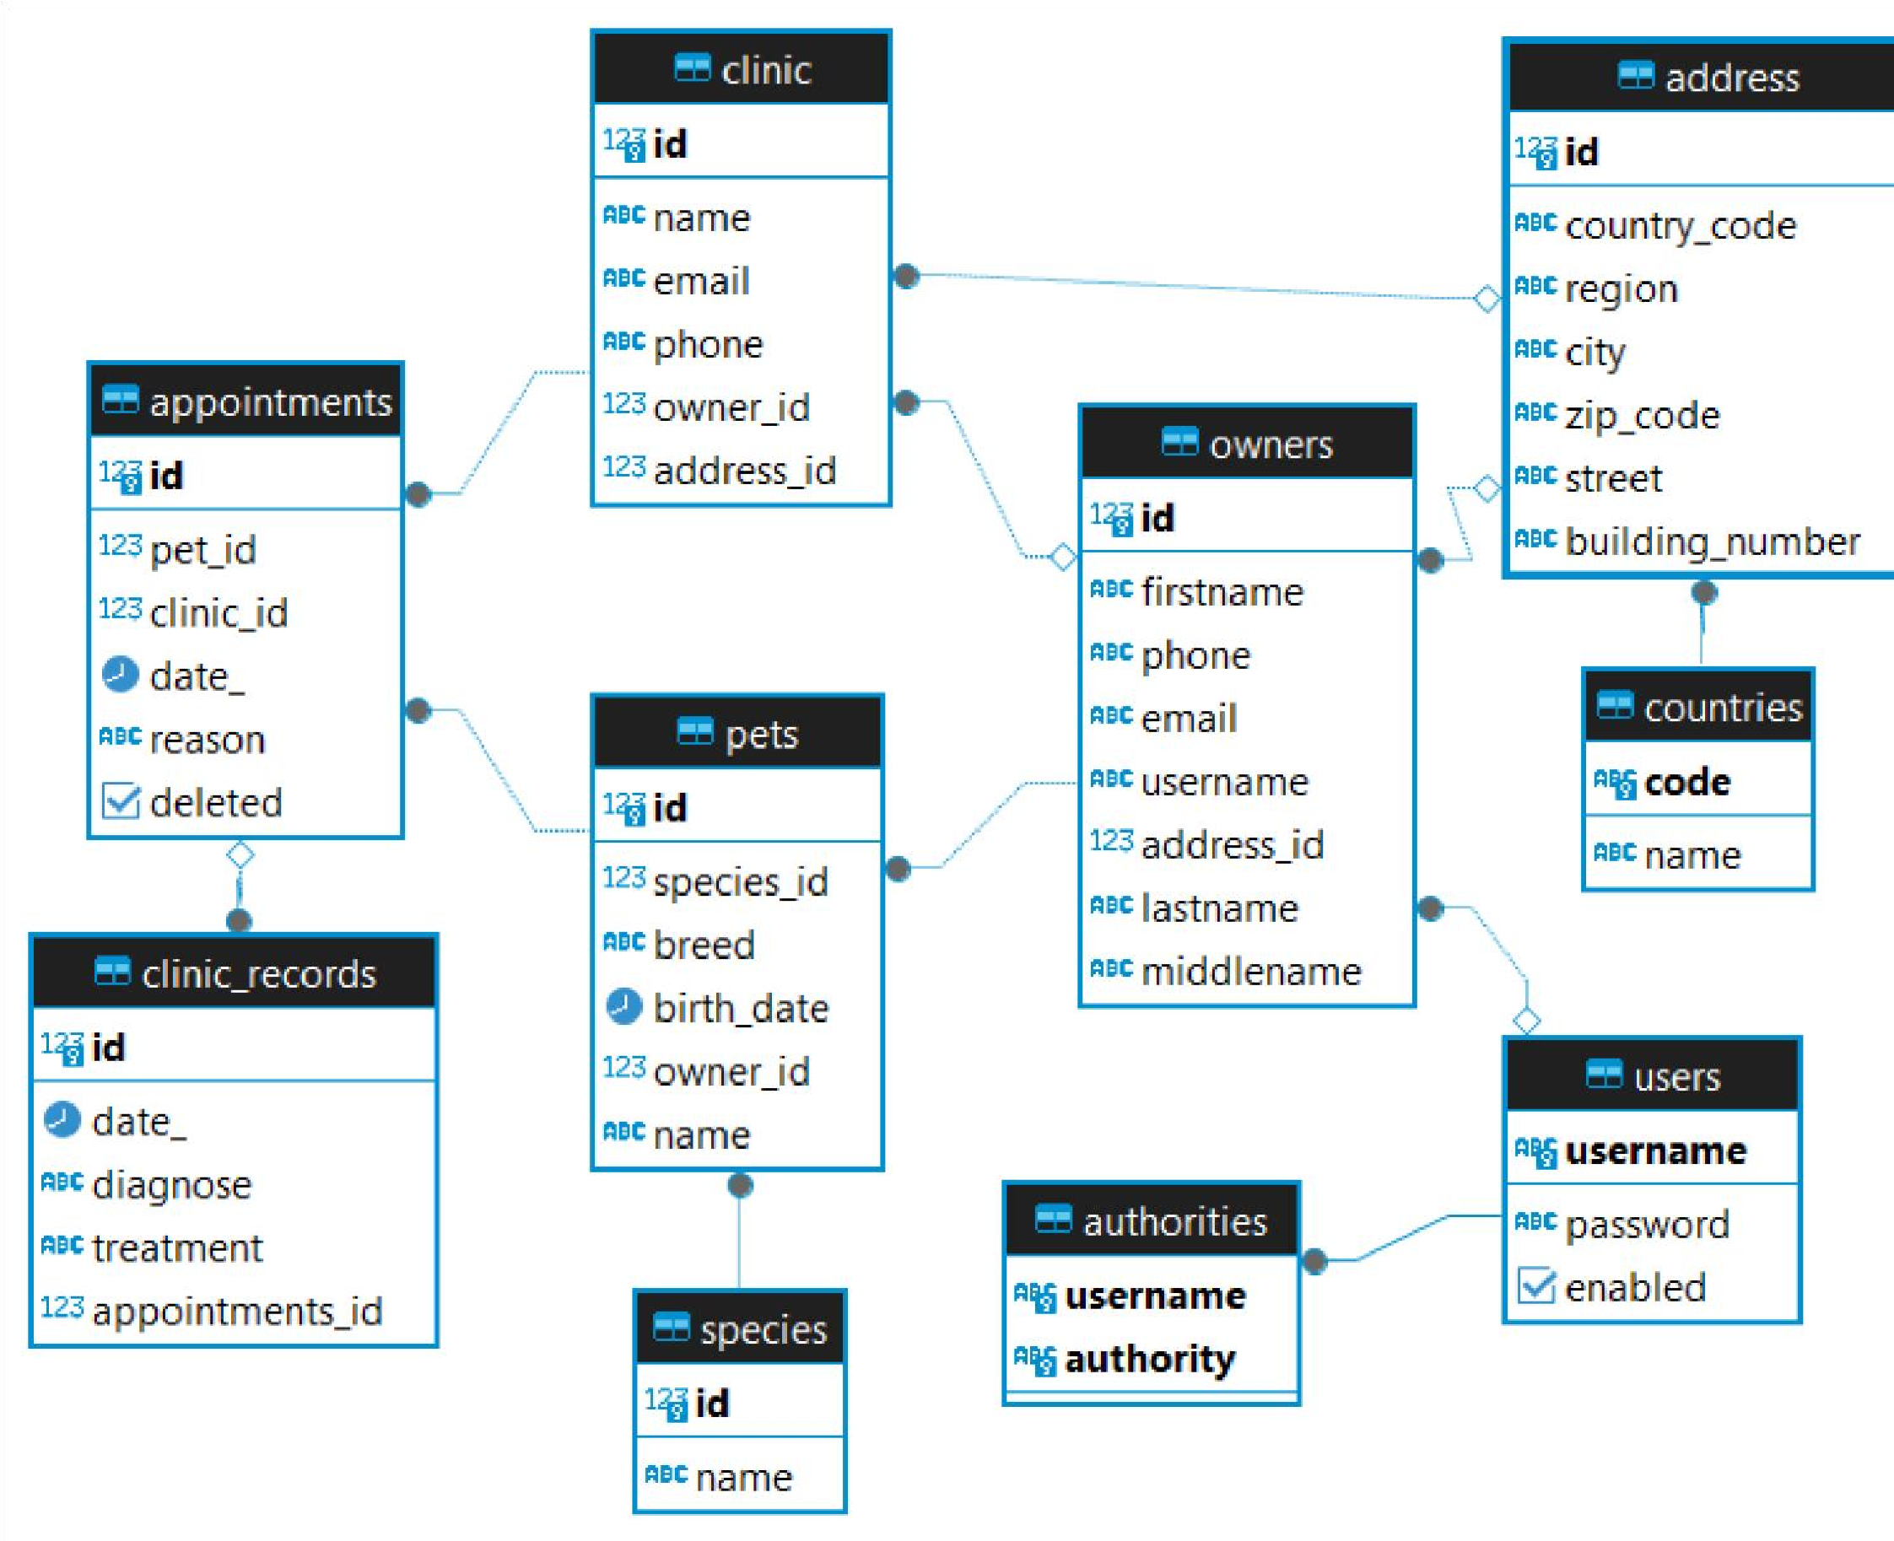
Design of Database

The Pet Clinic project is organized into several services, each responsible for various
aspects of the clinic's operations. Below is a detailed walkthrough of the key services:
- Appointment Service
- getAppointment: Retrieves an appointment by its ID, including details like a pet name, clinic name, and species name.
- deleteAppointment: Deletes an appointment by its ID.
- getListByOwnerId:
Fetches all appointments for a specific owner.
- getListByClinicId: Retrieves all appointments for a specific clinic.
- saveAppointment: Inserts or updates an appointment in the database.
- Clinic Record Service
- getListById: Retrieves a list of clinic records by the given ID.
- saveClinicRecord: Inserts or updates a clinic record.
- Clinic Service
- getClinic: Retrieves a clinic by its ID.
- getList: Fetches a list of all clinics.
- saveClinic:
Inserts or updates a clinic.
- getListByOwnerId: Retrieves clinics owned by a specific owner.
- Owner Services
- getOwnerByUsername: Fetches an owner by their username.
- getOwnerIdByUsername: Retrieves the owner's ID by their username.
- createOwner: Creates a new owner profile and user account.
- Pet Service
- getPetById: Fetches a pet by its ID.
- getPetsByOwnerId: Retrieves all pets owned by a specific owner.
- savePet: Inserts or updates a pet. o getSpecies: Fetches all species.

UML classes diagram
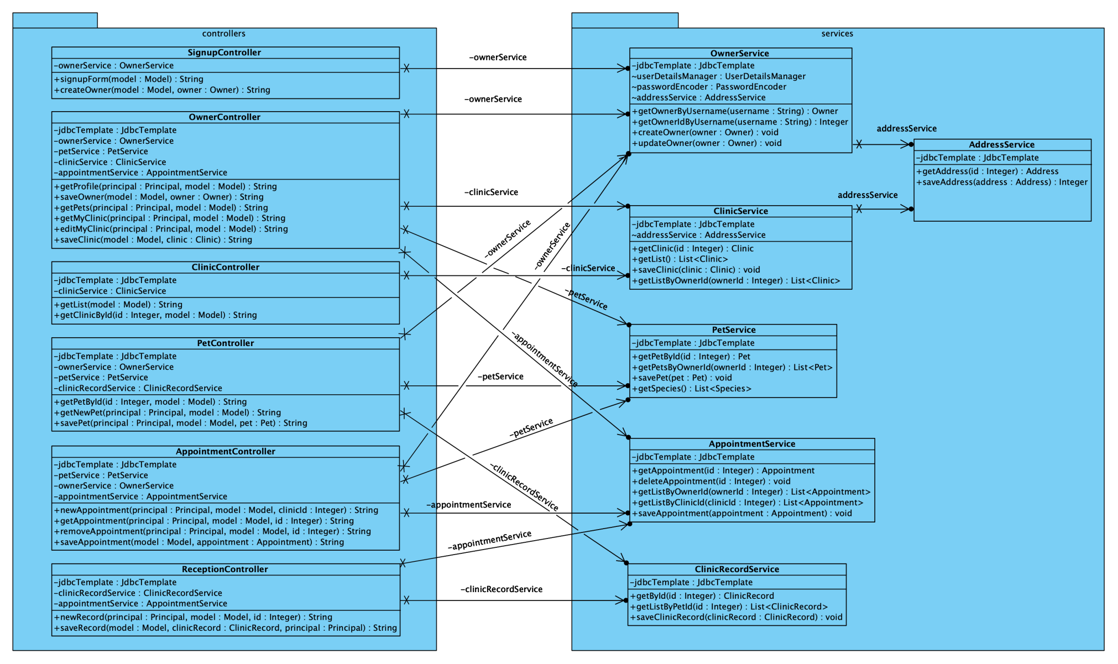

17

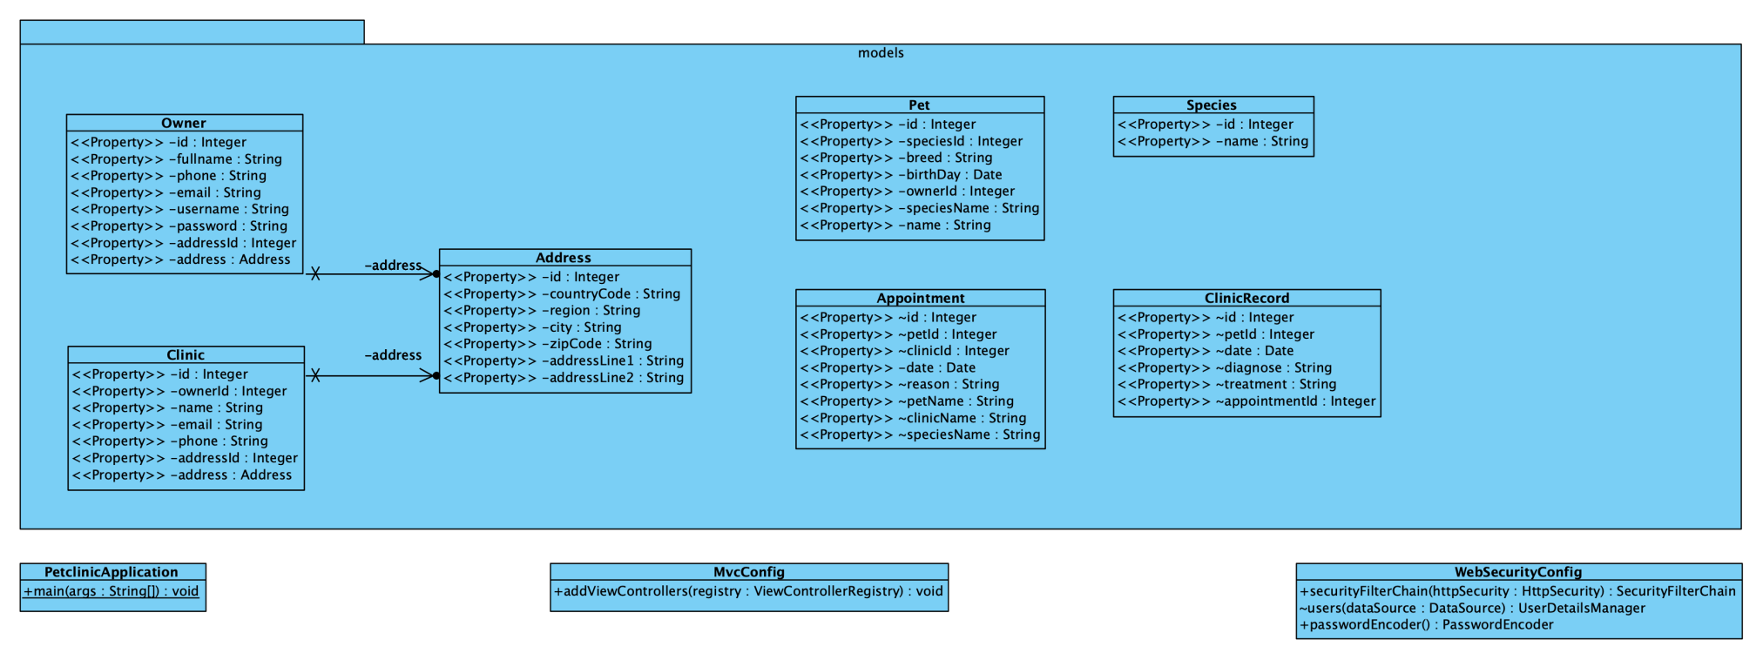
18

Key Functionalities
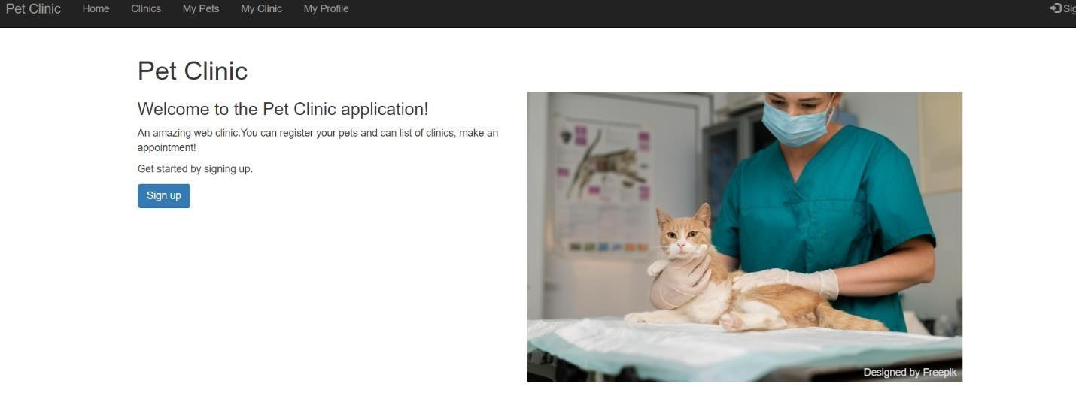
Home page
- Appointment Management
  - Booking: Allows users to schedule appointments, specifying pet, clinic, date, and reason.
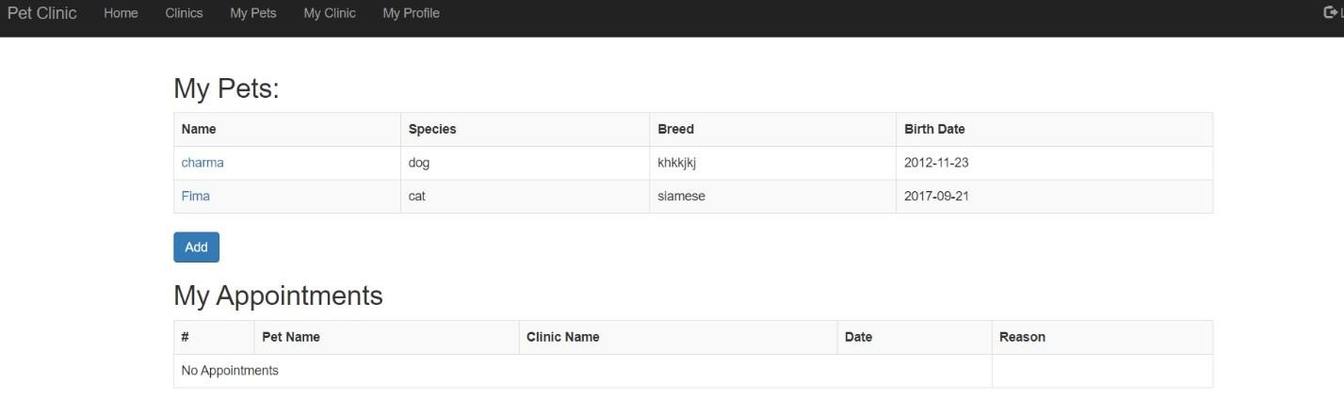
  - Modification: Users can update appointment details as needed.
  - Cancellation: Users can cancel appointments, freeing up slots for other clients.
- Clinic Records Management
- Record Keeping: Maintains detailed records of medical diagnoses and treatments for each pet.
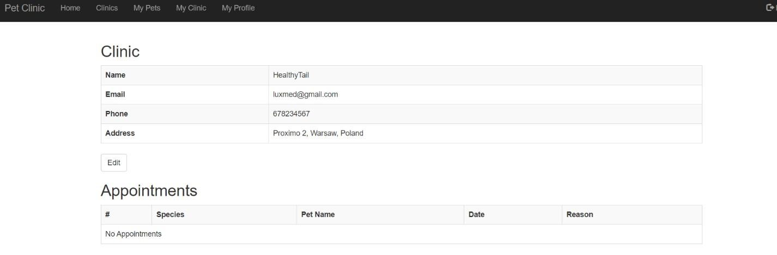
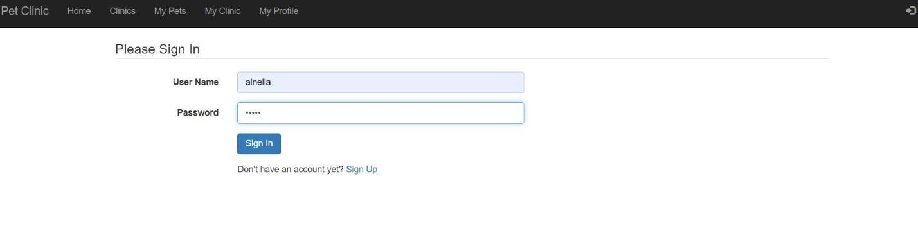
  - Historical Data: Provides a comprehensive history of a pet's medical treatments.
- Pet and Species Management
- Pet Details: Stores and manages details about pets, including breed, species, and medical history.
  - Species Catalog: Maintains a list of species for accurate classification and treatment planning.
- Owner Management
  - Profile Management: Allows for the creation and updating of owner profiles.
  - Authentication and Authorization: Ensures secure access to the system using Spring Security
.
- Clinic Management
- Clinic Information: Manages details about clinics, including contact information and ownership.
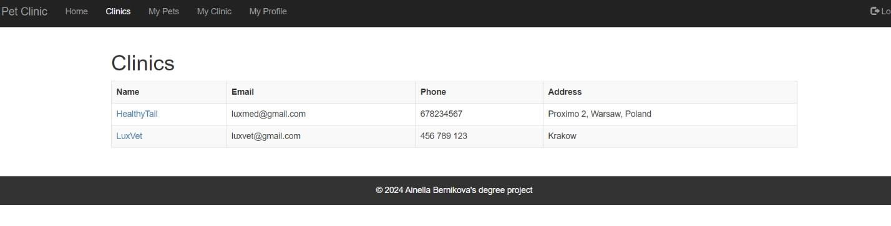
o Owner-Specific Clinics: Fetches and displays clinics associated with specific owners.
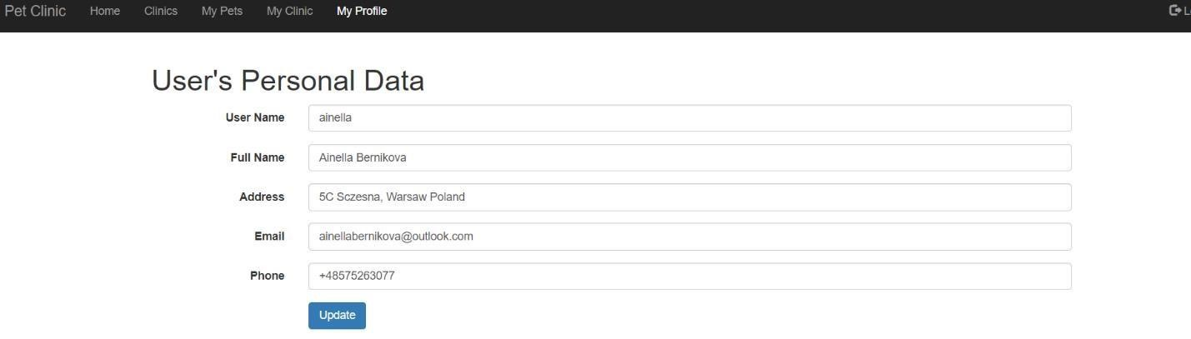

Security
Security is a critical aspect of the Pet Clinic application to ensure that sensitive data,
such as personal information of pet owners and medical records of pets, is protected. The application employs robust authentication and authorization mechanisms to safeguard data and control access.

Authentication
Authentication is the process of verifying the identity of users who attempt to access
the application. The Pet Clinic application uses Spring Security for authentication, leveraging its comprehensive features to secure user credentials and manage sessions.
User Registration:
During registration, users provide their details such as username, password, email, and other personal information.
The password is hashed using a secure hashing algorithm (e.g., BCrypt) before storing it in the database to ensure that even if the database is compromised, passwords remain protected.
Login Process:
Users enter their username and password to log in.
Spring Security handles the authentication process, comparing the provided credentials with the stored hashed password.
Upon successful authentication, a session is created for the user, and they are granted access to the application.
Security Context:
The SecurityContextHolder in Spring Security stores the authentication information of the current user, making it accessible throughout the application.
This information is used to manage the user’s session and ensure that authenticated users can access the resources they are authorized to.
Example code snippet for user authentication in Owner Services:
@Transactional
public void createOwner(Owner owner) {
// Create the user
UserDetails user = User.builder()
.username(owner.getUsername())
.password(passwordEncoder.encode(owner.getPassword()))
.roles("USER")
.build(); // Save the user userDetailsManager.createUser(user);
// Save owner profile
jdbcTemplate.update("INSERT INTO owners (fullname, address, phone, email, username) VALUES (?, ?, ?, ?, ?)",
owner.getFullname(), owner.getAddress(), owner.getPhone(),
owner.getEmail(), owner.getUsername());
}

Authorization
Authorization is the process of determining the permissions of an authenticated user, ensuring they have access only to the resources and actions they are permitted to.
Role-Based Access Control (RBAC):
Users are assigned roles (e.g., USER, ADMIN) during the registration process.
Each role has specific permissions associated with it, controlling access to different parts of the application.
For example, an ADMIN role may have access to manage all users and appointments, whereas a USER role may only access their personal information and appointments.
Method-Level Security:
Spring Security annotations, such as @PreAuthorize, are used to secure methods
at the service layer.
These annotations ensure that only users with the appropriate roles can execute certain methods.
Example code snippet for method-level security:
@Service
public class AppointmentService {
@PreAuthorize("hasRole('ADMIN') or #ownerId == authentication.principal.ownerId") public List<Appointment> getListByOwnerId(Integer ownerId) {
String query = "SELECT a.*, p.\"name\" AS pet_name, c.\"name\"
AS clinic_name, s.\"name\" AS species_name " +
"FROM appointments a " +
"JOIN pets p ON p.id = a.pet_id " +
"JOIN clinic c ON c.id = a.clinic_id " +
"JOIN species s ON s.id = p.species_id " +
"WHERE p.owner_id = ?";
return jdbcTemplate.query(query, new Appointment.Mapper(),
ownerId);
}
}
Access Control List (ACL):
The application can implement fine-grained security using ACLs to control access to
specific records based on user permissions.
This approach ensures that even within a role, access to individual records is restricted
based on ownership or other criteria.
Below the code shows the implementation:
@Configuration @EnableWebSecurity
public class WebSecurityConfig {
@Bean
public SecurityFilterChain securityFilterChain(HttpSecurity http)
throws Exception {
http
.authorizeHttpRequests(authorize -> authorize
.requestMatchers("/", "/style.css", "/error", "/signup", "/clinic", "/clinic/**", "/home.jpg").permitAll()
.anyRequest().authenticated()
)
.formLogin(form -> form
.loginPage("/login")
.permitAll()
)
.logout(logout -> logout
.permitAll()
);

return http.build();
}
}
@Bean
UserDetailsManager users(DataSource dataSource) { return new JdbcUserDetailsManager(dataSource);
}
@Bean
public PasswordEncoder passwordEncoder() {
return new BCryptPasswordEncoder();
}

}
By implementing these robust authentication and authorization mechanisms, the Pet Clinic application ensures that user data is secure, and access is controlled effectively, maintaining the integrity and confidentiality of the information.

Deployment Environment

5.1 Deployment Environment
The Pet Clinic application requires a specific environment to run efficiently. The
deployment environment includes the following components:
- Operating System: Linux (preferably Ubuntu)
- Java Development Kit (JDK): Version 11 or later
- Database: PostgreSQL
- Web Server: Embedded Tomcat (provided by Spring Boot)
- Build Tool: Maven
- Version Control: Git
- Containerization (optional): Docker

Steps for Deployment
Set Up the Server Environment
Install Java:
bash sudo apt update sudo apt install openjdk-11-jdk java
-version
Install PostgreSQL:
bash sudo apt update
sudo apt install postgresql postgresql-contrib sudo systemctl start postgresql sudo systemctl enable postgresql
Install Maven:
bash sudo apt update sudo apt install maven mvn -version
Create Database and User:
bash sudo -i -u postgres psql
CREATE DATABASE petclinic;
CREATE USER petclinicuser WITH PASSWORD 'password'; GRANT ALL PRIVILEGES ON DATABASE petclinic TO petclinicuser;
\q exit
Configure Database Settings in application.properties:
Properties
spring.datasource.url=jdbc:postgresql://localhost:5432/petclinic spring.datasource.username=petclinicuser
spring.datasource.password=password spring.jpa.hibernate.ddlauto=update
Clone the Project Repository o
Install Git:
bash sudo apt update sudo apt install git git
--version o
Clone the Repository:
bash git clone https://github.com/Ainella/PetClinic.git cd PetClinic
- Build the Project o Build with Maven:
bash mvn clean install
- Run the Application o
Start the Application:
bash mvn springboot:run
  - Access the Application: Open a web browser and navigate to
http://localhost:8080.
- Containerization with Docker
(Optional) o Install Docker:
bash sudo apt update sudo apt install docker.io sudo systemctl start docker sudo systemctl enable docker
  - Create a Dockerfile:
dockerfile
FROM openjdk:11-jre-slim
COPY target/petclinic-0.0.1-SNAPSHOT.jar petclinic.jar
ENTRYPOINT ["java", "-jar", "petclinic.jar"]
  - Build the Docker Image:
bash docker build -t petclinic .
  - Run the Docker Container:
bash docker run -d -p 8080:8080 petclinic

By following these steps, you can set up the deployment environment for the Pet Clinic
application and deploy it successfully. Regular maintenance and updates to the environment and application ensure smooth operation and security.

Maintenance
Maintenance of the Pet Clinic application involves regular updates, bug fixes, performance optimizations, and feature enhancements to ensure the application remains functional and secure over time. Key aspects of maintenance include:
Regular Updates:
- Software Updates: Ensure that all libraries, frameworks, and dependencies are up to date to prevent vulnerabilities and take advantage of new features.
- Application Updates: Regularly release new versions of the application with enhancements, bug fixes, and security patches.
Bug Fixes:
- Monitor user feedback and error logs to identify and fix bugs promptly.
- Use version control to track changes and ensure that fixes do not introduce new
issues.
Performance Optimization:
- Regularly monitor application performance using tools like Prometheus and Grafana. Optimize database queries and code to improve response times and reduce resource consumption.
Security Patches:
- Apply security patches to the operating system, database, and application components.
- Conduct regular security audits and vulnerability assessments to identify and mitigate risks.
Backup and Recovery:
Implement regular backup schedules for databases and application data. o Test recovery procedures to ensure data integrity and availability in case of failures.

Support
Support ensures that users can rely on the application for their daily operations,
helping and resolving issues they may encounter. Key aspects of support include:
User Support:
  - Provide documentation and FAQs to help users understand and use the application effectively.
  - Offer multiple channels for support, such as email, chat, and a ticketing system for reporting issues and requesting assistance.
Technical Support:
  - Have a dedicated technical support team to address issues related to application functionality, performance, and security.
  - Use a ticketing system to manage and prioritize support requests, ensuring timely resolution.
Training and Onboarding:
  - Offer training sessions and onboarding materials for new users to familiarize them with the application.
  - Provide ongoing training to existing users when new features or updates are released.
Monitoring and Incident Management:
  - Set up monitoring tools to detect and alert application issues, such as downtime or performance degradation.
  - Establish an incident management process to handle critical issues, including identification, resolution, and post-incident analysis.
Feedback and Improvement:
  - Encourage users to provide feedback on their experience with the application.
  - Use feedback to continuously improve the application and support services, addressing user needs and enhancing satisfaction.
By implementing comprehensive maintenance and support strategies, the Pet Clinic application ensures reliability, security, and a positive user experience, ultimately leading to greater user satisfaction and successful long-term operation.

Conclusion
The development and implementation of the Pet Clinic Management System was a
comprehensive project that aimed to streamline the operations of a pet clinic through the use of modern software solutions. This system addresses the specific needs of pet clinic management, including appointment scheduling, medical records management, billing, and customer relationship management.

Summary of the Project:
Objectives Achieved:
- Successfully developed a fully functional Pet Clinic Management System using contemporary web technologies such as Spring Boot, Hibernate, and Thyme Leaf.
- Implemented key features including appointment scheduling, pet and owner records management, and billing.

Enhanced User Experience: Developed an intuitive interface and responsive design to improve user engagement and accessibility.
System Design and Implementation:
- Robust System Architecture: Designed a scalable and maintainable system architecture to support future growth and ease of maintenance.

- Database Schema Development: Created a relational database schema optimized for managing clinic data efficiently.

- Role-Specific User Interfaces: Developed tailored user interfaces for various roles within the clinic, including veterinarians, receptionists, and administrators.
Testing and Validation:
- Comprehensive Testing: Conducted extensive testing, including unit, integration, and user acceptance tests, to ensure the system's reliability and accuracy.
- Requirements Validation: Verified the system against initial requirements, confirming that all functionalities operated as intended.

Challenges and Solutions:
Encountered difficulties in maintaining data integrity and handling intricate data linkages, which were resolved by using Hibernate and ORM (Object Relational Mapping) in combination with careful database architecture. By utilizing responsive design concepts and conducting extensive user testing, user interface design brought issues in delivering a seamless experience across various devices to a close.
Concluding Remarks: The Project for Pet Clinic Management System has effectively illustrated how digital technologies can revolutionize conventional clinic operations. The solution increases productivity lessens administrative hassles, and eventually raises the standard of care given to pets by automating repetitive procedures and offering a consolidated platform for all clinic proceedings. Along with giving pet clinics a useful tool, this project has taught me a lot about software development, project management, and issue resolution. Pursuing future undertakings in the fields of software development and healthcare technology will be made possible by the insights obtained from this research.

. References

- Walls, Craig (2015). Spring Boot in Action.
- Amuthan, G. (2014). Spring MVC Beginner’s Guide.
- Microsoft Corporation (2016). "Database Design Basics." Retrieved from Microsoft Support.
- Huawei Technologies Co., Ltd. (2022). "Database Design Fundamentals." Retrieved from ResearchGate.
- Spring.io. "Spring Boot." Retrieved from Spring Boot Project.
- Spring.io. "Spring MVC." Retrieved from Spring Framework Documentation.
- Spring.io. "Spring Data JDBC." Retrieved from Spring Data JDBC Project.
- Spring.io. "Spring Security." Retrieved from Spring Security Project.
- Thymeleaf.org. "Thyme leaf Documentation." Retrieved from Thyme Leaf Documentation.
- BootstrapDocs.com. "Bootstrap CSS Library." Retrieved from Bootstrap Documentation.

