Name : Ain Najihah binti Mohd Fahmi @ Izriq

Student ID : AM2307013916

LAB TEST SWC3404

20/3/2025

User Interface

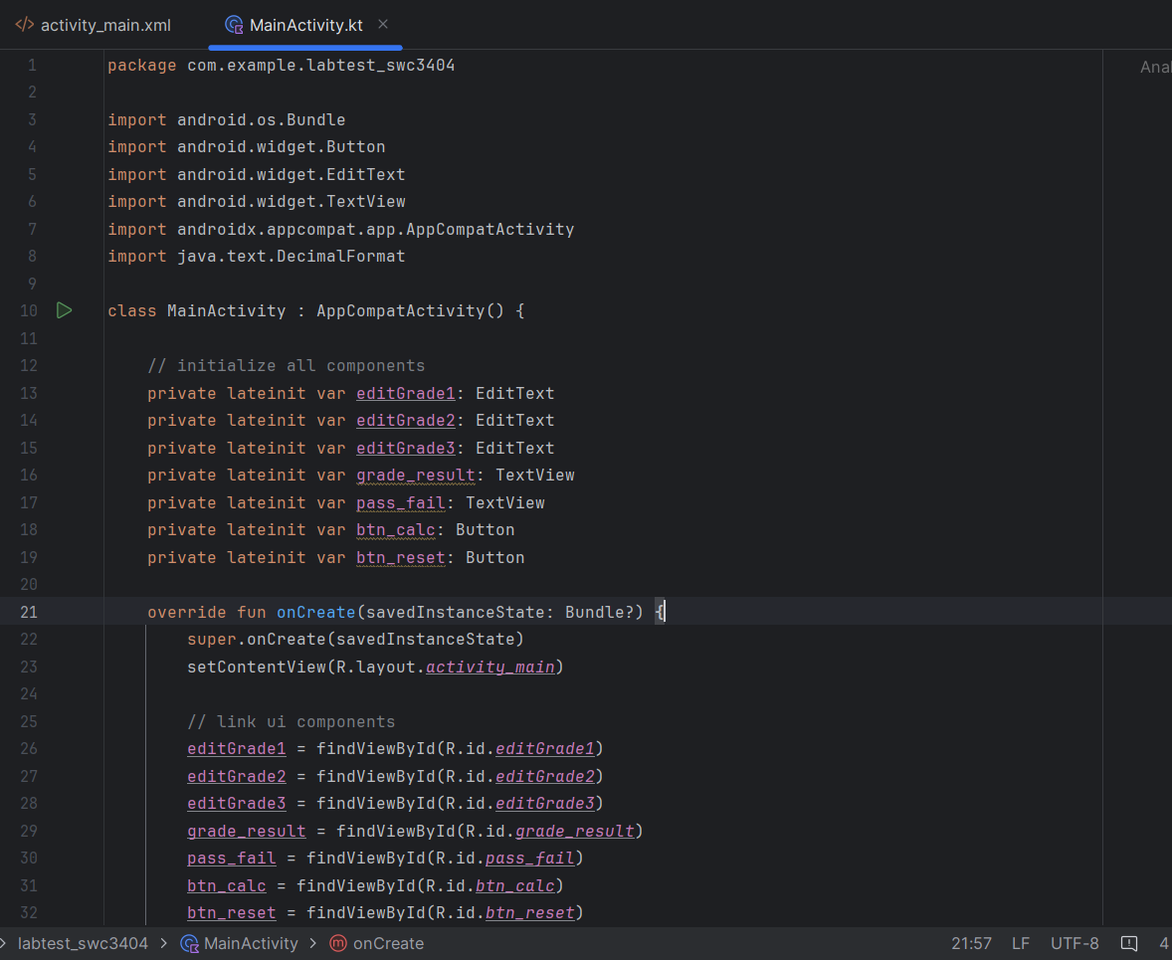

Coding part 1

Coding Part 2

LINK GOOGLE DRIVE

https://drive.google.com/drive/folders/1vGorFhSyZHI5CxAUeMYBJqarqZx3ed5C?usp=sharing