|  |  |
| --- | --- |
| **Event:**  **Latitude**:  **Longitude**:  **Address**:  **Type of structural collapse**:  **Building footprint area:**  **Aprox. Max. collapse distance:**  **Aprox. Max. Debris distance:**  **Building Material:**  **Structural system:**  **# of stories:**  **Approximate total height:**  **Apparent irregularities:**  **Approximate construction date:** | 1999 Armenia-Quindio Earthquake  4.532826286050765  -75.67241931034148  Calle 20 # 13-22 Armenia, Quindío, Colombia  Hybrid of Monolithic and Sidesway  rectangular  10 m  15 m  Reinforced concrete  RC columns with infill masonry walls  4  11 m  Vertical irregularities and pounding |

**BEFORE**

**AFTER**

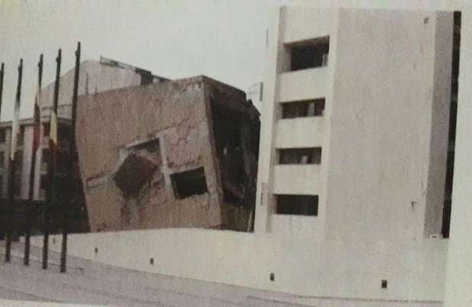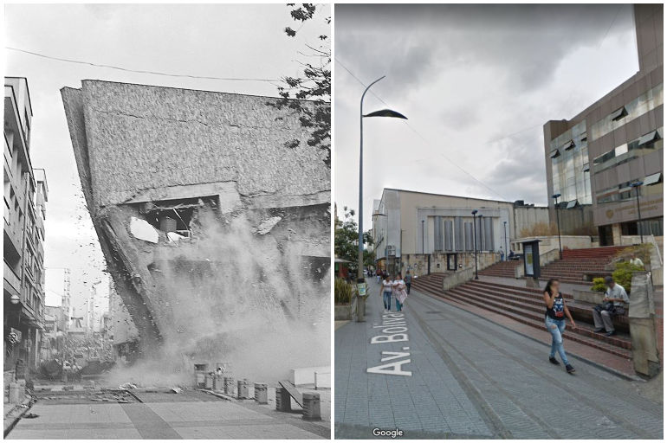

(Restrepo and Cowan, 2000)