问题1：脚手架到vue-cli3.0版本的时候出现了这个报错
You are using the runtime-only build of Vue where the template compiler is not available. Either pre-compile the templates into render functions, or use the compiler-included build.
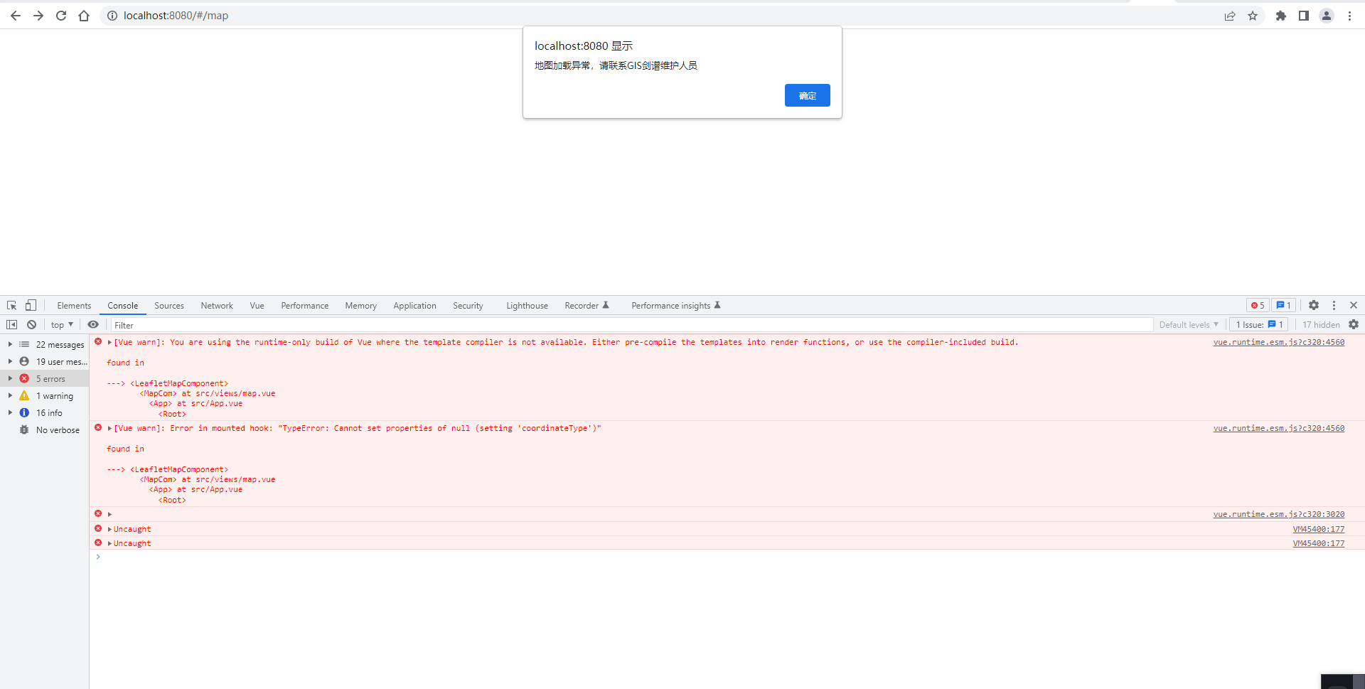
解决方案：
方法1：添加：runtimeCompiler: true 配置

const { defineConfig } = require('@vue/cli-service')
module.exports = defineConfig({
transpileDependencies: true,
runtimeCompiler: true,
})

方法2：在vue.config.js文件里加上webpack的如下配置即可
configureWebpack: {
resolve: {
alias: {
'vue$': 'vue/dist/vue.esm.js'
}
}
}

