Test 2 take home part

Laha Ale

April 5, 2019

## Problem I

model  
{  
 for( i in 1 : N ) {  
 lambda[i] ~dgamma(alpha,beta)  
 x[i] ~ dpois(lambda[i])  
 }  
   
 alpha ~ dgamma(1.0E-3,1.0E-3)  
 beta ~ dgamma(1.0E-3,1.0E-3)  
}  
  
  
list(x = c(5, 6, 5, 10, 3, 9, 4, 4, 4, 12), N=10)  
   
list(alpha=2, beta=1)

**The statistics for alpha and beta as follow:**

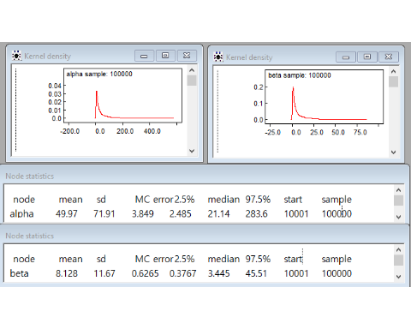 Both $α$ and $β$ are initial as Gamma distribution. The density curves show relatively smooth. Moth MC errors are less than their standard deviation of 5% or more. CI with 95% credit set are $2.485<α<283.6$ and $0.3767<β<45.51$.

**lambda density curve and statistics**

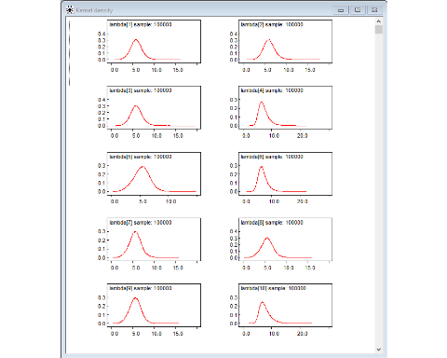 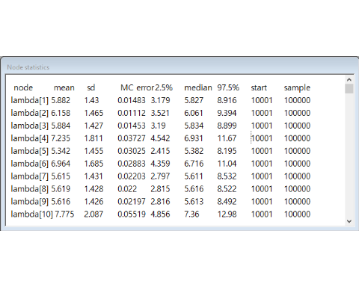 summary statistics show in the above table, for example, $λ_{1}$ has $mean=5.882$ and standard deviation $\sigma_{\lamda} = 1.43$ MC, error=0.01483 is less than standard deviation of 5%, median=5.827, and 95% credible set $3.179 < \lamda < 8.916$.