**Milestone 1: User Guide**

1. Fill out credentials, hit ‘Submit’. (only 10 characters for PW)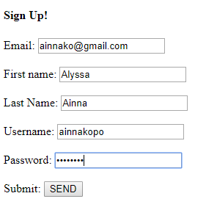
2. You should see the following message if submitted properly and your data is stored in our database:  
   