The Subject: Household Appliance Store

1. Business Description

Domain Overview
The selected subject area is a Household Appliance Store. This business operates both a physical showroom and an online sales channel. The database is designed to manage the core operational aspects of the business: inventory management, sales processing, customer relationships, supplier tracking, and financial transactions (payments).

Core Business Rules
- Products: The store sells various appliances (fridges, microwaves, etc.) organized by categories. Each product is sourced from a specific supplier and has a stock level that must be monitored.
- Sales: Customers place orders. An order can contain multiple items (products).
- Payments: Orders can be paid for using different methods (card, cash). Multiple transactions can be associated with an order (e.g., prepayments), or an order might be unpaid initially.
- Pricing: Product prices can change over time, but the price at the moment of sale must be preserved for historical accuracy (handled via unit_price_at_sale in order_item).
- Employees: Sales associates process orders. The system tracks which employee handled which order for commission or performance tracking.
- Constraints: * Strict Dates: Historical data and new insertions must be strictly after January 1, 2024.
  - Inventory: Stock quantities and prices cannot be negative.
  - Uniqueness: Customer emails and Order numbers must be unique.

2. Step-by-Step Approach to Modeling

Step 1: Conceptual Design
I identified the main entities involved in the business process:
- Customer: Who buys the item.
- Order: The sales agreement/event.
- Product: What is being sold.
- Supplier: Who provides the product.
- Employee: Who facilitates the sale.
- Category: How products are grouped.
- Transaction: The financial payment record.
I determined the following relationships between entities:
- Category to Products (1:N): One category (e.g., "Kitchen") classifies multiple products, but a product belongs to only one category.
- Supplier to Products (1:N): One supplier provides multiple products, but each product is sourced from a single specific supplier.
- Customer to Orders (1:N): One customer can place multiple orders over time, but each order belongs to exactly one customer.
- Employee to Orders (1:N): One sales associate can process multiple orders, but each order is handled by one primary employee (optional relation).
- Orders to Transactions (1:N): One order can be associated with multiple payment transactions (e.g., split payments), but a transaction belongs to one specific order.
- Orders to Products (M:N): One order contains many products, and one product can appear in many orders. This Many-to-Many relationship is resolved via the associative entity Order_Items.
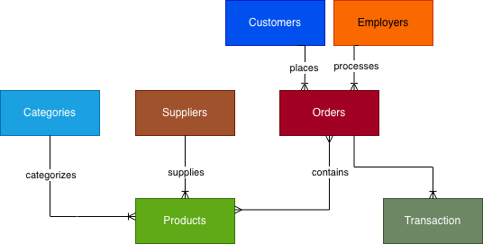

Step 2: Logical Design (3NF)
To ensure the Third Normal Form (3NF), I applied the normalization rules step-by-step:
- 1NF (First Normal Form): Ensured all attributes are atomic and there are no repeating groups. For example, instead of storing a list of purchased products in a single cell within the Orders table, I created a separate Order_Items table where each row represents one product in one order. Customer names are split into first_name and last_name.
- 2NF (Second Normal Form): Removed partial dependencies. This is particularly relevant for the associative entity Order_Items. Attributes like quantity depend on the specific combination of the Order and the Product. Attributes that depend only on the product (like brand or current stock_quantity) are kept in the Product table, not repeated in Order_Items.
- 3NF (Third Normal Form): Removed transitive dependencies. For example, a product's supplier information (like company_name, contact_email) is logically determined by the supplier, not the product itself. If stored in the Product table, it would depend on product_id → supplier_id → supplier_details. To resolve this, I moved all supplier details to a dedicated Supplier table and referenced them via supplier_id. Similarly, customer details are stored only in the Customer table, not repeated in Orders.
Logical Schema (8 Tables):
- category (PK: category_id)
- supplier (PK: supplier_id)
- product (PK: product_id, FKs: category_id, supplier_id)
- customer (PK: customer_id)
- employee (PK: employee_id)
- orders (PK: order_id, FKs: customer_id, employee_id)
- order_item (PK: order_item_id, FKs: order_id, product_id)
- transaction (PK: transaction_id, FK: order_id)
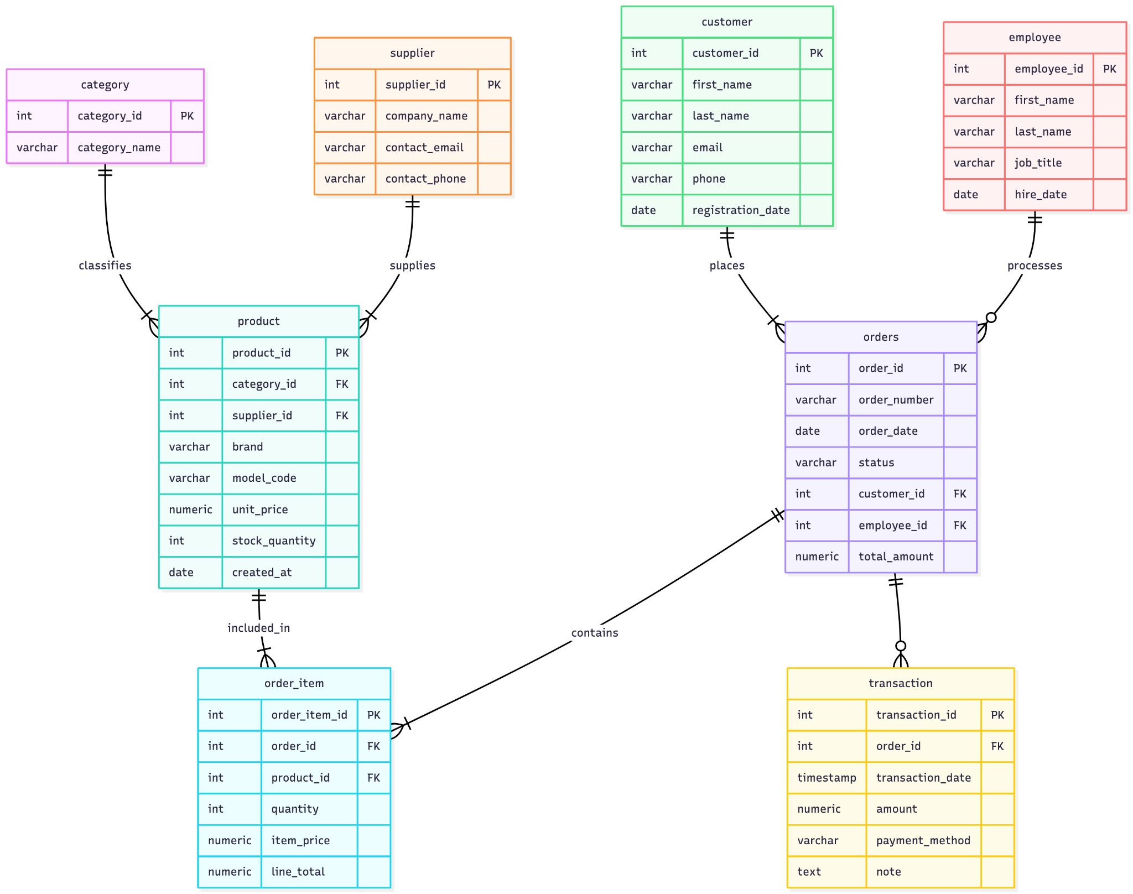

Step 3: Physical Implementation
- Database: PostgreSQL (Schema: store).
- Data Types: * NUMERIC(12,2) and NUMERIC(14,2) for monetary values to ensure precision.
  - TIMESTAMP for transaction timing.
  - VARCHAR with appropriate limits.
- Constraints: * Implemented CHECK constraints for dates (> '2024-01-01') and non-negative values (price >= 0, stock >= 0).
  - Used UNIQUE constraints for email and order_number.
  - Used ENUM simulation via Check constraints for Statuses (pending, shipped, etc.).
- Automation: * Used GENERATED ALWAYS AS IDENTITY for surrogate keys.
  - Used GENERATED ... STORED for calculating line totals automatically in order_item.

3. Explanation of Functions, Views, and Security

Functions
- store.update_product_column: A dynamic function to safely update specific product details (price, stock, brand) given a product ID.
- store.add_transaction: A function that allows adding a payment record by referring to the Order Number (natural key) rather than the internal ID, ensuring ease of use for clerks.

Analytics View
- store.quarter_sales_analytics: This view dynamically calculates the "most recently added quarter" by finding the maximum order date in the system. It aggregates revenue and items sold by Brand and Category for that specific quarter.

Security
- A manager_readonly role was created using a safe DO $$ ... IF NOT EXISTS block.
- This role has USAGE on the schema and SELECT permission on all tables..

