XML設計與應用實驗結報2

EDI: Store XML into MySQL

學生:410721312 謝霆

目錄:

1. Program file : page 2~3
2. XML file : page 4
3. program file

CreateXMLFile is the only file for this homework.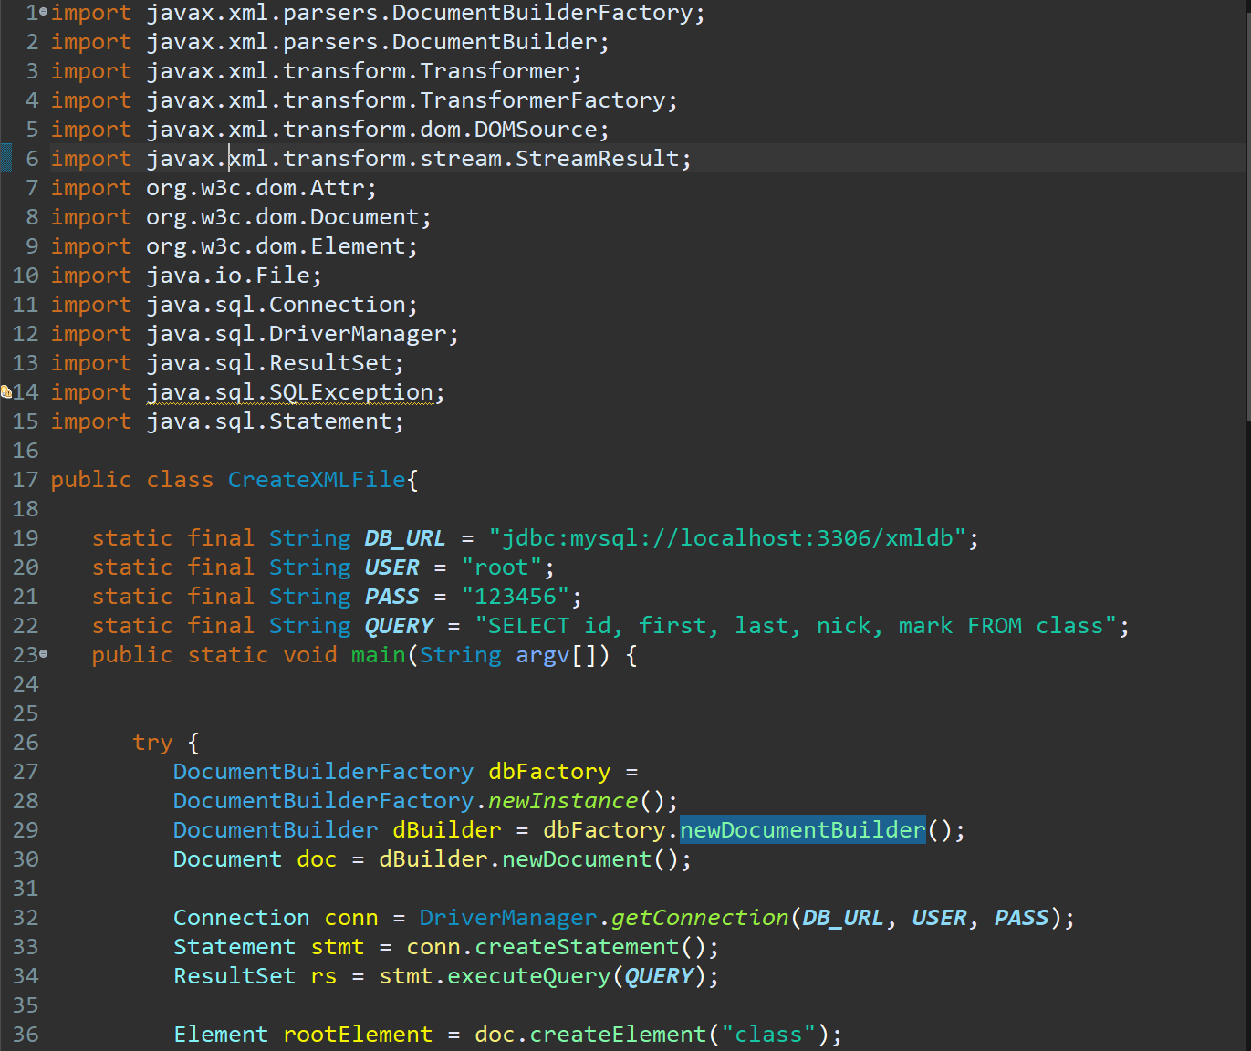 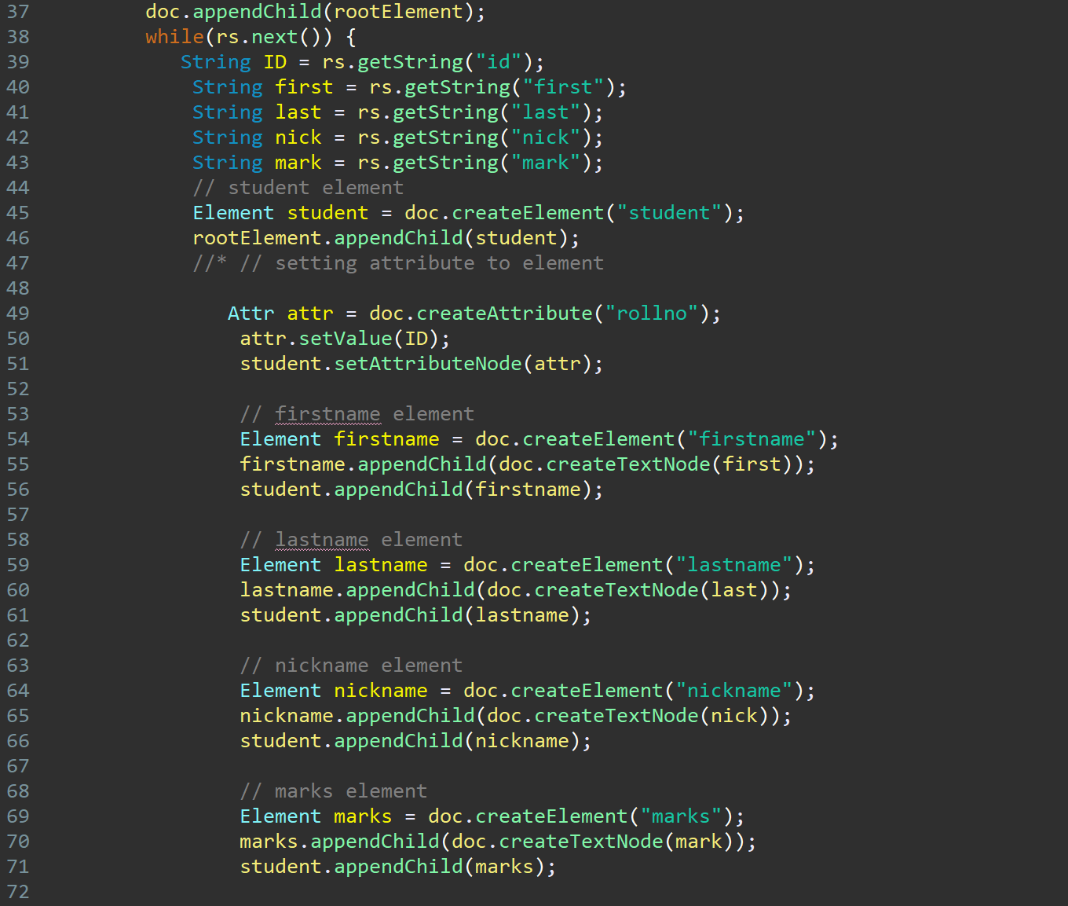 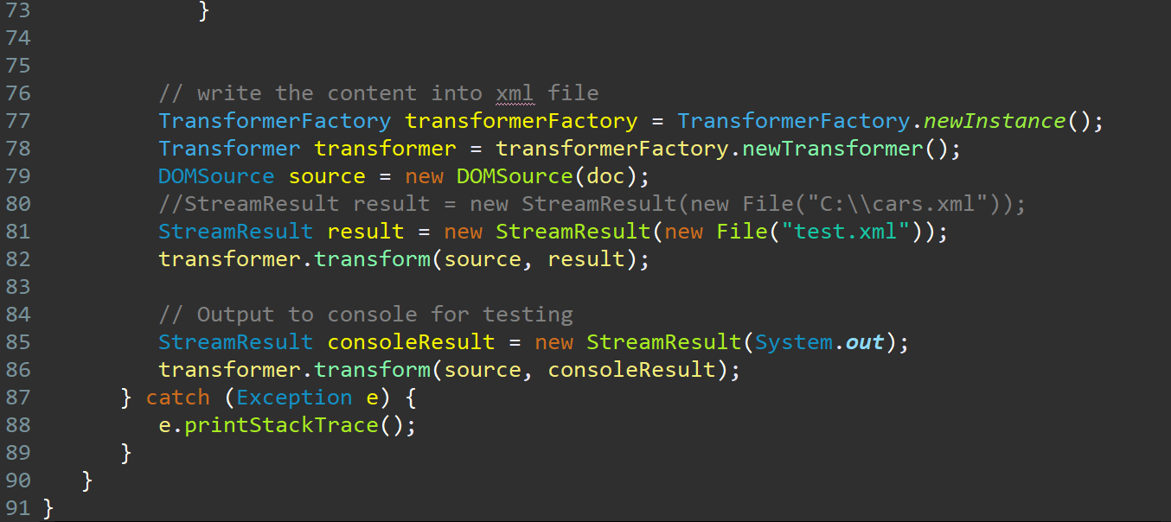

1. XML file

The xml file generated is called “test.xml”

