Variables to retain:

**site**: the site where the oysters were outplanted. Sites are labeled A, B, C, D, E.

**b_r**: essentially the subsite - whether the oysters were on a beach or grown off of a raft. b = beach, r = raft.

**bag**: which bag the oysters were sampled from at each subsite (1:5)

**outplant_time**: the time that has elapsed since the experiment began, in weeks

**shell_length** ( = length): the length of each oyster’s shell

**wet_mass** (= whole_mass = whole_oyster): the mass of each oyster before dissection (includes water weight)

**dry_whole** (= whole_oyster = whole_dry): the mass of each whole oyster when dried (includes tissue and shell weight)

**dry_tissue**: the mass of just the dry oyster tissue

All other variables can be removed from the data frames, or maybe it makes more sense to join the data frames and then select the relevant data afterwards.

Analysis information:

We will want to separate the beach and raft oysters during analysis since we would expect oysters in those growing environments to be affected by different explanatory variables. E.g. because of low tide, the mean max/min daily temperature will have a much larger effect for beach oysters than for raft oysters.

The response data do not follow a normal distribution. We will need to analyze it using some sort of alternative to the normal distribution – perhaps a gamma distribution?

Will probably need to use *glmmTMB* to account for the non-normal distribution of shell length, as well as the presence of the random term for bag and temporal autocorrelation. We can also first try a glmm and test for autocorrelation in the residuals by looking at ACF plots or similar.

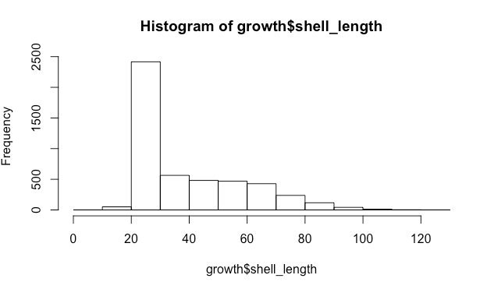

Model:

shell length ~ outplant time + mean temperature + mean salinity + mean maximum daily temperature + mean minimum daily temperature + mean minimum daily salinity + degree hours above 29 ˚C + ppt hours below 20 ppt salinity

* would want a random variable of bag to account for pseudoreplication:
  + in *glmmTMB*: + (1|site: bag)
* would expect temporal autocorrelation, so might want to include a term accounting for this…
  + in *glmmTMB*: + ar1(factor(outplant_time) + 1 | bag)