**NFC-Based Jukebox – Arduino Project**

Student: Avram Andreea-Ioana

Design with Microprocessors

Technical University of Cluj-Napoca January 8, 2023

**Contents**

**Introduction** 3

*1.1* *Purpose of the project* 3

*1.2* *Motivation* 3

**Bibliographic Research** 4

**Implementation** 6

*3.1 Hardware Implementation* 6

*3.2 Software Implementation* 7

**Testing and Validation** 8

**Conclusion** 9

**Bibliography** 10

# **Introduction**

## *Purpose of the project*

The primary purpose of this project is to develop a streamlined and interactive Jukebox system that utilizes ***NFC (Near Field Communication) technology*** to facilitate music playback. By integrating an NFC reader (the RFID-RC522) with a ***DFPlayer Mini module***, the system enables users to play specific songs by simply scanning designated NFC tags. This project aims to create an accessible and user-friendly platform for music enthusiasts to enjoy their favorite tracks effortlessly, enhancing the traditional Jukebox experience through modern technology.

## *Motivation*

The motivation for developing this NFC-based Jukebox system originates from a combination of nostalgic appreciation and the desire to explore contemporary technological applications in a familiar context. Traditional Jukeboxes, once common in social venues, have seen a decline in presence due to advancements in digital music streaming and personal playback devices. The objective of this project is to revive the classic Jukebox experience by integrating Near Field Communication (NFC) technology, effectively combining the timeless charm of vintage music selection with the convenience and efficiency of contemporary wireless communication, all while increasing its portability.

The project was chosen due to its simplicity and the enjoyable challenge it presents, making it an ideal attempt for hands-on learning and experimentation. The concept of using NFC tags to trigger specific music tracks offers a straightforward yet effective method to engage with both hardware and software components without the complexity often associated with more advanced systems. This accessibility ensures that the project remains manageable while still providing valuable insights into embedded systems and wireless communication technologies. Furthermore, the revival of the Jukebox concept addresses a niche interest, catering to those who appreciate the nostalgic elements of classical music selection devices. By undertaking this project, I aim to not only create a functional and interactive music player but also to deepen my understanding of *NFC integration*, *audio module interfacing*, and user-friendly design principles.

# **Bibliographic Research**

Traditional Digital Jukeboxes offer reliability and advanced features but lack the flexibility and affordability desired for a personal or educational project. Smartphone-Integrated and Cloud-Based Jukebox Systems provide advanced features and scalability but come with higher costs and complexity, making them less suitable for individual or small-scale implementations. NFC-Enabled Music Players align closely with the project's objectives by offering high customization, portability, and cost-effectiveness, albeit with a moderate to high implementation difficulty.

To assess the real value and effectiveness of the proposed NFC-based Jukebox system, it is essential to examine and compare existing similar projects available on platforms such as GitHub and online tutorials. Focusing on Arduino-based implementations provides a pertinent benchmark. The following comparison analyzes three existing Arduino-based Jukebox projects against the proposed NFC-based Jukebox, evaluating them based on key criteria including **Power Consumption**, **Difficulty to Implement**, **Cost of Resources and Implementation**, and **Adaptation to User's Needs.** This comparative analysis seeks to identify the strengths and limitations of each solution, thereby revealing the unique contributions and enhancements of my project.

|  |  |  |  |  |
| --- | --- | --- | --- | --- |
| Criteria | Arduino-Based Jukebox by hglkrijger [1] | Arduino-JukeBox by w29ahmed [2] | NFC Music Box by  layereight [3] | NFC-Based Jukebox (Proposed Project) |
| Description | Utilizes an Arduino Uno, MFRC522 NFC reader, DFPlayer Mini, and LCD display to create a functional Jukebox. Users can select songs via NFC tags, which trigger specific MP3 files stored on a microSD card. | Employs an Arduino Uno, LCD, speaker, potentiometer, and it allow users to select and play songs using a button. The system is designed for simplicity and ease of use, making it suitable for beginners. | Integrates a Raspberry Pi, RFID-RC522 module to create an NFC-enabled music box. Users can tap NFC tags to play corresponding songs stored on the Raspberry Pi. | Uses an Arduino-compatible microcontroller, MFRC522 NFC reader, DFPlayer Mini, and potentiometer to enable users to play music by scanning NFC tags. |
| Power Consumption | Low: Utilizes Arduino Uno and DFPlayer Mini, resulting in efficient power usage suitable for stationary setups. | Low: Employs Arduino Uno with efficient components, maintaining low power consumption. | Moderate: Incorporates Raspberry Pi, RFID-RC522 module, along with other peripherals. | Low: Utilizes an Arduino Uno (typically ~50mA), RFID-RC522 (~15mA), DFPlayer Mini (~30mA) => approx. 95mA |
| Difficulty to Implement | Moderate: Requires basic knowledge of Arduino programming, wiring, and integration of NFC and audio modules. | Easy to Moderate: User-friendly with detailed instructions, suitable for beginners with some Arduino experience. | High: Involves integrating Raspberry Pi with NFC modules, configuring VLC media player, and managing network-based updates. | Easy to Moderate: Similar to existing Arduino projects with straightforward implementation using NFC tags and audio modules. |
| Adaptation to User’s Need | High: Supports customization of NFC tags to play specific songs, allowing users to expand the music library as needed. | Moderate: Limited to predefined song selections but can be modified with additional programming. | High: Facilitates easy programming of NFC tags to link with specific songs, enabling extensive customization and support for a larger music library. | Medium: Facilitates easy programming of NFC tags and seamless addition of new songs. |
| Cost of Resources | Low: Affordable components | Very Low: Utilizes cost-effective parts. | Moderate to High | Low: Comparable to existing projects |

# **Implementation**

The NFC-based Jukebox system presents an innovative approach to music selection and playback by leveraging ***Near Field Communication (NFC) technology*** integrated with an Arduino-compatible microcontroller and a ***DFPlayer Mini audio module***. This section provides a comprehensive technical overview of the chosen solution, detailing the hardware and software implementations, including circuit design, algorithmic logic, and the debugging process undertaken to ensure system reliability and performance.

## *3.1 Hardware Implementation*

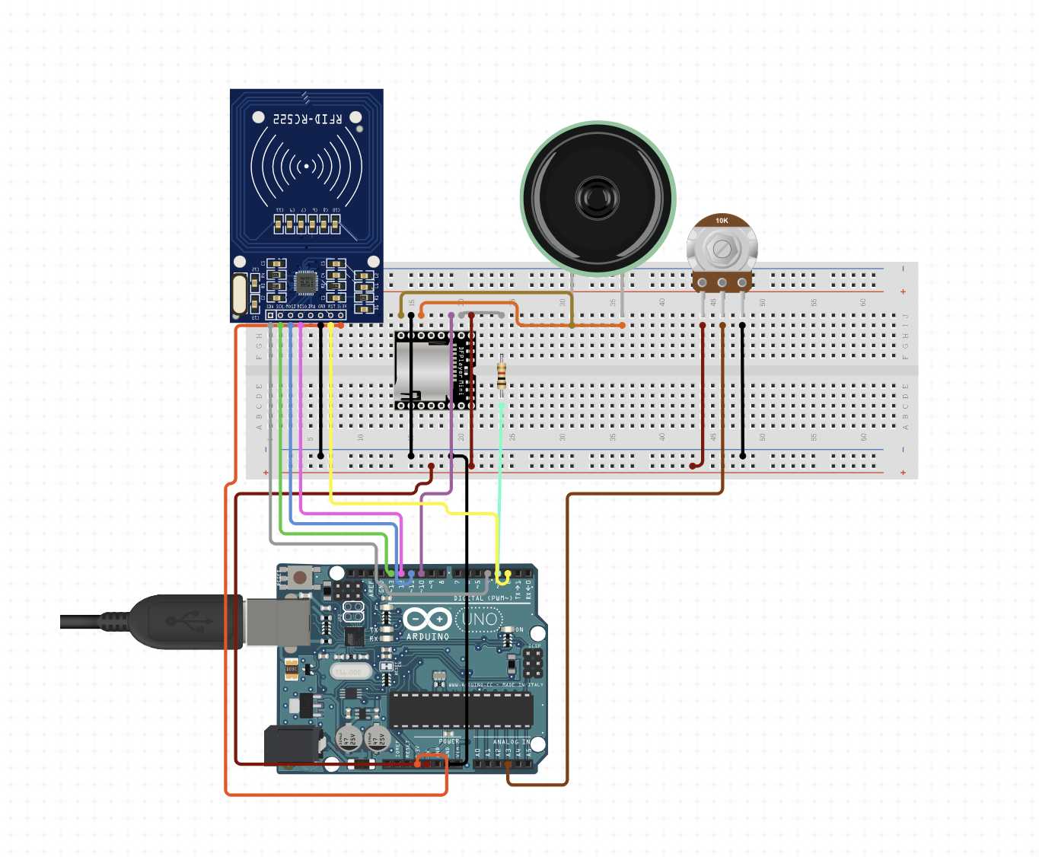

Figure 1: Hardware Implementation

Stuff to write2

The hardware architecture of the NFC-based Jukebox is meticulously designed to ensure seamless interaction between the user and the system through NFC tag scanning and audio playback.

The core components of this project are:

* **Arduino Uno**: acts as the central processing unit, orchestrating data flow between the NFC reader, audio module, and other peripherals.
* **RFID-RC522 [4]**: Detects and reads data from **NFC tags**, identifying the unique identifier (UID) associated with each tag. Uses **SPI** (Serial Peripheral Interface) for communication with the Arduino.
* **DFPlayer Mini Audio Module [5]**: Manages audio playback by reading MP3 files from a microSD card and outputting sound through connected speakers. Uses **UART** (Universal Asynchronous Receiver/Transmitter) for communication with the Arduino.
* **Speaker**: connected to the DFPlayer Mini's audio output pins to deliver music playback to the user.
* **Potentiometer**: for volume control.

## *3.2 Software Implementation*

The software development process for the NFC-based Jukebox was structured to ensure robust functionality and seamless user interaction. The initial stage concentrated on creating a program to ***read the Unique Identifier (UID) from NFC tags*** using the RFID-RC522 NFC reader module. This program was essential for establishing reliable communication between the NFC reader and the Arduino-compatible microcontroller. By utilizing the MFRC522 library within the Arduino IDE, the initial code was developed to continuously monitor for the presence of NFC tags, retrieve their UIDs upon detection, and output these identifiers to the serial monitor for verification and debugging purposes.

Once the UID reading functionality was successfully implemented and tested, the subsequent phase involved integrating this capability into the main Jukebox application. This integration required merging the UID detection logic with the audio playback controls managed by the DFPlayer Mini module. The final software implementation was designed to perform ***real-time comparisons between the scanned UIDs*** ***and a predefined array of stored UIDs***, each mapped to specific audio tracks stored on the microSD card. When a match was identified, the system would automatically trigger the corresponding song, ensuring an intuitive and user-friendly music selection experience.

To enhance user interaction, the software also incorporated ***dynamic volume control*** based on input from a potentiometer connected to an analog pin on the microcontroller. This feature allowed users to adjust the playback volume seamlessly, providing a customizable listening experience. The volume control was achieved by reading the analog input, mapping the potentiometer's position to a suitable volume level, and sending the appropriate commands to the DFPlayer Mini module to adjust the audio output accordingly.

# **Testing and Validation**

The testing phase of the NFC-based Jukebox primarily focused on evaluating the reliability and performance of the MFRC522 RFID reader under various conditions. The objective was to ensure consistent UID detection across different operational environments and physical interactions. To achieve this, a series of tests were conducted to assess the reader's functionality at varying distances and in the presence of thin obstructions, such as cartons or similar materials. The tests revealed that the system consistently detected tags when they were held close to the reader, with successful readings up to a distance of approximately 55 millimeters. Beyond this range, the detection accuracy began to decline, necessitating the recommendation for users to maintain proximity for optimal performance. Another important test involved introducing thin objects between the NFC tag and the reader to evaluate the system's resilience to minor obstructions. These tests were designed to simulate real-world scenarios where users might inadvertently place a thin barrier between the tag and the reader. The results demonstrated that the presence of such thin materials did not significantly impede the UID detection process, provided the thickness of the object did not exceed the established detection range. The testing affirmed that the NFC-based Jukebox operates reliably within a close range and is resilient to minor physical obstructions, providing a seamless user experience.

Despite foregoing the external amplifier, the Jukebox demonstrated satisfactory audio performance. Volume control functionality was tested extensively using an analog potentiometer connected to the system. The results confirmed that the volume could be smoothly and responsively adjusted across the entire range, allowing users to customize their listening experience effectively. While the audio quality met the project's baseline requirements, there remains room for improvement in achieving richer and more robust sound output. Future iterations may explore alternative amplification methods or higher-quality speakers to elevate the overall audio experience without compromising system stability and power efficiency.

In summary, the testing and validation process affirmed the NFC-based Jukebox's core functionalities, including reliable UID detection, accurate song mapping, and effective volume control. Although the initial attempt to enhance audio quality with an external amplifier was unsuccessful, the subsequent optimizations ensured that the system remains efficient and user-friendly. The successful integration of hardware components and the refinement of software algorithms culminated in a robust and versatile music playback solution. Future enhancements, such as exploring superior audio components or implementing wireless connectivity, hold the potential to further elevate the Jukebox's performance and user experience.

# **Conclusion**

The primary objective of developing a streamlined and interactive NFC-based Jukebox system was successfully achieved. By integrating the MFRC522 RFID reader with the DFPlayer Mini audio module, the project effectively enabled users to play specific songs through the simple action of scanning designated NFC tags. This fulfillment of the project's purpose underscores the viability of utilizing NFC technology to enhance traditional music playback experiences with modern, user-friendly interfaces.

Practical improvements for the NFC-based Jukebox include enhancing the user interface with visual indicators or a small display could provide real-time feedback and improve user interaction. Exploring more advanced audio components or implementing digital signal processing techniques could further enhance sound quality, offering a more immersive listening experience. These enhancements would not only elevate the system's functionality but also broaden its appeal and applicability across diverse user groups.

In conclusion, the NFC-based Jukebox project successfully melds nostalgic elements with contemporary technology, delivering a reliable and user-friendly music playback solution. Through diligent testing, thoughtful adaptations, and strategic optimizations, the project has laid a solid foundation for future advancements and applications, demonstrating the effective use of NFC technology in modern interactive systems.

# **Bibliography**

[1] Krijger, Hgl. "Jukebox." GitHub. Last modified June 15, 2021. <https://github.com/hglkrijger/jukebox>

[2] w29ahmed. "Arduino-JukeBox." GitHub. Last modified March 10, 2020. <https://github.com/w29ahmed/Arduino-JukeBox>

[3] LayerEight. "NFC-Music-Box." GitHub. Last modified January 5, 2022. <https://github.com/layereight/nfc-music-box>

[4] DFRobot. "DFPlayer Mini SKU DFR0299." DFRobot Wiki. Last modified August 20, 2023. <https://wiki.dfrobot.com/DFPlayer_Mini_SKU_DFR0299>

[5] Microcontrollerslab.com. "RC522 RFID Reader Pinout, Arduino Interfacing, Examples & Features." Microcontrollerslab.com. Last modified July 15, 2023. <https://microcontrollerslab.com/rc522-rfid-reader-pinout-arduino-interfacing-examples-features/>