004-URL Parser
Difficulty: Medium Expect Time: 60 min Author: Wayne, Hsu

Uniform Resource Locator (URL) is a reference to a web resource that specifies its location on a computer network. For Example, "https://www.ntust.edu.tw/home.php" is a URL. A URL is a specific type of Uniform Resource Identifier (URI).

- Basic Lexical Rule
  - ALPHA: Uppercase or lowercase English letter, ranging from A to Z or a to z
  - DIGIT: A single decimal digit character from 0 to 9
  - HEXDIGIT: DIGIT or a letter from A to F (uppercase or lowercase)
  - ALPHANUM: A character set composed of both ALPHA and DIGIT
  - UNRESERVED: A character that belongs to the ALPHANUM set, or is one of the following symbols: `-` , `.` , `_` , or `~`
  - GEN-DELIM = { ':', '/', '?', '#', '[', ']', '@' }
  - SUB-DELIM =
{'!', '$', '&', ''', '(', ')', '*', '+', ',', ';', '='}
  - RESERVED = A character set composed of both GEN-DELIM and SUB-DELIM.

- URL Encoding
Percent-encoding is a way to represent characters in a URI using only ASCII. Each encoded sequence starts with `%` followed by two HEXDIGIT characters. When encountering Percent-encoding, treat the two characters after `%` as a hexadecimal number and look up the corresponding ASCII character.
Example:
- %20 will parsed 0x20, ASCII(0x20) is ` `(space)
- %21 will parsed 0x21, ASCII(0x21) is `!`

(space) | ! | " | # | $ | % | & | ' | ( | ) | *
%20 | %21 | %22 | %23 | %24 | %25 | %26 | %27 | %28 | %29 | %2A
+ | , | / | : | ; | = | ? | @ | [ | ]
%2B | %2C | %2F | %3A | %3B | %3D | %3F | %40 | %5B | %5D
Table of percent-encoded representations for RESERVED characters.

- URL Structure
[Protocol]://[Authority][Pathname]?[Query]#[Fragment]
  - Protocol: Composed of ALPHA.
Example:
- https
- ftp

  - Authority:
[Username ":" Password "@"] Hostname [ ":" Port ]
    - Username<optional>:
Starts with an ALPHA , followed by zero or more ALPHANUM.
    - Password <optional>:
Composed only of ALPHANUM. Must be present only if a Username is provided.
    - Hostname:
One or more labels separated by `.`. Each label is composed of UNRESERVED and `-`. The final character of the hostname must be an ALPHANUM.
    - Port<optional>:
A DIGIT sequence, in the range 0 to 65535.

If the username and password are present, they must appear as a pair separated by a colon (`:`) and be followed by an at symbol (`@`) before the hostname; additionally, if the port is present, it must follow the hostname and be prefixed with a colon (`:`).
Example:
- zh.wikipedia.org
- john.doe:abc123@www.example.com:1234
- api.gateway.io:443

  - Pathname
A pathname is a sequence of segments separated by slashes (`/`), and starts with `/`. Each segment may contain UNRESERVED and RESERVED, but NOT INCLUDE the delimiters `?`, `#`, `/`. The segments may be empty string, but pathname must contain at least one non-empty string segment.
Example:
- /forum/questions/
parsed as vector{“forum”, “questions”}
- /api/test
parsed as vector{“api”, “test”}
- /api////test
parsed as vector{“api”, “test”}
- /data///////
parsed as vector{“data”}
  - Querystring<optional>: Appears after the first `?` character
Key "=" Value [ "&" Key "=" Value ]*
    - Key: Composed of ALPHANUM characters
    - Value: include UNRESERVED and RESERVED sequences, but NOT INCLUDE the delimiters `&`, `#`, `=`
    - Multiple queries are separated by `&`.
Example:
- tag=networking&order=newest
- boardType=0&searchType=&searchText=&Page=4
- tag=4&tag=5

Querystring allows DUPLICATE keys. If duplicate keys are present, they should be parsed into a std::vector.

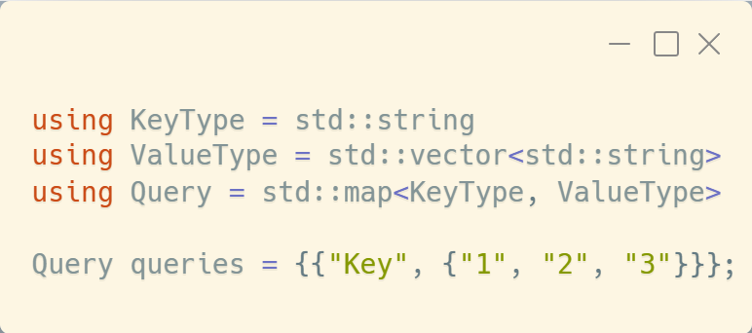
If the querystring Key=1&Key=2&Key=3 appears, it should be parsed into the same type as shown in the figure.

  - Fragment <optional>: Any string after the first `#` character.

Example:
- #top
- #:~:text=whatever

- Requirements
- Implement the method:
static std::shared_ptr<URL> from(std::string inputUrl).
- All members are allowed to be modified, and after any modification, location() must return the updated URL.
  - The test case will NOT modify the Querystring.
  - The test case will NOT modify any Pathname segments to be empty strings.
- Implement the method std::string location() to reconstruct the URL based
on object attributes.
  - Trailing `/` in Pathname must be trimmed
  - Trailing `&` in Query must be trimmed.
  - Query keys must be sorted alphabetically.
  - If either the username or the password is an empty string,
DO NOT display the [username ":" password "@"] segment.
  - If the port is 0, DO NOT display the the [ ":" Port ] segment.
  - When an optional section is missing, its delimiter should not be output either.
    - if Querystring is empty, `?` DO NOT display
    - if Fragment is an empty string, `#` DO NOT dispaly
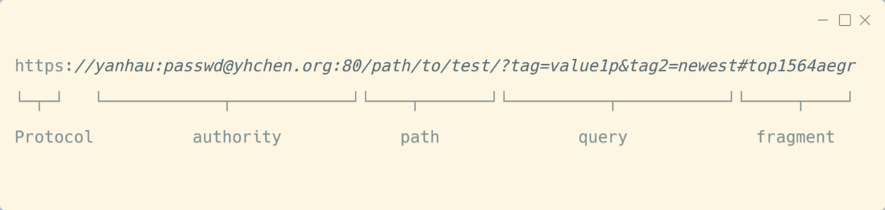
Input

- Complete the required class implementation. The following files already contain some implementations
  - URL.h
You can submit a header-only implementation, or split the implementation into *.cpp files.

- The Online Judge system will replace the following files:
  - entrypoint.cpp
  - case.h
  - test.h

- The test cases for student available in case.h, but not all test data is included in that file. The Online Judge system will also include hidden test inputs.

- Input range
  - The input will be a Single percent-encoded URL string, For example:
https%3A%2F%2Fen.wikipedia.org%2Fwiki%2FUniform_Resource_Identifier
which should be decoded to:
https://en.wikipedia.org/wiki/Uniform_Resource_Identifier
  - Consider the following URL:
https%253A%252F%252Fen.wikipedia.org%252Fwiki%252FUniform_Resource_Identifier%2525
which should be decoded to:
https%3A%2F%2Fen.wikipedia.org%2Fwiki%2FUniform_Resource_Identifier%25
Such a URL will NOT appear, as it requires decode twice.
  - All decoded URLs conform to the specified format, so you should not spend time verifying whether the URL matches the description.
  - The following cases will not occur:
    - Inputs with unpaired or incomplete query strings (e.g., ?key, ?key=) will not be included.
    - URLs with an entirely empty pathname (such as http://en.wikipedia.org/) are excluded.

Output

Online Judge will run the test:
- DON’ T output any information to the terminal.
- When any test failed, Online Judge will try to list error messages.

Note
Simplified URL Grammar based on RFC 2234 / RFC 5234 / RFC 3986

URL ::= protocol "://" authority pathname [ "?" query ] [ "#" fragment ]
# A URL consists of protocol, authority, path, optional query, and optional fragment.

protocol ::= [A-Za-z]+
# Protocol must consist of only alphabetic letters (e.g., "http", "https").

authority ::= [username ":" password "@"] hostname [ ":" port ]
# Authority may include optional username/password, followed by hostname and optional port.

username ::= [A-Za-z]+
# Username must start with a letter and contain only letters and hyphens.

password ::= [A-Za-z0-9]+
# Password appears only when username is present.

hostname ::= label ("." label)*, ends with a letter
# Hostname is made of one or more labels separated by dots, and ends with a letter.

label ::= [A-Za-z0-9.~-_]+
# A label is a non-empty sequence of letters or hyphens.

port ::= 0 ~ 65535
# Port is a positive integer.

pathname ::= "/" segment ( "/" segment )* [ "/" ]?
# Path consists of segments separated by "/", may end with an optional trailing slash.

segment ::= [A-Za-z0-9\-._~!$&'()*+,;=:@%]*
# Each segment may contain reserved, unreserved, and percent-encoded characters.
# Percent-encoded format: %XX, where X is a hexadecimal digit.

query ::= pair ( "&" pair )*
# Query is composed of key=value pairs separated by '&'.

pair ::= key "=" value
# Each key-value pair connects a query parameter to a value.

key ::= [A-Za-z0-9]+
# Keys use only letters and hyphens.

value ::= [A-Za-z0-9\-._~!$'()*+,;:@/%]*
# Values may include reserved, unreserved, and percent-encoded characters.

fragment ::= any characters after '#'
# Fragment is optional and accepts any content after '#' until the end of the URL.

pct-encoded ::= "%" HEXDIG HEXDIG
# A percent-encoded sequence begins with '%' followed by two hexadecimal digits.
# It represents a single byte using its ASCII hexadecimal form.
# Example: "%20" represents a space character(ASCII 0x20).

HEXDIG ::= [0-9A-Fa-f]
# A single hexadecimal digit (0–9, A–F, or a–f).

