  - AIORI HACKATHON 3

MOBI-HO Lab
Design, Implementation, Experimental Benchmarking, and Evaluation of a Cellular Handover Research Prototype
  - IEEE-Style Technical Product Documentation
Track 4 - 6G & Future Networks | Challenge PS-016 - Cellular Handover Benchmarking
TEAM CODE: A3-PS016-TC012
Joe Francis Sebastian | Debayan Ghose
Mentor: Dr. Shamanth N
Document version 1.0 | 31 October 2026
Project repository: https://github.com/aiori-hackathon/A3-PS016-TC012
Public recorded-data dashboard: https://mobi-ho-lab.vercel.app
Project video (previous milestone): https://youtu.be/p6eitYqHq6Y
Scope note: This document addresses only the official PS-016 Challenge on cellular handover benchmarking; unrelated home-broadband text is excluded.

Abstract
Cellular handover is a mobility-management operation that transfers user equipment (UE) connectivity between serving cells as radio conditions change. Evaluating candidate handover algorithms requires consistent experimental conditions, traceable measurements, and transparent comparison of network outcomes. MOBI-HO Lab is a working LTE-based research prototype that integrates ns-3.46.1 simulation, three handover decision approaches (A3-RSRP, rule-based and Random Forest), a Python/FastAPI experiment service, structured measurement processing, and a React interactive visualization dashboard. A 12-execution comparison was completed over two speeds (30 and 120 km/h), three controllers, and two RNG runs (11 and 12). At 120 km/h, the recorded mean received throughput was 3.1886 Mbps for A3-RSRP, 3.1715 Mbps for rule-based control, and 3.2350 Mbps for Random Forest. The prototype additionally provides a network-event replay, handover timeline, RF decision inspection, and browser-triggered local ns-3 jobs. Model-training metrics are reported transparently: 81.25% training accuracy on 16 observations, with no independent test validation. The proposed contribution is an inspectable and reproducible cellular handover benchmarking workflow, not a production-validated machine-learning controller.
Index Terms - LTE; handover; cellular mobility; ns-3; benchmarking; A3 RSRP; Random Forest; reproducibility; FastAPI; network digital twin.

Document map
This report follows the supplied AIORI structure: Problem Description, Background, Literature & RFC Review, Proposed Solution, Solution Optimization, Architecture Design, Data Flow, Deployment Timeline and Bibliography. Expanded product documentation includes functional specifications, interface behavior, algorithms, experiment protocol, numerical evaluation, model health, APIs, files, testing, safety and future work.

1. Problem Description

1.1 Cellular mobility challenge
A UE changes its radio environment while moving. The serving evolved Node B (eNB) may eventually provide less favorable signal conditions than a neighbor. A handover controller must balance timely transition, unnecessary transitions, signaling overhead, and service continuity. The most favorable behavior depends on speed, configuration and the modeled network environment.

1.2 Engineering problem addressed
- Handover-algorithm comparisons are difficult to interpret when scenario settings or measurement definitions differ.
- Raw simulator outputs contain detailed traces but are not immediately usable for cross-controller inspection.
- A learned controller needs not only a prediction output but evidence connecting recommendations to actual simulated events.
- Small-sample experiment reports are easily overstated if their statistical and ML limitations are not disclosed.
- Demonstrating an end-to-end executable workflow is more convincing and reproducible than static screenshots.

1.3 Objectives and scope
Primary objective: provide a controlled LTE handover benchmarking environment capable of executing multiple controller policies, collecting structured measurements, comparing observed outcomes, and investigating decisions. The current prototype is an LTE-only, simulated, single-UE/three-cell scenario and does not control physical base stations, reproduce a live cellular deployment, or provide a validated 5G/6G handover controller.

1.4 Stakeholders
Intended users include university research teams, cellular-networking students, mobility-algorithm developers, and pre-deployment evaluation engineers. The dashboard is an experiment-inspection interface; it is not a commercial network-management console.

2. Background and Technical Foundation

2.1 LTE system elements
The eNB provides radio access to the UE; the Evolved Packet Core (EPC) offers packet-network connectivity. A remote host acts as a traffic endpoint. Mobility changes the UE position and its relationship to serving and candidate cells. The experiment records a connection establishment and the start and successful completion of handovers when applicable.

2.2 Measurements and controls
Reference Signal Received Power (RSRP) supports measurement-based cell comparison. Event A3 denotes a neighboring cell becoming offset-better than the serving cell under the standardized measurement configuration. Hysteresis and time-to-trigger (TTT) can be used to reduce premature triggering. RSRP is a radio measurement, not directly a guarantee of application throughput or a proof of uninterrupted user service [2], [3].

2.3 Why RNG runs matter
RNG stands for Random Number Generator. Run identifiers 11 and 12 select different pseudo-random streams used by stochastic simulator processes, while holding the nominal scenario configuration constant. The run number is an identifier; it does not mean the number of executions or the quality of a run. Changing the RNG run may have no visible effect if a measurement is deterministic or independent of the modeled random processes.

3. Literature, Standards, and RFC Review
Reference | Relevant contribution | Application in MOBI-HO Lab
3GPP TS 36.331 [2] | LTE RRC measurement event definitions including Event A3 | Context for conventional neighbor-versus-serving measurements
ns-3 A3-RSRP reference [3] | ns-3 handover implementation, hysteresis, TTT | Source for interpreting the benchmark A3 controller
RFC 2330 [1] | Framework for clearly defined IP performance metrics and methods | Motivates transparent KPI definitions and repeatability
ns-3 project documentation [4] | Discrete-event networking simulation framework | Basis for LTE scenario development and event traces
Breiman, Random Forests [5] | Decision-tree ensemble methodology | Conceptual foundation for the exploratory ML controller
Standards applicability note: RFC 2330 is a measurement-methodology framework, not a cellular handover specification. The present implementation is not claimed to be a standards-conformance test suite. Citations supply technical context, while measured results derive from the project prototype.

4. Proposed Solution and Product Overview

4.1 System-level design
MOBI-HO Lab separates simulation, decision logic, experiment orchestration, telemetry/aggregation, and interactive presentation. The baseline comparison uses recorded and exported experiment summaries; the local application additionally issues new controlled jobs to FastAPI, which launches the ns-3 build and preserves outputs. The public Vercel deployment displays recorded data and does not run an internet-exposed ns-3 backend.

4.2 Technology stack
Layer | Technology | Role
Host/development | Windows 11 + WSL2 Ubuntu | Linux simulator runtime on a developer laptop
Simulator | ns-3.46.1, LTE/EPC, C++ | Radio/mobility/traffic and handover execution
Controllers | A3-RSRP, rule-based, RF prototype | Three experimental decision approaches
Model | Random Forest artifact and C++ integration | Candidate handover decision score
Backend | Python, FastAPI, Uvicorn | Read APIs, simulation jobs, status and results
Frontend | React, Vite, TypeScript, Recharts | Seven-workspace dashboard and graphs
Static hosting | Vercel | Recorded-data interface, no public job execution
Repository | GitHub organization repository | Code, experiment summaries and reproducibility

4.3 Distinguishing product capabilities
- Actual ns-3 simulation launches from the local React user interface through FastAPI.
- Comparison of three controllers under an explicitly listed experiment matrix.
- Network replay and timestamped handover-event inspection tied to recorded traces.
- RF decisions can be inspected alongside radio/mobility feature values.
- The model-evaluation view explicitly flags small, imbalanced training data and the absence of independent test accuracy.
- Recorded comparison data and new ad hoc job outputs are treated as distinct result sets.

5. Solution Optimization and Design Choices
Aspect | Without integration | MOBI-HO Lab enhancement
Experiment execution | Manual simulator command entry | Configured simulation jobs from dashboard (local installation)
Result interpretation | Manual parsing of separate log files | KPI plots, outcome donuts, event/timeline views
Controller comparison | Difficult to normalize settings | Explicit controller-speed-RNG experiment matrix
ML accountability | Single predicted label or score | Decision inspector plus health and evaluation warnings
Reproducibility | Unstructured one-off results | Structured output directories and machine-readable summaries
Demo accessibility | Only a terminal on a developer laptop | Public recorded-results dashboard plus local executable prototype
Analysis accuracy | Potential KPI conflation | Reception gaps and skipped sequences explicitly distinguished from proven packet loss
These improvements are workflow and observability enhancements. No production network throughput gain or statistically significant algorithm superiority is claimed on the basis of the current experiment count.

6. System Architecture and UML-Level Component View
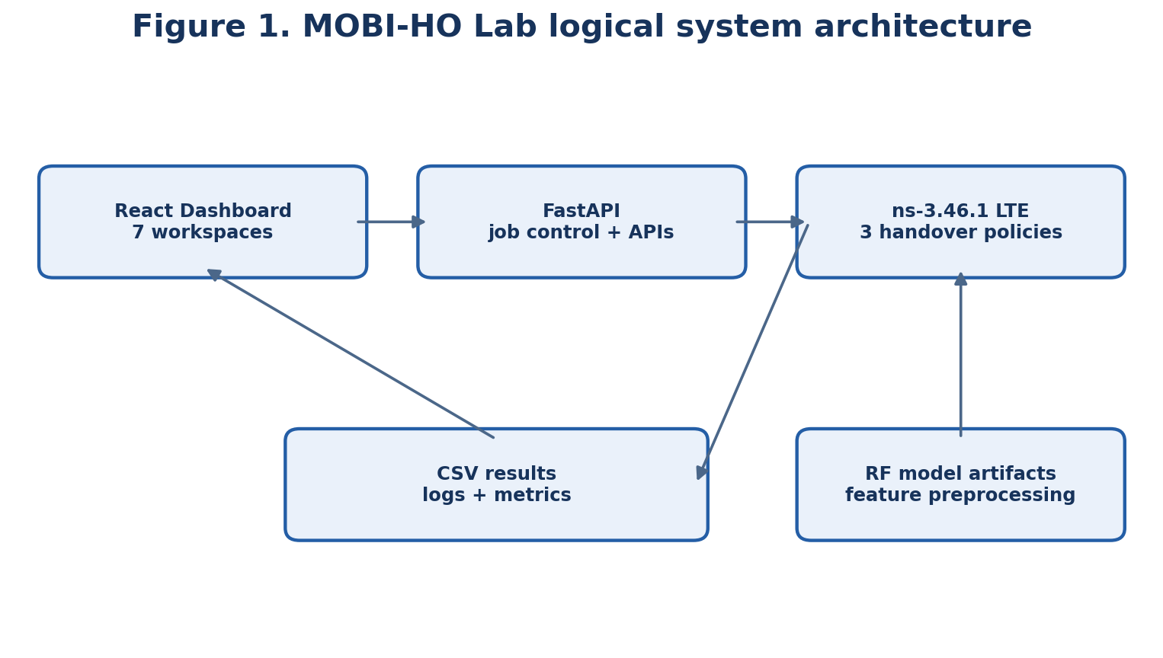
Fig. 1. Logical component architecture of the prototype.

6.1 Module responsibilities
The React layer renders data and captures selections. The FastAPI layer exposes benchmark and decision data and manages simulation jobs. The C++ ns-3 layer constructs a cellular experiment, applies one controller, and collects LTE and packet-level events. The data pipeline converts traces to CSV and JSON artifacts for comparison. Model artifacts provide the experimental RF parameters and preprocessing definition.

6.2 Deployment boundaries
Local: the browser reaches React on port 5173 and FastAPI on 127.0.0.1:8000; FastAPI invokes ns-3 inside WSL. Public: Vercel hosts only the static frontend, using exported JSON files. The absent public simulator service means that real Run Simulation is intentionally unavailable on Vercel. The original GitHub organization retains ownership of the source repository.

6.3 Security and concurrency considerations
The current local job runner must not be published directly. A public execution service would need API authentication, rate limiting, a strict scenario allowlist, process time and memory limits, queue isolation, output-directory and filesystem isolation, CORS configuration and TLS. In-process locking protects some local operations but is not a general cross-process or multi-instance concurrency guarantee.

7. Data Flow Diagram and Processing Workflow
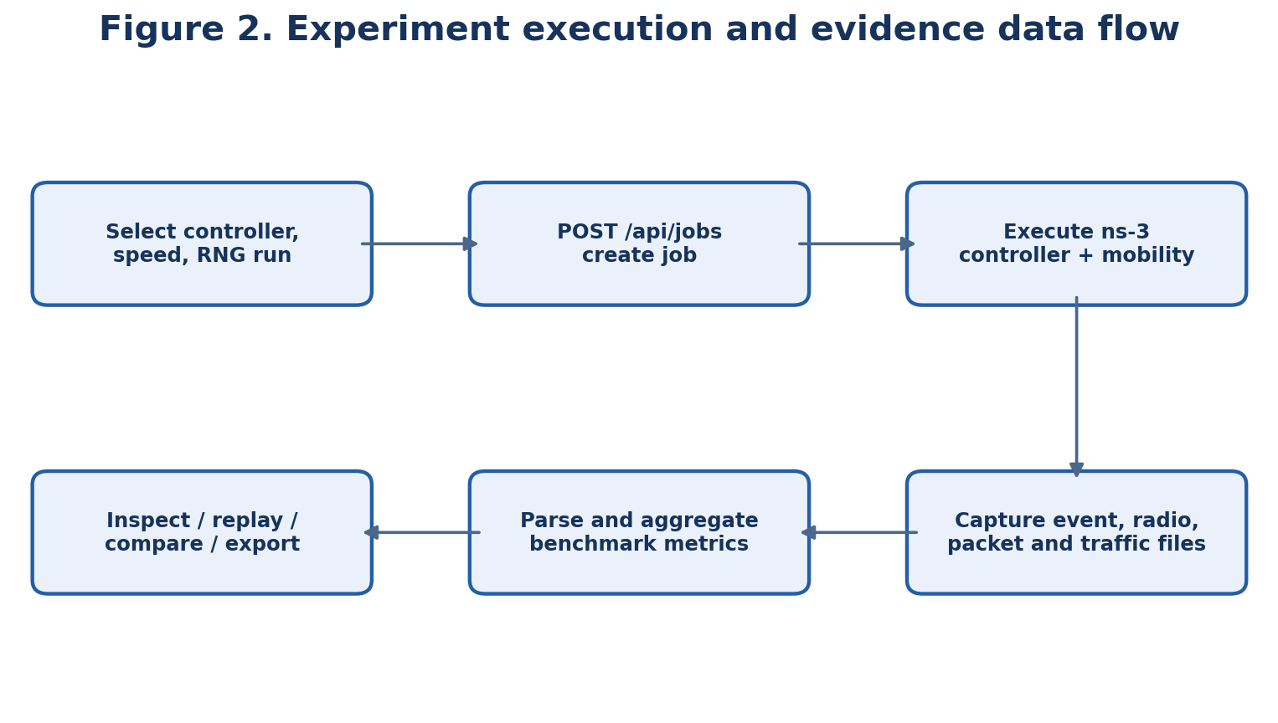
Fig. 2. End-to-end job execution and data transformation workflow.

7.1 Normal experiment path
The user selects a controller, speed and RNG run. The browser issues POST /api/jobs to the backend. The backend creates a job identifier and runs the configured ns-3 program. The simulator records relevant mobility, radio, packet and handover events. The backend stores artifacts and exposes job status/results. The frontend polls status and displays the new job evidence. Separately, the stable comparison view reads the recorded 12-run benchmark data exports.

7.2 Data lineage
A reported numerical result should be traceable from the chart to a metric summary, then to an individual benchmark configuration and its originating simulator trace. Ad hoc live jobs should not silently mutate the published comparison baseline; revised benchmark results require an explicit rerun of the full experiment protocol and re-export of summaries.

8. Dashboard Functional Specifications
The prototype has seven primary navigation workspaces. The RF Decision Inspector is an additional detailed view/component, and some pages combine several sub-panels. Exact layout and filters may evolve with code revisions; the following describes the implemented prototype discussed for the final demonstration.

8.1 Network Overview
Purpose: high-level situational awareness of selected recorded benchmark conditions. Inputs include UE speed (30/120 km/h) and available experiment/controller or RNG selectors, where displayed. KPI cards summarize throughput and handover-related values; changing selection updates the relevant display. UE stands for User Equipment. RNG is a pseudo-random stream run identifier, not a count of experiments.

8.2 Benchmark Comparison
Purpose: side-by-side evidence for A3-RSRP, rule-based and RF. Components include mean throughput plots, zoomed-throughput scale, reception-gap analyses, run-to-run comparisons, first-completed-handover timing, skipped sequence diagnostics, and success/failure outcome donuts. All charts must be interpreted using their units and sample sizes; visually magnified axis ranges must be labeled.

8.3 Network Digital Twin
Purpose: inspect a recorded cellular topology and mobility event sequence. Diagram includes remote host, EPC, eNB1/eNB2/eNB3 and the moving UE. Timeline playback, pause, seek and speed controls allow examination of transition points. Selecting objects opens contextual details. Up/downlink visual cues are illustrative traffic-direction animations, not a reconstruction of every individual packet.

8.4 Simulation Control
Purpose: initiate a new experiment through the local FastAPI/ns-3 backend. Inputs: handover controller, UE speed, RNG run. The backend creates a job ID; status progresses through accepted/queued/running/completed or failure states as implemented. Outputs include handover requests, success/failure totals, received traffic indicators, event logs and preserved artifact files. This requires a running local backend; the public static Vercel deployment cannot execute ns-3 jobs.

8.5 Handover Events
Purpose: time-order examination of connection establishment, handover initiation, handover completion and any logged failures. Event rows associate simulation timestamps with UE/cell identifiers and allow inspection of transition sequence. A missing logged failure is not proof of immunity to all failure modes.

8.6 Model Evaluation & Health
Purpose: evidence on the RF artifact, training metrics, class balance, confusion matrix, model export consistency, feature ranges and validation readiness. It distinguishes training resubstitution accuracy from held-out accuracy and reports the latter as unavailable. The health page identifies the ML component as an integration prototype, not deployment validated.

8.7 Model & Methodology
Purpose: document experiment assumptions, controller approach, measurement definitions, test matrix and observed limitations. This view helps judges and researchers distinguish simulator-derived evidence, modeled behavior, plotted aggregates and planned follow-on work.

8.8 RF Decision Inspector
The inspector shows recorded STAY versus HANDOVER recommendations, model score, relevant radio/mobility inputs, and their relationship to handover events. A configured threshold of 0.6 maps the experimental RF class score to the selected action. This score is not demonstrated to be a calibrated probability of correct handover or service success.

8.9 Export and artifact interpretation
The recorded benchmark dataset is exported to frontend-consumable JSON and retained in machine-readable CSV summaries. Live backend jobs preserve, as available, radio_measurements.csv, mobility.csv, handover_events.csv, traffic_rx.csv, packets.csv and simulation.log. These are backend-generated artifacts; this report does not assert that every file has a dedicated button for browser download.

9. Handover Algorithms and Decision Methods

9.1 Conventional A3-RSRP baseline
The LTE Event A3 concept compares a neighboring cell against the serving cell, with offsets/hysteresis and time-to-trigger conditions in standard configurations [2]. The ns-3 A3RsrpHandoverAlgorithm uses RSRP-based Event A3 reports [3]. It is the principal conventional reference for our measured comparison.

9.2 Rule-based controller
The rule-based policy makes decisions according to explicit handover conditions based on available radio and mobility observations. Its value is interpretability and a non-ML comparator. This report does not invent undocumented threshold values; reproducibility requires consulting the checked-in controller source and experiment configuration for exact decision constants.

9.3 Random Forest handover prototype
Random Forest is an ensemble of decision trees [5]. The experimental controller consumes a vector of serving and candidate signal measures, RSRP difference/trends, speed and timing-related features, then applies the exported model to produce a handover class score. At the configured score threshold of 0.6, it recommends either staying on the serving cell or requesting a handover. The integration path connects this decision to ns-3 execution and records decisions for later inspection.

9.4 Fairness and control of comparisons
For a defensible controller comparison, cell layout, UE mobility, traffic generation, measurement process, simulator release, RNG configuration and stopping conditions should remain as equivalent as possible. Any controller-dependent differences in sampling opportunity or decision timing must be documented. The present benchmark is preliminary and should not be treated as a field deployment comparison.

10. Experimental Design and Results

10.1 Test matrix
Factor | Configurations | Number
Handover controller | A3-RSRP; Rule-Based; Random Forest | 3
UE speed | 30 km/h; 120 km/h | 2
RNG run | 11; 12 | 2
Total | 3 x 2 x 2 | 12

10.2 Measured mean throughput
Controller | 30 km/h (Mbps) | 120 km/h (Mbps)
A3-RSRP | 3.2354 | 3.1886
Rule-Based | 3.2341 | 3.1715
Random Forest | 3.2375 | 3.2350
The observed RF-versus-A3 difference at 120 km/h is (3.2350 - 3.1886) / 3.1886 x 100 = approximately 1.46%. This is a descriptive difference computed from reported means, not a confidence-bounded or independently reproduced improvement.

10.3 Handover outcomes and temporal diagnostics
The 12 recorded experiments logged two successful handovers per execution, yielding 24 recorded successful handovers and zero logged handover failures in the baseline matrix; no ping-pong handovers were observed in these logged runs. The maximum excess reception-gap figures previously reported were approximately 100 ms for A3 and rule-based control versus 20 ms for RF under the tested configurations. Reception gaps are defined by inter-arrival timing and a configured threshold; they must not be directly represented as protocol-layer interruption duration without additional validation.

10.4 Interpretation of measured differences
At 30 km/h, average throughput values differ only slightly. At 120 km/h, the observed RF mean is higher than the other tested means and the reported reception-gap diagnostic is smaller. With two RNG runs per controller-speed condition and one topology, these observations are insufficient for a population-level superiority claim, confidence interval, or statistically significant statement. No field traces or independent traffic workloads establish how results transfer to real-world networks.

11. Machine-Learning Evaluation and Confusion Matrix

11.1 Training report
Metric | Recorded training result | How to interpret
Accuracy | 81.25% (13/16) | Proportion of training examples correctly labeled
Balanced accuracy | 90.00% | Mean class recall on training examples
HANDOVER precision | 100.00% | No false predicted HANDOVER among training rows
HANDOVER recall | 80.00% | 12 of 15 actual HANDOVER examples detected
HANDOVER F1 | 88.89% | Harmonic mean of training precision and recall
Brier score | 0.0676 | Training score quality; not held-out calibration proof
Independent test accuracy | Not available | No validated generalization estimate

11.2 Confusion matrix: actual versus predicted
Actual \ Predicted | STAY (negative) | HANDOVER (positive)
STAY | 1 (TN) | 0 (FP)
HANDOVER | 3 (FN) | 12 (TP)
TN = true negative, FP = false positive, FN = false negative, TP = true positive, taking HANDOVER as the positive class. Accuracy = (TN+TP)/(TN+FP+FN+TP) = (1+12)/16 = 81.25%. Precision = TP/(TP+FP) = 12/12 = 100%. Recall = TP/(TP+FN) = 12/15 = 80%. F1 = 2PR/(P+R) = approximately 88.89%. Balanced accuracy = [recall(STAY)+recall(HANDOVER)]/2 = (1+0.8)/2 = 90%.

11.3 Dataset limitations and model-readiness status
The training data contains 16 rows but only four unique feature vectors and a markedly imbalanced distribution (one STAY, fifteen HANDOVER). This makes the fitted model unsuitable for strong generalization claims. The saved report identifies the model as integration_prototype_unvalidated. JSON/sklearn reference prediction parity was reported as passing; independent C++ standalone parity was not shown as completed in the saved evaluation record. The model must not be called 81.25% accurate on real networks or on independent test data.

11.4 Validation plan
- Collect or generate larger balanced/representative datasets across distinct UE speeds, topologies, RF conditions and traffic loads.
- Split training, validation and test by scenario/group to prevent near-duplicate leakage.
- Run repeated-controller comparisons with sufficient seeds and report means, spread and uncertainty intervals.
- Check calibration and decision-score interpretation separately from classification accuracy.
- Verify C++ RF decision parity against frozen golden examples, including tolerance bounds and edge cases.
- Evaluate safety-related and mobility KPIs under deliberately difficult scenarios before any deployment claims.

12. Backend API and Reproducibility Guide

12.1 Documented API surface
Endpoint | Method | Function
/api/health | GET | Health/readiness reporting
/api/benchmark | GET | Recorded benchmark aggregate data
/api/rf-decisions | GET | Recorded RF decision records
/api/scenarios | GET | Supported scenario options
/api/jobs | POST | Create a configured local simulation job
/api/jobs/{job_id} | GET | Read job state and resulting evidence

12.2 Local startup (Windows 11, WSL2 Ubuntu)
Run two independent Ubuntu terminals. Terminal A starts the backend from the repository root:
cd ~/MOBI-HO-Lab/A3-PS016-TC012
source backend/.venv/bin/activate
python -m uvicorn backend.main:app --host 127.0.0.1 --port 8000
Terminal B starts the frontend from its folder:
cd ~/MOBI-HO-Lab/A3-PS016-TC012/frontend
npm run dev -- --host 0.0.0.0
The local frontend reads VITE_API_BASE_URL=http://127.0.0.1:8000 from its development environment file. Browser endpoints: http://localhost:5173 and http://127.0.0.1:8000/docs. The ns-3 runtime resides at ~/MOBI-HO-Lab/ns-3.46.1. No separate ns-3 daemon is required for API-triggered jobs.

12.3 Build and artifact locations
Path | Role
frontend/src/App.tsx | Dashboard workspace composition and navigation
frontend/src/components/ | Specialized charts, digital twin, RF inspector and job controls
backend/main.py | API application
backend/simulation_jobs.py | Local simulation-job orchestration
ns-3.46.1/scratch/mobi-ho-rf-live.cc | RF-integrated ns-3 scenario
ns-3.46.1/scratch/rf_prototype.hpp | C++ RF prototype logic
results/final_benchmark_v1/ | Recorded benchmark CSV summaries
models/rf-prototype-v1/ | Saved model, preprocessing and evaluation artifacts
frontend/public/ | Exported data powering static dashboard
Some ns-3 paths lie outside the Git repository in the developer workspace; packaging must account for that if reproducing on a separate machine. Do not assume a frontend-only Vercel deployment contains the simulator binaries or model-training runtime.

13. Verification, Quality Assurance, and Acceptance Criteria
Test area | Method | Expected evidence
Build | Vite production build | React bundle succeeds without errors
Local API | Open /api/health and /docs | Backend is reachable on loopback
A3 control | Run approved speed and RNG | ns-3 job completes and emits handover records
Rule control | Run approved speed and RNG | Output available under job results
RF control | Run approved speed and RNG | Recorded decisions and event logs accessible
Benchmark dataset | Load all 12 recorded configurations | Comparisons and charts populate
Digital Twin | Play, pause, seek, inspect object | Event replay responds and event points are traceable
ML evaluation | Open model report | Training/test distinction and confusion matrix visible
Public site | Open Vercel address in browser | Static analysis works; live job action not represented as public capability
Observed working status: local baseline, custom ns-3 builds, the three controller test paths, the React production build, API-linked simulation control, and static Vercel deployment were reported as functional in the team development history. This document does not substitute for a signed, machine-executed QA report; final submission should include screenshots and fresh job logs.

14. Applications, Impact, and Product Positioning
- Academic and telecommunications research: inspect and compare candidate handover control policies using repeatable simulated conditions.
- High-mobility studies: vary UE speed to study algorithm behavior under different movement rates, including scenarios relevant to vehicular mobility.
- ML-controller integration research: test how a trained decision policy interfaces with a cellular network simulation and audit the decisions.
- Network engineering education: demonstrate serving cells, EPC, radio conditions, handovers, metrics and experimental reproducibility.
- Pre-deployment screening: identify candidates and failure cases worth further laboratory, emulator, field-trial and independent evaluation.
Current limitation: results cannot be used to promise operating performance for a commercial mobile network. The tool is a simulation and research platform, not an operational carrier optimization system.

15. Deployment Timeline and Project Milestones
Date / period | Milestone | Observed outcome
10-12 Oct 2026 | Level 1 proposal and introduction video | Submitted; advanced to Level 2
20 Oct 2026 | Level 2 qualification communication | Team qualification recorded
24 Oct 2026 | WSL/ns-3 baseline integration | LTE handover example and custom scratch baseline executed
Late Oct 2026 | Controller integration and analytics | A3, rule-based, RF, 12-run comparison and exports prepared
29-30 Oct 2026 | Full-stack UI and public frontend | React/FastAPI workflow locally tested; Vercel frontend deployment ready
31 Oct 2026 | Level 2 documentation and video | Final submission target; acceptance not yet established

15.1 Proposed next engineering milestones
Phase 1: expand scenario breadth and statistical repetitions. Phase 2: retrain and validate the RF decision model with independent group-separated data. Phase 3: harden job execution and infrastructure for optional public API deployment. Phase 4: compare against 5G NR research scenarios after verified simulator support and integration. Proposed milestones are not completed features.

16. Known Limitations, Risks, and Ethical Engineering
- Experiments are LTE simulation results rather than measurements from a field-deployed network.
- The scenario currently emphasizes one moving UE and three base stations; generalization to dense multi-UE networks is unknown.
- Only two RNG runs per condition were recorded; statistical claims are not supported.
- RF training data is very small, repetitive and heavily class-imbalanced.
- 81.25% is a training resubstitution metric, not independently validated accuracy.
- Successful logged handovers do not guarantee absence of packet interruption, radio-link failure or other unmeasured problems.
- An inter-packet arrival gap and a skipped sequence ID do not by themselves prove standardized interruption duration or packet loss.
- The publicly hosted Vercel UI has no live simulator backend and must not imply that a remote ns-3 run is occurring.
- Local simulation-job orchestration requires additional security and isolation before internet exposure.

16.1 Risk mitigation
Disclose scope and sample limitations; preserve raw traces and run settings; expose model readiness warnings; validate algorithms and metric definitions; keep server control APIs local until securely hardened; and add disciplined scenario and data splits before making performance claims.

17. Conclusion
MOBI-HO Lab demonstrates a functioning end-to-end research workflow for cellular handover benchmarking: configure an LTE experiment; execute conventional or exploratory RF controller logic in ns-3; preserve radio, mobility, packet and handover evidence; compare recorded performance; inspect event sequences; and communicate both model outputs and validation caveats. The measured RF-versus-A3 throughput difference at 120 km/h is promising as an exploratory result, but the limited repetitions and small training sample prevent strong performance or generalization claims. The engineering contribution is the transparent integration of simulation, algorithm execution, trace collection, reproducible comparison, network replay, and model-health reporting into a coherent prototype. This establishes a practical foundation for broader mobility research, stronger experiments and future 5G NR extensions.

References
[1] V. Paxson, G. Almes, J. Mahdavi, and M. Mathis, “Framework for IP Performance Metrics,” RFC 2330, May 1998. https://www.rfc-editor.org/rfc/rfc2330
[2] 3GPP, “E-UTRA Radio Resource Control (RRC); Protocol specification,” TS 36.331, Section 5.5.4.4, Event A3. https://www.3gpp.org/
[3] ns-3 Project, “ns3::A3RsrpHandoverAlgorithm Class Reference,” ns-3 documentation. https://www.nsnam.org/docs/release/3.29/doxygen/classns3_1_1_a3_rsrp_handover_algorithm.html
[4] ns-3 Project, “ns-3 Network Simulator Documentation.” https://www.nsnam.org/documentation/
[5] L. Breiman, “Random Forests,” Machine Learning, vol. 45, pp. 5–32, 2001. doi:10.1023/A:1010933404324
[6] Team A3-PS016-TC012, “MOBI-HO Lab: Source Repository and Experimental Artifacts,” AIORI-3, 2026. https://github.com/aiori-hackathon/A3-PS016-TC012

Appendix A. Presenter Demonstration Runbook
- Start WSL2 Ubuntu; launch FastAPI and React in separate terminals.
- Open local /api/health and dashboard; verify both are reachable before recording.
- In Simulation Control, choose RF, 120 km/h and RNG Run 11; start a simulation and wait for the result state to report completion.
- Show the new job timeline and distinguish it from the fixed 12-run comparison set.
- Open Benchmark Comparison and explain 120 km/h throughput values plus sample limitations.
- Replay the Digital Twin timeline and inspect a handover event.
- Open Model Evaluation to explain matrix [[1,0],[3,12]] and why 81.25% is training-only.
- Show the Vercel public dashboard only as a recorded-results viewer.

Appendix B. Glossary
Term | Definition
UE | User Equipment; the simulated moving device
eNB | Evolved Node B; LTE base station
EPC | Evolved Packet Core
RSRP | Reference Signal Received Power
A3 | Neighbor becomes offset-better than serving cell event
RNG run | Pseudo-random sequence run identifier
TTT | Time-to-trigger for measurement event
KPI | Key performance indicator
RF | Random Forest (within the ML-controller discussion)
CSV | Comma-Separated Values
DFD | Data Flow Diagram
API | Application Programming Interface

