DNS
XDP RATE LIMITER
eBPF / XDP-Based Rate Limiting for DNS Query Floods

MENTORED BY:
DR.SHAMANTH M
TEAM MEMBERS:
RICHA FELIX-2460431
PRARTHANA PUTHANPURAYIL- 2462526

Abstract
Domain Name System (DNS) services are essential to network communication, but high-volume DNS query traffic can consume server and network resources and may reduce the availability of legitimate requests. This project investigates an early packet-processing approach using eBPF (extended Berkeley Packet Filter) and XDP (eXpress Data Path) to apply rate-limiting decisions to DNS traffic in a controlled laboratory environment.
The system checks packet headers, identifies DNS traffic over UDP, and applies configurable limits to individual sources and to the overall traffic flow. We compare three setups—no additional filter, nftables, and XDP—and observe throughput, CPU usage, packet counts, successful legitimate queries, and response time.
The project separates Windows simulation from live XDP testing on Linux. Results from the Windows version show how the rate-limiting logic behaves in the application; they are not proof of kernel-level XDP performance. We describe results as live XDP measurements only when the program has actually been loaded and tested on a suitable Linux system.
Keywords: DNS, eBPF, XDP, rate limiting, nftables, packet processing, network security, benchmarking.

Report completion note
Before submitting, fill in the team details, add your own application screenshots, and enter the results from your tests. Keep only the features you have actually built and checked.

Table of Contents
- 1. Introduction
- 2. Problem Statement and Motivation
- 3. Objectives and Scope
- 4. Background and Related Technologies
- 5. Proposed System
- 6. System Architecture and Workflow
- 7. Technology Stack
- 8. Implementation
- 9. Experimental Methodology
- 10. Results and Analysis
- 11. Screenshots and User Interface
- 12. Limitations and Challenges
- 13. Conclusion and Future Enhancements
- 14. References
- Appendix A. Reproduction Checklist

1. Introduction
DNS translates human-readable domain names into network addresses and is a foundational service for modern networks. Because DNS commonly uses UDP, a server may receive many small query packets that still require packet processing and application-level work. A high rate of requests can increase CPU utilization, consume network capacity, and affect the response time experienced by legitimate clients.
Traditional filtering mechanisms, including firewall rules, can enforce traffic policies. However, packet-processing location and per-packet overhead may differ between approaches. Linux XDP provides a programmable hook early in the receive path, allowing selected packets to be inspected and acted upon before they proceed through much of the normal networking stack.
This project explores whether an XDP-based rate limiter can provide a useful early filtering mechanism for DNS query traffic in a controlled lab. It also establishes a repeatable comparison against a no-filter baseline and an nftables baseline.

2. Problem Statement and Motivation
The project addresses the problem of high-volume UDP DNS query traffic that can place unnecessary load on a DNS service and its host. The goal is to design and evaluate a bounded rate-limiting mechanism that identifies DNS query packets and restricts traffic that exceeds configured thresholds while monitoring the treatment of legitimate DNS probes.

2.1 Motivation
- Reduce excess DNS query traffic before it consumes additional host networking and application resources.
- Explore per-source and global rate-limiting policies.
- Measure the effect of filtering on legitimate DNS query success and latency.
- Compare XDP with nftables and a no-filter baseline under equivalent controlled workloads.

2.2 Project boundaries
The project is a laboratory prototype and benchmark, not a production DDoS mitigation service. Tests must use isolated systems and explicitly authorized interfaces. The prototype does not claim to prevent all DNS attacks, spoofing, amplification, reflection, or attacks originating beyond the tested network path.

3. Objectives and Scope

3.1 Objectives
- Develop an eBPF/XDP program that safely parses Ethernet, IPv4, UDP, and the DNS header boundary.
- Implement configurable per-source IPv4 and global rate limits using bounded BPF maps.
- Maintain counters for observed, allowed, restricted, and malformed packets.
- Create a controlled traffic generator and local DNS test service.
- Evaluate normal traffic, a bounded single-source burst, and bounded multiple-source load.
- Compare no-filter, nftables, and XDP configurations using consistent workload definitions.
- Measure throughput, host CPU utilization, packet outcomes, legitimate probe success, and latency.
- Present benchmark results through a dashboard and exportable records.

3.2 Scope
The evaluation is limited to DNS-like traffic and legitimate probes within a controlled lab. The system may provide a Windows simulation mode for development and demonstration, while genuine XDP execution requires a compatible Linux kernel, suitable privileges, and a supported network interface/driver.

4. Background and Related Technologies

4.1 DNS over UDP
DNS commonly uses UDP port 53 for query and response messages. A basic packet classifier can inspect the IP protocol, UDP destination port, and minimum DNS header length. This header-level classification is not equivalent to fully validating DNS message semantics.

4.2 eBPF
eBPF allows verified programs to execute in the Linux kernel for networking, observability, and other tasks. Maps provide kernel-managed storage for configuration, counters, and state shared between kernel and user space.

4.3 XDP
XDP is an early ingress processing hook in the Linux networking stack. An XDP program can pass, drop, or redirect packets according to its policy. The exact performance depends on hardware, driver, attachment mode, kernel version, and workload. Native/driver mode and generic/SKB mode should be reported separately.

4.4 Rate limiting
A token bucket is a common rate-limiting model. Tokens accumulate at a configured rate up to a burst capacity. A packet is admitted when sufficient tokens are available; otherwise it is restricted. Per-source buckets can limit individual senders, while a global bucket constrains aggregate traffic.

4.5 nftables baseline
nftables is the Linux packet-filtering framework used as a comparison baseline. Its rules and counters must be scoped to the experiment and must not remove unrelated host firewall protections.

5. Proposed System
The proposed platform combines a packet-filtering component, a userspace controller, a controlled DNS workload generator, a metrics collector, persistent benchmark storage, and a dashboard.

5.1 Execution modes
Mode | Purpose | Measurement interpretation
Windows simulation | Develop and demonstrate the rate-limiting policy without kernel XDP. | Software simulation counters and host metrics; not XDP kernel performance.
Linux live XDP | Compile, attach, configure, and measure the eBPF/XDP program on an authorized lab interface. | Kernel/BPF counters and host metrics, only after verified live execution.

5.2 Filtering configurations
Configuration | Description
No Filter | Experiment-specific filtering is not applied; unrelated host protections remain enabled.
nftables | A documented nftables rule set applies the baseline rate-limiting policy.
XDP | The eBPF/XDP program applies the configured packet-level rate-limiting policy.

6. System Architecture and Workflow

6.1 Main modules
Module | Responsibility
XDP/eBPF filter | Safely classifies relevant packets, applies rate limits, and updates BPF counters.
Userspace controller | Configures maps, attaches/detaches XDP, and reads counters.
nftables baseline | Applies and removes experiment-specific firewall rate-limit rules.
Traffic generator | Creates bounded synthetic DNS workloads in the lab.
Local DNS test server | Responds to test queries and supports legitimate probe measurements.
Metrics collector | Collects throughput, CPU, packet outcomes, probe success, and latency.
Backend and storage | Validates configuration, manages runs, and stores benchmark records.
Dashboard | Displays status, metrics, charts, history, and exports.

6.2 Workflow
- The operator selects the execution mode, filtering architecture, scenario, and bounded test parameters.
- The application validates the configuration and confirms the authorized lab target.
- The selected filtering mode is prepared and its active state is verified.
- The local DNS test service and legitimate probe client are checked.
- The workload generator runs the selected bounded scenario.
- The metrics collector records counters, CPU utilization, throughput, probe outcomes, and latency.
- The run is saved with its environment and configuration metadata.
- The dashboard presents results and allows export for analysis.

7. Technology Stack
Technology | Role in the project
C | Implementation language for the eBPF/XDP program.
eBPF / XDP | Kernel-level packet inspection and early filtering on supported Linux systems.
libbpf / bpftool / clang | Build, load, inspect, and manage eBPF programs, as applicable to the implementation.
nftables | Linux firewall baseline.
Python | Traffic generation, metrics collection, experiment orchestration, and backend services.
FastAPI | Backend API, configuration validation, benchmark status, and results.
React / TypeScript | Interactive dashboard frontend.
Recharts | Benchmark visualization.
SQLite / JSON / CSV | Persistent experiment records and data export; specify the actual storage used.
psutil | Host CPU and system metrics where supported.

8. Implementation

8.1 Packet parsing
The XDP program should validate packet boundaries before accessing each protocol header. The parsing sequence is Ethernet, IPv4, UDP, and the minimum DNS header. The implementation must define how it handles non-IPv4 traffic, non-UDP traffic, fragmented packets, malformed/truncated packets, non-DNS UDP traffic, and map-capacity errors.

8.2 Rate-limiting algorithm
The intended policy uses a token-bucket model with a per-source bucket and an aggregate global bucket. The implementation should use bounded map capacity and safe synchronization or atomic update techniques appropriate to the chosen map and kernel environment. Configuration values, burst capacity, time units, and behavior when state allocation fails must be documented.
Pseudocode (adapt this to match the implemented code):
ON_PACKET(packet):
validate Ethernet header
validate IPv4 header and supported fragmentation policy
validate UDP header
if packet is not a DNS query candidate:
apply documented non-DNS policy
identify source IPv4 address
obtain/update per-source token bucket
if per-source bucket has no token:
increment per-source-limit counter
DROP
obtain/update global token bucket
if global bucket has no token:
increment global-limit counter
DROP
consume required tokens
increment allowed counter
PASS

8.3 Dashboard and backend
The dashboard should expose the current execution mode and measurement source for each metric. Simulation data must be labelled as simulation. Live XDP data must be labelled live only after successful program attachment and counter retrieval. Unavailable metrics should include a reason rather than being replaced with guessed values.

8.4 Safety controls
- Restrict generated traffic to explicitly configured, isolated, authorized lab endpoints.
- Use conservative request-rate and duration limits, with a reliable stop mechanism.
- Do not expose arbitrary shell execution through the backend.
- Do not flush unrelated firewall rules or attach to arbitrary interfaces.
- Ensure cleanup scripts remove only project-created rules and attachments.

9. Experimental Methodology
The experiment compares three filtering configurations under three workload scenarios. The same workload definition, legitimate probe count, test duration, and client configuration should be used across filtering modes wherever technically possible. Record any unavoidable differences.
Scenario | Description | Evaluation focus
Normal DNS traffic | A modest, bounded stream of DNS queries with legitimate probes. | Baseline throughput, CPU, latency, and legitimate query success.
Single-source burst | A bounded burst from one synthetic source. | Per-source rate limiting and legitimate probe behavior.
Multiple-source load | Bounded traffic from multiple isolated synthetic clients. | Per-source and global limit behavior.

9.1 Measurement definitions
Metric | Definition / collection method
Throughput (PPS) | Measured packet count divided by elapsed measurement time; state whether generated, received, processed, or allowed packets are counted.
CPU utilization | Host CPU utilization over the measurement window; do not call it XDP-specific CPU unless directly measured.
Filter drops | Counter from the selected filter: simulation engine, nftables rule counter, or XDP/BPF map.
Legitimate query success | Successful valid responses divided by total legitimate probes, multiplied by 100.
Latency | Round-trip time for valid legitimate probes; report average, P50, and P95 when sample count supports it.
Duration | Actual elapsed time from workload start to completion/stop.

9.2 Experimental record
For each run, record date/time, OS and kernel version, CPU model, interface, XDP attachment mode, tool versions, filtering configuration, rate limits, workload settings, number of repetitions, and any errors or packet loss outside the filter.

10. Results and Analysis
Complete this section only after running the experiments. Do not insert estimated or illustrative values as measured results. If a mode cannot be executed, mark it NOT TESTED and explain why.
Scenario | Mode | Achieved PPS | CPU % | Filter drops | Legitimate success % | P50/P95 latency
Normal | No Filter | [Measured] | [Measured] | [Measured / N/A] | [Measured] | [Measured]
Normal | nftables | [Measured] | [Measured] | [Measured] | [Measured] | [Measured]
Normal | XDP | [Measured / NOT TESTED] | [Measured] | [Measured] | [Measured] | [Measured]
Single-source burst | No Filter | [Measured] | [Measured] | [Measured / N/A] | [Measured] | [Measured]
Single-source burst | nftables | [Measured] | [Measured] | [Measured] | [Measured] | [Measured]
Single-source burst | XDP | [Measured / NOT TESTED] | [Measured] | [Measured] | [Measured] | [Measured]
Multiple-source load | No Filter | [Measured] | [Measured] | [Measured / N/A] | [Measured] | [Measured]
Multiple-source load | nftables | [Measured] | [Measured] | [Measured] | [Measured] | [Measured]
Multiple-source load | XDP | [Measured / NOT TESTED] | [Measured] | [Measured] | [Measured] | [Measured]

10.1 Analysis questions
- How did throughput change across the three filtering configurations?
- What CPU utilization was observed, and how was it measured?
- Did the rate limiter restrict traffic at the configured thresholds?
- How did legitimate DNS probe success change under each workload?
- How did P50 and P95 latency change?
- Were there differences between native XDP and generic/SKB mode?
- What limitations or sources of measurement error affected the results?

11. Screenshots and User Interface
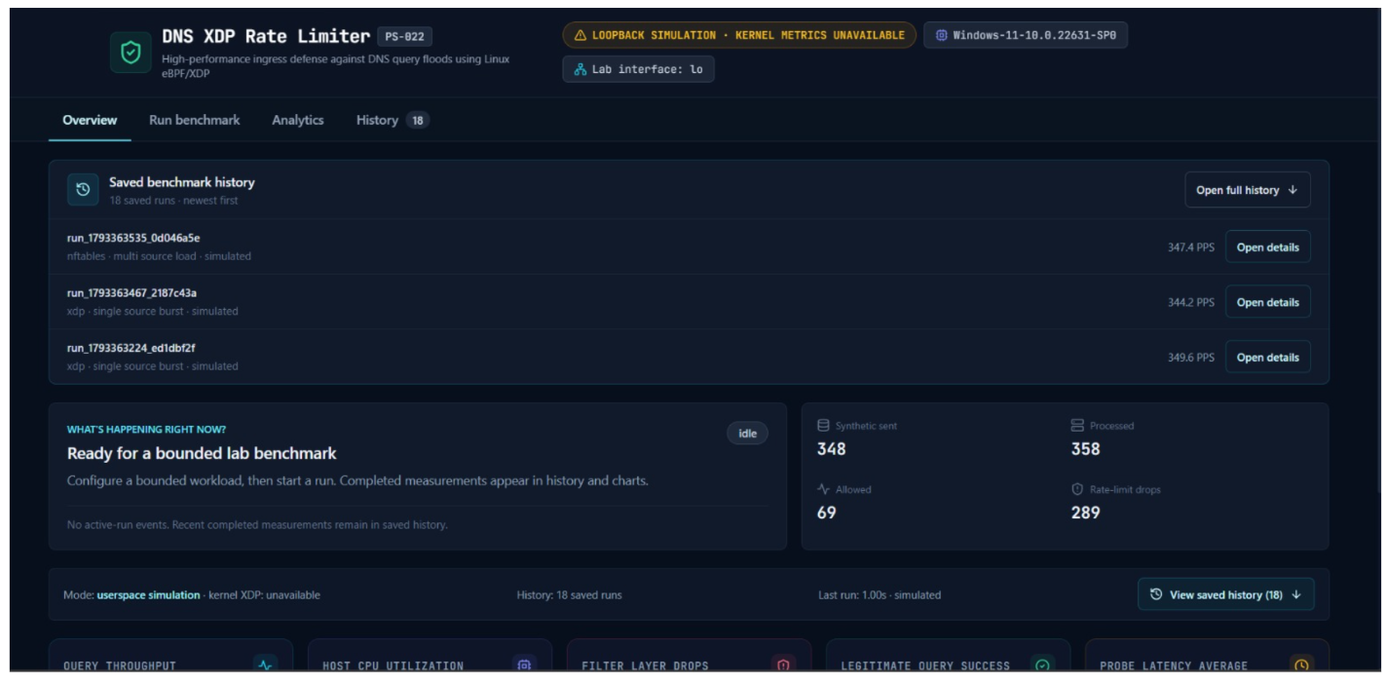
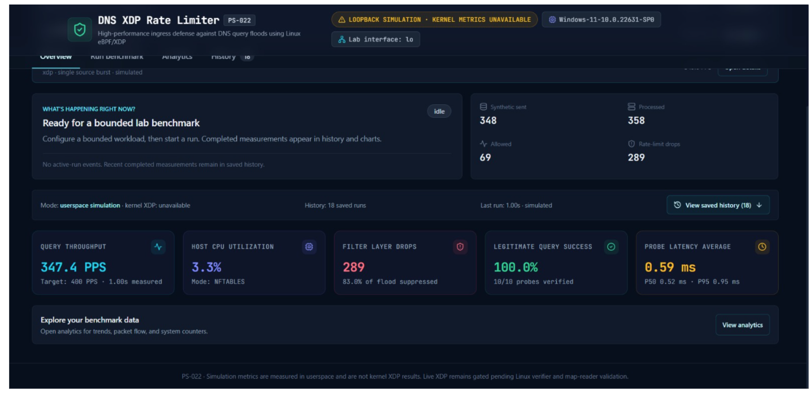
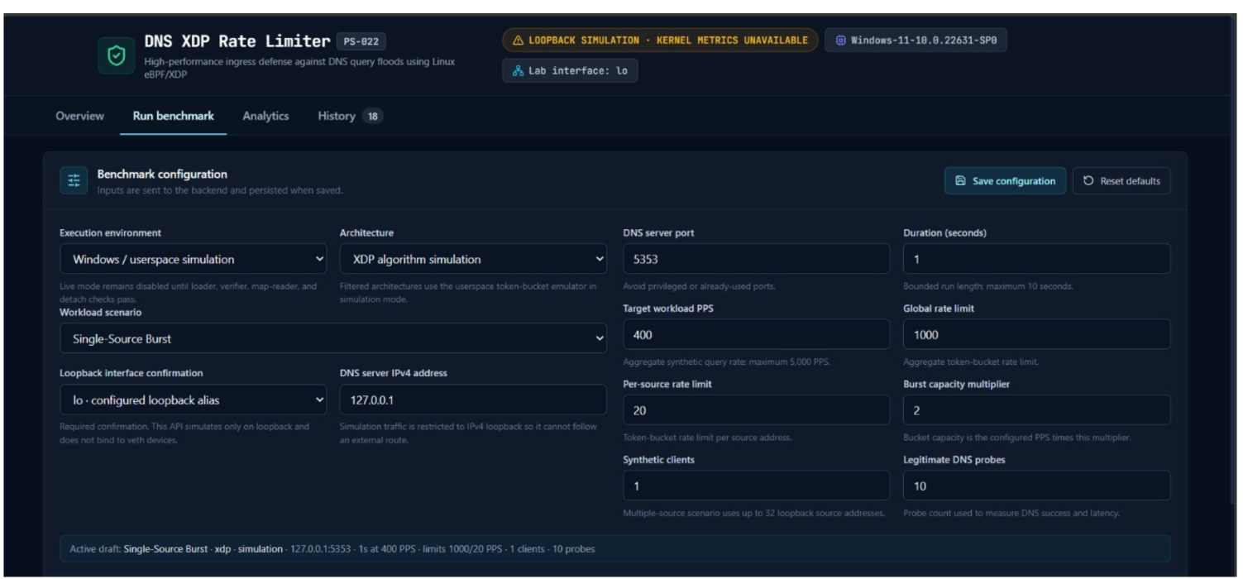
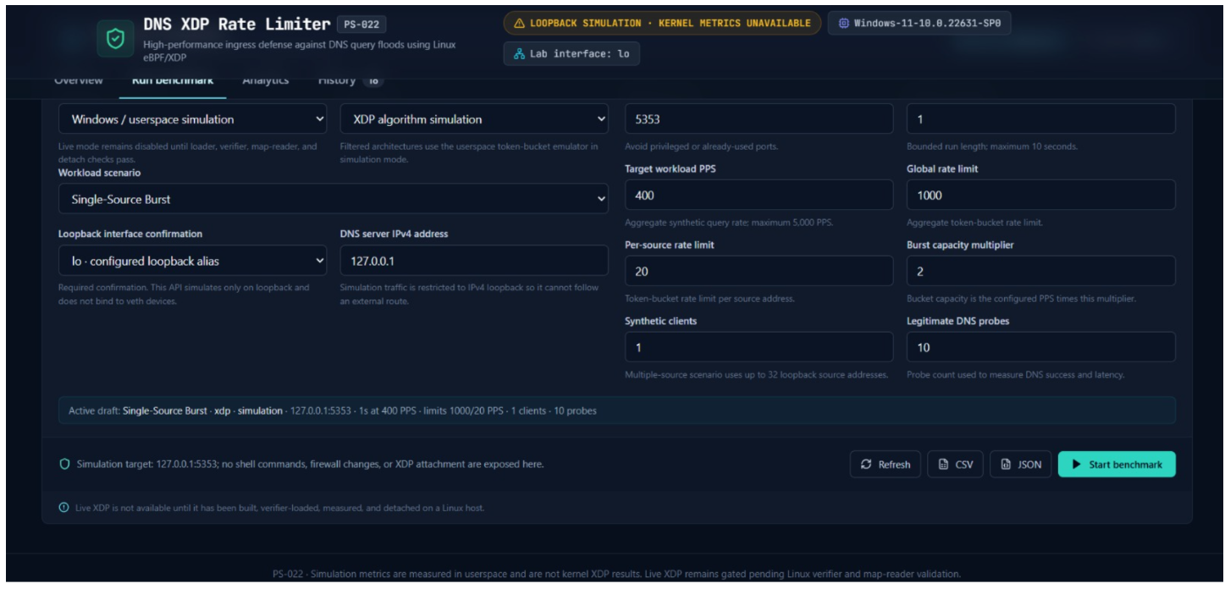
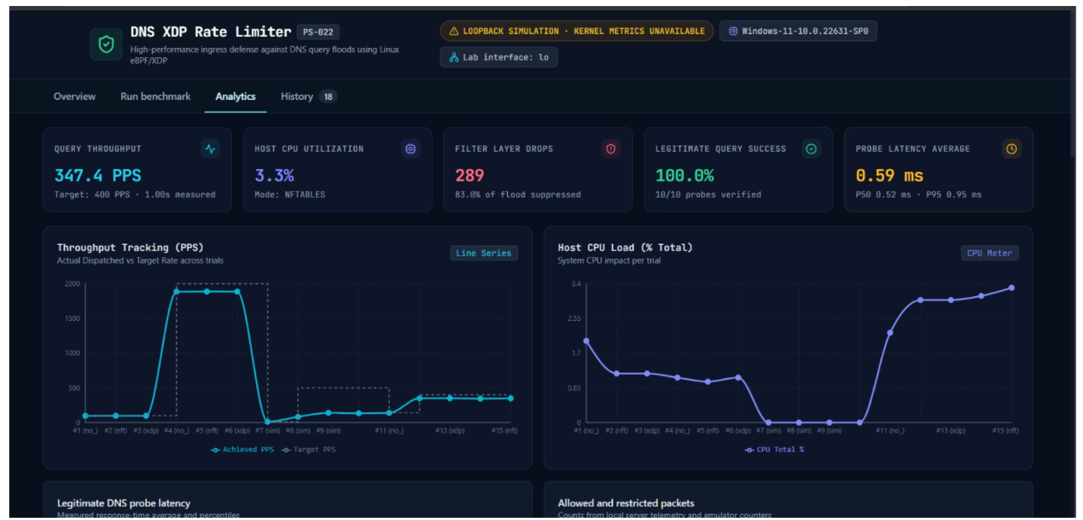
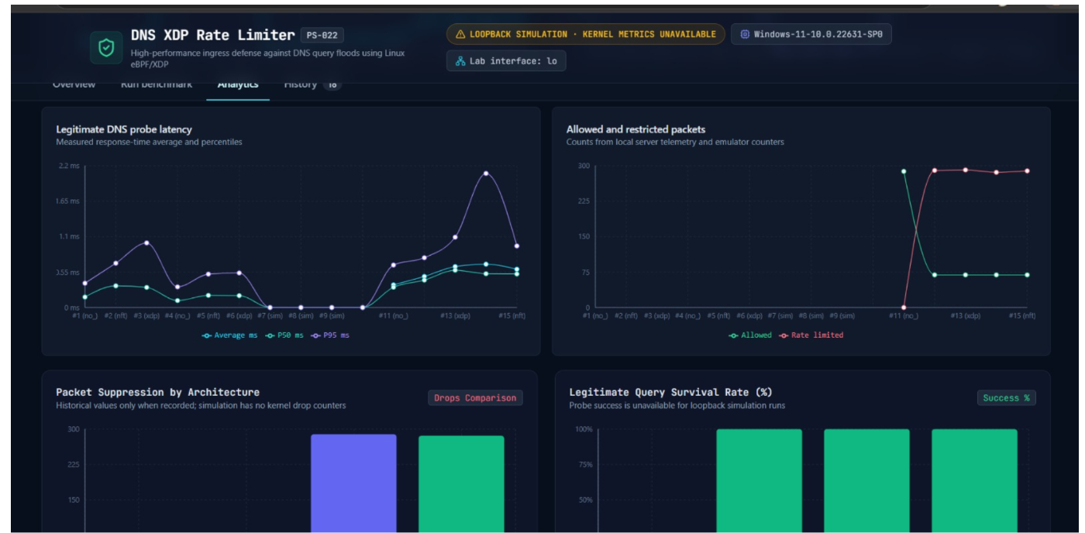
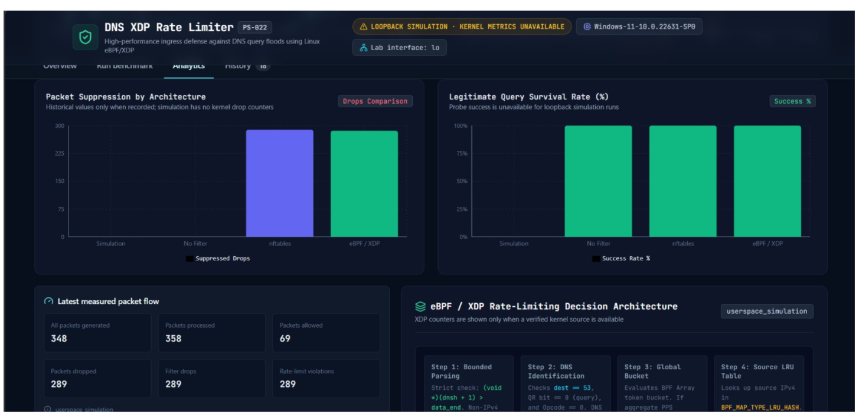
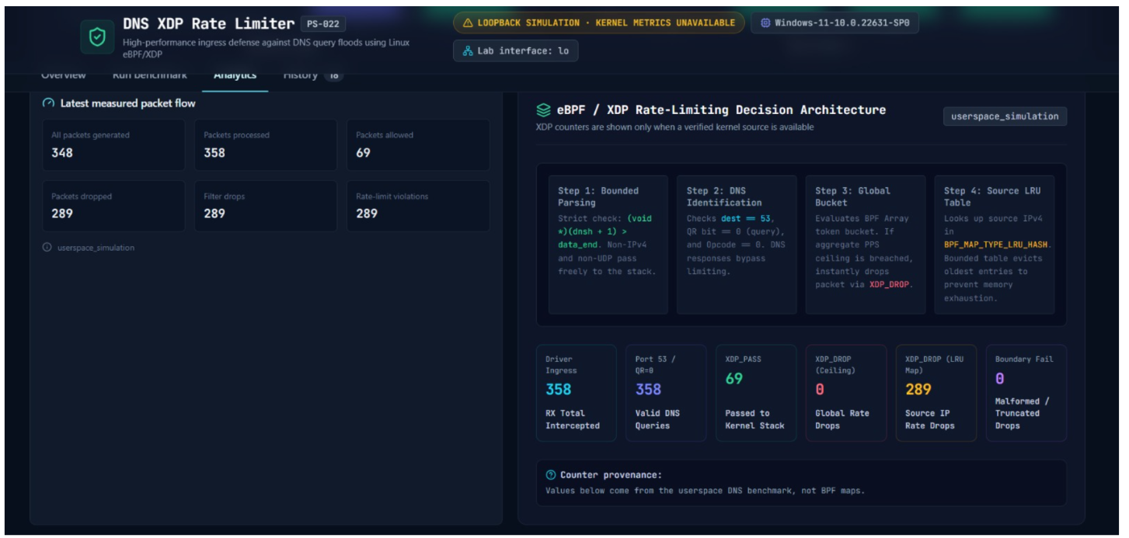
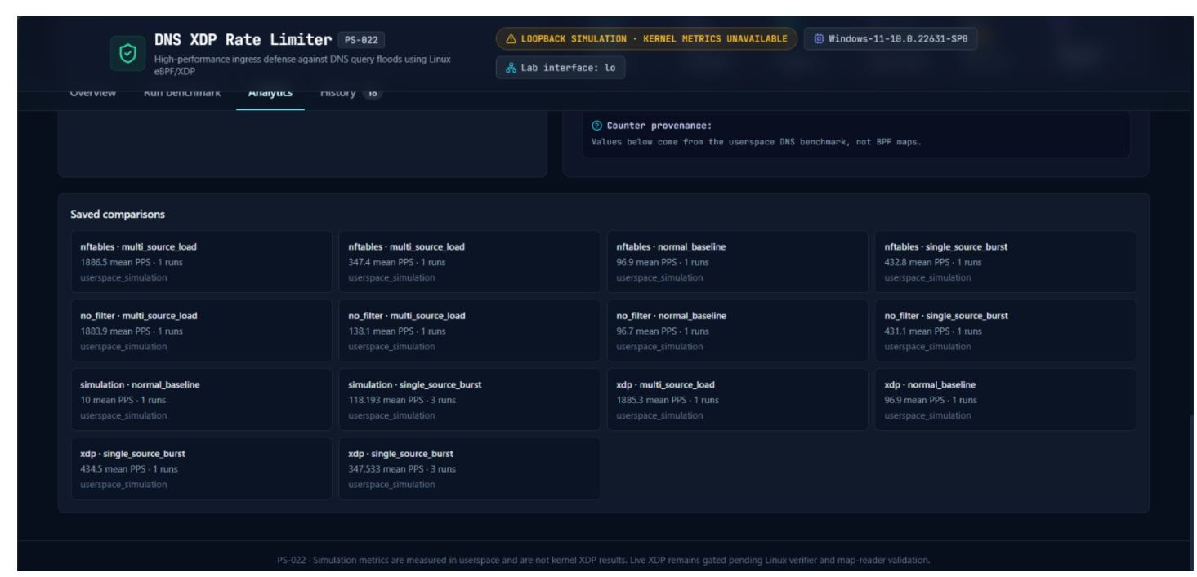
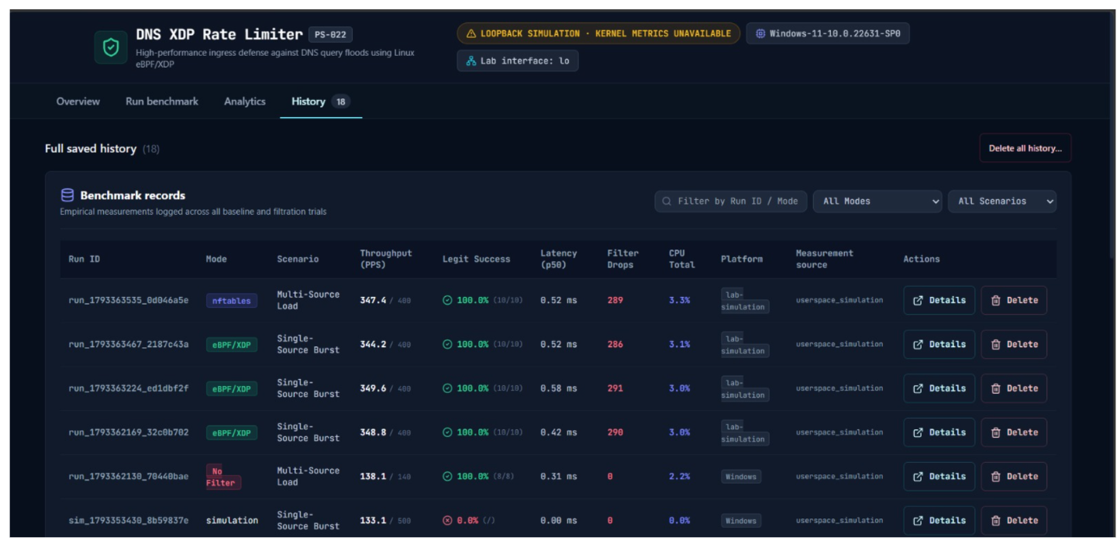
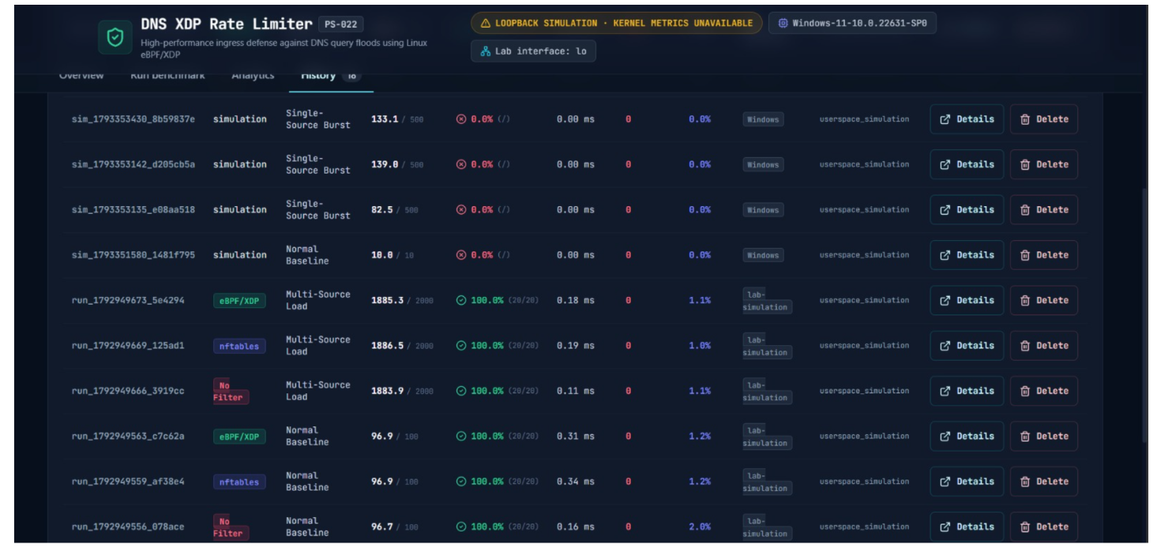
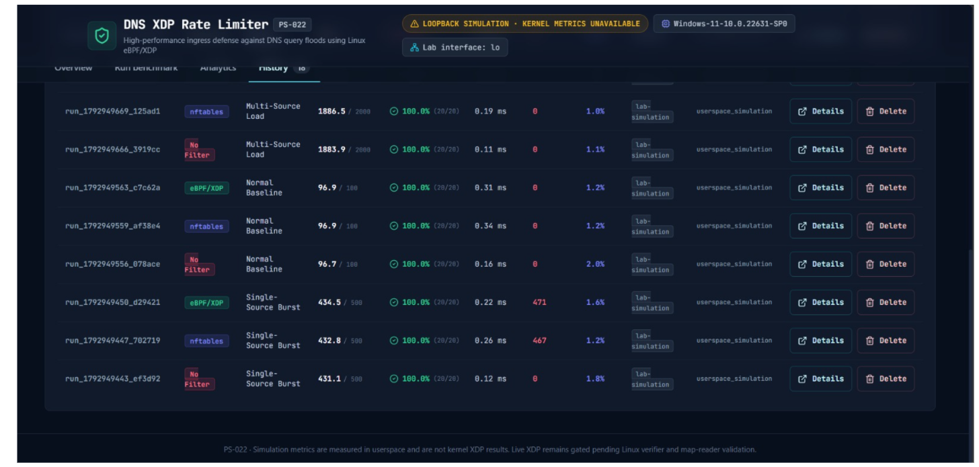

12. Limitations and Challenges
- Live XDP execution depends on Linux kernel support, driver capabilities, privileges, and compatible tooling.
- Windows simulation validates application logic but cannot establish kernel-level XDP performance.
- A loopback or virtualized test environment may not represent physical network interface performance.
- Header-level DNS identification does not validate every aspect of DNS message semantics.
- Per-source state requires bounded map capacity and a documented policy for new sources and capacity exhaustion.
- CPU and throughput measurements can be affected by background processes, virtualization, packet generator limits, and sampling intervals.
- Results from a small lab do not establish protection against all real-world DNS attacks.

13. Conclusion and Future Enhancements
This project brings together DNS traffic testing, rate limiting, performance measurements, and a dashboard for viewing the results. It gives us a way to compare no additional filtering, nftables, and XDP under controlled conditions. The final assessment depends on the features completed and the results collected during testing.

13.1 Future enhancements
- Extend protocol handling and policy controls while preserving verifier-safe parsing.
- Improve map lifecycle, stale-source cleanup, and observability.
- Evaluate additional XDP drivers and attachment modes.
- Add repeatable trials, confidence intervals, and more detailed latency analysis.
- Explore IPv6 support and carefully scoped DNS-over-TCP handling.
- Add alerting, configurable policy profiles, and longer-term trend analysis.
- Evaluate behavior under a wider range of legitimate query patterns.

14. References
- Linux Kernel Documentation, BPF — https://docs.kernel.org/bpf/
- Linux Kernel Documentation, XDP — https://docs.kernel.org/networking/af_xdp.html
- libbpf documentation — https://libbpf.readthedocs.io/
- nftables project documentation — https://netfilter.org/projects/nftables/
- Python documentation — https://docs.python.org/3/
- FastAPI documentation — https://fastapi.tiangolo.com/
- React documentation — https://react.dev/
- Recharts documentation — https://recharts.org/
- RFC 1035, Domain Names — Implementation and Specification — https://www.rfc-editor.org/rfc/rfc1035

Appendix A. Reproduction Checklist
☐ Record the exact source-code commit or version used for the experiment.
☐ Record OS, kernel, CPU, interface, driver, and toolchain versions.
☐ Confirm the lab endpoints are isolated and authorized.
☐ Confirm the selected filtering mode is active before each run.
☐ Use the same workload parameters across comparison modes.
☐ Run multiple trials where time permits and preserve raw records.
☐ Export raw CSV/JSON results and retain the original files.
☐ Detach XDP and remove only project-created nftables rules after testing.
☐ Insert genuine screenshots and verify all captions and figure references.
☐ Replace every bracketed placeholder and remove untested claims before submission.

