An Equivalent-Key Chosen-Plaintext Break of a
2025 Chaos-Based Image Cipher
[AUTHOR NAME]
[Department / Unit]
[Institution]
[City, Country]
[email@domain]
Abstract—Chaos-based image ciphers are published at a high rate and validated by statistical scores that do not measure resistance to a chosen-plaintext attack. We break a 2025 chaos-based image cipher (Jain et al., Optik; Lorenz/logistic maps, “LLEO”) that reports near-ideal entropy (7.9914) and a 99.6 % NPCR. From 4 chosen plaintexts we recover a key-free decryptor and decrypt any 512×512 ciphertext pixel-exactly in 0.037 s, without the key. The cause is structural: LLEO’s keystream and both permutations depend only on the secret key, never on the image, so the whole cipher is one fixed map. Its reported differential metric is then an illusion: with no plaintext diffusion the true one-pixel NPCR is 0.000381 % (100/MN), not 99.6 %. The break is structural, not incidental: any cipher whose keystream is fixed by the key alone falls to the same recovery. Good statistics are not security.
Keywords—cryptanalysis, image encryption, chaotic cipher, chosen-plaintext attack, equivalent key, NPCR
0.95

Introduction
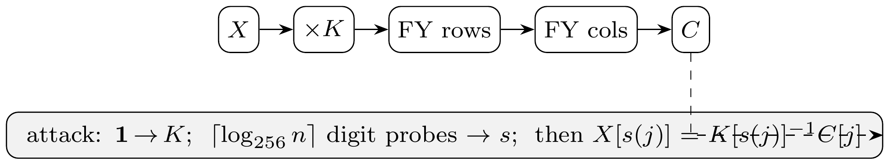
- LLEO encryption (top) and our equivalent-key attack (bottom).
Chaos-based image ciphers appear in the literature at a high rate, and a recurring lesson from the cryptanalysis side is that a large fraction of them succumb to the same structural attack. Most follow a permutation–diffusion template: a confusion stage that rearranges pixels and a diffusion stage that masks pixel values with a chaotic keystream. When that keystream is a function of the secret key alone and not of the image, the entire cipher collapses to a fixed permutation–substitution map, and an equivalent key (a stand-in that decrypts every ciphertext under the same secret key, without being the key itself) can be recovered from a handful of chosen plaintexts (input images the attacker picks and has encrypted) [1]–[4]. The defence is equally well known: the keystream must depend on the plaintext, and the cipher must actually diffuse [5].
A second, persistent problem is methodological. Authors validate schemes with statistical scores: Shannon entropy (a measure of randomness), adjacent-pixel correlation (how alike neighbouring pixels are), and the differential metrics NPCR and UACI (how much the output changes when one input pixel changes), and treat near-ideal values as evidence of security. None of these scores measures resistance to a chosen-plaintext attack, and, as we show, all of them can be near-ideal for a cipher that is broken in seconds; these statistical tests are known to be necessary but not sufficient [6].
Why this matters operationally. Image ciphers sit in the middle of real decisions: protected medical imaging, sealed evidence, access-controlled documents. Chaos-based image ciphers in particular are proposed as the confidentiality layer for exactly these sensitive streams, most prominently telemedicine and DICOM medical imaging [7]. A break is therefore a standing capability to decrypt every future ciphertext of the probed size, so a security argument should rest on an attack model rather than a statistics table. The quantity that matters is not how noise-like a single ciphertext looks but whether any value in the cipher depends on the image, the one binary property that separates “broken in 4 queries” from “resists.”

Real-World Stakes
Chaos-based image encryption is a large, active design literature, published at high volume and aimed at the most sensitive, most resource-constrained image streams: medical and DICOM imaging, the Internet of Medical Things, IoT-edge and surveillance pipelines, and satellite links, with real-time FPGA and hardware realisations [8]. No publicly documented product is yet known to rely on such a cipher, these designs are not standardised by ISO/IEEE/NIST [9], and mainstream systems still use vetted primitives such as AES; they are proposed as lightweight replacements for exactly those settings, on a motivation whose security benefit has itself been questioned [6], which makes their security a practical question rather than an academic one. A structural, few-query break of a single scheme is therefore a concrete warning about a technology being advanced toward that field, and a reminder that security here should be argued from an attack model, not a statistics table.
This paper applies both lessons to a 2025 scheme [10] (which we abbreviate LLEO) built from the Lorenz [11] and logistic maps with Fisher–Yates block shuffling; Fig. 1 sketches both its three-step encryption, a key-only multiplicative substitution ×K followed by two Fisher–Yates block shuffles, and our equivalent-key attack, which recovers the multiplier K and the source map s from a few chosen plaintexts and inverts the cipher without the key. Our contributions are:
- We identify that LLEO is entirely key-driven and therefore a fixed monomial map over ℤ₂₅₆: each output pixel is one input pixel times a fixed multiplier, with all arithmetic taken modulo 256 (wrapping around like a clock) (Section III–IV).
- We give an equivalent-key chosen-plaintext attack that recovers the full map in 1+⌈log₂₅₆MN⌉ chosen plaintexts (4 for a 512×512 image) and decrypts any image pixel-exactly without the key (Section IV).
- We reproduce LLEO, confirm it matches the paper’s reported statistics, and then show those statistics coexist with zero plaintext diffusion: the true one-pixel NPCR is 0.000381 %, not 99.6 % (Section V).
- Most importantly, we show this failure is structural, not incidental to LLEO: by Proposition 1, any cipher whose keystream and permutations are fixed by the key alone collapses to the same monomial or affine map, so extra rounds, chaotic maps, or block shuffles cannot help and only a plaintext-dependent keystream defeats the attack (Section IV).
Fig. 2 previews the outcome: four standard 512×512 images, their LLEO ciphertexts, and our key-free recoveries, each bit-identical to the original and obtained in 4 chosen plaintexts in 0.037 s, without the key. That grid is rendered in a perceptual colour map for legibility; the underlying images and every reported statistic are grayscale.

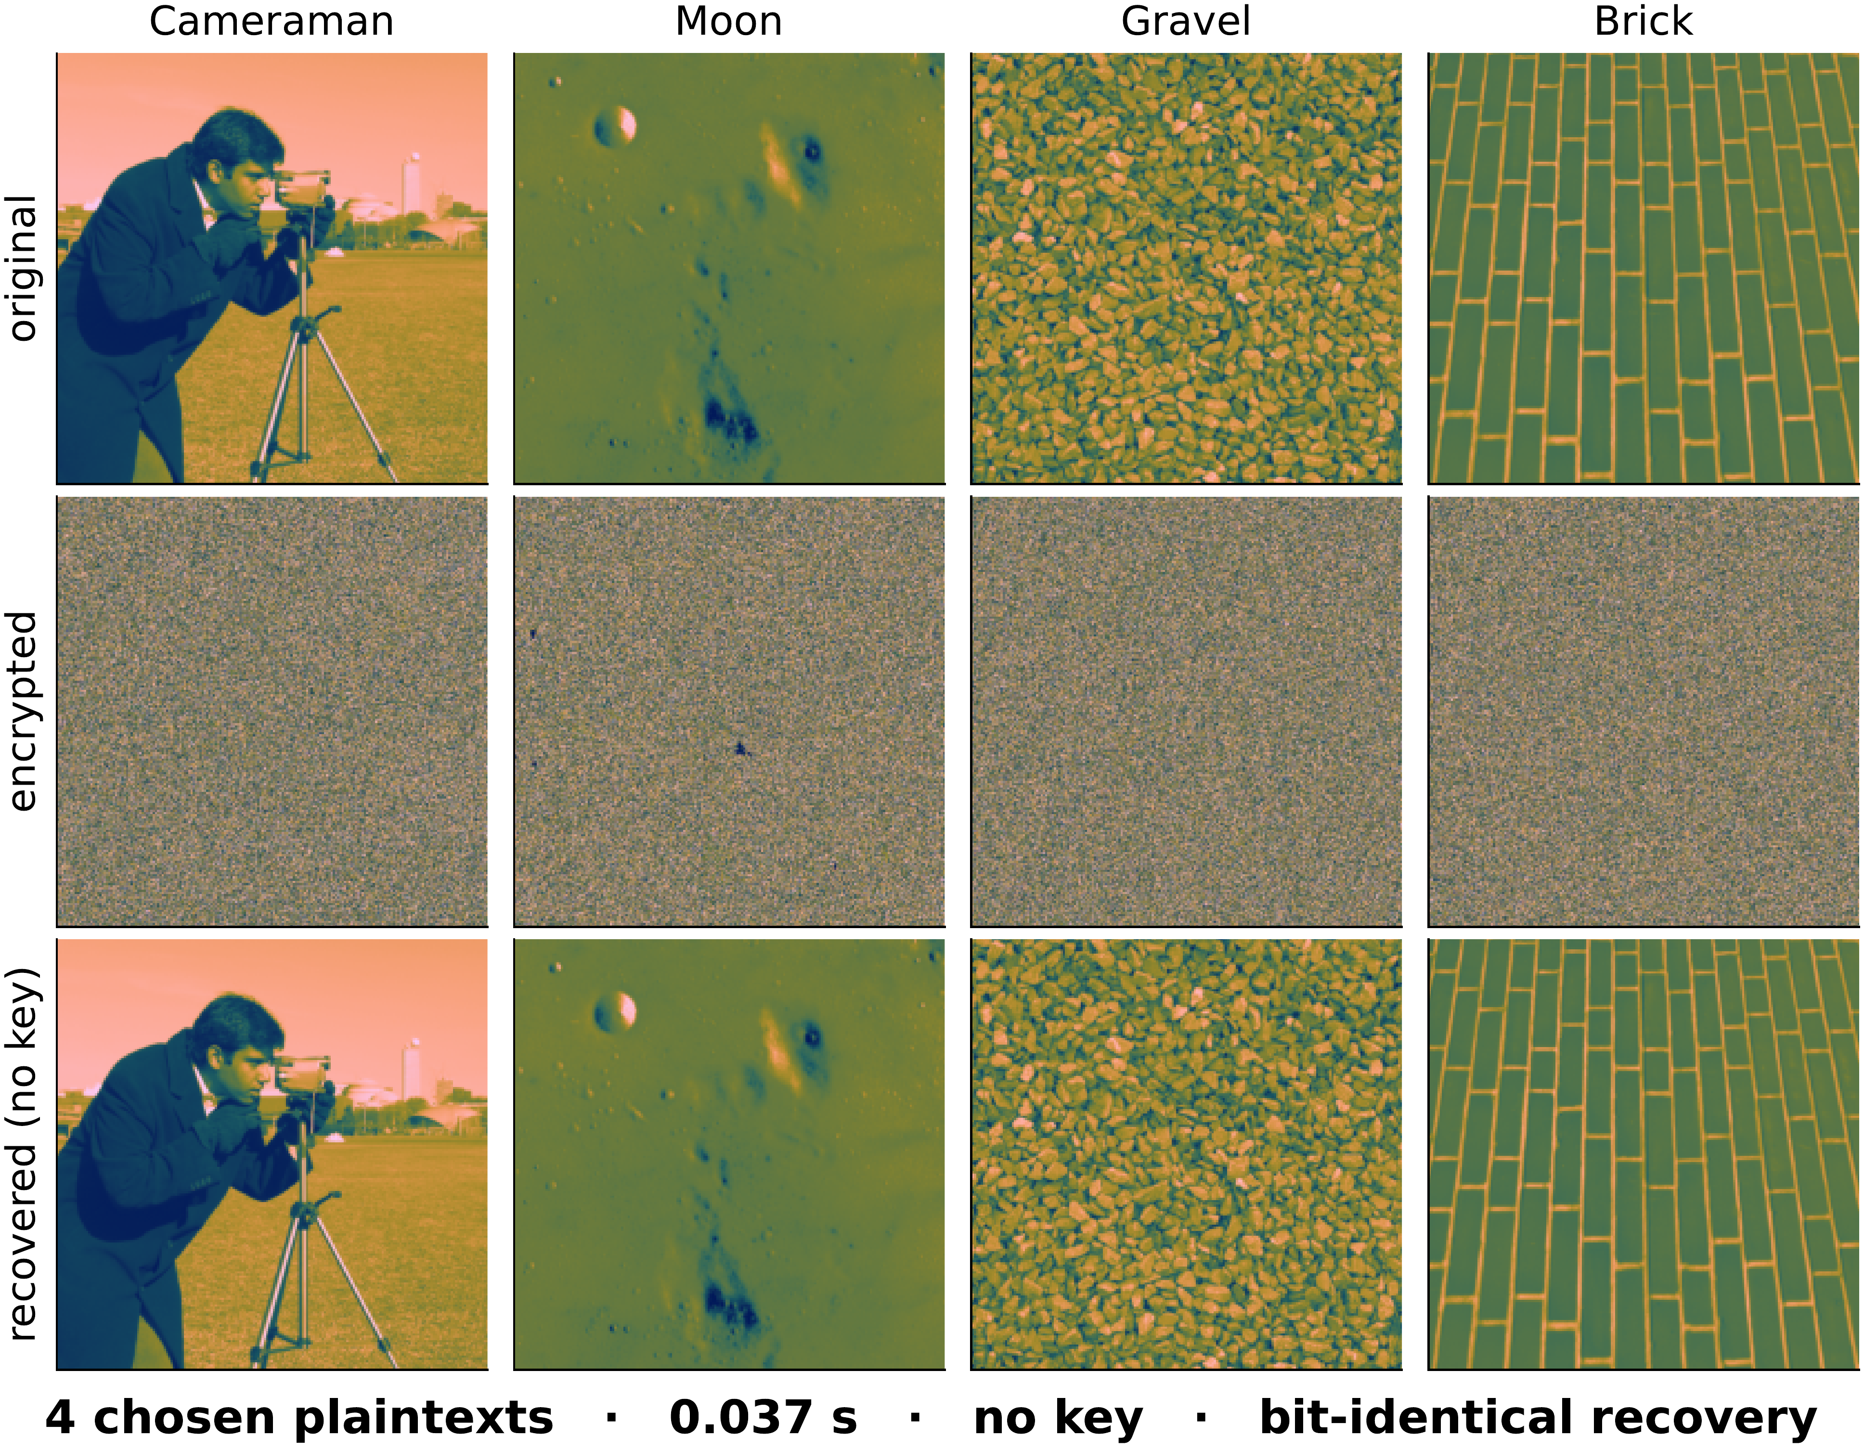
- Four LLEO ciphertexts and our key-free recoveries.

Related Work
The equivalent-key methodology for permutation–diffusion ciphers is well established. Arroyo et al. [3] broke a “total shuffling” scheme by recovering its key-only keystream; Li et al. [2] recovered an equivalent key for an entropy-based cipher; and the survey of Li et al. [1] catalogues a year of such breaks, nearly all exploiting plaintext-independent diffusion. For the confusion stage alone, Li and Lo [4] established the optimal number of known/chosen plaintexts needed to invert a permutation-only multimedia cipher, of order log_{L}(MN) for L intensity levels, the same logarithmic regime our attack achieves; the general quantitative theory of permutation-only cryptanalysis [12] bounds this effort, and recent chosen-plaintext breaks continue to recover equivalent keys from a handful of images [13], [14]. Alvarez and Li [5] set out basic requirements for chaos-based cryptosystems, including plaintext-dependent keystreams and sensitivity to the plaintext; LLEO violates these. The differential metrics we scrutinise were standardised by Wu et al. [15], who also note that NPCR/UACI quantify sensitivity to a one-pixel plaintext change, precisely the quantity LLEO fails to deliver despite its reported value.
The pattern is structural, not incidental: when both confusion and diffusion are fixed by the key the cipher is, as a function of the plaintext, an affine or monomial map, and composing more such stages changes only its coefficients [1], [4]. The decisive question is binary: does any key material depend on the image? Schemes that answer “no” (LLEO included) fall to an equivalent key, while those that bind the keystream to a per-image value resist, both sides of which our positive control demonstrates on the same construction (Section V).
What is new here. Prior equivalent-key cryptanalyses (Arroyo et al. [3], Li et al. [1], [2]) break one named scheme at a time by hand, each analysis bespoke to its target. This paper makes the analysis structural rather than bespoke: we identify the position-wise algebra of LLEO (a monomial map over ℤ₂₅₆), recover an equivalent key from a few chosen plaintexts, confirm it on held-out ciphertext, and show by Proposition 1 that the same argument covers any cipher whose keystream and permutations are fixed by the key. The few-query bound matches the Li–Lo permutation-only optimum [4]. Table I places our break beside prior equivalent-key cryptanalyses. Its “chosen PT” column counts the chosen (or known) plaintexts an attack consumes, and its “equiv. key” column records whether a key-free decryptor is recovered. Like the earlier attacks, ours recovers an equivalent key from a handful of chosen plaintexts; unlike them, that recovery reconstructs the full map, permutation and multiplier together, rather than the permutation alone.
- EQUIVALENT-KEY CRYPTANALYSES OF CHAOS AND PERMUTATION IMAGE CIPHERS
Work | Target scheme | Chosen PT | Equiv. key
Li & Lo [4] | permutation-only | ⌈log_{L}MN⌉ | perm.
Jolfaei et al. [16] | permutation-only | ⌈log₂₅₆MN⌉ | perm.
Arroyo et al. [3] | total-shuffling | few | yes
Wen & Lin [17] | chaos+DNA (QCMDC) | 4 | yes
Recent [13], [14] | 2020–2025 chaos | handful | yes
This work | LLEO [10] | 4 | full map

The Target Cipher
LLEO encrypts an M×N grayscale image X in three key-driven steps.
(1) Substitution. X is split into 16 horizontal strips. The eight odd strips are combined with a keystream k_{log} produced by the logistic map x_{n+1}=r x_{n}(1−x_{n}), and the eight even strips with a keystream k_{lor} produced by the Lorenz system ẋ=σ(y−x), ẏ=x(ρ−z)−y, ż=xy−βz, through an invertible per-position operation; decryption uses the modular “conjugate” of the keystream, i.e. a multiplicative inverse.
(2) Permutation 1. The 16 horizontal strips are reordered by a Fisher–Yates shuffle (a standard method for randomly reordering a list).
(3) Permutation 2. The result is divided into 16 vertical strips and shuffled again, giving the ciphertext.
The four “decryption keys” are the two keystreams (d₁,d₂) and the two shuffle index lists (d₃,d₄). The chaotic initial conditions are derived from the secret key and the shuffles are seeded from it; no quantity depends on the image X. Although the scheme is repeatedly called “asymmetric,” the same four keys both encrypt and decrypt: it is a symmetric cipher.

Cryptanalysis

Threat Model
We work in the standard chosen-plaintext setting under Kerckhoffs’s principle (the attacker knows the algorithm; only the key is secret): the attacker can obtain the ciphertext of any image it chooses under a fixed unknown key, and seeks an equivalent key, a procedure that decrypts any ciphertext of the probed size, not the chaotic secret seed itself. Because the cipher is plaintext-independent, the same equivalent key also follows from enough known plaintext–ciphertext pairs [18]; we present the chosen-plaintext version as it is minimal.

The Whole Cipher Is One Fixed Map
Index the image as a length-n vector, n=MN. Each LLEO step is linear over ℤ₂₅₆ and fixed by the key: substitution multiplies coordinate p by a fixed unit K[p] (odd, hence invertible mod 256), and the two block shuffles compose into one position permutation P. Therefore
C[j] = K[s(j)]·X[s(j)] (mod 256), s=P⁻¹, (1)
a fixed monomial map: every ciphertext pixel is a single plaintext pixel scaled by a fixed unit and relocated. Two consequences are immediate. There is no additive constant, since E(0)=0. And there is no diffusion: C[j] depends on exactly one input coordinate s(j), so a one-pixel plaintext change alters exactly one ciphertext pixel. Fig. 3 makes this visible, plotting the absolute ciphertext difference with dark for unchanged and bright for changed: flipping a single plaintext pixel leaves one isolated dot (ringed) in the ciphertext difference, whereas two unrelated images differ almost everywhere. Its third panel seeds the keystream from SHA-256 of the plaintext, which diffuses that same one-pixel change into full noise, what a one-pixel NPCR should measure. We turn this into a quantitative refutation of the cipher’s differential claims in Section V.
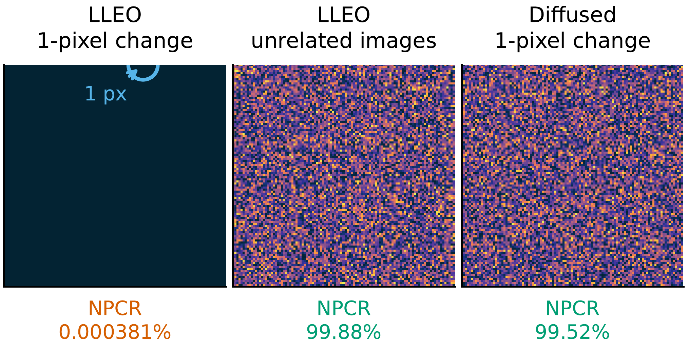
- Absolute ciphertext difference |C₀−C₁| under one fixed key: one-pixel change (left), unrelated images (centre), plaintext-seeded keystream (right).
Proposition 1. If a permutation–diffusion cipher’s keystream and permutations depend only on the key, it realises a fixed affine map of the plaintext: the monomial (1) with each K[p] a unit in ℤ₂₅₆ when the substitution is a modular multiply, or an affine map C=Mx⊕b over GF(2) (with b=E(0) possibly nonzero) when the substitution is XOR-based; composing any number of such rounds yields a map of the same form. In either case it is recovered from 1+⌈log₂₅₆n⌉ chosen plaintexts: one all-ones (resp. all-zeros) query fixes the substitution at every output position, and ⌈log₂₅₆n⌉ index-digit queries fix the permutation s.
Proof sketch. Each stage, multiplication by the key-derived K and the two block shuffles, is a fixed function of the key applied to pixel values or positions, so any composition is a fixed key-only map; over ℤ₂₅₆ this is the monomial (1). The keystream is forced odd, so K[p] is a unit and x↦K[p] x is a bijection with inverse K[p]⁻¹. Querying X=1 gives C[j]=K[s(j)]; querying the t-th base-256 digit of the index gives C[j]=K[s(j)] digit_{t}(s(j)), and dividing by the recovered K[s(j)] yields digit_{t}(s(j)); collecting all digits reconstructs s. If instead the substitution is XOR with a key-only keystream, the same argument over GF(2) gives an affine map C=Mx⊕b with b=E(0): the all-zeros query returns b and the index-digit queries return s, exactly as in a CBC-like XOR cipher.

Four Images Recover the Full Map
In plain terms: because nothing in the cipher depends on the picture, it always does the same two things: shuffle the pixel positions in one fixed way, and multiply each pixel by one fixed number. So feed it an all-ones image and it hands back the multipliers; feed it images whose pixels carry their own position numbers and it hands back the shuffle. About four such images, and the cipher is undone forever, without ever learning the key.
Formally, because K and s are fixed, two kinds of chosen plaintext suffice.
(a) Multiplier, one query. Encrypting the all-ones image 1 gives, by (1), C[j]=K[s(j)]·1=K[s(j)]: the exact multiplier acting at every output position.
(b) Permutation, ⌈log₂₅₆n⌉ queries. Let P_{t} be the plaintext whose pixel i holds the t-th base-256 digit of its index i. Then C[j]=K[s(j)]·digit_{t}(s(j)); multiplying by the already-known K[s(j)]⁻¹ yields digit_{t}(s(j)). Collecting all ⌈log₂₅₆n⌉ digits reconstructs s(j) for every j, hence the full permutation.
The recovered pair (s,K) is an equivalent key; any ciphertext is inverted by X[s(j)]=K[s(j)]⁻¹ C[j]. The total cost is
1+⌈log₂₅₆n⌉chosenplaintexts,
i.e. 4 for a 512×512 image, independent of the nominal key length.
Concretely, a 512×512 image needs four queries, one all-ones image and three index-digit images, after which the following procedure returns the full map in a single pass. Write T=⌈log₂₅₆n⌉ for the number of index-digit queries.
1) Query the all-ones image, K̂←Enc(1); then K̂[j]=K[s(j)] is the multiplier acting at output position j.
2) For t=0,…,T−1, query C←Enc(P_{t}) and divide out that multiplier: d_{t}[j]←C[j]·K̂[j]⁻¹ mod 256 for all j.
3) Reassemble the digits into the permutation: s[j]←∑_{t}d_{t}[j] 256^{t} is the source index feeding output j.
4) Return the decryptor: X[s(j)]←K̂[j]⁻¹C[j] mod 256 inverts any ciphertext C.
Table II states the complexity for an n=MN-pixel image over L=256 intensity levels and compares it to the optimal permutation-only bound of Li and Lo [4]: our query count is order-optimal and the cost is independent of the cipher’s nominal key length, so the advertised keyspace is irrelevant; the equivalent key bypasses key recovery entirely [16].
- ATTACK COMPLEXITY VS. THE PERMUTATION-ONLY OPTIMUM
 | This attack | Optimal perm.-only [4]
Data (chosen plaintexts) | 1+⌈log₂₅₆n⌉ | ⌈log_{L}n⌉
Time | O(n⌈log₂₅₆n⌉) | O(n⌈log_{L}n⌉)
Memory | O(n) | O(n)

Why Extra Structure Does Not Help
A composition of fixed key-only maps is again one, so extra rounds, chaotic maps, or block shuffles leave (1) intact (only K,s change) and the attack applies unchanged; it is moreover a known-plaintext attack whenever the available plaintexts span the index digits. The single property that would defeat it is a keystream that depends on X.

Experimental Results
We reconstructed LLEO from its description (reimplemented from scratch, no code reused) and ran it on four standard 512×512 images.

Reproduction
Table III shows the reconstruction reproduces LLEO’s claimed statistics: cipher entropy approaches the ideal 8 (Cameraman 7.9914, up from the plaintext’s 7.2317) and adjacent-pixel correlation drops to near zero (-0.0073); its last two columns record the chosen plaintexts each break consumed and confirm that every image is recovered pixel-exactly without the key. Fig. 4 shows the near-uniform cipher histogram, and Fig. 5 plots every horizontal pixel pair as a hexbin density, in which the plain image’s tight diagonal ridge, where neighbours are alike, collapses into an unstructured cloud filling the plane uniformly. By the usual yardsticks the cipher looks strong, yet it is trivially broken.
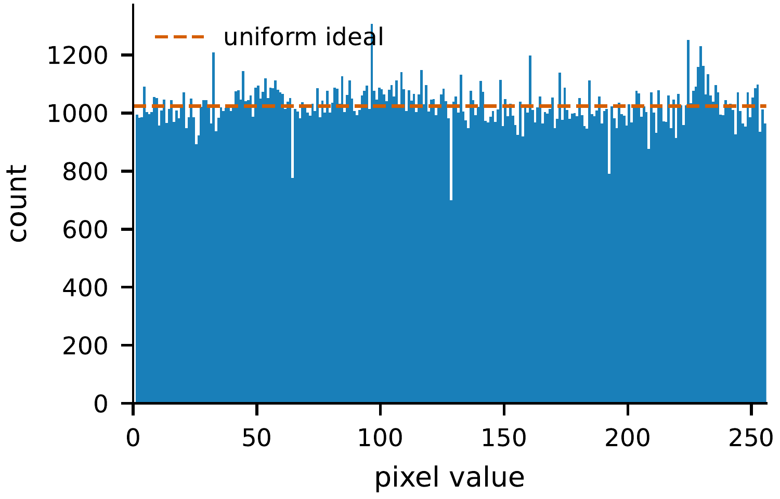
- Cipher histogram (Cameraman).
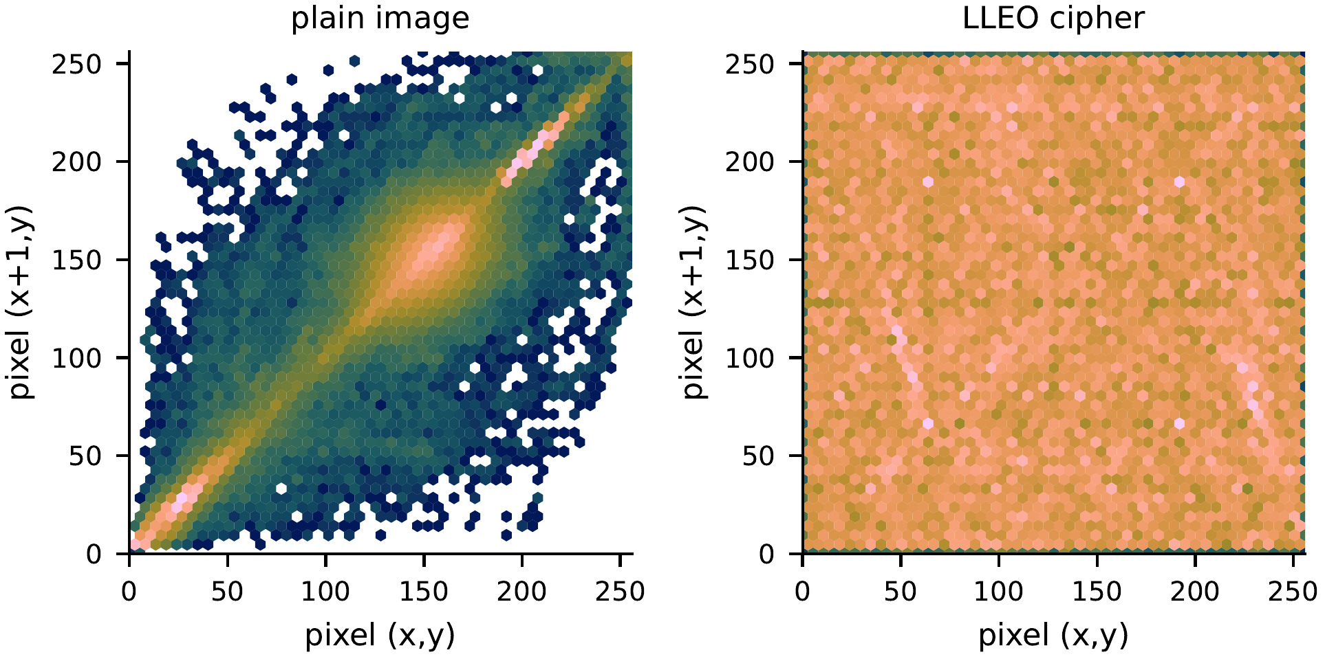
- Adjacent-pixel correlation as a hexbin density, log counts (Cameraman).
- RECONSTRUCTION STATISTICS AND ATTACK OUTCOME
Image | H plain | H cipher | corr. | CP | broken
Cameraman | 7.2317 | 7.9914 | -0.0073 | 4 | yes
Moon | 4.885 | 7.9316 | 0.0011 | 4 | yes
Gravel | 7.2531 | 7.9876 | -0.0005 | 4 | yes
Brick | 5.4553 | 7.8966 | -0.0007 | 4 | yes

The Break
The attack of Section IV recovers the equivalent key in 4 chosen plaintexts and decrypts a fresh ciphertext pixel-exactly in 0.037 s at 512² (single core, Table IV; recovery is image-content-independent, so this time holds for any image), using no key. Fig. 2 shows the original, the LLEO ciphertext, and the key-free recovery, which is identical to the original.

Cost Scales Logarithmically
Table IV reports how the attack’s cost scales with image size. Because it needs only 1+⌈log₂₅₆MN⌉ chosen plaintexts, the count stays nearly flat as the image grows: 3 plaintexts at 128², 4 at 512², and still 4 at 1024², where a random plaintext is recovered exactly in 0.254 s on a single core. The key length the scheme advertises does not enter this cost.
- ATTACK COST VS. IMAGE SIZE
Size | chosen PT | time (s) | recovered
128×128 | 3 | 0.003 | exact
256×256 | 3 | 0.009 | exact
512×512 | 4 | 0.037 | exact
1024×1024 | 4 | 0.254 | exact

The Differential Metric Is Illusory
LLEO reports NPCR ≈99.6 % as evidence of differential-attack resistance. But by (1) flipping one plaintext pixel changes exactly one ciphertext pixel (Fig. 3, left), so the true one-pixel NPCR, the quantity NPCR was defined to measure [15], is 100/MN=0.000381 % (UACI 4×10⁻⁶ %), five orders of magnitude below the reported value. The 99.6 % figure instead measures the difference between unrelated images, which for LLEO is 99.88 % (Fig. 3, centre); this is achieved by any cipher with a near-uniform output and says nothing about chosen-plaintext security. Table V contrasts each claimed property with what the cipher actually provides. Finally, Fig. 6 shows the chaotic keystreams are themselves non-uniform: the logistic keystream is sharply peaked, its invariant density spiking at the extremes, and even the Lorenz stream is measurably lumpy, whereas a secure stream cipher would match the flat uniform reference plotted alongside them. A chi-square test (a standard check for whether values are evenly spread) rejects uniformity for both, for the logistic keystream at χ²=525839.6 (p<10⁻³⁰⁰, numerically zero).
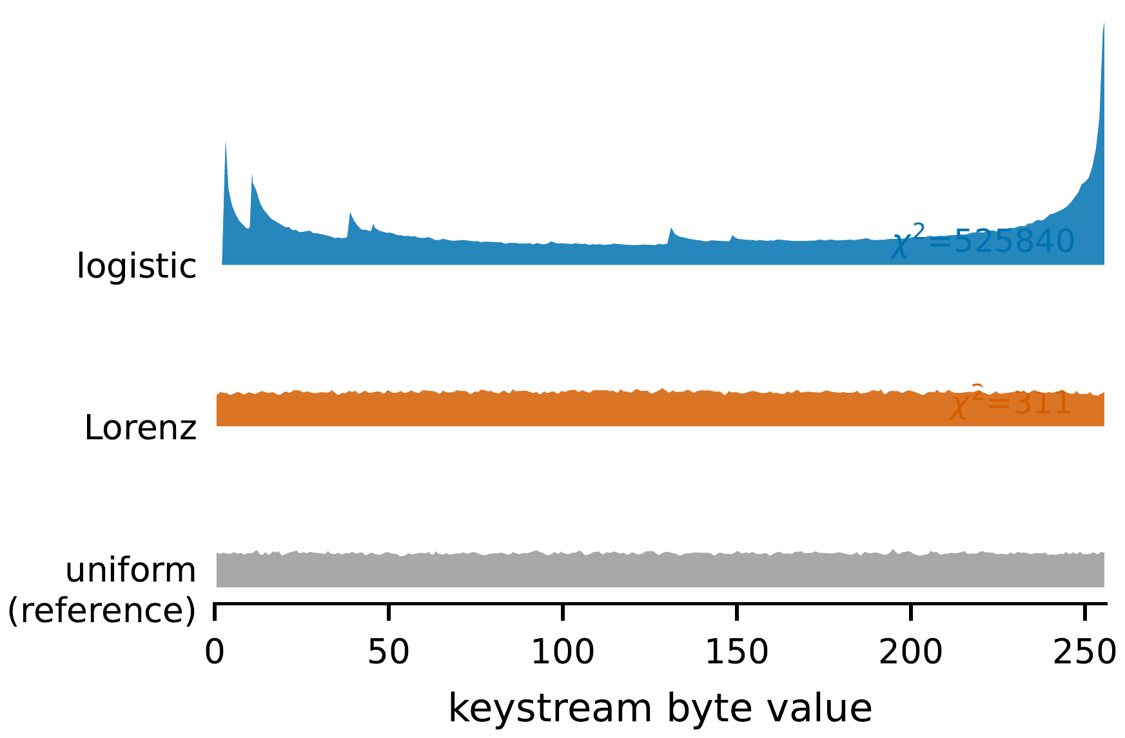
- Keystream byte distributions (ridgeline).
- CLAIMED VS. ACTUAL SECURITY OF LLEO
Property | Reported | Actual
Entropy (Cameraman) | ≈7.997 | 7.9914 (genuine)
NPCR (1-pixel change) | ≈99.6 % | 0.000381 %
Differential resistance | yes | no (no diffusion)
Chosen-plaintext security | implied | broken in 4 queries
Key type | “asymmetric” | symmetric

The single break generalises. The same equivalent-key recovery applies to any cipher whose keystream and permutations are fixed by the key: a handful of chosen plaintexts either reconstruct a key-free decryptor, which we then confirm against held-out ciphertext, or they do not, and that binary outcome is exactly a decision of plaintext-independence.

Discussion
LLEO illustrates a persistent failure mode: good statistics are not security. A flat histogram, near-ideal entropy, near-zero correlation, and a large inter-image NPCR are all satisfied by our fixed, key-only map, which we nonetheless break in 4 queries; testing plaintext sensitivity directly [5], [15] is what catches this. The scheme’s “asymmetric” label is also a misnomer: the same keys encrypt and decrypt, which is a labeling error rather than a structural one.
The remedies are standard. (i) Make the keystream depend on the plaintext, e.g. derive the chaotic initial conditions from a SHA-256 hash of the image, so a different plaintext yields an unrelated keystream. (ii) Add genuine diffusion, e.g. a chaining rule C[i]=f(X[i],k[i],C[i−1]), so one plaintext change propagates. With either, (1) is no longer fixed across images and the attack fails: it recovers 100.0 % of pixels against the key-only cipher but only 0.2518 % (chance) once the keystream is SHA-256–seeded from the image.

Limitations
One bound on our claims: we recover an equivalent key that decrypts any ciphertext of the probed size, not the underlying chaotic secret seed itself, the standard, defensible claim in this literature [1].

Future Work
The recovery of Section IV is demonstrated on LLEO and justified structurally, but not yet automated. Three extensions follow directly. First, it can be packaged as a black-box structural audit that, given only oracle access to an unknown cipher, decides plaintext-independence and returns a key-free decryptor confirmed on held-out ciphertext. Second, running that audit across a corpus of recently published 2023–2025 chaos and permutation image ciphers would measure how widespread this failure mode is. Third, the binary verdict can be refined into a graded plaintext-keying-capacity metric that quantifies how much of a cipher’s output genuinely depends on the plaintext, separating fragile designs from those with real diffusion. We develop these directions in an extended version.

Conclusion
A 2025 chaos-based image cipher is completely broken by an equivalent-key chosen-plaintext attack in 4 chosen plaintexts and a fraction of a second, despite near-ideal entropy and a reported NPCR of ≈99.6 %: good statistics are not security, and the cipher’s differential metric, measured correctly, is 0.000381 %. We recommend plaintext-dependent keystreams and real diffusion, and that statistical scores accompany, rather than replace, an explicit chosen-plaintext security argument. More broadly, the attack is not specific to LLEO: any cipher whose keystream is fixed by the key alone admits the same equivalent-key recovery, so plaintext-independence, not statistical uniformity, is the property a designer must test.

Acknowledgment
The author used a large language model (Anthropic Claude) to assist with code, reproduction, and editing. All claims were verified by the author; the AI system is not an author. Generative-AI use is disclosed per IEEE policy.
1

References
- C. Li, Y. Zhang, and E. Y. Xie, “When an attacker meets a cipher-image in 2018: A year in review,” Journal of Information Security and Applications, vol. 48, p. 102361, 2019.
- C. Li, D. Lin, B. Feng, J. Lü, and F. Hao, “Cryptanalysis of a chaotic image encryption algorithm based on information entropy,” IEEE Access, vol. 6, pp. 75 834–75 842, 2018.
- D. Arroyo, C. Li, S. Li, G. Alvarez, and W. A. Halang, “Cryptanalysis of an image encryption scheme based on a new total shuffling algorithm,” Chaos, Solitons & Fractals, vol. 41, no. 5, pp. 2613–2616, 2009.
- C. Li and K.-T. Lo, “Optimal quantitative cryptanalysis of permutation-only multimedia ciphers against plaintext attacks,” Signal Processing, vol. 91, no. 4, pp. 949–954, 2011.
- G. Alvarez and S. Li, “Some basic cryptographic requirements for chaos-based cryptosystems,” International Journal of Bifurcation and Chaos, vol. 16, no. 8, pp. 2129–2151, 2006.
- M. Preishuber, T. Hütter, S. Katzenbeisser, and A. Uhl, “Depreciating motivation and empirical security analysis of chaos-based image and video encryption,” IEEE Transactions on Information Forensics and Security, vol. 13, no. 9, pp. 2137–2150, 2018.
- W. Al Nassan et al., “Chaos-based encryption system of DICOM medical images,” in Proc. SPIE, vol. 13033, 2024, p. 130330T.
- T. M. Hoang, Q. A. Pham, M.-H. Hoang, D. Q. Tran, and S. El Assad, “Novel structures of chaos-based parallel multiple image encryption and FPGA implementation,” Scientific Reports, vol. 15, 2025.
- J. S. Teh, M. Alawida, and Y. C. Sii, “Implementation and practical problems of chaos-based cryptography revisited,” Journal of Information Security and Applications, vol. 50, p. 102421, 2020.
- S. Jain, A. Samal, A. Sharma, M. Khurana, and B. Sharma, “Advanced image security through chaotic system-based encryption and Fisher–Yates matrix shuffling,” Optik, vol. 327, p. 172304, 2025.
- E. N. Lorenz, “Deterministic nonperiodic flow,” Journal of the Atmospheric Sciences, vol. 20, no. 2, pp. 130–141, 1963.
- S. Li, C. Li, G. Chen, N. G. Bourbakis, and K.-T. Lo, “A general quantitative cryptanalysis of permutation-only multimedia ciphers against plaintext attacks,” Signal Processing: Image Communication, vol. 23, no. 3, pp. 212–223, 2008.
- Y. Ma, C. Li, and B. Ou, “Cryptanalysis of an image block encryption algorithm based on chaotic maps,” Journal of Information Security and Applications, vol. 54, p. 102566, 2020.
- Y. Zhao, Q. Shi, and Q. Ding, “Cryptanalysis of an image encryption algorithm using DNA coding and chaos,” Entropy, vol. 27, no. 1, p. 40, 2025.
- Y. Wu, J. P. Noonan, and S. Agaian, “NPCR and UACI randomness tests for image encryption,” Cyber Journals: Journal of Selected Areas in Telecommunications (JSAT), vol. 1, no. 2, pp. 31–38, 2011.
- A. Jolfaei, X.-W. Wu, and V. Muthukkumarasamy, “On the security of permutation-only image encryption schemes,” IEEE Transactions on Information Forensics and Security, vol. 11, no. 2, pp. 235–246, 2016.
- H. Wen and Y. Lin, “Cryptanalysis of an image encryption algorithm using quantum chaotic map and DNA coding,” Expert Systems with Applications, vol. 237, p. 121514, 2024.
- L. Y. Zhang, Y. Liu, C. Wang, J. Zhou, Y. Zhang, and G. Chen, “Improved known-plaintext attack to permutation-only multimedia ciphers,” Information Sciences, vol. 430–431, pp. 228–239, 2018.

