Knowing When to Abstain: Calibration and Selective Prediction
for Machine-Learning Network Intrusion Detection
[AUTHOR NAME]
[Department / Unit]
[Institution]
[City, Country]
[email@domain]
Abstract—Machine-learning intrusion detectors face attack families absent from training (open-set shift), where “detection collapse” reads as a representational dead end. We propose no new detector and ask whether off-the-shelf detectors know when they are wrong, on NSL-KDD and two modern flow corpora (CIC-IDS-2017/2018). (i) Over-confidence is task-dependent: detectors are badly miscalibrated under NSL-KDD’s shift and no post-hoc calibrator transfers, yet well calibrated on both modern corpora (ECE and Brier agree). (ii) The blind spot is an operating-point failure, not representational: benign-mimicking families stay discriminable yet are missed at the global argmax threshold, so the collapse is mostly a thresholding artifact, cleanest for R2L, weaker for partly-representational Infiltration. (iii) The operating point is the lever: a budget-tuned threshold lifts unknown-R2L recall from 0.003 to 0.508 at matched cost, while an added abstention/novelty stack gives no further gain. Selective prediction helps only when confidence ranks errors; fixed-partition intervals understate uncertainty severalfold.
Keywords—intrusion detection, selective prediction, calibration, uncertainty, open-set recognition, NSL-KDD
0.95

Introduction
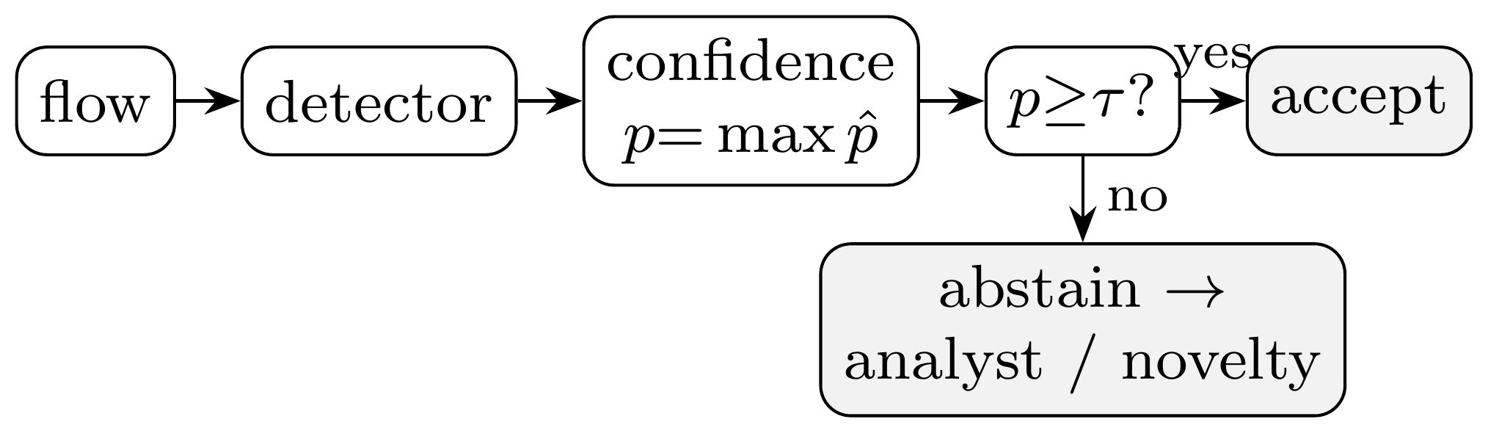
- The selective-prediction (reject-option) wrapper we evaluate.
A network intrusion detector that emits only “attack” or “benign” gives an operator no way to tell a confident verdict from a guess. In practice this matters twice over: alerts compete for scarce analyst attention, and genuinely novel attacks are exactly what a static classifier is least equipped to label. A detector that could say “I am not sure” on these inputs, and defer them to a human or a secondary control, would be more useful than one forced to commit. Fig. 1 sketches the reject-option wrapper we evaluate: the detector’s label is accepted when its confidence p clears a threshold τ, and otherwise routed to an analyst or a benign-only novelty stage. We ask whether p is trustworthy, and what becomes of attacks that look benign.
The narrow, practical question. Do off-the-shelf machine-learning intrusion detectors know when they are wrong: producing confidence scores trustworthy enough to drive an abstention policy, and behaving safely on attacks they have never seen? We propose no new detector; we evaluate existing ones. We answer empirically on NSL-KDD [1], whose published test split deliberately contains attack types absent from training, and on two modern flow corpora (CIC-IDS-2017 and CIC-IDS-2018) under cross-day and cross-corpus drift (Section IV-E). The contribution is a dissociation between two failure modes, made precise with threshold-free analysis. Over-confidence under shift is task-dependent: no post-hoc calibrator (Platt [2], isotonic, or temperature scaling [3]) removes it on NSL-KDD, yet the same task is well calibrated on both modern corpora (Section IV-A). The benign-mimicry blind spot is an operating-point failure, not a representational one, and recurs across all three corpora: minority families stay discriminative (AUROC well above chance) yet are missed at the global threshold, so the much-cited “detection collapse” is mostly a thresholding artifact (Sections IV-B, IV-D). Selective prediction [4], [5] cuts selective risk only for models whose confidence ranks errors, and on the blind spot the lever is the operating point, not an added abstention/novelty stack (Sections IV-C, IV-G). Throughout we follow the evaluation guidance of Arp et al. [6]: no test information leaks into model selection. Unless stated otherwise, NSL-KDD metrics are means over multiple seeds with 95% CIs, which on this fixed test partition capture only train/model variance; we report a bootstrap over the evaluation distribution separately (Section IV-A).

Related Work
Calibration. Modern classifiers often output probabilities that do not match empirical accuracy [3], [7]; expected calibration error (ECE) summarises this gap, and temperature/Platt scaling are common post-hoc fixes [2]. These analyses typically assume the evaluation data is drawn from the training distribution, an assumption that fails for intrusion detection.
Selective prediction. A classifier with a reject option [4] trades coverage for higher accuracy on what it accepts; the risk–coverage curve and its area [5] quantify the trade-off. The model’s highest class probability is a strong baseline score [8].
ML for intrusion detection. The limits of learned detectors, especially on novel attacks and under distribution shift, were argued early [9] and remain a methodological hazard [6].
Unknown attacks and shift. The failure of closed-world classifiers on inputs unlike their training data motivates out-of-distribution and open-set detection [8]. Our family-holdout protocol complements NSL-KDD’s built-in novelty with a controlled version that makes the “unknown” condition causal.

Methodology
Data. NSL-KDD [1] provides 125973 training and 22544 test records with 41 features (three categorical) and a binary normal/attack label; each attack maps to one of four families: DoS (denial of service), Probe (network scanning), R2L (remote-to-local intrusion), and U2R (user-to-root escalation). Its test split contains 17 attack types (3750 records) that never appear in training, a built-in open-set test (the model must face attack kinds it never saw). Numeric features are standardised and categorical features one-hot encoded; the encoder is fit on training data only. We pair NSL-KDD with two modern flow corpora (Section IV-E).
Models. We use scikit-learn [10] logistic regression (a linear model), a random forest, and histogram gradient boosting (two ensembles of decision trees), deliberately standard detectors, since our subject is their confidence, not their architecture. The calibration analysis (Section IV-A) is on these three. Table I summarises all of them and adds a fourth family, a neural MLP, to test whether informative confidence (low AURC) generalizes beyond trees and the linear model; it reports accuracy, ECE, Brier, AURC, and r(0.8) over K=15 seeds that resample the fit/calibration split and model randomness, with lower ECE, Brier, and AURC all better.
Calibration. For each model we report ECE (15 equal-width bins of the predicted class probability) raw and after three post-hoc calibrators: Platt (sigmoid) scaling, isotonic regression, and temperature scaling [3], each fitted on a 20% held-out split of the training set, both in-distribution and on the shifted test set.
Per-family detection and operating points. Besides operating-point recall we report the threshold-free detection AUROC of the attack score (benign vs. family) per family; the binary target is near-balanced (46.5% attack), so we also report recall under class_weight=“balanced” and at a per-family 10% benign-FPR threshold, plus a bootstrap over the test partition (B=1000) for an evaluation-distribution CI.
Selective prediction. The confidence of a prediction is its maximum class probability. Sorting the test set by confidence and accepting the most-confident fraction c yields the selective risk r(c); we report the area under r(c) (AURC) and r(0.8). Fig. 2 plots these risk–coverage curves for the three detectors, with the AURC shaded for the two extremes and a ring at the 80%-coverage operating point.
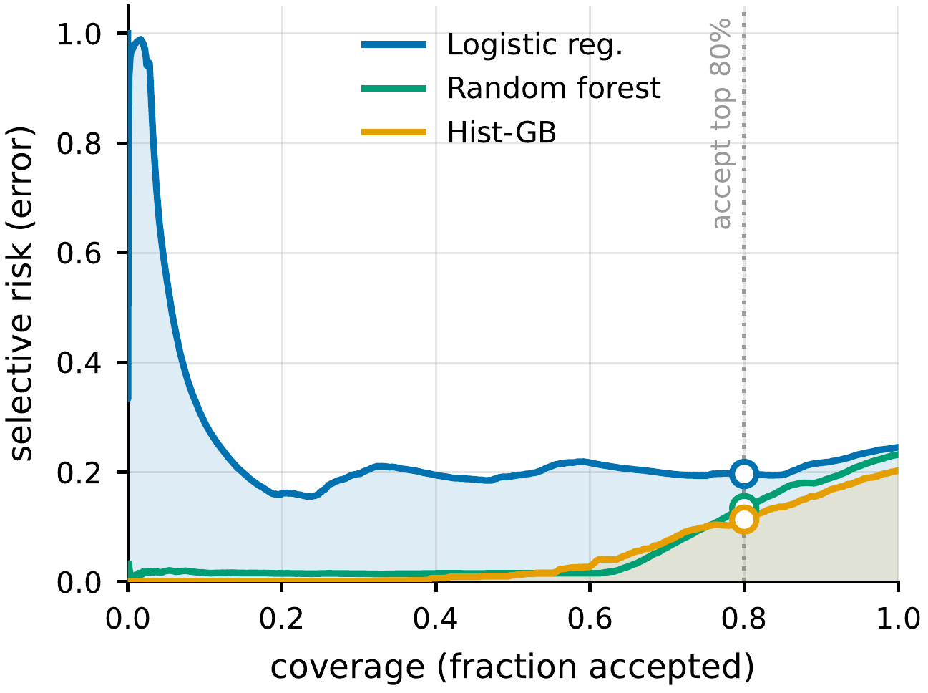
- Risk–coverage curves on NSL-KDD.
Open-set protocol (LOFO). To probe genuinely unknown attacks under control, our leave-one-family-out protocol removes one attack family entirely from training (keeping benign traffic and the other families), retrains, and measures detection and confidence on that family’s test records. We also report, at a global threshold giving 80% coverage, the fraction of unknown-family records that abstention rejects.

Results

Over-Confidence Under Shift, and No Calibrator Fixes It
All three detectors are markedly over-confident on the benchmark’s shifted test set, with ECE from ≈0.16 (random forest) to ≈0.22 (logistic regression) (Table I). This is induced by distribution shift, not intrinsic: on a held-out in-distribution split the same models are nearly perfectly calibrated (ECE ≲0.01). No post-hoc calibrator fit on source data removes the shift-induced miscalibration: Platt, isotonic, and temperature scaling all leave test ECE essentially where it was (gradient boosting 0.1806 raw vs. 0.1762/0.1702/0.1816; the random forest is slightly worse after every one). Fig. 4 makes the pattern visible: for every model the raw, Platt, isotonic, and temperature markers cluster high on the shifted test set, even though each method drives in-distribution ECE below 0.01. The Brier score (Table I), a proper scoring rule, tells the same story (it too barely improves under calibration and worsens for the random forest), so the over-confidence is a property of the scores under shift, not a binning artefact of ECE. So we turn to abstention, which needs only a usable confidence ranking.
How precise are these numbers? Because the canonical KDDTest+ partition is held fixed, our seed CIs (Table I) capture only train/model variance and look reassuringly tight. They understate generalization uncertainty by construction. Resampling the evaluation distribution (bootstrap over the test partition) widens the accuracy interval from a seed half-width near 0.001 to ±0.0052, about fivefold, which is the honest scale of uncertainty for a single fixed benchmark.

- NSL-KDD TEST METRICS
Model | Acc. | ECE | Brier | AURC | r(0.8)
Logistic reg. | 0.752 ± 0.001 | 0.2151 ± 0.0008 | 0.2242 ± 0.0005 | 0.2259 ± 0.0115 | 0.1955 ± 0.0008
Random forest | 0.769 ± 0.004 | 0.1630 ± 0.0036 | 0.1647 ± 0.0013 | 0.0604 ± 0.0013 | 0.1328 ± 0.0026
Hist. grad. boost. | 0.799 ± 0.004 | 0.1806 ± 0.0037 | 0.1828 ± 0.0031 | 0.0530 ± 0.0027 | 0.1130 ± 0.0047
MLP (neural) | 0.793 ± 0.004 | 0.1937 ± 0.0040 | 0.1971 ± 0.0041 | 0.1160 ± 0.0180 | 0.1438 ± 0.0089

The Benign-Mimicry Blind Spot Is an Operating-Point Failure
The most attackable reading of the blind spot is that R2L’s near-zero detection is just an unbalanced classifier cut at argmax (the default 0.5 decision boundary). It is not class imbalance, but it is largely the threshold. The attack score separates R2L from benign well above chance (AUROC 0.872 when R2L is seen in training, 0.804 when it is held out), yet at the global argmax cut only 0.059 of R2L is flagged. Training with class_weight=“balanced” barely moves this (0.064), expected, since the binary attack/normal task is already near-balanced, whereas a per-family threshold at a 10% benign false-positive rate recovers 0.493. So R2L is the hardest family, but it is discriminable: the catastrophic recall is one global operating point being wrong for a minority, benign-mimicking family, not a representational dead end. This corrects an over-strong “structural blind spot” reading; the blind spot is real but it lives in the decision threshold.
Table II gives the threshold-free view that also accounts for “detection collapse”. For each family it reports the attack-score AUROC when the family is seen in training and when it is held out, the change Δ between them, and operating-point recall at the global argmax cut (means over K=6 seeds; AUROC CI half-width ≤0.047). Holding a family out costs little AUROC: DoS 0.988→0.927 (a drop of 0.061), Probe 0.01, R2L 0.068, even though operating-point recall falls steeply. The score stays discriminative for every family (AUROC ≫0.5) while argmax recall is low for the minority ones: the global cut, not the score, is what misses them. Fig. 3 plots the same seen-versus-held-out AUROCs, where every family stays well above chance and R2L is lowest but never near 0.5. The much-cited recall collapse on unknown families is therefore mostly the global threshold mismatching the now-unknown family, not the score losing discriminative power. Operationally this matters: the fix is a better operating point or abstention, not richer features.
- THRESHOLD-FREE PER-FAMILY DETECTION ON NSL-KDD
Family | AUROC (seen) | AUROC (unk.) | Δ | recall @argmax
DoS | 0.988 | 0.927 | 0.061 | 0.864
Probe | 0.982 | 0.972 | 0.01 | 0.781
R2L | 0.872 | 0.804 | 0.068 | 0.077
U2R | 0.951 | 0.936 | 0.015 | 0.177

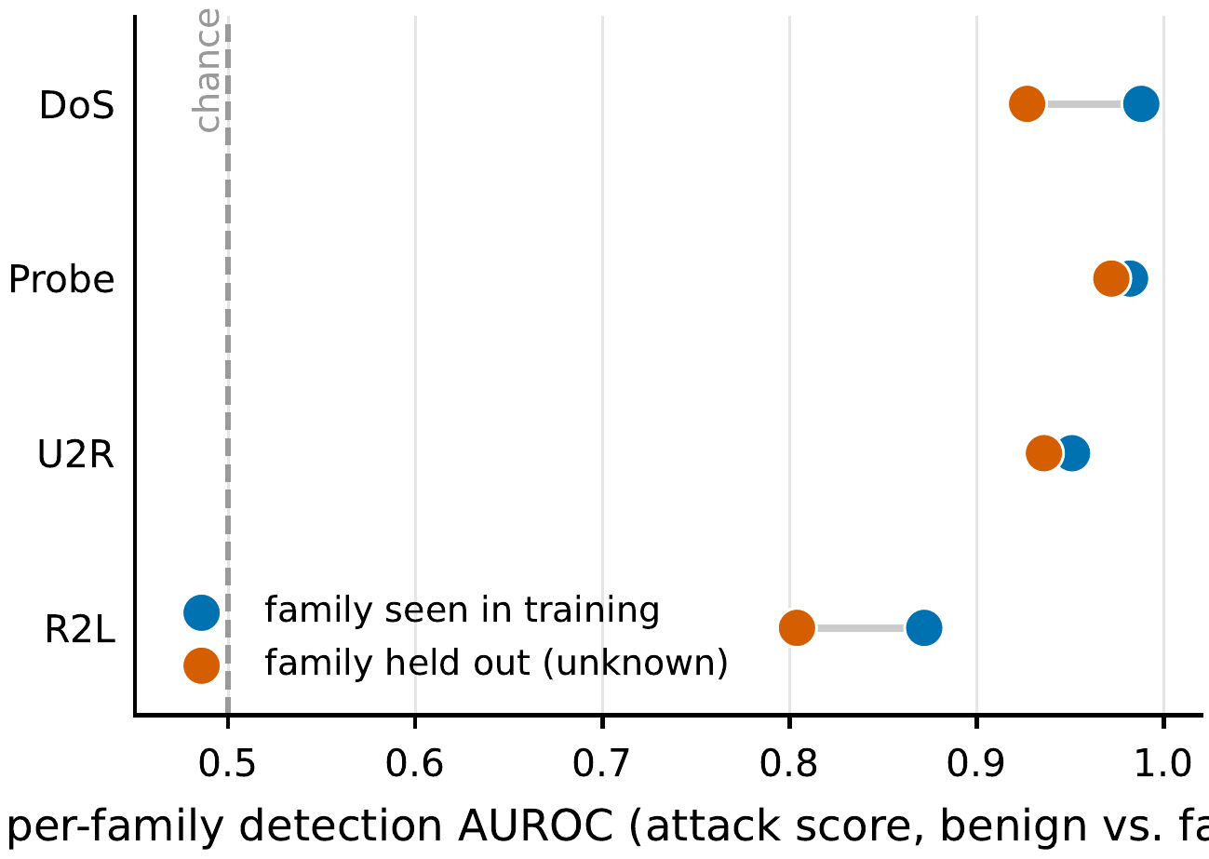
- Per-family detection AUROC, family seen vs. held out of training.

Abstention Helps, If Confidence Is Informative
Fig. 2 shows that abstaining on the least-confident inputs lowers selective risk, but only when the model’s confidence ranks its errors. For gradient boosting, rejecting the least-confident 20% of inputs lowers selective risk to 0.1130 ± 0.0047 (AURC 0.0530 ± 0.0027); the random forest is similar (AURC 0.0604 ± 0.0013). Logistic regression is the cautionary case: its confidence barely ranks its errors (AURC 0.2259 ± 0.0115), so abstention buys little (0.1955 ± 0.0008).
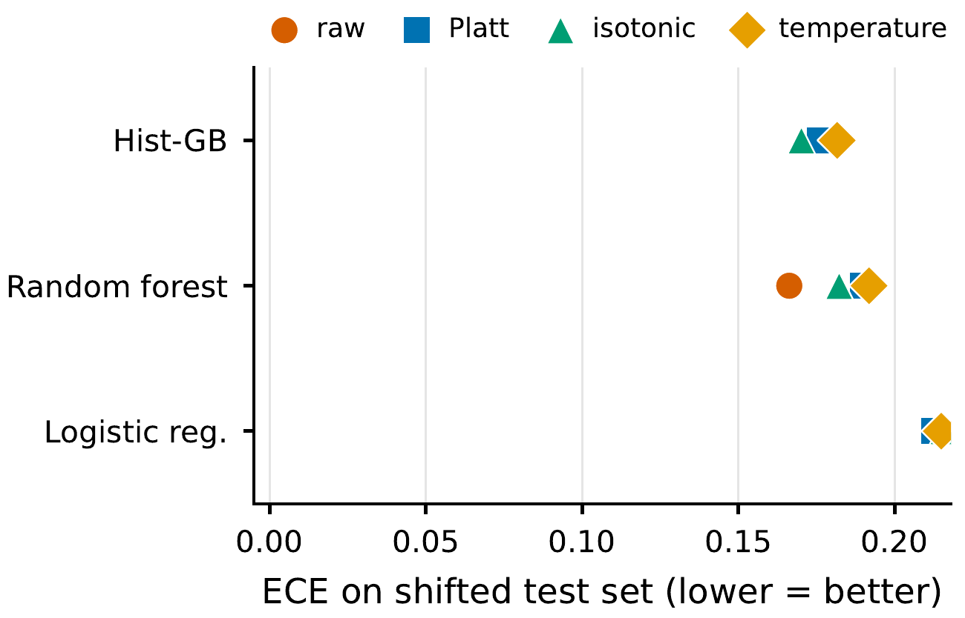
- ECE on the shifted test set, raw and after three post-hoc calibrators.

Leave-One-Family-Out (LOFO): The Operating-Point View
Section IV-B measured detection threshold-free; here is what an operator sees at a fixed operating point under the same LOFO protocol. Table III reports the deployment-time consequences of those threshold-free AUROCs: per family, argmax detection when it is seen in training, when it is held out, and the fraction of unknown-family records abstention rejects at 80% coverage (means over K=10 seeds; 95% CI half-width ≤0.064). At argmax, detection of DoS falls from 0.863 (seen) to 0.603 (unknown) and Probe from 0.788 to 0.426; abstention at 80% coverage then rejects 0.406 and 0.371 of the unknown family, recovering part of the gap. R2L is the worst case (0.003 detected when unknown, only 0.168 rejected by abstention) because R2L overlaps the benign feature manifold for two independent benign-only detectors alike (Fig. 5), and confidence abstention fires on unusual inputs, which R2L is not. As Section IV-B established, this is an operating-point and manifold-overlap effect, not an uninformative score (R2L still scores AUROC 0.804 when unknown).
- LEAVE-ONE-FAMILY-OUT ARGMAX RECALL ON NSL-KDD
Family | det. (seen) | det. (unknown) | rejected by abstention
DoS | 0.863 | 0.603 | 0.406
Probe | 0.788 | 0.426 | 0.371
R2L | 0.073 | 0.003 | 0.168
U2R | 0.175 | 0.049 | 0.61

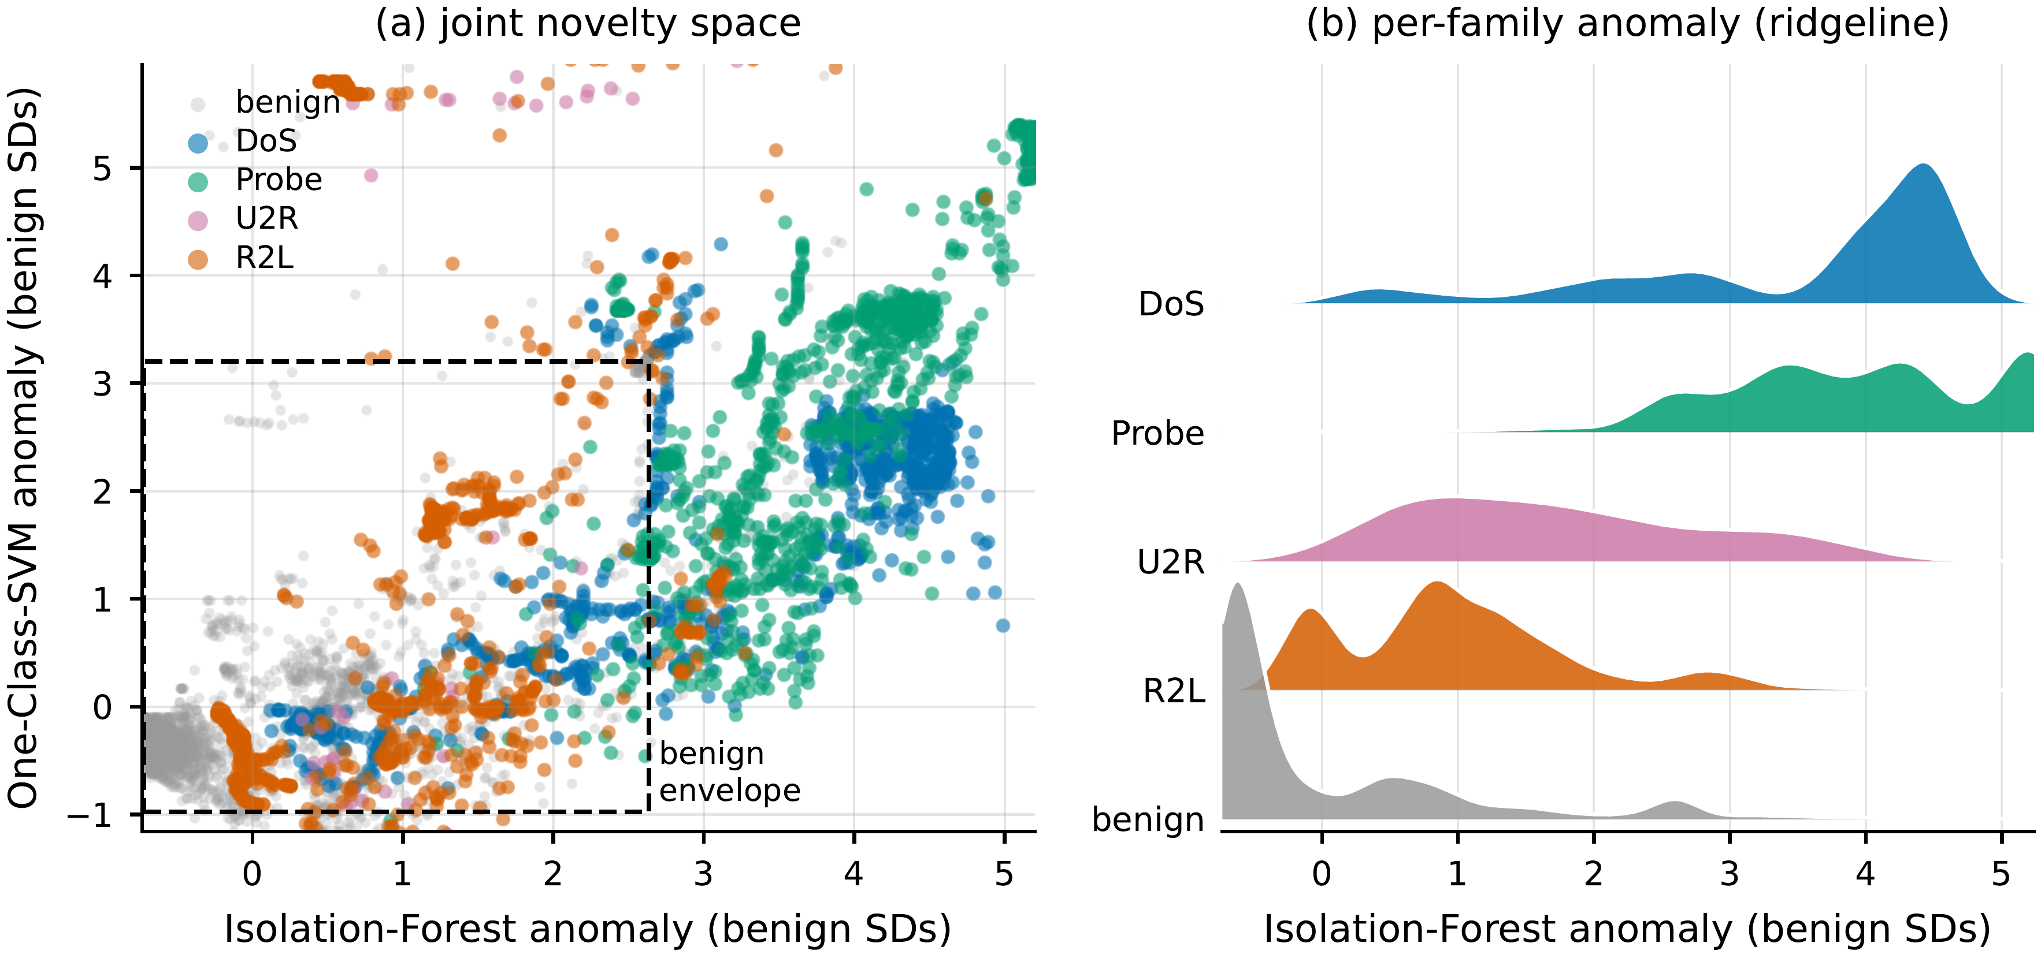
- (a) The joint benign-only novelty space. (b) Per-family Isolation-Forest anomaly ridgeline.

Two Modern Corpora: Calibration Recovers, the Blind Spot Recurs
The dissociation holds across two further corpora, taking the benign-mimicry result beyond n=2. CIC-IDS-2017. Within a random split this flow-based corpus (78 features; DDoS, PortScan, Web) is far easier than NSL-KDD (gradient boosting reaches accuracy 0.9998 at ECE 0.0001) so over-confidence simply disappears: calibration quality is a property of the task, not an intrinsic flaw. Table IV reports all three detectors on this corpus under both a random split and the cross-day split below (K=5 seeds; 95% CI half-width ≤0.0219). Abstention’s value persists under drift: with a cross-day split (train Friday DDoS/PortScan, test Thursday with Web unknown), which avoids the optimistic bias of a random split [11], Web detection falls from 0.9816 to 0.7916 and abstention rejects 0.9516 of unknown Web, more than NSL-KDD’s R2L, because Web flows, unlike R2L, do not mimic benign traffic.
CIC-IDS-2018 (third corpus). Its Infiltration day (150000 flows) is the textbook benign-mimicking family and shows the same qualitative pattern as R2L: well calibrated (ECE 0.006, like CIC-2017), yet the hardest family, under-detected at the global argmax cut (0.251) and only partly recovered by a per-family 10% benign-FPR threshold (0.394). We grade the dissociation rather than claim it uniform, though: Infiltration’s threshold-free score is only moderately discriminative (AUROC 0.708), well below R2L’s 0.872, and its recovered recall trails R2L’s 0.493. So the operating-point reading is cleanest for R2L; for Infiltration part of the miss is representational (the score itself is weaker), not purely a thresholding artifact. The honest three-corpus picture is therefore a graded dissociation, not a uniform one.
- CIC-IDS-2017 METRICS, RANDOM SPLIT AND CROSS-DAY
Model | Acc. | ECE | AURC | r(0.8)
Logistic reg. | 0.9831 | 0.0157 | 0.0016 | 0.0017
Random forest | 0.9998 | 0.0007 | 0.0 | 0.0
Hist. grad. boost. | 0.9998 | 0.0001 | 0.0 | 0.0
Cross-day: Web detection 0.9816→0.7916 (unknown);
abstention rejects 0.9516 of unknown Web at 80% coverage.

Cross-corpus transfer. Training on CIC-2017 and testing on CIC-2018 (the 27 CICFlowMeter features whose names match across releases) is the strongest external-validity test: the phenomena transfer but the guarantees do not. Accuracy falls to 0.674, calibration collapses (ECE 0.2625), and abstention recovers far less than within-corpus (selective risk 0.326→0.269), with Infiltration again the blind spot (detected 0.142; K=5 seeds, CI half-width ≤0.0184).

Which Signal, and Can Coverage Be Guaranteed?
Is max-softmax (MSP) the right abstention signal, and can abstention carry a formal guarantee? On NSL-KDD, MSP is a strong, well-rounded default among classical signals. Random-forest ensemble disagreement is statistically indistinguishable from it (paired ΔAURC -0.0002 ± 0.0003, CI includes 0). Mahalanobis distance ranks errors marginally better (-0.0022 ± 0.0014) but separates unknown attacks worse, and kNN is worse on both (+0.0072 ± 0.0030). The leverage is in the abstention framework, not the estimator. We compare classical signals only: energy- and ODIN-style scores assume a neural net, which we deliberately do not use, so our claim is scoped to off-the-shelf tabular models. For a guarantee, split conformal prediction [12] attains target 0.90 coverage in-distribution (0.930 ± 0.001) but only 0.611 ± 0.002 under the train–test shift [13], the conformal analogue of the Section IV-A calibration failure. Restoring it needs shift-aware weighting with estimable likelihood ratios, impractical for genuine zero-days.

A Benign-Only Novelty Stage Partially Closes the Blind Spot
Confidence-based abstention barely flags R2L (Section IV-D) because such attacks lie on the benign feature manifold. Fig. 5 shows why: panel (a) places each NSL-KDD test record by how anomalous the two benign-only detectors find it, z-scored so benign sits near the origin (the dashed box is the central 95% of benign), and panel (b) is the per-family Isolation-Forest anomaly ridgeline. In both, R2L’s distribution sits on top of benign’s, an overlapping support, while DoS, Probe, and U2R separate, so neither abstention nor a benign-only novelty detector can cleanly flag benign-mimicking R2L. The apt detector for that regime is a benign-only density model, a one-class novelty detector, distinct from the two-class Mahalanobis used above for error ranking. We fit an Isolation Forest [14] and a one-class SVM [15] on benign records only. At a 10% benign false-positive budget the Isolation Forest recovers 0.513 of U2R and 0.243 of R2L (the one-class SVM 0.657 and 0.41; means over K=8 seeds, 95% CI half-width ≤0.036), against abstention’s ≈0.168 for unknown R2L, a clear if partial gain. Fig. 7 orders the families by how cleanly a benign-only model separates them from benign, plotting means with 95% CI whiskers against a dashed chance line; DoS and Probe are easy, while U2R and R2L, the abstention blind spot, are only partially recoverable. Its AUROC ceilings (R2L 0.824, U2R 0.897) show the limit is real but not absolute: R2L is hardest because its support most overlaps benign, so no benign-only detector fully recovers it, yet a novelty stage remains a cheap complement, since abstention and novelty catch different failure modes (confident errors vs. benign-mimicking attacks).
The recipe, re-baselined honestly. Stacking looks like a win only against the argmax cut, a bad threshold for a minority family. We instead compare three policies on held-out (unknown) R2L at the same review budget (0.124): argmax, a global threshold tuned to that budget, and the full stack (argmax/abstention/novelty). Argmax is blind (0.003); a tuned threshold recovers 0.508; the full stack reaches only 0.397, below the tuned threshold at matched cost. Two distinct resamplings agree on no gain. The seed-paired gap is -0.111 (over the six training seeds). Resampling the evaluation distribution of a fixed model gives a gap of -0.058 (95% CI [−0.102,0.002], upper bound ≈0). Fig. 6 sets the three policies side by side at matched analyst cost, as means over K=6 seeds with 95% CIs and a dashed line at the matched review load. The recovery is the operating point, not the gates; even so, the tuned threshold still misses about half of unknown R2L (the stack about 60%). This is not a single-corpus result: Section IV-H repeats the comparison across three review budgets on both unknown R2L and cross-corpus Infiltration, with the same conclusion.
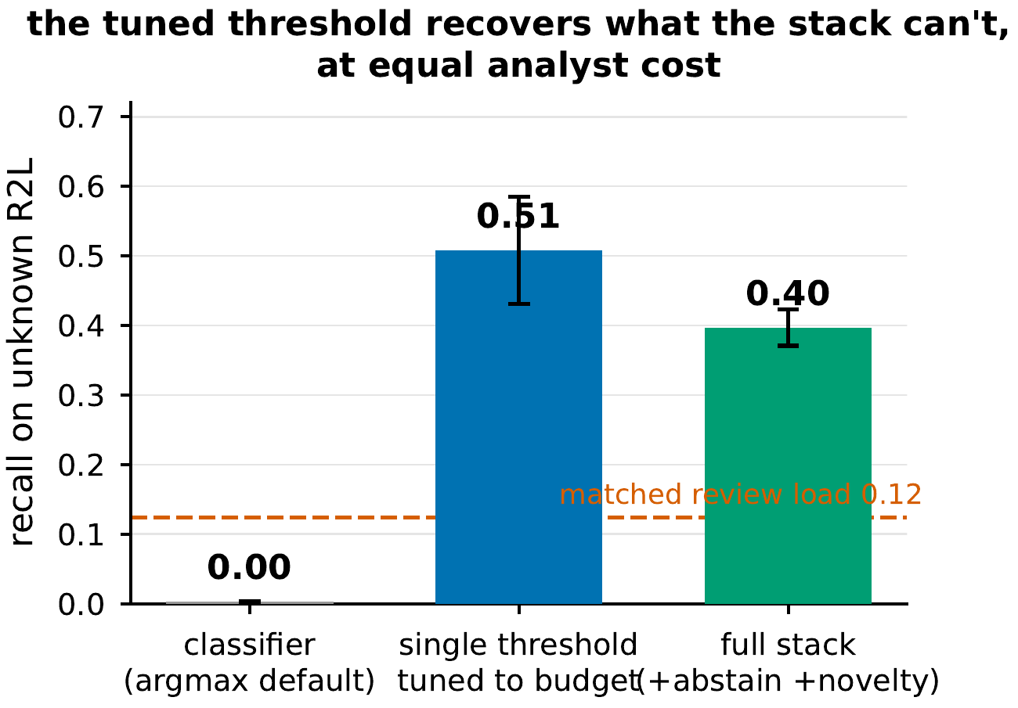
- Unknown-R2L recall at matched analyst cost, for three policies.
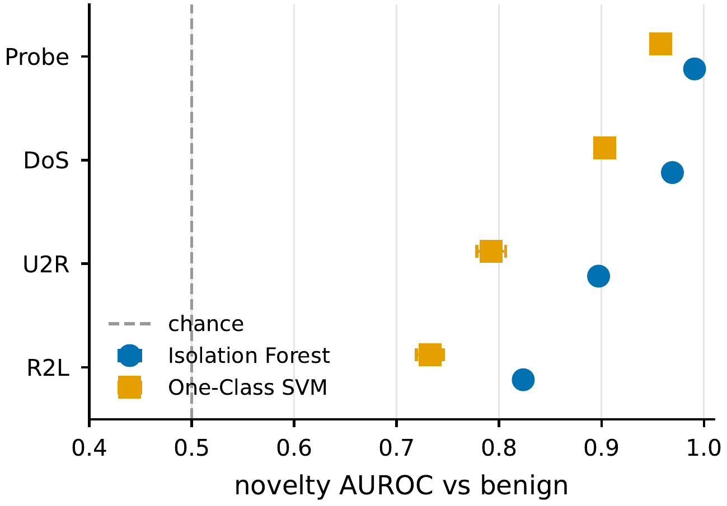
- Benign-only novelty detection: AUROC separating each attack family from benign.

Validating the Fix Across Budgets and Corpora
At a matched analyst review budget b∈{5,10,20}% (benign FPR) we compare a single global threshold tuned to b against the classifier ∪ abstention ∪ novelty stack, on unknown R2L (NSL-KDD) and cross-corpus Infiltration (CIC-2018), over K=6 seeds. The stack beats the tuned threshold in one of six budget×corpus cells (CIC at b=5%, Δ=0.015) and loses the other five, decisively on unknown R2L (Δ=−0.087 at b=10%, −0.389 at 20%); at equal analyst cost the novelty stage adds no recall a budget-tuned threshold does not already deliver, because on a benign-mimicking family the novelty and classifier scores are positively dependent and the union spends extra benign review for little marginal recall. The comparison favours the stack rather than strawmanning it: its gates take generous settings and the tuned-threshold baseline gets the same benign review budget, so the negative result is conservative.

Discussion and Limitations
Selective prediction is a cheap, model-agnostic safety layer, but our results bound the claim. First, the value of abstention is inherited from the confidence signal, a spectrum of quality across models rather than a linear/nonlinear dichotomy. Second, post-hoc calibration on source data does not survive distribution shift, so calibrated probabilities should not be trusted as deployment-time guarantees. The contribution is the diagnosis: the much-cited “detection collapse” on unknown families is largely a thresholding artifact over a score that stays discriminable, not a new defense mechanism. Third, and most important operationally, a single global argmax operating point silently under-detects minority benign-mimicking families (R2L, Infiltration) even though their score is discriminable, and an added abstention/novelty stack does not beat a budget-tuned threshold at matched cost (Section IV-G).

Recommendations
The diagnosis turns into concrete guidance, in order. (1) Pick a model whose confidence ranks errors: low validation AURC, strongest for the tree ensembles, still useful for the neural MLP, and poor for logistic regression (Table I); calibrated probabilities are neither required nor, under shift, achievable post-hoc. (2) Set the operating point to the analyst review budget before reaching for novelty detection: a budget-tuned (ideally per-family) threshold recovers 0.508 of unknown R2L versus 0.003 at argmax, while an abstention/novelty stack adds no recall at matched cost (Section IV-H). (3) Set selective coverage from the risk–coverage curve to a target precision, route the abstained minority to a secondary control, and monitor the abstention rate as a cheap, label-free drift signal [16], [17]. (4) Report bootstrap confidence intervals over the evaluation distribution, not just fixed-partition seed intervals, which understate uncertainty severalfold on a single fixed benchmark.

Limitations
We retain dated, hand-crafted NSL-KDD for comparability with the prior selective-prediction and “detection-collapse” results we revisit; absolute numbers will differ on modern corpora, but the mechanisms we isolate (over-confidence under shift, model-dependent confidence quality, and the operating-point blind spot on benign-mimicking families) reproduce on CIC-IDS-2017 and 2018, so they are not specific to it. We study binary detection with a single abstention signal (maximum class probability); richer signals and the multi-class attack-typing setting are natural extensions. We evaluate a cross-day split and a cross-corpus transfer (CIC-2017→2018) on shared features; a full time-ordered evaluation, the label-corrected CIC-2017 [18], and standardized NetFlow-v2 multi-network transfer remain future work.

Conclusion
Off-the-shelf intrusion detectors are over-confident under NSL-KDD’s shift and not fixable by post-hoc calibration, yet well-calibrated on two modern corpora: calibration need is task-dependent. The second failure recurs on all three corpora but is an operating-point one: a single global threshold silently under-detects minority benign-mimicking families whose attack score is in fact discriminable, so the much-cited “detection collapse” on unknown families is mostly a thresholding artifact. A reject option lowers selective risk where confidence ranks errors, and tuning the operating point to the analyst budget recovers much of the benign-mimicking traffic the argmax default hides, while a stacked novelty gate adds no further recall at matched cost. Selective prediction is worth adding to ML intrusion detection, provided its confidence signal and its blind spots are measured, not assumed.

Acknowledgment
The author used a large language model (Anthropic Claude) to assist with code scaffolding, editing, and literature search. All experiments, results, and claims were verified by the author; the AI system is not an author. Generative-AI use is disclosed per IEEE policy.
1

References
- M. Tavallaee, E. Bagheri, W. Lu, and A. A. Ghorbani, “A detailed analysis of the KDD CUP 99 data set,” in IEEE Symposium on Computational Intelligence for Security and Defense Applications (CISDA), 2009, pp. 1–6.
- J. Platt, “Probabilistic outputs for support vector machines and comparisons to regularized likelihood methods,” in Advances in Large Margin Classifiers, A. J. Smola, P. Bartlett, B. Schölkopf, and D. Schuurmans, Eds. MIT Press, 1999, pp. 61–74.
- C. Guo, G. Pleiss, Y. Sun, and K. Q. Weinberger, “On calibration of modern neural networks,” in International Conference on Machine Learning (ICML), 2017, pp. 1321–1330.
- R. El-Yaniv and Y. Wiener, “On the foundations of noise-free selective classification,” Journal of Machine Learning Research, vol. 11, pp. 1605–1641, 2010.
- Y. Geifman and R. El-Yaniv, “Selective classification for deep neural networks,” in Advances in Neural Information Processing Systems (NeurIPS), 2017, pp. 4878–4887.
- D. Arp, E. Quiring, F. Pendlebury, A. Warnecke, F. Pierazzi, C. Wressnegger, L. Cavallaro, and K. Rieck, “Dos and don’ts of machine learning in computer security,” in USENIX Security Symposium, 2022, pp. 3971–3988.
- A. Niculescu-Mizil and R. Caruana, “Predicting good probabilities with supervised learning,” in International Conference on Machine Learning (ICML), 2005, pp. 625–632.
- D. Hendrycks and K. Gimpel, “A baseline for detecting misclassified and out-of-distribution examples in neural networks,” in International Conference on Learning Representations (ICLR), 2017.
- R. Sommer and V. Paxson, “Outside the closed world: On using machine learning for network intrusion detection,” in IEEE Symposium on Security and Privacy (S&P), 2010, pp. 305–316.
- F. Pedregosa et al., “Scikit-learn: Machine learning in Python,” Journal of Machine Learning Research, vol. 12, pp. 2825–2830, 2011.
- F. Pendlebury, F. Pierazzi, R. Jordaney, J. Kinder, and L. Cavallaro, “TESSERACT: Eliminating experimental bias in malware classification across space and time,” in USENIX Security Symposium, 2019, pp. 729–746.
- A. N. Angelopoulos and S. Bates, “Conformal prediction: A gentle introduction,” Foundations and Trends in Machine Learning, vol. 16, no. 4, pp. 494–591, 2023.
- R. J. Tibshirani, R. Foygel Barber, E. J. Candès, and A. Ramdas, “Conformal prediction under covariate shift,” in Advances in Neural Information Processing Systems (NeurIPS), 2019, pp. 2526–2536.
- F. T. Liu, K. M. Ting, and Z.-H. Zhou, “Isolation forest,” in IEEE International Conference on Data Mining (ICDM), 2008, pp. 413–422.
- B. Schölkopf, J. C. Platt, J. Shawe-Taylor, A. J. Smola, and R. C. Williamson, “Estimating the support of a high-dimensional distribution,” Neural Computation, vol. 13, no. 7, pp. 1443–1471, 2001.
- R. Jordaney, K. Sharad, S. K. Dash, Z. Wang, D. Papini, I. Nouretdinov, and L. Cavallaro, “Transcend: Detecting concept drift in malware classification models,” in USENIX Security Symposium, 2017, pp. 625–642.
- L. Yang, W. Guo, Q. Hao, A. Ciptadi, A. Ahmadzadeh, X. Xing, and G. Wang, “CADE: Detecting and explaining concept drift samples for security applications,” in USENIX Security Symposium, 2021, pp. 2327–2344.
- G. Engelen, V. Rimmer, and W. Joosen, “Troubleshooting an intrusion detection dataset: The CICIDS2017 case study,” in IEEE Security and Privacy Workshops (SPW), 2021, pp. 7–12.

R2L’s recall at the global argmax cut is one quantity measured in three independent experiments: 0.059 here, 0.077 in the per-family panel (Table II), and 0.073 under LOFO (Table III); the ∼0.02 spread is seed and train-split variation, not a discrepancy. U2R’s 0.177/0.175 differ for the same reason.
U2R (train n=52, test n=67) is too rare for its per-seed estimates to support qualitative claims; we list it in Table III for completeness only and draw no conclusions from it.

