Overview

AI Risk
This resource provides an AI Risk score for each Standard Occupational Classification (SOC) code, grouped into five categories: Very High, High, Medium, Low, and Very Low exposure. Occupations with tasks that are repetitive, rules-based, or language-intensive tend to have higher exposure, while those requiring physical skills, in-person interaction, or complex decision-making tend to have lower exposure. Unlike traditional measures, AI Risk combines three dimensions: (1) theoretical task-based exposure, (2) adaptive capacity, and (3) real-world labor market trends (Figure 1).
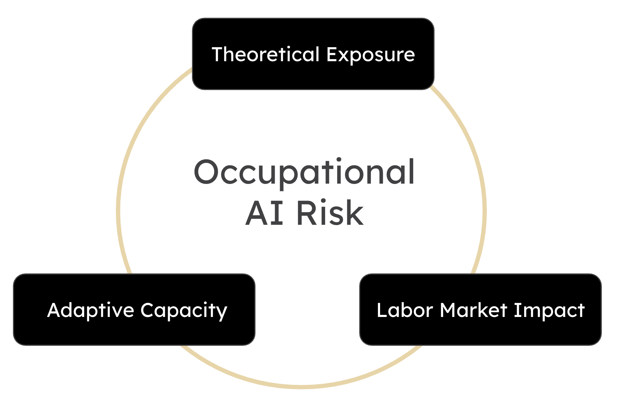
Figure 1. Occupational AI Risk Dimensions
This approach reflects research showing that no single measure fully captures AI’s impact on jobs. By incorporating worker characteristics (such as skill transferability) alongside observed changes in employment and job postings, AI Risk provides a more complete and practical view of how occupations may be affected by AI.

Occupational Transition
occupations with high AI exposure are connected to related occupations with lower exposure to help users explore potential career transitions. Rather than treating occupations in isolation, the approach leverages relationships between occupations to identify feasible pathways into roles that are less susceptible to AI-driven disruption.
For each high-exposure occupation, we surface a curated set of related occupations with lower or moderate exposure levels. We then link these occupations to relevant education and training programs, allowing users to understand not only where they could transition, but also how to get there.

Defining AI Risk

Theoretical Exposure
Organizations including O*NET, the International Labour Organization, Anthropic, and academic researchers have developed independent measures of occupational AI exposure. One of the most widely used is from Tyna Eloundou et al., which estimates how much generative AI can accelerate task completion. However, multiple alternative measures exist, each capturing different dimensions of exposure.
Research from the Yale Budget Lab shows that while these measures tend to align for low-exposure occupations, they diverge substantially for highly exposed roles. For example, one metric may identify web developers as most at risk, while another highlights telemarketers, reflecting differences in how exposure is defined. This variability underscores a key limitation: theoretical exposure alone does not indicate where displacement will occur, how large the effects will be, or how quickly they may materialize.
To address this, we adopt a hybrid approach inspired by the Yale Budget Lab, combining multiple exposure measures into a single index using principal component analysis (PCA). Conceptually, PCA extracts the shared signal across measures by identifying a weighted combination that explains the greatest common variation. If $X_{1},X_{2},…,X_{k}$represent standardized exposure measures, the composite index is:
$$PC_{1}=w_{1}X_{1}+w_{2}X_{2}+⋯+w_{k}X_{k}$$
where weights $w_{j}$ are chosen to maximize explained variance. This produces a more stable, consensus-based estimate of exposure. A complete list of selected AI measures and PCA weights are provided in Table 1.
Table 1. AI Measures and Associated Principal Component Weights
Metric | Source | Measuring | PCA Weight
dv_rating_beta | Eloundou et al. (2024) | GPTs and auxiliary technologies speeding up task completion | 0.426
human_rating_beta | Eloundou et al. (2024) | GPTs and auxiliary technologies speeding up task completion | 0.425
genaiexp_estz_total | Eisfeldt et al. (2023) | Task completion efficiency (all tasks) | 0.419
genai_exp_estz_core | Eisfeldt et al. (2023) | Task completion efficiency (core tasks) | 0.407
AIOE | Felten et al. (2021) | Occupational ability's exposure to various AI applications | 0.410
ai_applicability_score | Tomlinson et al. (2025) | How successfully does the model complete the user's task | 0.359

We exclude the exposure measure developed by Michael Webb, as it captures patent-based technological overlap rather than task-level AI capability. Including this measure did not materially change PCA-derived scores but substantially reduced occupational coverage due to data limitations. As a result, excluding it improved consistency and completeness without affecting overall results.

By integrating multiple theoretical measures into a single composite index, this approach provides a more robust foundation for assessing occupational exposure, while recognizing that exposure alone is only one component of broader labor market risk.

Adaptive Capacity
To complement measures of AI exposure, this analysis incorporates an occupation-level measure of adaptive capacity, following the framework developed by Manning and Aguirre. Adaptive capacity is defined as the ability of workers within an occupation to transition to alternative employment opportunities and mitigate welfare losses in response to technological disruption.
Adaptive capacity is modeled as a composite index capturing multiple dimensions of worker resilience. Let $o$ index occupations. The adaptive capacity score for occupation $o$, denoted $AC_{o}$, is defined as a weighted combination of standardized components:
$$AC_{o}=\sum_{k=1}^{K}{w_{k}}⋅Z_{ok}$$
where:
- $Z_{ok}$ represents the standardized (z-scored) value of component $k$ for occupation $o$,
- $w_{k}$ are weights applied to each component, and
- $K$ is the number of dimensions included in the index.
Following the NBER framework, the index incorporates four primary dimensions:
- Financial Capacity ($Z_{o}^{wealth}$)
Proxied by measures of liquid or net wealth available to workers in the occupation, capturing the ability to withstand periods of unemployment or invest in retraining.
- Skill Transferability ($Z_{o}^{skills}$)
Measures the extent to which an occupation’s skill set can be applied to other occupations. This is typically derived from task or skill similarity metrics (e.g., O*NET-based similarity scores), reflecting the breadth of feasible occupational transitions.
- Local Labor Market Density ($Z_{o}^{density}$)
Captures the availability of alternative employment opportunities within local labor markets, often proxied by occupational employment concentration or job availability across regions.
- Demographic Factors ($Z_{o}^{age}$)
Incorporates age-related characteristics, recognizing that younger workers may have greater flexibility in retraining and occupational mobility relative to older workers.
Each component is standardized:
$$Z_{ok}=\frac{X_{ok}-μ_{k}}{σ_{k}}$$
where $X_{ok}$ is the raw value of component $k$ for occupation $o$, and $μ_{k}$, $σ_{k}$ are the mean and standard deviation across occupations.
In the absence of explicit weighting guidance, equal weights are applied:
$$w_{k}=\frac{1}{K}$$
resulting in a normalized index where higher values indicate greater adaptive capacity.

Labor Market Impact
To estimate how AI is affecting occupations, we apply the Synthetic Control Method (SCM) to both employment and job posting data. This approach allows us to compare observed trends for high AI-exposed occupations to a data-driven counterfactual (ie what would have likely occurred in the absence of recent advances in AI).
Employment estimates were derived from Lightcast OES time series data, which integrates federal Occupational Employment and Wage Statistics (OEWS) with additional modeling to produce consistent, time-indexed occupation-level employment estimates. Job posting data are sourced from Lightcast’s Job Posting Analytics database, which aggregates postings from thousands of online sources and applies deduplication and occupational coding.
Occupations were first classified by AI exposure using our composite AI Risk measure. Occupations in the “High” and “Very High” categories are considered treated units, representing those most exposed to AI capabilities. A donor pool of lower-exposure occupations (Medium, Low, and Very Low) is then constructed to serve as potential comparison units.
To ensure comparability, donor occupations are restricted to those with similar pre-period trends in employment or postings and are drawn from the same major occupational groups.
For each high-exposure occupation, SCM creates a synthetic control, a weighted combination of lower-exposure occupations that closely matches the treated occupation’s pre-AI trend. These weights are optimized so that the synthetic control reproduces the treated occupation’s trajectory prior to the widespread adoption of modern AI systems.
The treatment period is defined as beginning following 2022, corresponding with the rapid diffusion of large language models such as ChatGPT. After constructing the synthetic control, we compared observed outcomes to the counterfactual:
- Employment impact: Difference between actual and synthetic employment levels using Lightcast OES data
- Demand impact: Difference in job postings relative to the synthetic trend
These differences were interpreted as AI-associated deviations, capturing whether high-exposure occupations experienced relative declines, stability, or growth compared to similar, lower-exposure occupations.
We assess model quality using standard SCM diagnostics, including pre-period fit and placebo tests applied to donor occupations. Results are interpreted cautiously: SCM estimates reflect relative changes, not absolute causal effects, and should be understood as indicative of divergence from expected trends rather than definitive measures of displacement.

Integrating Exposures
AI exposure, adaptive capacity and observed labor market changes were combined to assess occupational vulnerability to AI. Let:
- $E_{o}$ denote AI exposure for occupation $o$, derived from task-based measures (e.g., share of tasks exposed),
- $LM_{o}$ denote labor market change indicators (e.g., percent change in employment or job postings), and
- $AC_{o}$ denote adaptive capacity.
We define a composite AI vulnerability index as:
$$V_{o}=E_{o}⋅(1-AC_{o})$$
where:
- Higher $E_{o}$ increases vulnerability,
- Higher $AC_{o}$ reduces vulnerability.
To incorporate observed labor market dynamics, the framework was extended as:
$$V_{o}^{*}=E_{o}⋅(1-AC_{o})⋅f(LM_{o})$$
where $f(LM_{o})$ is a transformation of labor market trends, such as:
$$f(LM_{o})=1-ΔEmployment_{o}\text{or}1-ΔPostings_{o}$$
This allows the model to distinguish between occupations that are highly exposed but currently stable versus those already experiencing declines.

Defining Occupational Transitions

Identifying Related Occupations
We use occupational similarity data from O*NET to identify relationships between occupations. Specifically, we rely on O*NET’s “Related Occupations” framework, which links occupations based on:
- Shared skills (e.g., critical thinking, programming)
- Common work activities (e.g., data analysis, customer interaction)
- Overlapping knowledge domains (e.g., finance, healthcare)
These relationships are precomputed by O*NET using a combination of task similarity and expert validation.
For each high AI-exposure occupation, we extract its set of related occupations and retain those that meet two criteria:
- Lower or moderate AI exposure classification
- Sufficient similarity score, ensuring transitions are realistic in terms of skill transferability
This filtering produces a set of viable transition occupations grounded in empirical similarity measures.

AI Exposure Alignment
Each occupation is assigned an AI exposure level based on a composite measure (described in the methodology section). To construct transition pathways:
- High-exposure occupations serve as the starting point
- Related occupations with lower exposure levels are identified as target roles
- Occupations with equal or higher exposure are excluded from transition recommendations
This ensures that suggested pathways consistently move users toward roles that are less exposed to automation or augmentation risks.

Ranking Transition Pathways
Not all related occupations are equally viable. We rank potential transitions using a combination of:
- O*NET similarity scores (primary driver)
- Exposure reduction magnitude (difference between source and target exposure)
- Optional labor market indicators (e.g., demand, wage levels)
This prioritization ensures that recommended occupations balance feasibility with meaningful risk reduction.

Linking Education and Training Pathways
To translate occupational transitions into actionable steps, we connect target occupations to education and training programs using standardized classification systems:
- Occupations are mapped to instructional programs using a CIP–SOC crosswalk (Classification of Instructional Programs to Standard Occupational Classification)
- Training programs are sourced from state and national education datasets (e.g., community colleges, workforce training providers)
For each target occupation, we identify:
- Relevant degree or certificate programs
- Training providers aligned with occupational requirements
- Program types (e.g., short-term certificates, apprenticeships, associate degrees)

Data Integration Pipeline
The full pipeline integrates multiple data sources:
- Occupation-level AI exposure scores
- O*NET related occupation mappings
- CIP–SOC crosswalks
- Training provider and program data
These datasets are merged at the occupation level, allowing the system to generate transition pathways and associated training opportunities.

Other
X, Y, Z skills were defined by the O*NET database, which includes a rich set of variables that describe work and worker characteristics, including skill requirements. Developers and other customers are encouraged to incorporate the O*NET database within their products, services, and research. (ONET)
  - https://www.onetcenter.org/database.html#all-files

