**Balancing Governance Efficiency and Information Privacy In Urban Governance**

* **Gautham Ravichander and Chintan Vaishnav**

Indian cities have started to embrace technology at an unprecedented pace and are establishing digital governance systems and deploying smart technologies to improve the quality of urban governance and service delivery. These systems are generating data ranging from transactional data, operational data and sensor data, resulting in cities becoming data rich rapidly. With this growth in the availability of digital data, city managers are starting to explore the use of this data for improving decision making, informing governance reforms and catalyzing innovation. A key example of this is India’ draft strategy for the use of AI produced by the NITI Aayog.

At the same time there is a growing legal recognition of the right to privacy and the need to protect citizen privacy and data internationally. Data Protection has been a sensitive topic in India ever since the Supreme Court judgment in August, 2017 holding privacy to be a fundamental constitutional right of every Indian, and the subsequent work by the Srikrishna committee in producing the Personal Data Protection Bill in August, 2018.

In this environment it is hard for busy city managers and policy makers to spend time on the deep thought and analysis needed to strike a balance between using data for driving greater efficiencies in governance and the need to maintain citizen privacy. The first is an imperative for a state machinery that collectively serves 1.2 billion citizens while the second is a bedrock on which trust between citizens and governments will be built and maintained in the 21st century. Current mainstream discourses treat these two needs as being fundamentally opposed, thus resulting in a stalemate that frustrates progress. These discussions cast the tradeoffs and equilibria between governance efficiencies and information privacy as resulting in a zero sum game as shown below. However must this balance between the two neccessarily be a zero sum game?

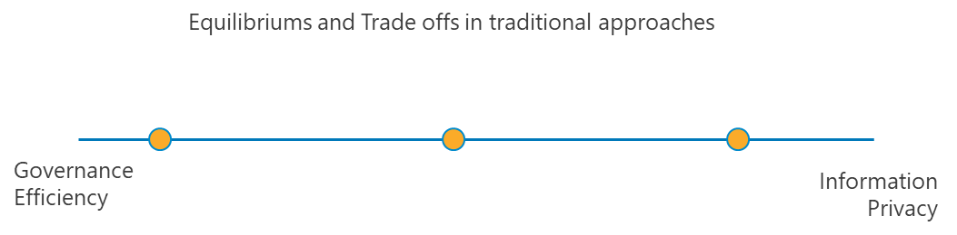

Over the past eighteen months we have been exploring this tension between governance and privacy using a combination of metadata analysis from digital governance systems, field surveys and interviews with government officers. Based on our research we are proposing two numerical indices that not only measure governance efficiency and information privacy, but also offer a way to maximize each:

* A *Governance Efficiency Index (GEI)* – This index measures the delivery of the service within a prescribed timeline (often set forth by a citizen charter) and the accuracy of service delivery (delivering the right service to the right citizen without any rework). In our initial analysis we have not included in this index the cost of service as this information was not available for the initial analysis, however we are confident that in future iterations of the index we will be able to do so, thus providing a more holistic view on governance efficiency.
* An *Information Privacy Index (IPI)* that measures the responsible collection, use and disclosure of citizen data by government agencies. Responsible collection refers to limiting the collection of data to that which enables the government to deliver the service in the first place or to improve the accuracy and efficiency of service delivery (eg: name and address of a person who has applied for a water connection, along with type of connection requested). Responsible use similarly denotes the appropriate application of this data for service delivery in a manner that improves governance efficiency without compromising citizen privacy. This could mean limiting the information shared with employees to only those fields or elements needed to complete the service delivery (eg: a water engineer will not need access to property tax records for the purpose of providing a connection). Responsible disclosure denotes the protection of citizen privacy by minimizing the disclosure of personally identifiable information.

These indices allow us to shift the current conversation to a new construct in which we can have a more nuanced approach on the governance vs privacy debate as shown below:

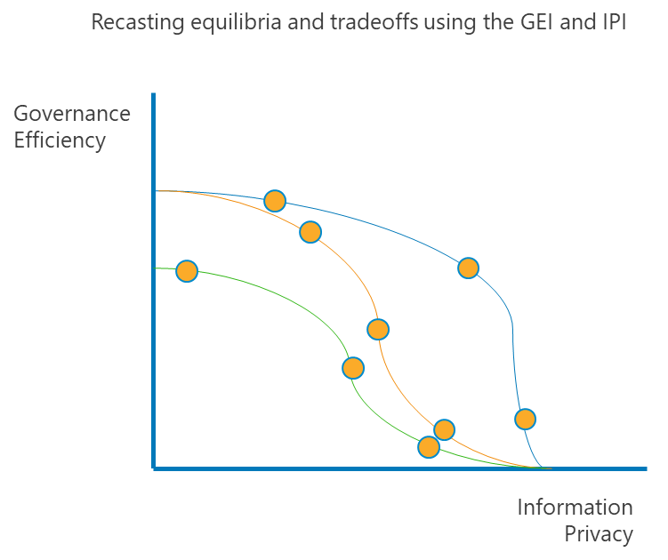

Our research shows that equilibria between governance efficiency and information privacy is not a zero sum game, as shown in the figure above. By calibrating their existing practices around data collection, data use and data disclosure using the GEI and IPI, city managers can achieve a high level of efficiency while ensuring the privacy of citizens’ information is not compromised in a harmful manner. For example, city managers could decide to implement simple rules preventing financial information pertaining to citizens and their properties from being accessed by non-revenue functionaries who do not have a direct need for the information in order to perform their function without reducing the overall quality of service delivery to citizens.

Furthermore by reengineering processes and policies, it might even be possible for the city manager to shift the set of possible equilibria towards further improving both governance efficiency as well as information privacy simultaneously.

The construct of the GEI and IPI has been designed in a manner that allows it to scale from the level of an individual form or service, to entire departments and the city at large, thus enabling more targeted policies. We believe the GEI and IPI could act as a significant tool in helping city managers make decisions on the collection, usage and disclosure of data within their jurisdictions in a structured manner. It is hope that the GEI and IPI will act as a crucial building block for cities to effectively unlock data economies without compromising citizen privacy by identifying which data and data aggregates can be released safely to spur data driven innovation.