IWK (Thailand) Limited
OQ HMI Navigation / Parameter
Machine type: | SC X, TFS 80-X, FPXX-Y
Order no.: | XXXXX
Serial no.: | [Number]
Version: | TEMPLATE

Table of Contents
1 Document History 3
2 Test Procedure 4
2.1 Purpose 4
2.2 Prerequisites 4
2.3 Procedure 5
2.3.1 Special handling of the screens containing parameters 5
2.4 Acceptance Criteria 5
2.5 Handling of the input fields 5
3 Test Protocol 6
3.1 Limit check for parameter input 6
1. “Value input” dialog for Parameters 6
3.2 Limit check for cam control unit 8
2. “Cam control” dialog 8
3.3 Masks 9
3. \ 10
4 Summary 11
4.1 Comments 11
4.2 Approval of test protocol 11

Document History
Version | Change | Date
TEMPLATE | Initial Version | DD-MMM-YYYY

Test Procedure

Purpose
The purpose is to verify that the screen navigation is as specified and that the parameters can only be set within their specified limits.
This document considers: 21 Part 11 Subpart B Chapter 11.10: (h) Use of device (e.g., terminal) checks to determine, as appropriate, the validity of the source of data input or operational instruction.

Prerequisites
The machine is switched on and the language is set to IWK-English. The executing personal is trained to handle the navigation through the different screens and to make entries to the input fields.

Procedure
Log in as the “Administrator”.

Verify the menu structure of the HMI for the SC X, TFS 80-X, FPXX-Y.

- Open and compare the touchscreens that are displayed on the subsequent pages.
- Check that all stated parameters can be accessed and that the displayed parameters are within the specified limits.
- The parameter to be checked is listed in the “Acceptance criterion” and its limits in the “Limits” columns.
Note: Please do not check the displayed values. The figures in the masks are recorded at a specific time, meaning the values shown may differ from those currently displayed on the machine. Additionally, it may be the case that keys are grayed out on the figures, while these buttons can be operated on the machine, provided the user has the corresponding authorizations.
Sometimes elements may be visible on the screen shots which are not visible on the HMI. These are dependent from operation modes (i.e. Jog mode, drive empty and others). To make them visible the respective operation mode needs to be activated.
The handling of access rights for the machine functions are tested in a separate test.

Special handling of the screens containing parameters
The parameters can be accessed by different methods:
- From the Operation menu by pressing the correspondent button (icon displayed on the left side of the screen shot) of a function unit in the machine layout and selecting the respective register.
- By pressing the button “Formats” on the main menu, selecting the current format, pressing button edit and opening the machine station.
The simplest way to access all parameters for testing is to select the different parameter lists via the machine layout selecting the respective register and scrolling through the parameter list.

Acceptance Criteria
The navigation is working correctly; all screens shown in the table below can be accessed.
It is not possible to enter data to input fields outside the limits.
The limits in column Limits are set correctly as listed in the table below.

Handling of the input fields
Touch the input field to display the parameter input dialogue.
For numeric values the limits are displayed on the top of the parameter input mask. Check the limit values in the “Value input” dialogue against the limits shown in this document.
- Table column “Limits” contains the minimum and maximum acceptable values; check the limits.
- If Table column “Limits” contains “Format depending” either for the lower or the upper limit, the respective limit can vary depending on the loaded format and can only be verified for the active format.
(If required create a format report and attach the report to the test protocol. In the format report all limits are listed for the current format specification)

Test Protocol

Limit check for parameter input
This function is checked once for all input fields since all limit checks are performed by the same procedure.
- “Value input” dialog for Parameters
Open the value input dialog for \Service \ User Administration \ General / Password length

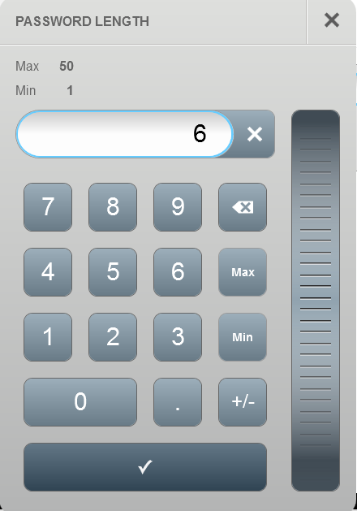

Execute the following test procedure:
- Note the current value of the password length: ___________
- Try to enter a value above the max limit (press button Max and increment the displayed value by 1)
- Try to enter a value below the min limit (press button Min and decrement the displayed value by 1)
- Restore the noted value of the password length
Acceptance criterion | Limits | Pass / Fail: Dev-No. | Date | Initials
It is not possible to enter values out of the limits.
The value is displayed with a red frame.
At value confirmation the window is closed and the value is not transferred into the value display and cannot be transmitted to the control system.

Limit check for cam control unit
This function is checked once for all cam control fields since all cam control checks are performed by the same software module.
All cam control units have the same limits.
- “Cam control” dialog
Number of cams
Switching-on point
Switching-off point
Pre-run correction
Acceptance criterion | Limits | Pass / Fail: Dev-No. |  | Date | Initials
Check one of the cam control units listed below
Number of cams | 1 … 5
Switching-on point | 0 … 359
Switching-off point | 0 … 359
Pre-run correction | Component dependent … Component dependent
“Cam control” units are used on following screens in the HMI
Cross reference |  |  | Name
\ Settings\ Flap transfer \ Flap transfer |  |  | Blow-off air for tube alignment
\ Settings\ Product sensing \ Product sensing |  |  | Monitoring area
\ Settings\ Monitoring, leaflet code \ Monitoring, leaflet code |  |  | Monitoring area
\ Settings\ Monitoring, carton code \ Monitoring, carton code |  |  | Monitoring area
\ Settings\ Inserting \ Insertion |  |  | Monitoring area, product not completely inserted
\ Settings\ Gluing \ Gluing |  |  | Gluing timing, front
\ Settings\ Gluing \ Gluing |  |  | Gluing timing, rear
\ Settings\ Carton imprint \ Printer |  |  | Print area
\ Settings\ Monitoring, carton labeling \ Monitoring, carton labeling |  |  | Monitoring area

Masks
XXXX

Summary

Comments

Approval of test protocol
Acceptance criteria fulfilled? | Yes ◻ | No ◻
Performer: | Date | Signature
Verifier: | Date | Signature

