KARNAVATI UNIVERSITY
UNITEDWORLD INSTITUTE OF TECHNOLOGY
COMPUTER NETWORKS – MINI PROJECT REPORT
DESIGN AND SIMULATION OF A SMALL OFFICE NETWORK
USING VLANs, INTER-VLAN ROUTING, DHCP AND DNS
Submitted by:
Manav Sarvaiya
KUID: KU2407U683
Class: CSE – E
B.Tech. – Semester V
Submitted to:
Department of Computer Science
Unitedworld Institute of Technology
Karnavati University, Gandhinagar, Gujarat
Academic Year: 2026–2027

Abstract
This project presents the design of a small office computer network using Cisco Packet Tracer. The proposed network separates departments into Virtual Local Area Networks (VLANs), enables communication between VLANs through router-on-a-stick inter-VLAN routing, and provides automatic IP configuration through Dynamic Host Configuration Protocol (DHCP). Domain Name System (DNS) is included to demonstrate name-to-IP address resolution. The design improves logical separation, simplifies administration and provides a practical demonstration of core concepts from the Computer Networks syllabus.

1. Introduction
A computer network allows devices to exchange data and share resources. In an office environment, employees from different departments may need access to shared services while remaining logically separated. A flat network places all devices in one broadcast domain, which can make administration and traffic control difficult. VLANs divide a physical switched network into multiple logical networks. Routing is then used when devices in different VLANs need to communicate.
This project models four departments—Administration, Sales, IT and Guest—using separate VLANs. A router provides inter-VLAN routing, while DHCP and DNS services demonstrate network-layer configuration and application-layer name resolution.

2. Problem Statement
Design a manageable small-office network in which departmental devices receive IP settings automatically, remain separated into logical networks, and communicate across departments only through a Layer 3 routing device. The network should also demonstrate DNS name resolution.

3. Objectives
- Create a small-office topology in Cisco Packet Tracer.
- Divide the network into four VLANs for Administration, Sales, IT and Guest users.
- Configure an 802.1Q trunk between the switch and router.
- Configure router subinterfaces for inter-VLAN routing.
- Provide DHCP address allocation for each VLAN.
- Configure DNS records and verify name resolution.
- Test connectivity using ping and other Packet Tracer tools.

4. Syllabus Mapping
Syllabus unit/topic | Project implementation | Learning outcome
Unit I – DNS and network applications | DNS server and a sample domain record | Understand name-to-IP resolution
Unit III – IP addressing and routing | Subnet plan, router subinterfaces and routing | Understand addressing and packet forwarding
Unit III – DHCP | DHCP pools for each VLAN | Automatic host configuration
Unit IV – VLANs and switches | Access VLANs and 802.1Q trunk | Logical LAN segmentation
Practical 6–8 | DHCP server and VLAN configuration | Packet Tracer configuration practice

5. Network Design
The topology contains one router (R1), one managed Layer 2 switch (S1), end devices grouped by department, and a server providing DHCP and DNS services. The router connects to the switch through an 802.1Q trunk. Switch access ports are assigned to the appropriate VLAN.
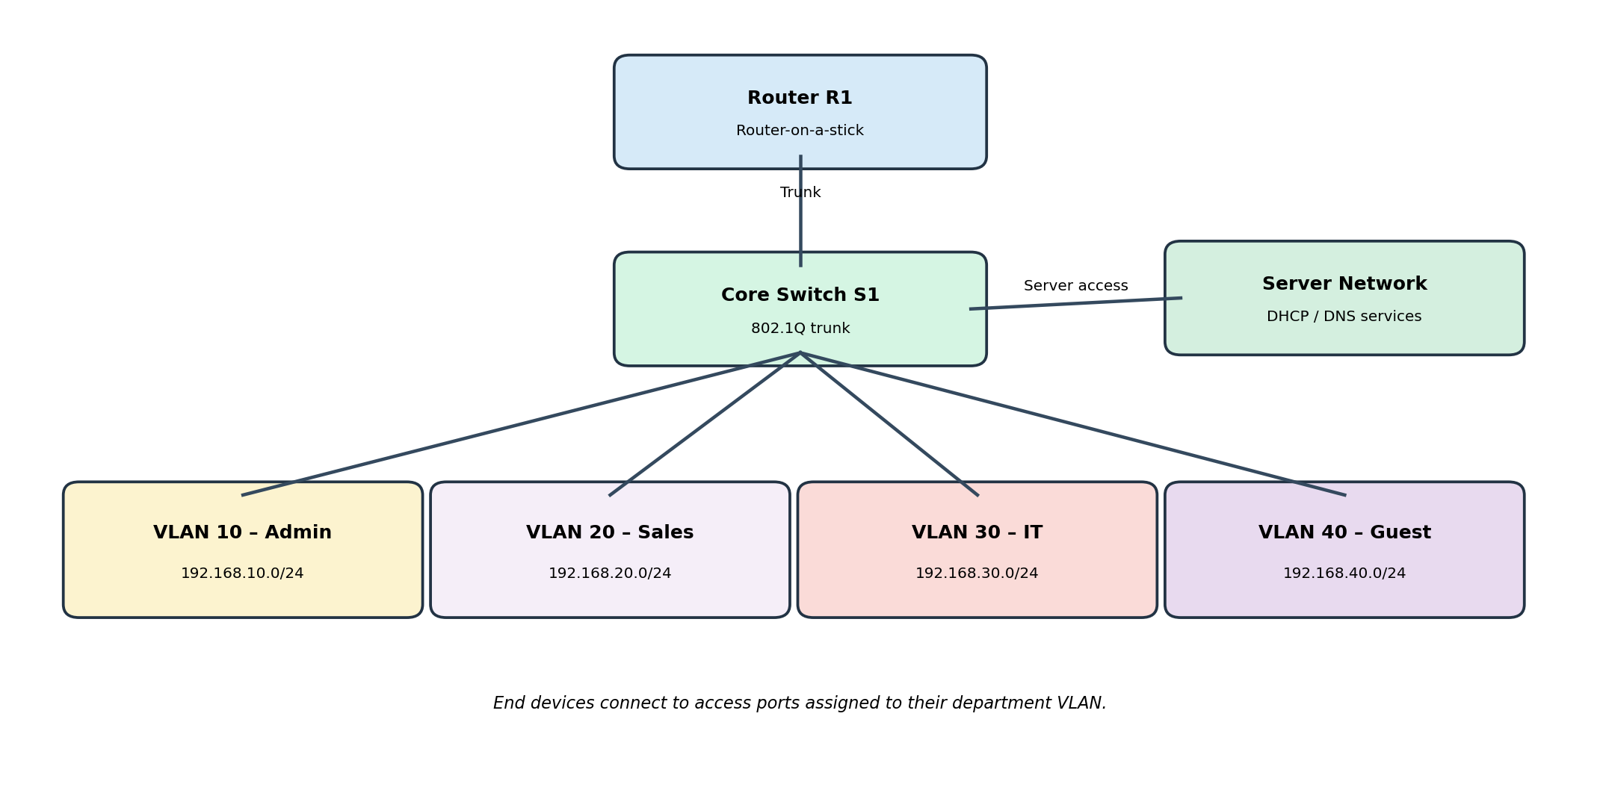
Figure 1: Proposed logical network topology.

5.1 VLAN and IP Addressing Plan
Department | VLAN ID | Network | Default gateway | Example DHCP range
Administration | 10 | 192.168.10.0/24 | 192.168.10.1 | 192.168.10.100–199
Sales | 20 | 192.168.20.0/24 | 192.168.20.1 | 192.168.20.100–199
IT | 30 | 192.168.30.0/24 | 192.168.30.1 | 192.168.30.100–199
Guest | 40 | 192.168.40.0/24 | 192.168.40.1 | 192.168.40.100–199
Server network | 50 | 192.168.50.0/24 | 192.168.50.1 | Static server addresses
The example ranges are illustrative. The DHCP server address, DNS server address and gateway should be reserved or excluded from dynamic pools to prevent address conflicts.

6. Technologies and Protocols Used

6.1 VLAN (Virtual Local Area Network)
A VLAN is a logical grouping of switch ports that creates a separate Layer 2 broadcast domain. Devices in different VLANs do not communicate directly at Layer 2; communication between them requires routing. VLANs help organize users by department and reduce unnecessary broadcast traffic.

6.2 Inter-VLAN Routing
Inter-VLAN routing enables devices in different VLANs to communicate. In this design, router-on-a-stick is used: one physical router interface carries multiple VLANs using IEEE 802.1Q tags. A logical subinterface is configured for each VLAN, and each subinterface acts as that VLAN’s default gateway.

6.3 DHCP
DHCP automatically provides hosts with configuration parameters such as an IP address, subnet mask, default gateway and DNS server. A DHCP pool is created for each subnet. If the DHCP server is on a different subnet, a DHCP relay (for example, the router’s ip helper-address feature) is required so that client broadcasts can reach the server.

6.4 DNS
DNS translates human-readable domain names into IP addresses. A DNS server can host a record such as intranet.office.local pointing to the internal web server address. A client configured with the DNS server address can resolve the name instead of remembering the numeric IP address.

7. Implementation Procedure
- Open Cisco Packet Tracer and place one router, one managed switch, end devices for each department and a server.
- Connect the router to the switch using a Gigabit Ethernet link. Connect PCs to switch access ports.
- Create VLANs 10, 20, 30, 40 and 50 on the switch.
- Assign each department’s access ports to its corresponding VLAN. Configure the router-facing switch port as an 802.1Q trunk.
- Configure router subinterfaces for VLANs 10, 20, 30, 40 and 50. Assign each subinterface the gateway address from the addressing table and enable the physical interface.
- Configure DHCP pools for the client VLANs, or configure a dedicated server with separate scopes. Exclude gateway and reserved addresses.
- If DHCP is hosted in the server VLAN, configure DHCP relay on the client VLAN router interfaces using the server’s IP address.
- Assign a static IP address to the DNS server and enable its DNS service. Add a sample A record such as intranet.office.local.
- Set client PCs to obtain IP configuration automatically and configure the DNS server address.
- Test same-VLAN communication, inter-VLAN communication, DHCP allocation and DNS name resolution.

8. Illustrative Cisco IOS Configuration
The following is a reference configuration for a router-on-a-stick design. Interface names and switch port numbers must be adapted to the Packet Tracer devices used.
! Switch S1 (example)
enable
configure terminal
vlan 10
name ADMIN
vlan 20
name SALES
vlan 30
name IT
vlan 40
name GUEST
vlan 50
name SERVERS
!
interface gigabitEthernet 0/1
switchport mode trunk
!
interface range fastEthernet 0/1-5
switchport mode access
switchport access vlan 10
!
! Router R1 (example)
enable
configure terminal
interface gigabitEthernet 0/0
no shutdown
!
interface gigabitEthernet 0/0.10
encapsulation dot1Q 10
ip address 192.168.10.1 255.255.255.0
interface gigabitEthernet 0/0.20
encapsulation dot1Q 20
ip address 192.168.20.1 255.255.255.0
interface gigabitEthernet 0/0.30
encapsulation dot1Q 30
ip address 192.168.30.1 255.255.255.0
interface gigabitEthernet 0/0.40
encapsulation dot1Q 40
ip address 192.168.40.1 255.255.255.0
interface gigabitEthernet 0/0.50
encapsulation dot1Q 50
ip address 192.168.50.1 255.255.255.0
!
! Example DHCP relay (if DHCP server is 192.168.50.10)
interface gigabitEthernet 0/0.10
ip helper-address 192.168.50.10

9. Testing and Verification
Test | Expected result | Purpose
PC obtains DHCP settings | Valid IP, mask, gateway and DNS server | Verify automatic configuration
Ping gateway from each VLAN | Successful replies | Verify local gateway reachability
Ping between VLANs | Successful if routing and policy allow it | Verify inter-VLAN routing
Resolve intranet.office.local | Returns configured server IP | Verify DNS
Check VLAN membership | Ports appear in intended VLAN | Verify segmentation
Check trunk status | Trunk carries required VLANs | Verify switch-router link
No Packet Tracer execution screenshots or measured test results are claimed in this report. The table lists the tests to perform and the expected outcomes; actual results should be recorded after implementing the topology.

10. Expected Results
- Each department’s devices belong to a separate VLAN and subnet.
- Client devices receive network settings automatically through DHCP.
- The router forwards traffic between VLANs when permitted.
- Clients can resolve the configured internal domain name using DNS.
- Network troubleshooting becomes easier because VLANs and subnets provide a clear structure.

11. Advantages
- Logical separation of departments without requiring separate physical switches.
- Centralized and consistent IP configuration through DHCP.
- Easy-to-understand addressing and administration.
- DNS makes internal services easier to access.
- Scalable design: additional VLANs and subnets can be added as the office grows.

12. Limitations and Future Scope
- The topology is a simulation and does not measure real-world throughput or wireless coverage.
- A single router and switch create single points of failure.
- Guest VLAN access should be restricted using ACLs or firewall policies in a production network.
- Future improvements can include redundant switches/routers, dynamic routing, wireless access points, monitoring and stronger access-control policies.

13. Conclusion
The project demonstrates how VLANs, inter-VLAN routing, DHCP and DNS work together in a small office network. It connects concepts from the Application, Network and Link layers with practical configuration tasks. Cisco Packet Tracer provides a safe environment to build the topology, configure network devices and verify connectivity before deploying a similar design in a real environment.

14. References
- Kurose, J. F. and Ross, K. W., Computer Networking: A Top-Down Approach, Pearson.
- Forouzan, B. A., Data Communications and Networking.
- Cisco Networking Academy, Packet Tracer: https://www.netacad.com/courses/packet-tracer
- Computer Networks course syllabus, Unitedworld Institute of Technology, Karnavati University (uploaded course syllabus).

