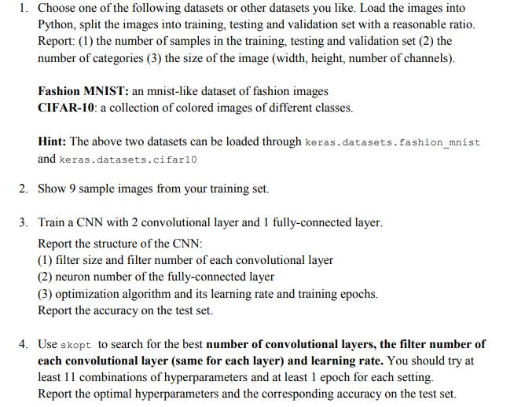

answer:

1.

(1)(3):

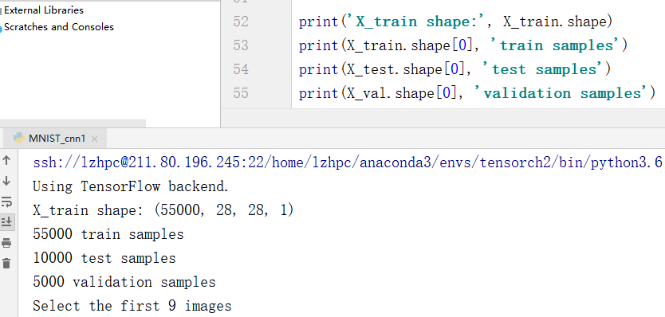

The number of samples in training,testing and validation set

respectively are 55000,10000,5000.

the size of the image(width,height,number of channels) is (28,28,1) .

1. :

IMG_256

the number of categories is ten.

2.

the 9 sample images from training set as follows.

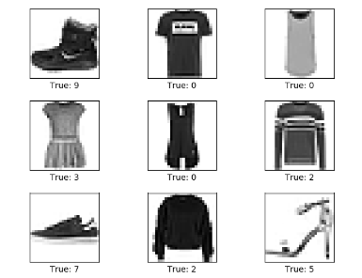

3.

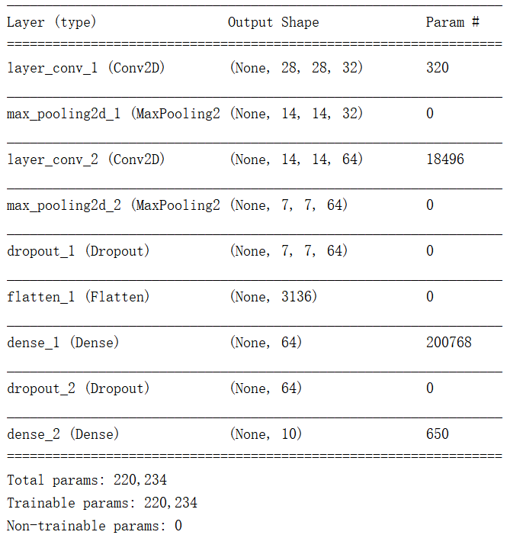

(1)filter size is 3\*3,the filter numbers of each convolutional layer respectively are 32 and 64.

(2)the neuron number of fc is 64.

(3)optimization: Adam the lr is 1e-3 when epochs is before 12 epochs,after 12epochs,the lr is 1e-4.

4.

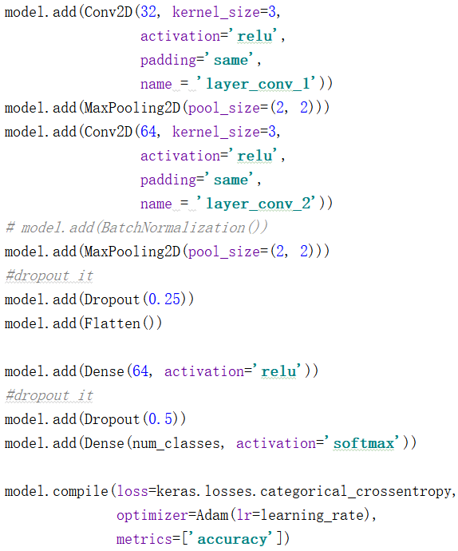

IMG_256

Skopt:the best acc is 0.9205.the best lr=1e-3

Conv filter size is 3\*3