**Project Report**

**On**

**“Student Management System”**



**Submitted By: Guided By:**

1. Gunjan Agrawal Mr. Sanjay Rathore

2. Kaushal Kishor Agrawal GRRAS SOLUTION Pvt. Ltd., Jaipur

**Student Management System**

**A Project Report Submitted**

**in Partial Fulfillment of the Requirements**

**for the Degree of**

**Bachelor of Technology**



**Swami Keshvanand Institue Of Technology, M & G, Jaipur**

**(Department of Information Technology)**

**RAJASTHAN TECHNICAL UNIVERSITY**

**CERTIFICATE**

This is to certify that the Industrial Training Project Report entitled Student Management System, submitted to the Department of Information Technology, Swami Keshvanand Institute Of Technology, Jaipur, for partial fulfilment of the Degree of Bachelor of Technology of Rajasthan Technical University, is a record of bona fide work carried out by Mr. Kaushal Kishor Agrawal, Roll No. 16ESKIT053, under our supervision and guidance.

All help received by her from various sources have been duly acknowledged.

**Acknowledgements**

The satisfaction that accompanies the successful completion of any project work would be impossible without the mention of the people who made it possible and whose constant guidance and encouragement crown all the efforts. This thesis was only an endeavor but also an interesting learning experience for me and it bears the imprint of a number of people who directly or indirectly were a great source of help and constant encouragement.

I would like to express my sincere thanks to my mentor Mr. Vipin Jain for his continuous motivation. Her valuable suggestions, comments and support were an immense help for me. I am grateful to her for taking out time from their busy schedule and being very supportive in guiding my work.

I would also like to thank the supervisors Mr. Sanjay Rathore, Mr. Ankush and Mr. Rajat Goyal for helping and guiding me throughout with the technical issues.

I am also very grateful to Dr. Anil Choudhary (HOD, IT) for his kind support. I would like to take this opportunity to show my gratitude towards Mr. Jaipal Meel (Director) who helped me in successful completion of my Industrial Training. They have guided, motivated & were source of inspiration for me to carry out then necessary proceedings for the training to be completed successfully.

Lastly but most importantly, I would also like to thank my father Mr. Vedprakash Gupta, my mother Indra Gupta and my sister Komal Agrawal for their constant source of encouragement. It would be impossible to stand here at the end of the road without their endless love, constant support and motivation. I also want to express my gratitude to my friend Gunjan Agrawal whose direct or indirect suggestions help me to develop this project.

Kaushal Kishor Agrawal

**ABSTRACT**

Student Management System can be used by education institutes to maintain the records of students easily. Achieving this objective is difficult using a manual system as the information is scattered, can be redundant and collecting relevant information may be very time consuming. All these problems are solved using this project.

**CONTENTS**

**Certificate I**

**Acknowledgement II**

**Abstract III**

**Chapter 1. Introduction 01**

**1.1 Introduction. . . . . . . . . . . . . . . . . . . . . . . . . . . . . . . . .. .**

**1.2 Purpose. . . . . . . . . . . . . . . . . . . . . . . . . . . . . . . . . . . . . . ..**

**1.3 Scope. . . . . . . . . . . . . . . . . . . . . . . . . . . . . . . . . . . .**

**1.4 Features. . . . . . . . . . . . . . . . . . . . . . . . . . . . . ..**

**1.5 Overview**

**1.6 Technology Used**

**Chapter 2: Software Requirement Specification 04**

**2.1 Proposed. . . . . . . . . . . . . . . . . . . . . . . . . . . . . . . . . . .**

**2.2 Scope. . . . . . . . . . . . . . . . . . . . . . . . . . . . . . . . . . . . . . . .**

**2.3 Specific Requirement . . . . . . . . . . . . . . . . . . . . . . . . . . .**

**2.3.1 Software Requirement. . . . . . . . . . . . . . . . . . . . . . . . . . . . .**

**2.3.2 Hardware Requirement**

**2.4 Constrain . . . . . . . . . . . . . . . . . . . . . . . . . . . . . . . . . . . .**

**2.5 Conclusion . . . . . . . . . . . . . . . . . . . . . . . . . . . . . . . . . .**

**Chapter 3: Design**

**3.1 Data Tables**

**3.2 ER Diagram**

**3.3 Data Flow Diagram**

**Chapter 4: Testing and Validation 08**

**4.1 Introduction. . . . . . . . . . . . . . . . . . . . . . . . . . . . . . . . . . .**

**4.2 Design of Test Case. . . . . . . . . . . . . . . . . . . . . . . . . . . . .**

**4.3 Validation . . . . . . . . . . . . . . . . . . . . . . . . . . . . . . . . . . . .**

**4.4 Conclusion . . . . . . . . . . . . . . . . . . . . . . . . . . . . . . . . . . .**

**Chapter 5: Project Footprints**

**5.1 Screen Shots**

**5.2 Bibliography**

**5.3 Future Scope**

**Chapter: 1**

**INTRODUCTION**

* 1. **Introduction**

Student management system is an environment where all the process of the student in the institution is managed. It is done through the automated computerized method. Conventionally this system is done using papers, file and binders. This system saves the time of the student and of the administrator. It includes process like registration of the student’s details, assigning the department based on their course and maintenance of the record.

* 1. **Purpose**

The objective of Student information System is to allow the administrator of any organization to edit and find out the personal details of a student and allows the student to keep up to date his profile .It’ll also facilitate keeping all the records of students, such as their id, name, mailing address, phone number, DOB etc. So all the information about an student will be available in a few seconds. Overall, it’ll make Student Information Management an easier job for the administrator and the student of any organization. The main purpose of this SRS document is to illustrate the requirements of the project Student information System and is intended to help any organization to maintain and manage its student’s personal data.

* 1. **Scope**

Without a Student information System, managing and maintaining the details of the student is a tedious job for any organization. Student Information system will store all the details of the students including their background information, educational qualifications, personal details and all the information related to their resume.

**1.4 Features**

* Secure
* Easy to use
* Reliable and accurate
* Update and Delete Of records are there

**1.5 Overview**

* Student Management System has following stages

**For Admin-**

* Create Student
* Create Teacher
* View Students
* View Teachers
* Add Courses
* View Courses
* Upload Assignment
* View Assignment
* Submitted Assignment
* Users

**For Teacher-**

* Profile
* Upload Assignment
* View Assignment
* Submitted Assignment
* Login Details

**For Student-**

* Profile
* View Assignment
* Submit Assignment
* Login Details

**1.6 Technologies Used**

* Front end as:

HTML, CSS, BOOTSTRAP, JS, Angular

* Back end as:

Express, Node

* Database:

MongoDB

**1.7 Objective of proposed system**

• Economic feasibility

• Time Flexibility

• Technical feasibility

• User-friendly interface

• Eco-Friendly System

**Chapter: 2**

**Software Requirement Specification**

**2.1** **Product Perspective**

The website Student Management System is aimed towards recording a considerable number of student records and needs online assistance for managing records of students. Website should be user-friendly, ‘quick to learn’ and reliable website for the above purpose. Student Management System is intended to be a stand-alone product and should not depend on the availability of other website. The system will also have an administrator who has full-fledged rights with regards to performing all actions related to control and management of the website.

**2.2 Product Function**

There are two different users who will be using this product:

Administrator who can view and edit the details of any students.

Students who can view their details as well as they can edit their details.

**The features that are available to the Administrator are:** An Administrator can login into the system and perform any of the available operations. Can enable/disable student. Can edit student information to the database. Can make search for a specific student. Can access all the details of the student.

**The features that are available to the Student are:** Student can login into the system and can perform any of the available options. Can view his/her personal details. Can edit his/her personal details Can upload his/her resume. Can upload his/her image.

**2.3 Specific requirements**

**2.3.1 Software requirement (TECHNOLOGIES USED)**

***Front end as:***

HTML, CSS, JS, Angular

***Back end as:***

Express, Node

***Database:***

MongoDB

*Operating System:*

Windows 10.1

**2.3.2** **Hardware Requirement**

• Browser: Chrome

• Processor: Pentium 2.0 and above.

• RAM: 256 MB Server Side:

• Processor: Pentium and above.

• RAM: 4GB and Above

• Hard disk space: 4GB 2.4 User Requirements Every user should be:

• Comfortably work with computer.

• User must also have basic knowledge of English.

**2.5 Constraints**

• Graphical user interface is only in English.

• Enrolment email id and password is used for identification of user.

• Only registered users will be authorized to use the services.

• *Limited to HTTP or HTTPS.*

*• This system is working for single server.*

**2.6 Conclusion**

In this phase, we understand the software requirement specifications for the system. We arrange all the required components to develop the project in this phase itself so that we will have a clear idea regarding the requirements before designing the project. Thus, we will proceed to the design phase followed by the implementation phase of the project.

**Chapter: 3**

**3.1Data Tables**

**ADMIN:**

|  |  |  |
| --- | --- | --- |
| **S. No.** | **Field Name** | **Description** |
| **1.** | **Create Students** | Create a Details of new student |
| **2.** | **Create Teacher** | Create a details of new teacher |
| **3.** | **View Students** | View the details of every students |
| **4.** | **View Teachers** | View the details of every teachers |
| **5.** | **Add Courses** | Create courses with course id |
| **6.** | **View Courses** | View course with course id |
| **7.** | **Upload Assignment** | Can upload assignment via teacher and admin |
| **8.** | **View Assignment** | Can View Assignment which has been upload |
| **9.** | **Submitted Assignment** | Can view Assignment which has been submitted by students |
| **10.** | **Users** | Can view Users which has been signup account |

**TEACHER:**

|  |  |  |
| --- | --- | --- |
| **S. No.** | **Field Name** | **Description** |
| **1.** | **Profile** | Can view Personal Details |
| **2.** | **Upload Assignment** | Can upload assignment to the students |
| **3.** | **View Assignment** | Can view assignment which has been uploaded |
| **4.** | **Submitted Assignment** | Can view Assignment which has been submitted by Student |
| **5.** | **Login Details** | Can View login details and update the details |

**STUDENT:**

|  |  |  |
| --- | --- | --- |
| **S. No.** | **Field Name** | **Description** |
| **1.** | **Profile** | Can view Personal Details |
| **2.** | **View Assignment** | Can view assignment which has been uploaded by teacher |
| **3.** | **Submit Assignment** | Can submit assignment which has been given by teacher |
| **4.** | **Login Details** | Can view login details and update the details |

**3.2 Entity Relationship Diagram**

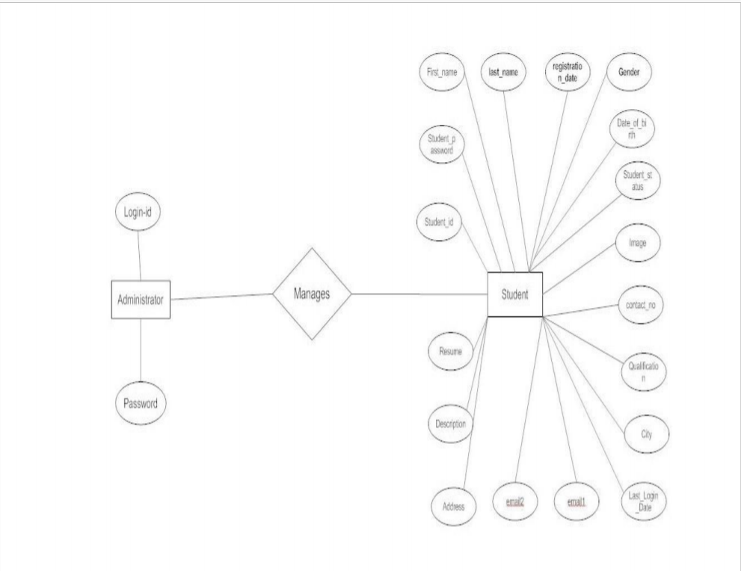

**3.3 Data Flow Diagram**

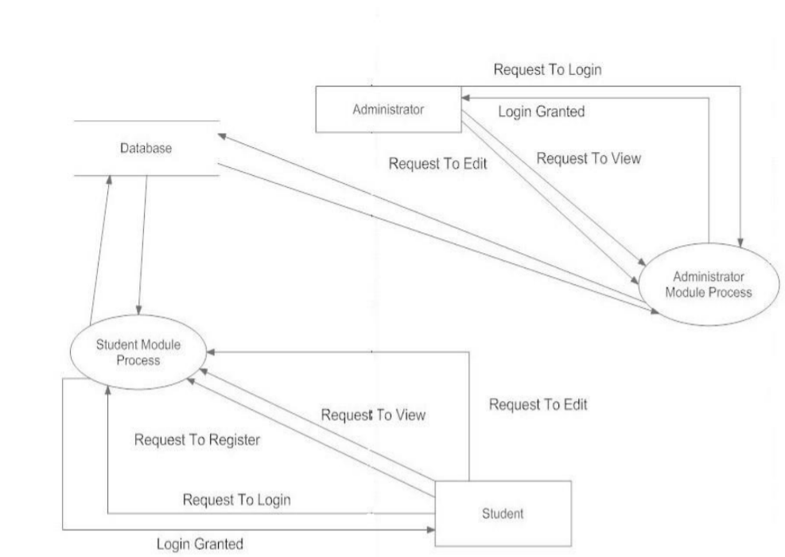

**Chapter: 4**

**Testing and Validation**

**4.1 Introduction**

Software testing is a critical element of software quality assurance and represents the ultimate review of specification, design and coding. In fact, testing is the one step in the software engineering process that could be viewed as destructive rather than constructive.

A strategy for software testing integrates software test case design methods into a well-planned series of steps that result in the successful construction of software.

Testing is the set of activities that can be planned in advance and conducted systematically. The underlying motivation of program testing is to affirm software quality with methods that can economically and effectively apply to both strategic to both large and small-scale systems.

**4.2 Design of test cases & scenario**

The objective is to design tests that systematically uncover different classes of errors and do so with a minimum amount of time and effort. Testing cannot show the absence of defects, it can only show that software defects are present.

**4.2.1 System Testing**

Software is only one component of a system. Software will be incorporated with other system components and system integration and validation test performance.

**4.2.2 Validation Testing**

Validation aims to demonstrate that the software functions in a manner that can be reasonably expected by the user. An experiment has done for checking the consistency for the user requirements regarding the username and password which should be validated through the server and the username and password should be matched.

**4.4 Conclusion**

In this way we also completed the testing phase of the project and ensured that the system is ready to go live.

**Chapter: 5**

**Project Footprints**

**5.1 Screen Shots**

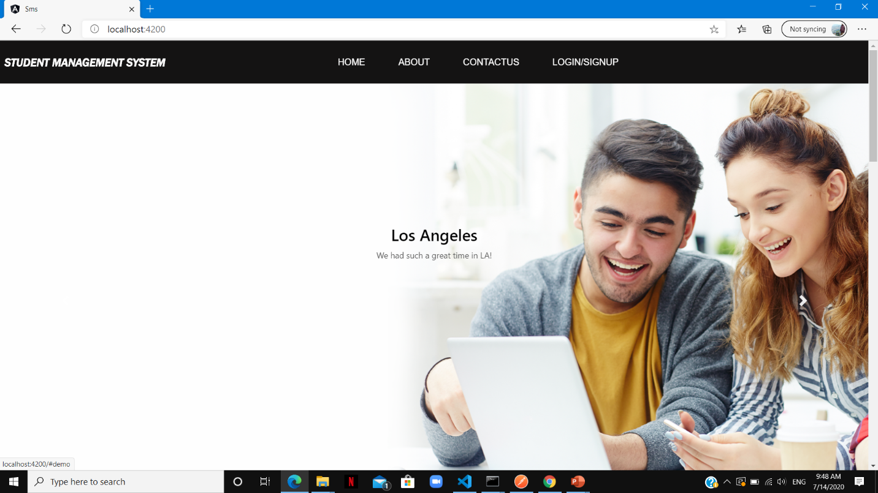

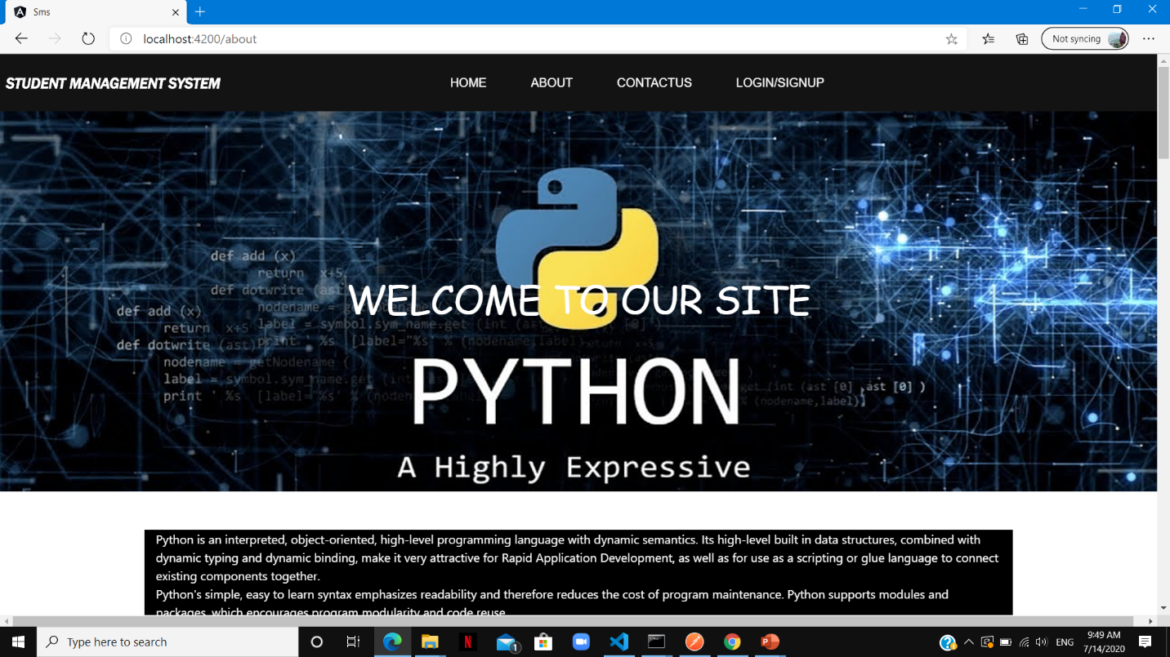

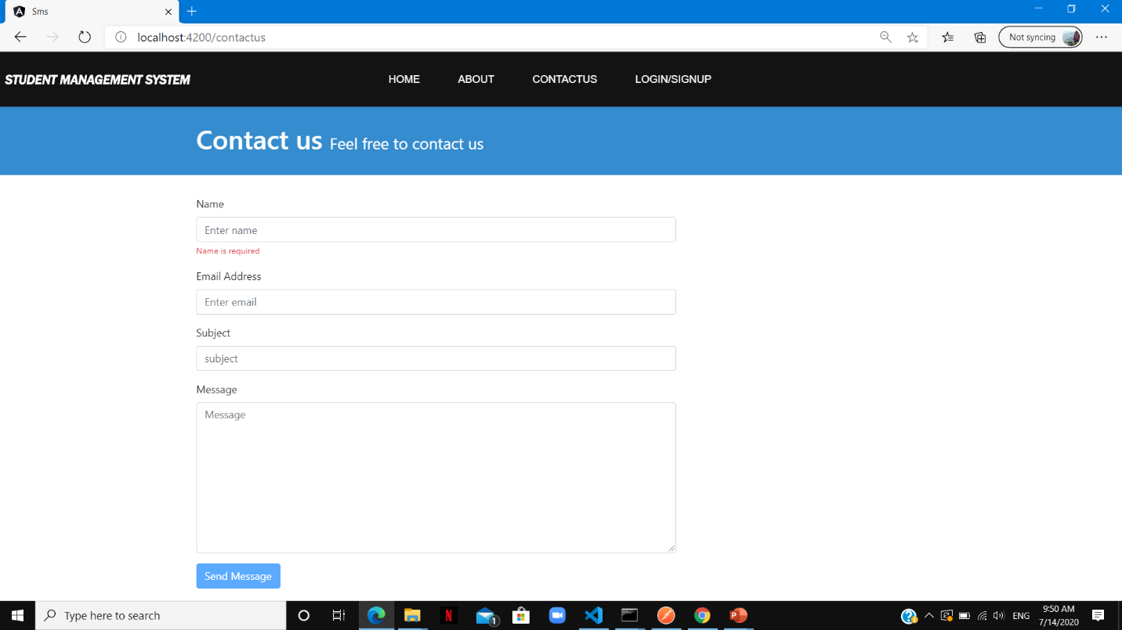

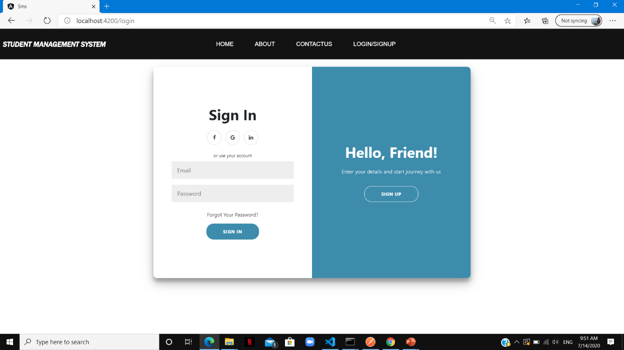

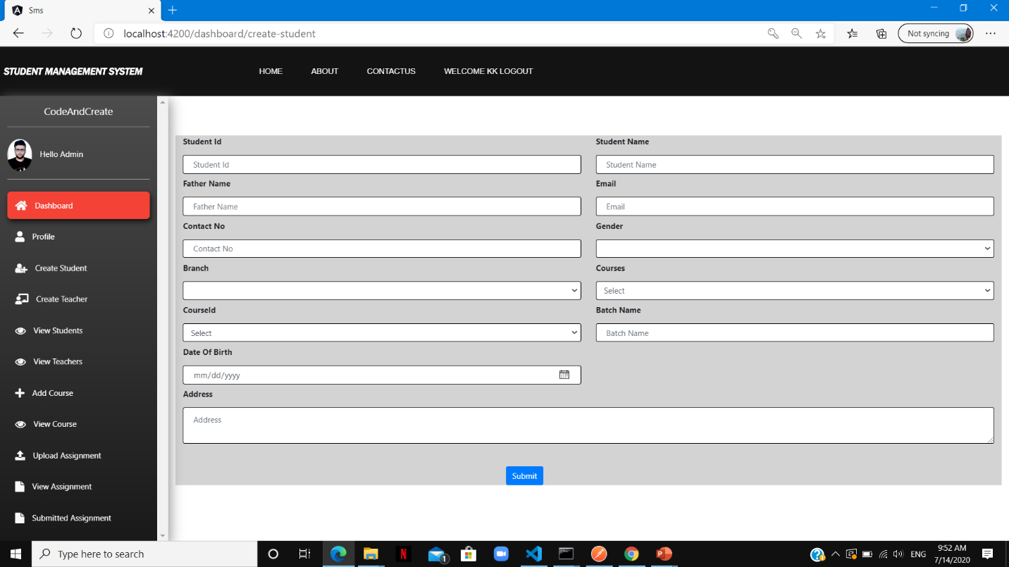

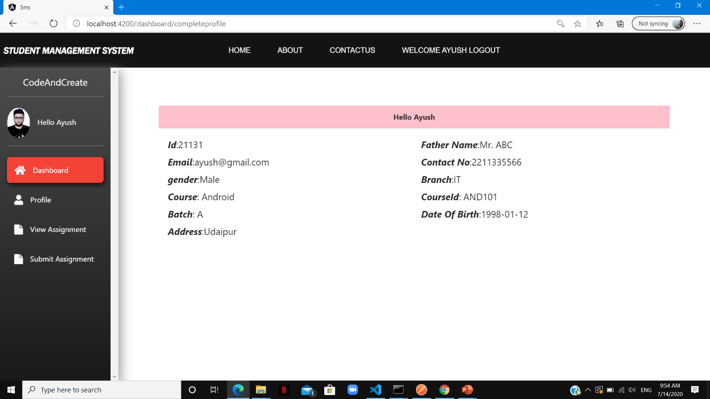

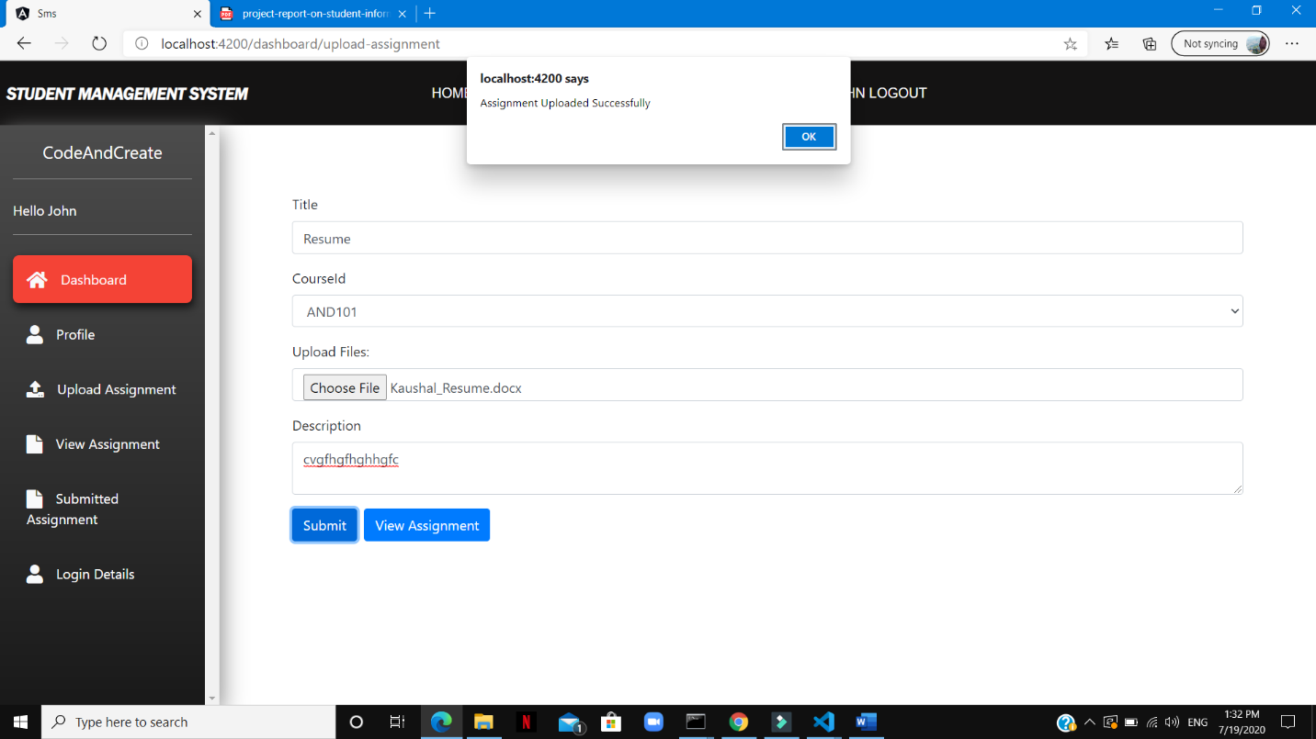

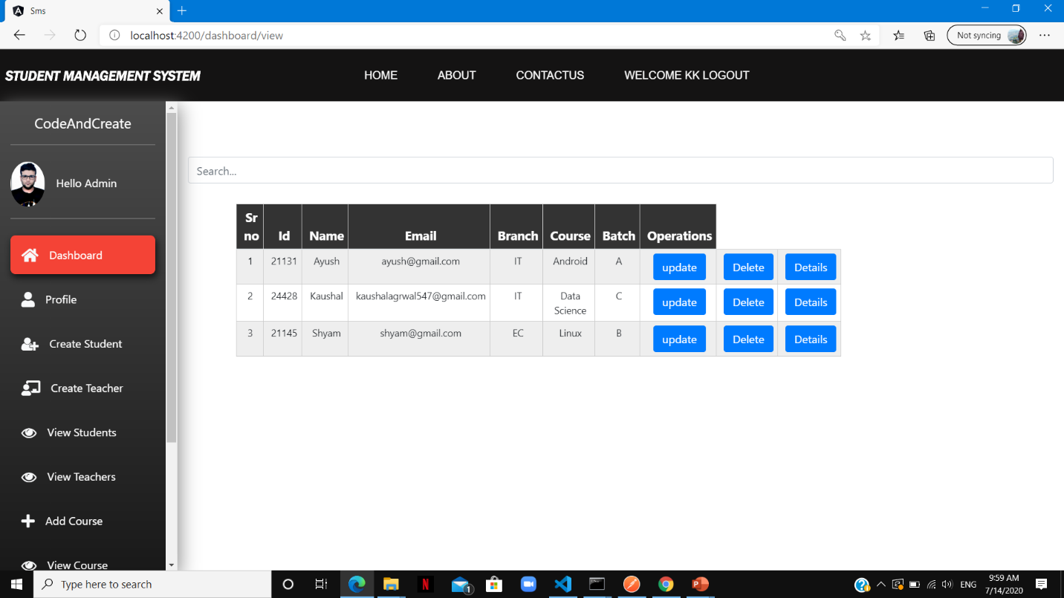

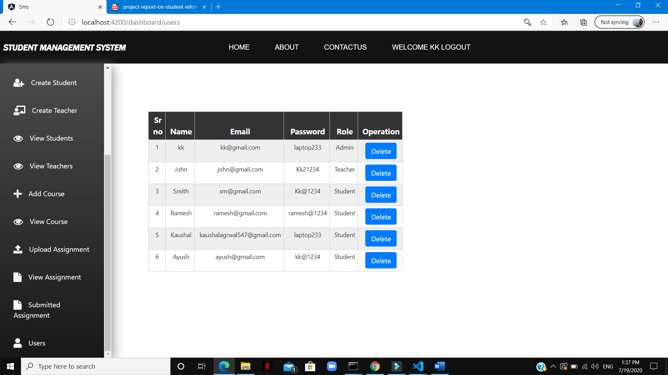

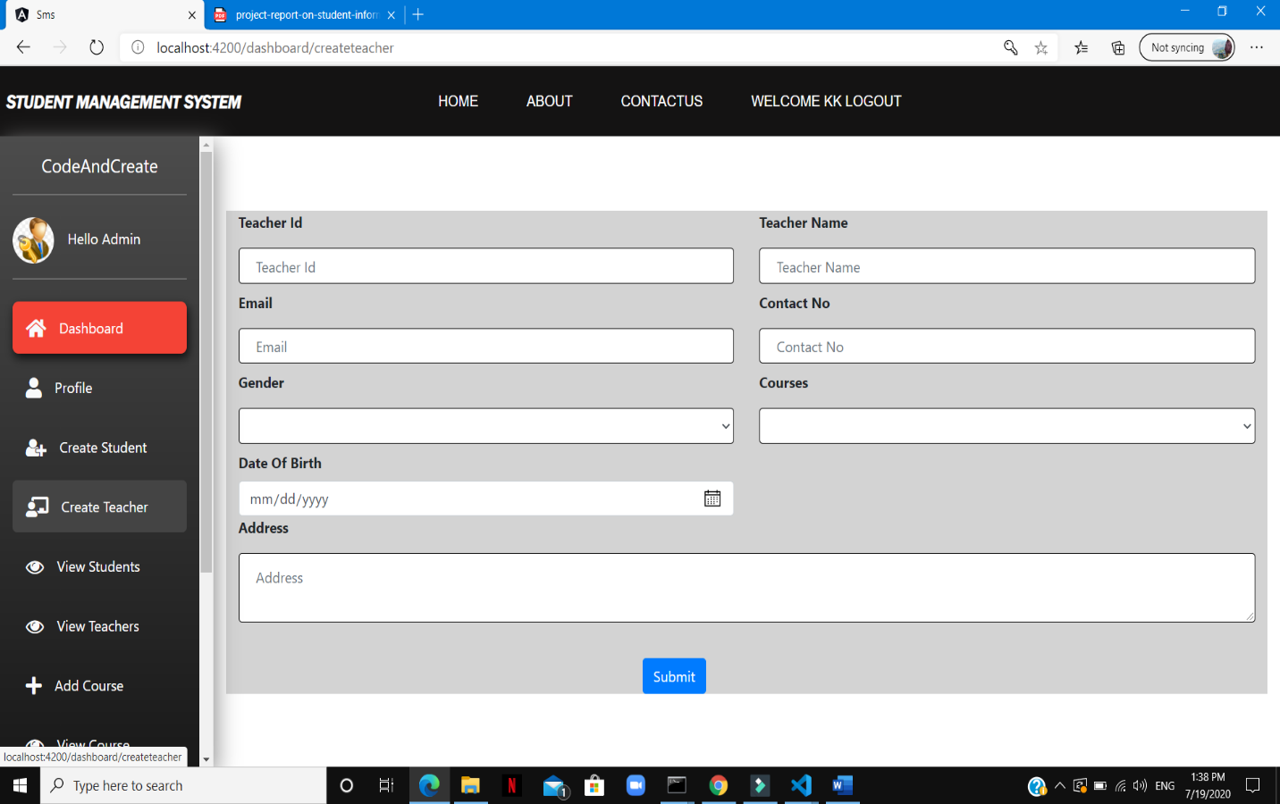

**5.2 Bibliography**

* W3school.com
* <http://services.lovelycoding.org/student-management-system/>

**5.3 Future Scope**

Student Management System can be used by educational institutions to maintain their student records easily. Achieving this objective is difficult using the manual system as the information is scattered, can be redundant and collecting relevant information may be very time-consuming.

All these problems are solved by this project. This system helps in maintaining the information of pupil of the organization. It can be easily accessed by the manager and kept safe for a long period of time without any changes.