**RC522 MANAGER**

**REFERENCE**

**Welcome**

Welcome to use “Rc522 Manager”.

The software is produced by ICStation in 2014.

**Environment**

Operating system support:

Windows 7, Windows 7 Service Pack 1, Windows Server 2003 Service Pack 2, Windows Server 2008, Windows Server 2008 R2, Windows Server 2008 R2 SP1, Windows Vista Service Pack 1, Windows XP Service Pack 3

Hardware requirements:

Suggest the minimum requirements:

Pentium 1 GHz or faster, 512 MB RAM or greater  
Minimum disk space:

x86 – 850 MB

x64 – 2 GB

Software requirements:

Framework 4.0

**Function**

Software is used to communicate with the RC522 module which can operate IC card.

**Usage method**

1. Connect module and PC through the serial port.  
   Open the software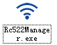 like follows:  
   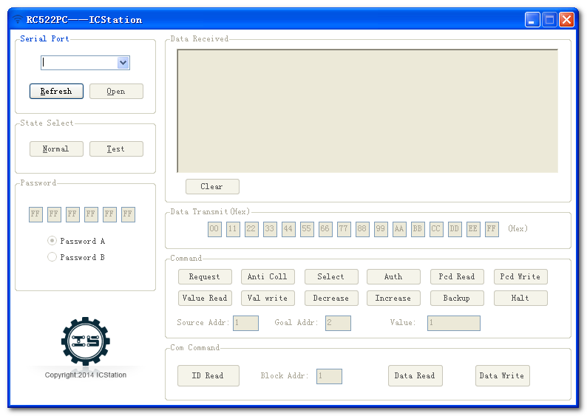.
2. Select the serial port.  
   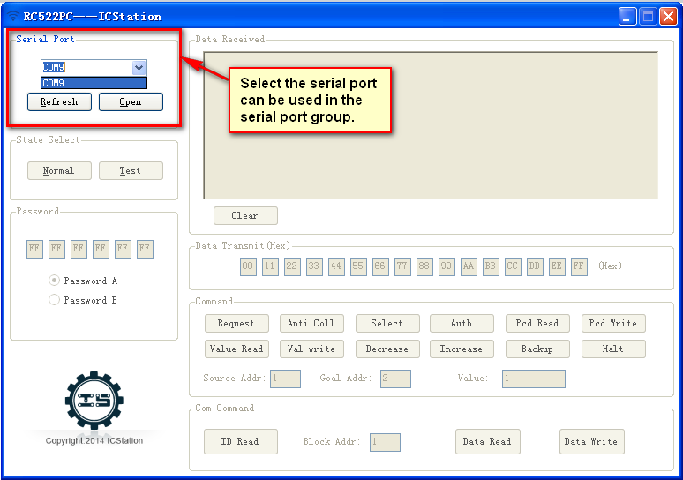
3. Select the work mode.  
   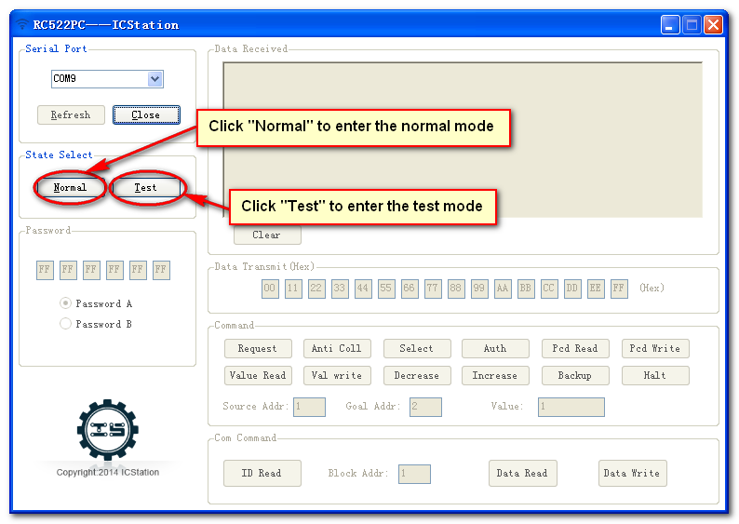
4. In the test mode, when the IC card close to the module, data receiving area displays basic information of the card and data of block 1 card as follows:  
   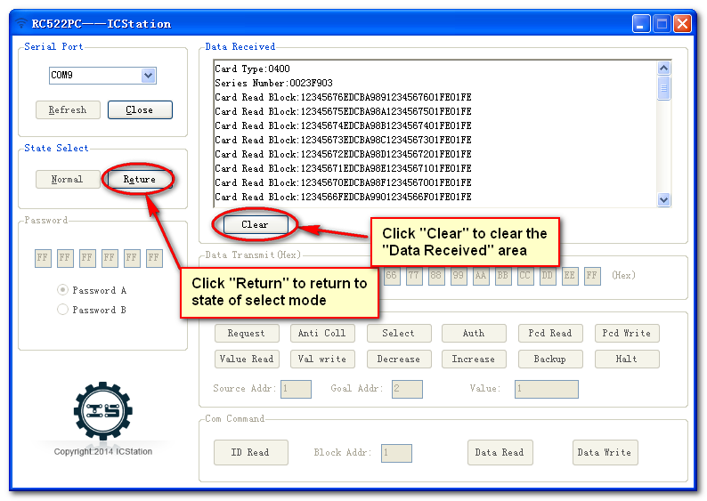.  
   Remove the card .Then click “Return” button to return to return to the previous state.
5. In normal mode, must first be close to the module card.  
   Click “ID read” button in “Com Command” area to read the card information.  
   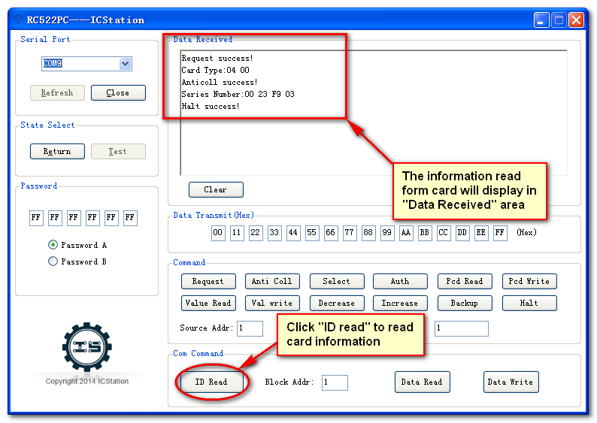Command “ID read” in “Com Command” area is equivalent to turn call “Request”,”Anti Coll”,”Halt” in “Command” area.
6. Input block address and password. Click ”Data Read” button to read the data from the block.  
   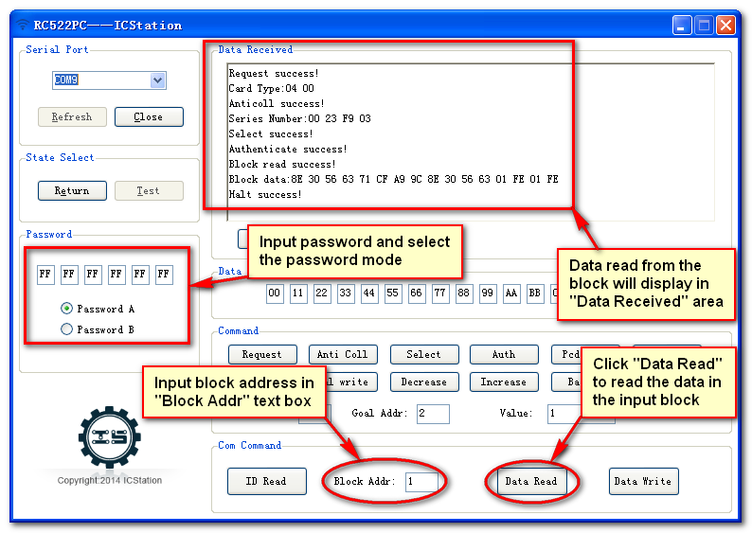Command “Data Read” in “Com Command” area is equivalent to turn call “Request”,”Anti Coll”,”Select”,”Auth”,”Pcd Read” ,”Halt” in “Command” area.Block address is range from 0 to 63.Card use password A “FF FF FF FF FF FF” in default.
7. Input data that will transmit to the block . Click ”Data Write” button to write the block.  
   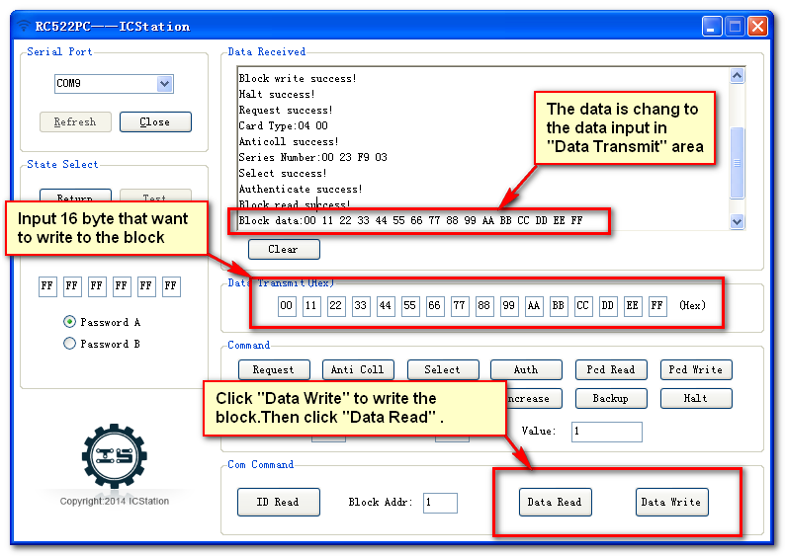Command “Data Read” in “Com Command” area is equivalent to turn call “Request” , ”Anti Coll” , ”Select” , ”Auth” , ”Pcd Read” , ”Halt” in “Command” area.  
   Reclick “Data Read” . You can see data is changed.
8. Input “Block address” , password and “Value “(The “Value” is range from 0 to 2147483647). Call command “Request” , ”Anti Coll” , ”Select” , ”Auth” in trun in “Command” area(Any fallen will you recall the command from “Request”).Click “Val Write” to write the block . Click ”Value Read” to read the value . You can see the data read is as same as the data you write.   
   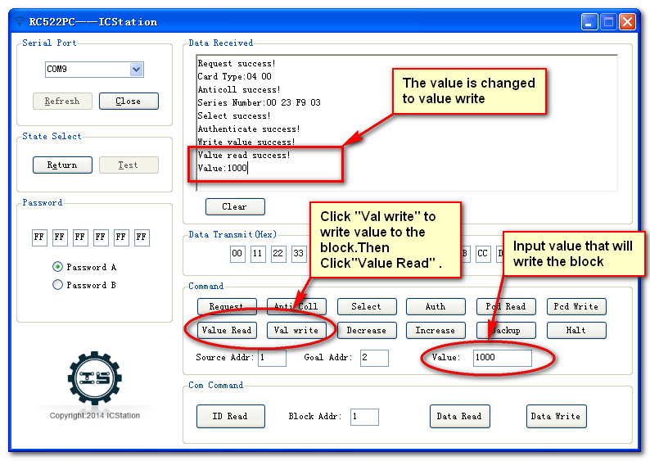Click “Decrease” and “Increase” to decrease and increase the block value.  
   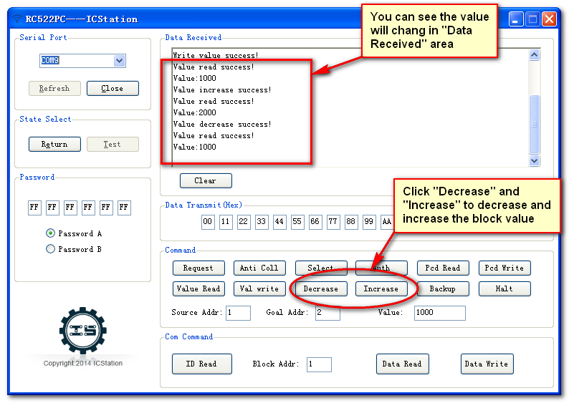
9. Input “source addr” and “Goal addr” . Call command “Request” , ”Anti Coll” , ”Select” , ”Auth” in trun in “Command” area(Any fallen will you recall the command from “Request”) . Click “Backup” to backup source block to goal block.  
   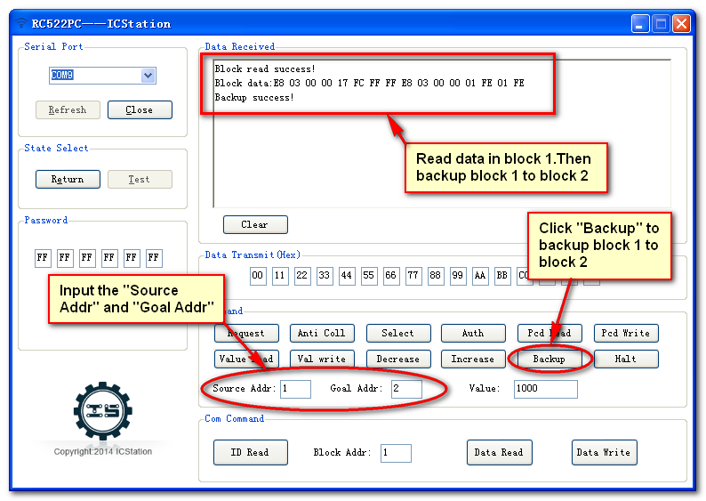Change “Block Addr” into “2” . Click “Pcd Read” to display data in block 2 .   
   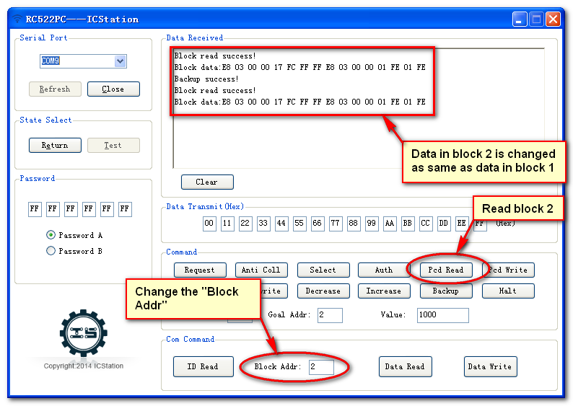

**Thanks**

Thank you for reading . Have a nice time.