DESCRIPTION OF THE DESIGN
AND LAYER STACKUP OF THE PRINTED CIRCUIT BOARD

Project:
Air quality sensor “ Altruist Urban”

Board Version: V1.0
Date: 2025
Developer:
Hardware for Cyberpunks

Printed Circuit Board Design Description
The printed circuit board is designed with all key components and connectors placed on the top layer. The board has an L-shaped topology, which allows the functional sections to be routed compactly and provides convenient sensor connections.
In the central lower area of the top layer, the ESP32-C6-WROOM-1-N8 module is placed. The region underneath the module and around its antenna is free of copper, maintaining the required keep-out zone to ensure proper RF characteristics. The antenna is located at the board edge and is not obstructed by traces or plated pads. All signal lines from the ESP32-C6 are routed with short, mostly straight traces and a minimal number of vias.
In the upper-right section of the board, the power supply block is located, including the 5 V input, voltage regulation, and 3.3 V distribution. Power lines use widened traces. Bypass capacitors and filtering elements are placed close to their respective circuits.
Near the power block are connectors for external sensors: the I²C interface (SCL, SDA) for temperature and humidity sensors, the SDS011 connector, and the connector for the microphone/noise sensor. Each connector is positioned close to its I/O lines, reducing critical trace length and minimizing noise pickup. Pull-up resistors are provided on the I²C connector.
On the right side of the board, a group of GPIO pins is arranged as a multi-pin header. Power and ground lines, as well as several ESP32-C6 digital I/O lines, are routed to this connector, allowing external user sensors and peripheral modules to be connected. Traces to the GPIO header are routed as a dense, symmetrical “comb” with controlled geometry.
A large ground (GND) pour is implemented on the top layer, providing shielding, reduced impedance, and improved stability for the digital section. All major current paths and sensitive circuits are routed to minimize mutual interference.
The overall design focuses on stable RF performance, ease of assembly, and compatibility with both standard and custom sensor modules.

PCB Layer Stack
The printed circuit board uses a four-layer structure based on FR-4 material with JLC04161H-7628 specifications. The board thickness is 1.6 mm. The outer layers use 1 oz copper, while the inner layers use 0.5 oz. The surface finish is Lead-Free HASL. The material corresponds to Tg155, ensuring stable electrical and mechanical characteristics at elevated temperatures.
The layer stack is organized as follows:

Top Layer PCB
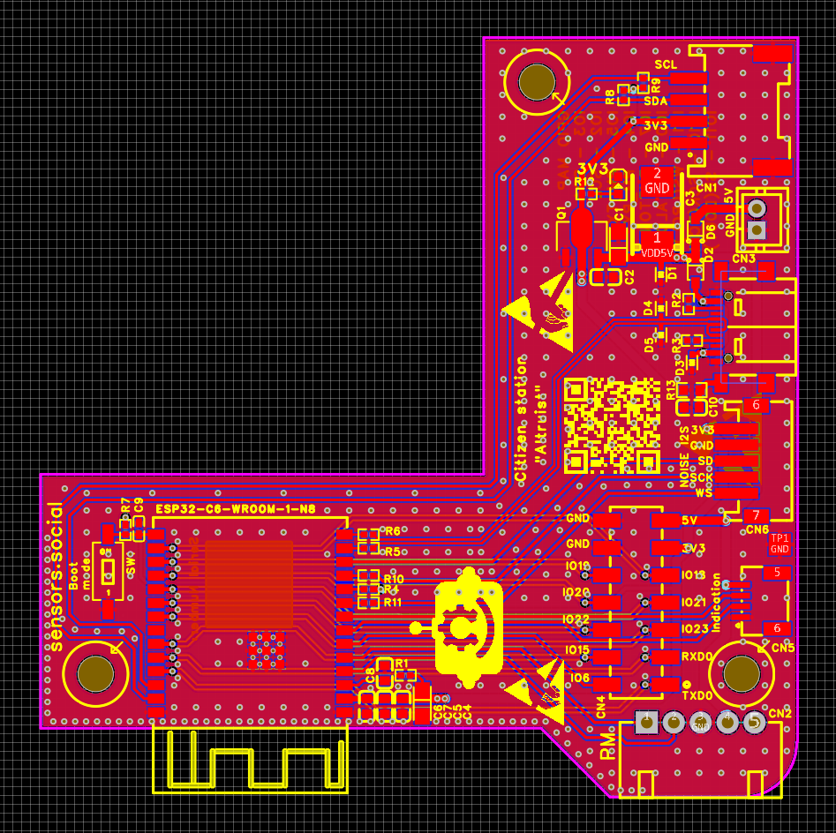
Top Layer (Layer 1 — Top Layer)
All components are placed on the top layer, including the main ESP32-C6-WROOM-1 module, sensor connectors, USB power input, and power circuitry. The primary signal routing is also located here. A copper-free keep-out region is maintained under the module’s antenna. The top layer serves as the main signal layer and connection level for all key interfaces.

Inner Layer 1
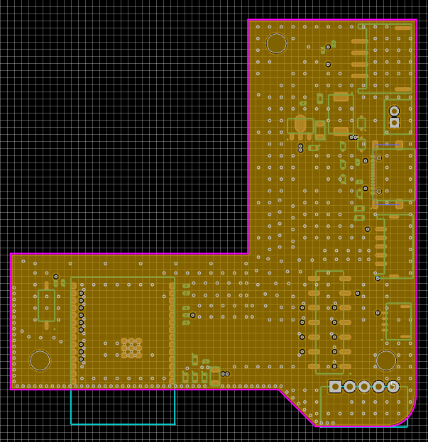
Inner Layer 1 (Layer 2 — Inner 1, GND Plane)
The first inner layer is dedicated entirely to the ground reference. It is a solid ground plane with minimal interruptions, designed to reduce return-path impedance, improve high-frequency performance, and provide shielding. This ground plane forms the reference for differential and single-ended traces routed on both the top and bottom layers.

Inner Layer 2
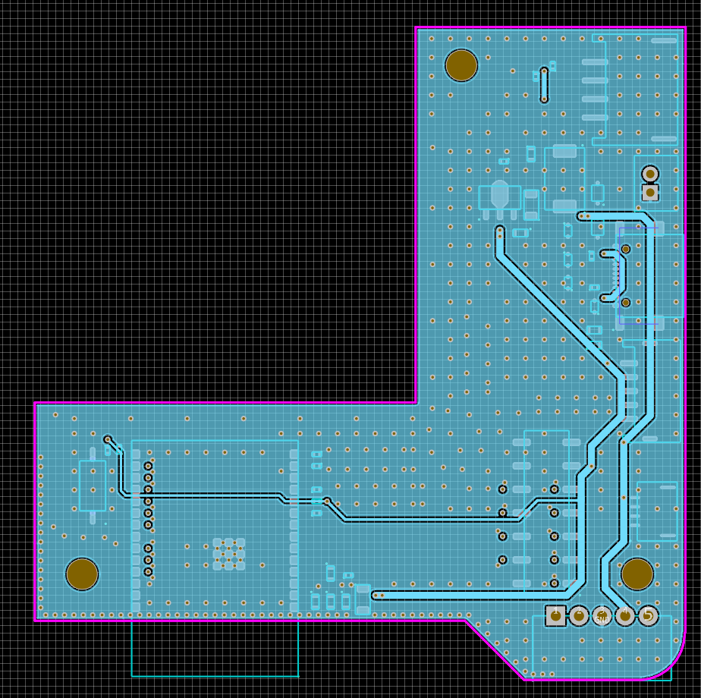

Inner Layer 2 (Layer 3 — Inner 2, GND + Power Plane)
The third layer is a combined structure: most of the layer is allocated as an additional ground reference, while designated regions provide distributed 5 V and 3.3 V power rails. Splitting the power distribution across an internal plane reduces voltage drop, lowers electromagnetic interference, and ensures even power delivery to digital and peripheral modules. This layer acts as the board’s main power plane.

Bottom Layer
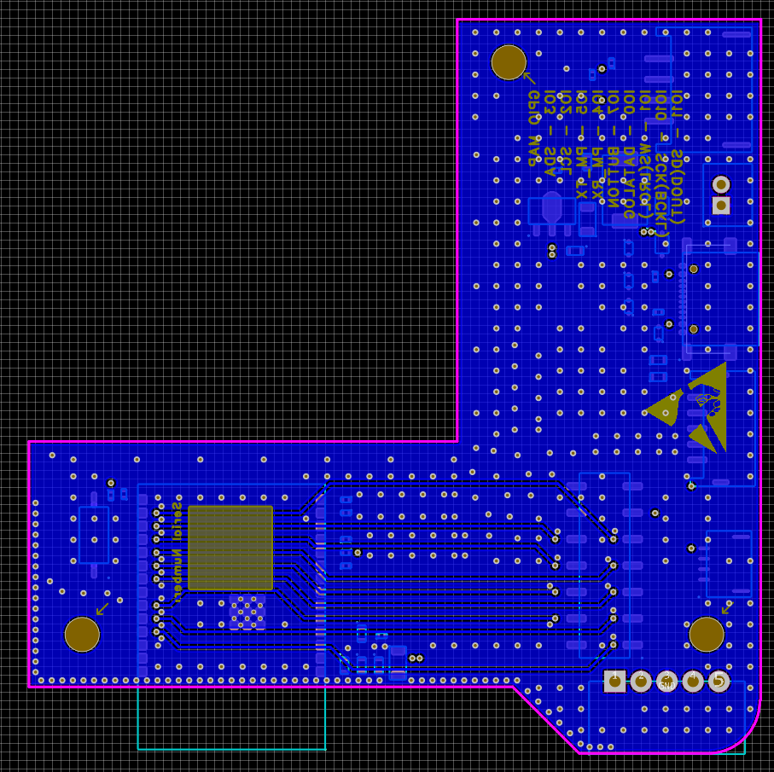
Bottom Layer (Layer 4 — Bottom Layer)
The bottom layer is used for additional signal routing. It is free from large power loops, reducing current cross-coupling and potential interference. This layer carries signals that do not require minimal delay or high-frequency handling, as well as secondary interfaces.

Electromagnetic Compatibility (EMC) Features and Recommendations
The board design is optimized for stable operation in environments with digital interference and radio-frequency noise typical for ESP32-C6–based devices. The four-layer stack includes two reference ground planes—on the second and third layers—which provide low return-path impedance and form a reliable shield for high-frequency circuits.
Placing the ESP32-C6-WROOM-1 on the top layer allows the internal ground plane to act as a stable reference surface beneath the high-frequency section. The area under the antenna is cleared of copper to prevent radiation detuning and reduce parasitic capacitance. Traces associated with high-frequency interfaces and module calibration are kept as short as possible and do not cross ground-plane splits.
The 3.3 V and 5 V power rails are routed on the third layer, minimizing noise in the power network and reducing voltage droop during digital switching. Each power source is accompanied by local decoupling capacitors placed as close as possible to the ESP32С6 pins and external modules, improving suppression of high-frequency disturbances. Decoupling components are connected with short, wide traces to the power rail and the nearest ground point.
Connectors for peripheral sensors are placed so that sensitive lines do not cross power traces and do not pass through zones of high-frequency noise. The I²C interface includes pull-up resistors to ensure clean signal shaping when long external cables are used. The SDS011 and microphone connectors use traces routed away from high-speed signals to reduce coupling.
Vias are used moderately, and return currents can flow through continuous internal ground planes. This reduces the likelihood of loop formation and lowers emissions. In areas where a signal transitions between layers, sufficient ground reference is provided on all levels to maintain a proper current path.
Regions with higher routing density and peripheral interfaces are additionally shielded by ground pours on both the top and bottom layers. This decreases radiated noise and reduces susceptibility to external RF interference.
Together, these measures ensure strong electromagnetic compatibility, minimizing emissions and improving noise immunity for both the digital and analog sections of the device.

RF Section Description of ESP32-C6-WROOM-1-N8 Module
The ESP32-C6-WROOM-1-N8 module features a fully integrated 2.4 GHz radio subsystem that supports Wi-Fi 6 (802.11ax), Bluetooth Low Energy 5, and IEEE 802.15.4-based protocols including Thread and Zigbee. The entire RF chain is implemented on the module’s multilayer PCB and includes an impedance-matched PCB-etched antenna, RF front-end components, and an optimized transmission path designed and tuned by Espressif.
A high-precision 40 MHz crystal oscillator (TCXO) is already mounted inside the module. It provides a stable reference clock for all wireless subsystems (Wi-Fi, BLE, Zigbee/Thread). The crystal is fully shielded and requires no external clock source or additional timing components from the user.
The ESP32-C6 chip and the entire module are protected by a solid metal RF shield (can) placed over the top surface. This shield serves two critical purposes:
- it prevents electromagnetic interference (EMI) from the digital and RF circuitry from radiating outward;
- it protects the internal circuits from external interference and mechanical damage. Thanks to the integrated shield, the module meets electromagnetic compatibility (EMC) requirements out of the box and greatly simplifies certification of the final product.
The RF front-end consists of the internal transmitter and receiver stages of the ESP32-C6 SoC, followed by matching components and a compact low-loss matching network placed directly on the module PCB. This network ensures proper 50 Ω impedance matching, minimizes return loss, and delivers stable performance across typical device enclosures and environmental conditions. No external RF tuning is required.
The module employs a PCB-etched antenna located along the outer edge. Its geometry is a meandered inverted-F design, offering an optimal balance between compact size, gain, and the omnidirectional radiation pattern typical of embedded antennas. Edge placement minimizes ground plane interference and promotes efficient radiation characteristics.
To preserve RF performance, a keep-out zone must be maintained around the antenna area. No copper pours, ground planes, traces, or metallic components are allowed beneath or in close proximity to the antenna. The host PCB must include a cutout or clearance region aligned with the antenna footprint to keep the radiating element unobstructed. Device enclosures should also avoid metal near the antenna to prevent detuning and signal attenuation.
When layout guidelines are followed, the antenna provides stable performance across the Wi-Fi, BLE, and 802.15.4 bands, delivering sufficient gain and efficiency for low-power embedded IoT applications. The fully integrated design — including the on-module crystal, metal RF shield, and pre-tuned RF path — eliminates the need for external RF components, simplifies certification, and ensures consistent wireless behavior across all production units.

Additional Boards
Common PCB Specifications The boards are manufactured on FR-4 TG155 substrate with the following parameters:
- 2 layers
- thickness 1.6 mm
- blue solder mask on both sides
- white silkscreen
- Lead-Free HASL surface finish
- outer copper weight 1 oz (35 µm)
- inner copper weight 0.5 oz (18 µm)
- manufactured to IPC Class 2 standard
- minimum track width and spacing 0.15 mm
BME280 Sensors PCB

Top Layer (Layer 1 — Bottom Layer) Bottom Layer(Layer 2 — Bottom Layer)
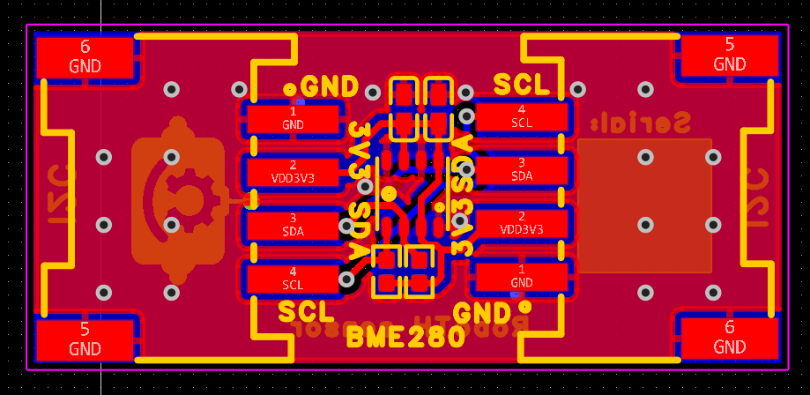
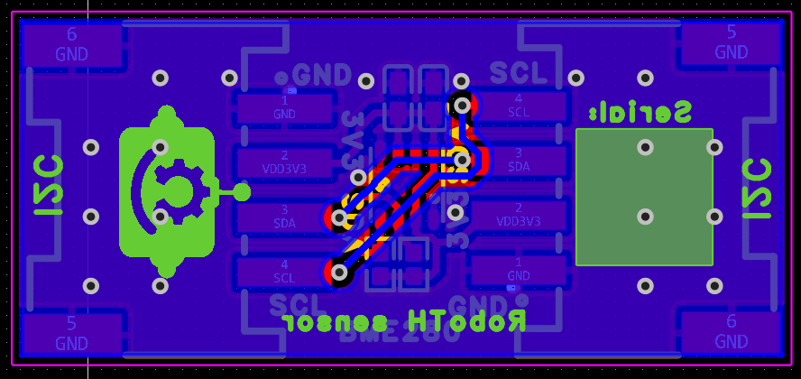

General information
The board is a compact module with a BME280 sensor designed to measure temperature, humidity and pressure. The design is designed to work with the I²C interface. The board has multiple pins for power and data bus connections, making it easy to integrate the module into other devices.

External Status Indicator Board with Action Button
Top Layer (Layer 1 — Bottom Layer) Bottom Layer(Layer 2 — Bottom Layer)
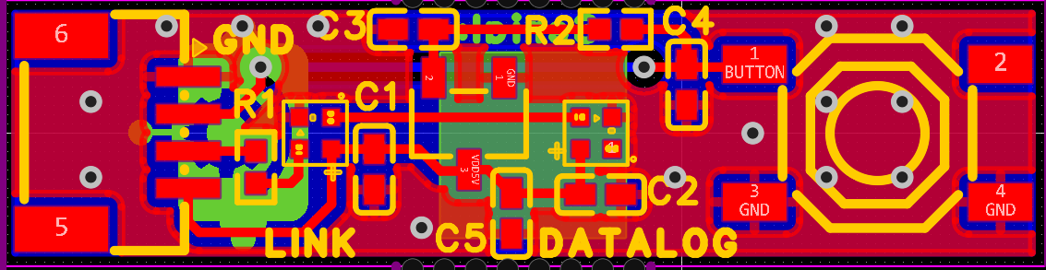
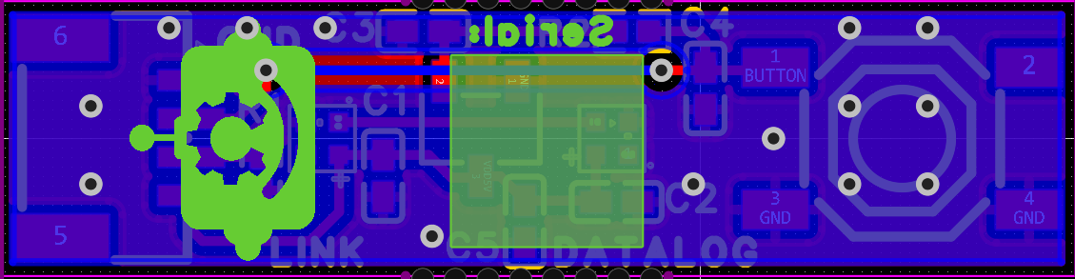

Noise Sensor Board with ICS43434 Microphone
Top Layer (Layer 1 — Bottom Layer) Bottom Layer(Layer 2 — Bottom Layer)
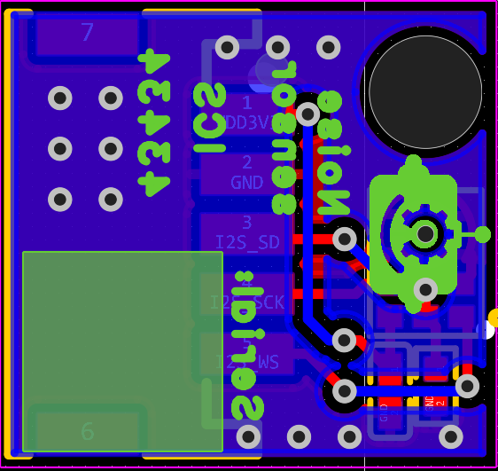
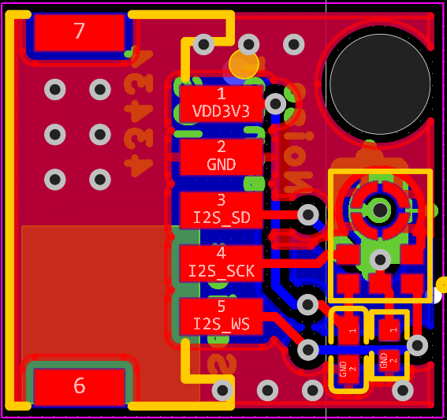
This is a compact board featuring a high-quality digital MEMS microphone ICS43434, designed for measuring sound levels. The board outputs data via the I²S interface, allowing direct connection to microcontrollers without the need for an ADC.

