DESCRIPTION OF THE DESIGN
AND LAYER STACKUP OF THE PRINTED CIRCUIT BOARD

Project:
Air quality sensor “ Altruist Insight”

Board Version: V1.0.3
Date: 2025
Developer:
Hardware for Cyberpunks

Printed Circuit Board Design Description
The printed circuit board is a four-layer design measuring 92 × 78.5 mm, manufactured on FR-4 material with TG155 rating. It uses the JLC04161H-7628 stackup with an overall thickness of 1.6 mm. The outer copper layers are 1 oz, and the inner layers are 0.5 oz. The PCB is produced in blue with white silkscreen and a Lead-Free HASL surface finish.
All components, connectors, and the contact pad for the 4.2" e-paper display are located on the top layer. The bottom side of the board is completely free of components and remains flat, allowing secure attachment of the e-paper module.
The main control element—the ESP32-C6-WROOM-1 module—is placed on the right side of the top layer. The antenna area is kept completely clear of copper, traces, and vias to ensure proper RF performance. Signal routing from the module is kept as short as possible, with a minimal number of layer transitions to maintain signal integrity.
The CO₂ sensor SCD41 is located in the central area of the board, while the BME680 sensor for temperature, humidity, and pressure is placed below it. Both sensors are connected via the I²C interface; the SCL and SDA lines are routed with short, compact traces to reduce noise. All required decoupling capacitors are positioned as close as possible to the sensor and microcontroller pins.
A USB-C connector is placed at the top center of the board and serves as the power input. From it, the 5 V line and the 3.3 V rail are distributed across the board through wide power traces and strategically placed vias.
A microSD card slot is positioned at the bottom center, with its data lines routed symmetrically and with matched lengths to minimize crosstalk.
In the lower-right area, a connector for the 4.2" e-paper display is placed. The signals, including SPI, are routed with controlled impedance and optimized to reduce reflections.
Twenty-eight WS2812B RGB LEDs are arranged around the perimeter of the PCB. Each LED is equipped with an individual decoupling capacitor to suppress voltage ripple and reduce power-supply noise.
Four buttons are also located on the top layer: one BOOT button for placing the ESP32-C6 into programming mode, and three user buttons (Up, Down, Enter). All buttons are connected to the module’s GPIO lines using short, direct traces.
A large portion of the top layer is covered by a ground polygon, providing shielding, low-impedance return paths, and improved stability for both analog and digital sections. Power and signal areas are separated to reduce interference. Strategically placed vias interconnect the GND polygons across all layers, forming a solid ground network.

The layer stack is organized as follows:

Top Layer PCB
Top Layer (Layer 1 — Top Layer)
All components are placed on the top layer, including the main ESP32-C6-WROOM-1 module, the USB power input, and the power supply circuits. An area free of copper wires is provided under the module's antenna. The top layer serves as the signal layer and connection layer for the I2C interface and USB interface.

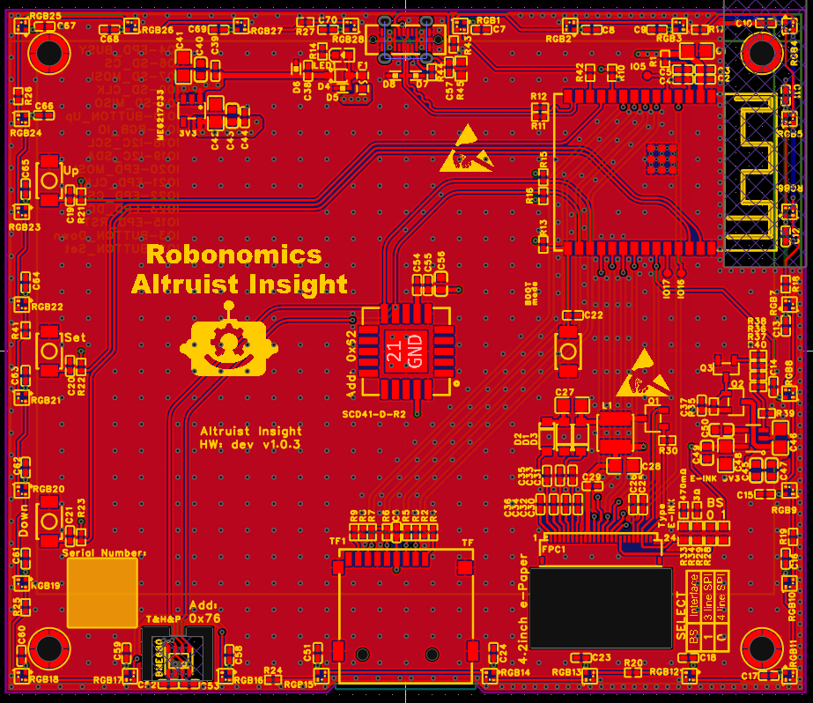
Inner Layer 1
Inner Layer 1 (Layer 2 — Inner 1, GND Plane)
The first inner layer is dedicated entirely to the ground reference. It is a solid ground plane with minimal interruptions, designed to reduce return-path impedance, improve high-frequency performance, and provide shielding. This ground plane forms the reference for differential and single-ended traces routed on both the top and bottom layers.
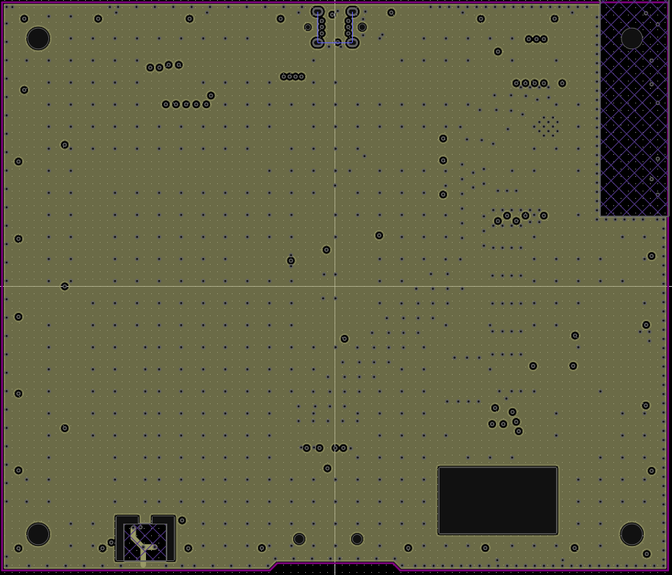
Inner Layer 2

Inner Layer 2 (Layer 3 — Inner 2, GND + Power Plane)
The third layer is a hybrid structure: part of the layer is dedicated to additional ground reference, while dedicated areas provide distributed 5V and 3.3V power rails. Splitting the power supply across the internal plane reduces voltage drop, minimizes electromagnetic interference, and ensures uniform power delivery to digital and peripheral modules. This layer serves as the board's primary power plane.

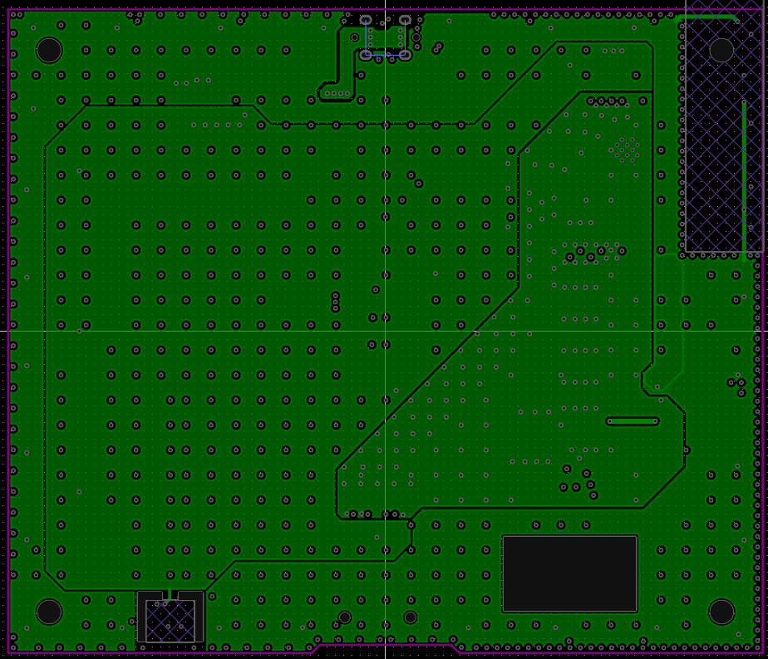
Bottom Layer
Bottom Layer (Layer 4 — Bottom Layer)
The bottom layer is used for additional signal routing. It is free of large power supply loops, reducing current crosstalk and potential interference. This layer transmits signals. The ISP interfaces for the display and SD card are located on this layer.
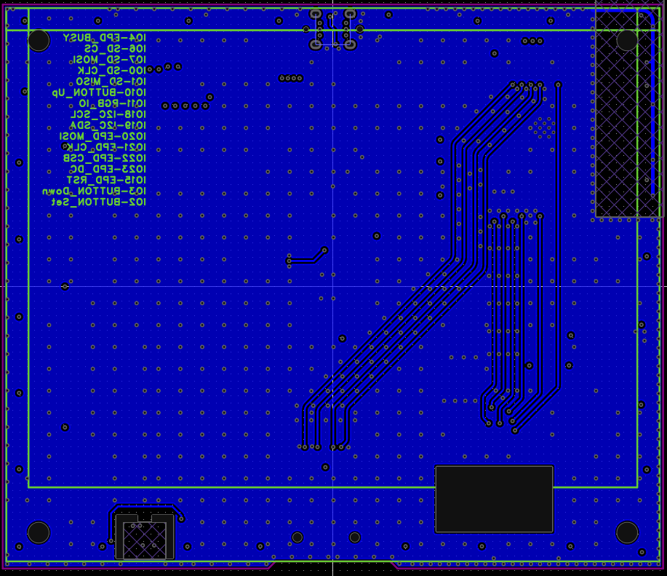

Electromagnetic Compatibility (EMC) Features and Recommendations
The board design is optimized for stable operation in environments with digital interference and radio-frequency noise typical for ESP32-C6–based devices. The four-layer stack includes two reference ground planes—on the second and third layers—which provide low return-path impedance and form a reliable shield for high-frequency circuits.
Placing the ESP32-C6-WROOM-1 on the top layer allows the internal ground plane to act as a stable reference surface beneath the high-frequency section. The area under the antenna is cleared of copper to prevent radiation detuning and reduce parasitic capacitance. Traces associated with high-frequency interfaces and module calibration are kept as short as possible and do not cross ground-plane splits.
The 3.3 V and 5 V power rails are routed on the third layer, minimizing noise in the power network and reducing voltage droop during digital switching. Each power source is accompanied by local decoupling capacitors placed as close as possible to the ESP32С6 pins and external modules, improving suppression of high-frequency disturbances. Decoupling components are connected with short, wide traces to the power rail and the nearest ground point.
Connectors for peripheral sensors are placed so that sensitive lines do not cross power traces and do not pass through zones of high-frequency noise. The I²C interface includes pull-up resistors to ensure clean signal shaping when long external cables are used.
Vias are used moderately, and return currents can flow through continuous internal ground planes. This reduces the likelihood of loop formation and lowers emissions. In areas where a signal transitions between layers, sufficient ground reference is provided on all levels to maintain a proper current path.
Regions with higher routing density and peripheral interfaces are additionally shielded by ground pours on both the top and bottom layers. This decreases radiated noise and reduces susceptibility to external RF interference.
Together, these measures ensure strong electromagnetic compatibility, minimizing emissions and improving noise immunity for both the digital and analog sections of the device.

RF Section Description of ESP32-C6-WROOM-1-N8 Module
The ESP32-C6-WROOM-1-N8 module features a fully integrated 2.4 GHz radio subsystem that supports Wi-Fi 6 (802.11ax), Bluetooth Low Energy 5, and IEEE 802.15.4-based protocols including Thread and Zigbee. The entire RF chain is implemented on the module’s multilayer PCB and includes an impedance-matched PCB-etched antenna, RF front-end components, and an optimized transmission path designed and tuned by Espressif.
A high-precision 40 MHz crystal oscillator (TCXO) is already mounted inside the module. It provides a stable reference clock for all wireless subsystems (Wi-Fi, BLE, Zigbee/Thread). The crystal is fully shielded and requires no external clock source or additional timing components from the user.
The ESP32-C6 chip and the entire module are protected by a solid metal RF shield (can) placed over the top surface. This shield serves two critical purposes:
- it prevents electromagnetic interference (EMI) from the digital and RF circuitry from radiating outward;
- it protects the internal circuits from external interference and mechanical damage. Thanks to the integrated shield, the module meets electromagnetic compatibility (EMC) requirements out of the box and greatly simplifies certification of the final product.
The RF front-end consists of the internal transmitter and receiver stages of the ESP32-C6 SoC, followed by matching components and a compact low-loss matching network placed directly on the module PCB. This network ensures proper 50 Ω impedance matching, minimizes return loss, and delivers stable performance across typical device enclosures and environmental conditions. No external RF tuning is required.
The module employs a PCB-etched antenna located along the outer edge. Its geometry is a meandered inverted-F design, offering an optimal balance between compact size, gain, and the omnidirectional radiation pattern typical of embedded antennas. Edge placement minimizes ground plane interference and promotes efficient radiation characteristics.
To preserve RF performance, a keep-out zone must be maintained around the antenna area. No copper pours, ground planes, traces, or metallic components are allowed beneath or in close proximity to the antenna. The host PCB must include a cutout or clearance region aligned with the antenna footprint to keep the radiating element unobstructed. Device enclosures should also avoid metal near the antenna to prevent detuning and signal attenuation.
When layout guidelines are followed, the antenna provides stable performance across the Wi-Fi, BLE, and 802.15.4 bands, delivering sufficient gain and efficiency for low-power embedded IoT applications. The fully integrated design — including the on-module crystal, metal RF shield, and pre-tuned RF path — eliminates the need for external RF components, simplifies certification, and ensures consistent wireless behavior across all production units.

