Class04.R

aishu

2022-10-06

#This is a comment  
x <- 1:50  
plot(x, sin(x))

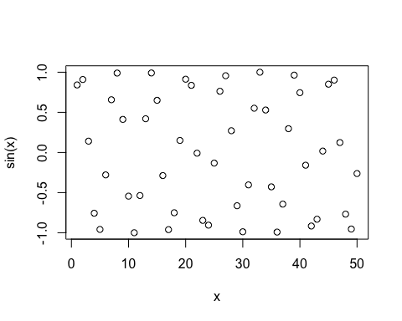

#Add more input arguments to plot  
#to get it how we want  
plot(x=x, y=sin(x), typ='l', col='red', lwd=3)

