Try using "IoT Servo Controller TITAN"
Many of the things that move around us are driven by motors or engines.In particular, servo motors are used for precise positioning, such as mounting equipment for machine tools, electronic components, and medical devices.
In addition to the main body of the motor, the servo motor includes an encoder that detects the rotation position and speed of the motor, a servo amplifier that drives the motor, and a controller.It is composed of a servo controller that controls the operation of the motor.Accurate positioning is possible by controlling the motor by feedback information from the encoder.
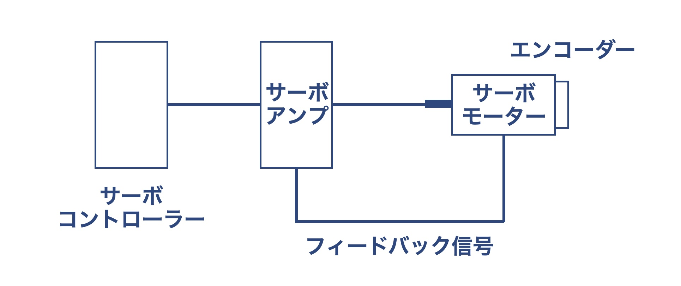
This time, I was able to borrow the "IoT servo controller TITAN" and motor from Japan Pulse Motor, so I connected it to the Raspberry Pi to create a servo motorI tried to get the operation data of the data controller.
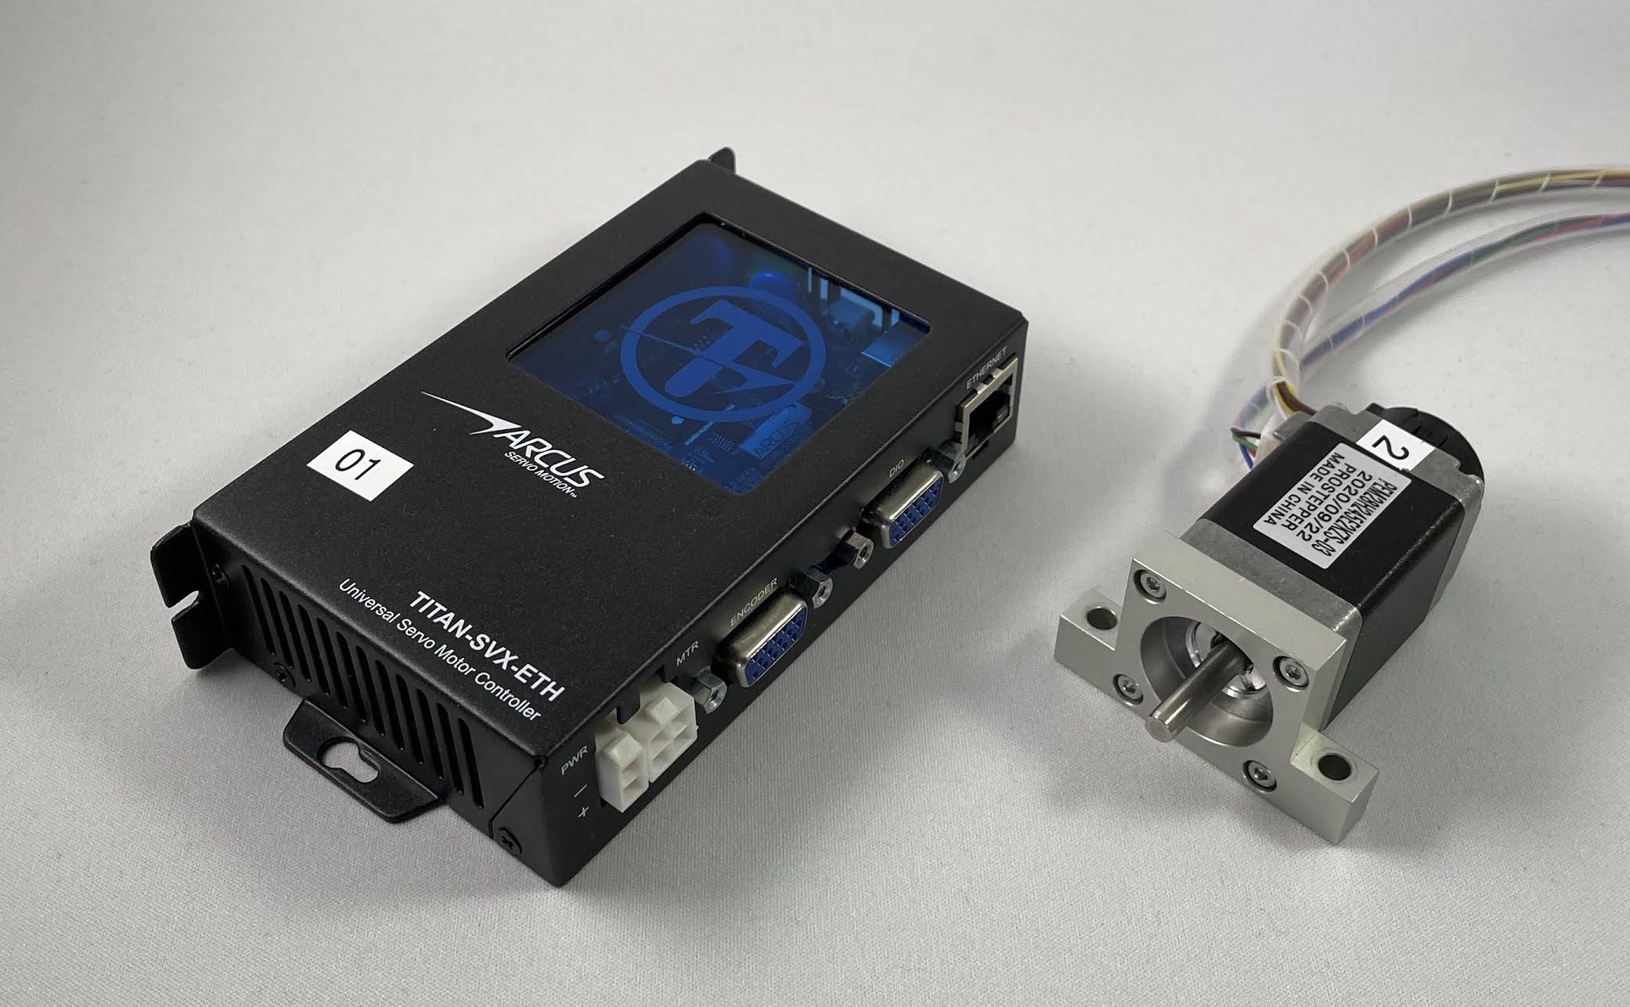IoTサーボコントローラーTITAN（左）とステッピングモーター（右）

"IoT Servo Controller TITAN"
TITAN is a servo controller with functions of servo amplifier and servo controller, stepper motor, rotary servo motorVarious types of motors such as linear servo motors can be controlled.You can write instructions for the motor in a scripting language and save the script program inside TITAN so that you can stand alone with TITAN and the motorIt is possible to operate alone.TITAN can also communicate with computers via Ethernet, RS485, and USB.It is a servo controller suitable for configuring IoT systems, such as monitoring the operating state while the motor is running.
This time, as the first setting phase, we will connect a PC, TITAN, and a motor to perform initial setup of TITAN and write a script program.Next, we removed the computer to operate the TITAN and the motor standalone, and connected the Raspberry Pi to obtain the motor operation data.
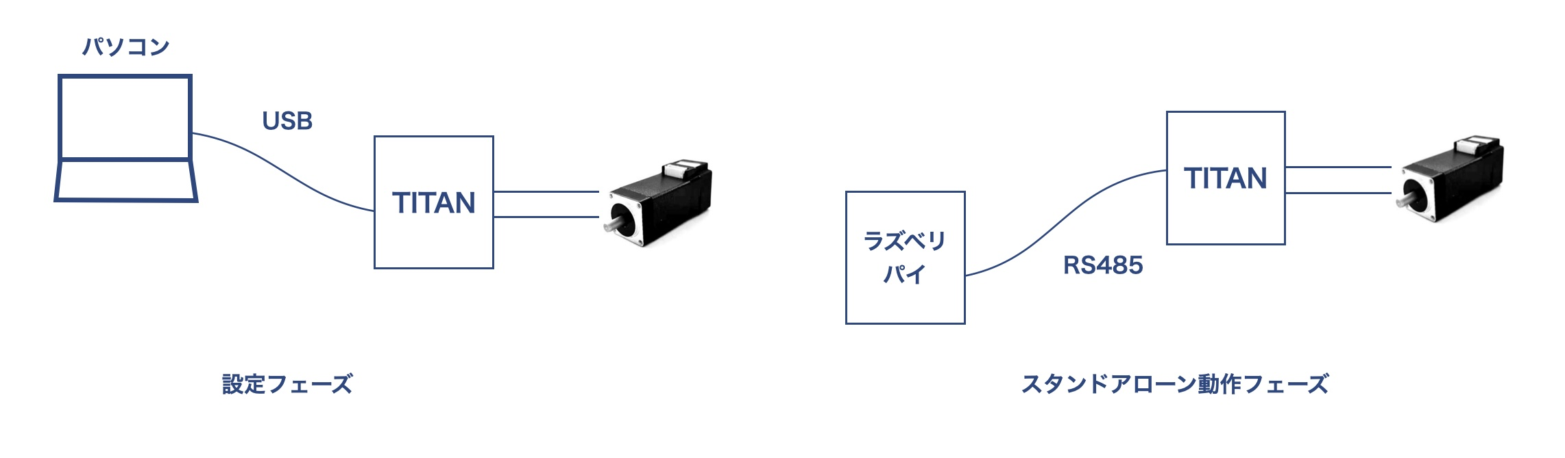

Related materials
The initial setup of TITAN is done according to the following document.This document can be downloaded without user registration.
- TITAN Startup Guide
In order to control the servo motor in TITAN, the following related materials will be helpful.
- TITAN-SVX-ETH Hardware Instruction Manual
- TITAN Software Instruction Manual
- TITAN Communication (ASCII Communication) Instruction Manual
- TITAN Communication (MODBUS) User Manual
- TITAN Programming Language (A-Script) User Manual
These materials can be downloaded from the download page of the Nippon Pulse Motor Co., Ltd. website.User registration is required when downloading.
- Japan Pulse Motor Co., Ltd. Download page

Equipment and connections
- IoT Servo Controller: TITAN-SVX-ETH
- Motor: 2 phase stepper motor with Prostepper encoder PEM28H245E2KZS-03
- DC24V6.4A power supply
- Raspberry Pi 3BPlus
- USB to RS485コンバーター DSD TECH SH-U10
The motor has a power cable and a signal cable for the encoder to detect the rotation position and speed.Connect the power cable to the TITAN motor connector and the signal cable from the encoder to the TITAN encoder connector.
During the setup phase, connect TITAN to your Windows PC via a USB cable.The TITAN side is mini-B type, so you need a mini-B type USB cable.
In the stand-alone operation phase, TITAN and Raspberry Pi were connected via RS485.The Raspberry Pi side connects the USB to RS485 converter to the USB port of the Raspberry Pi, and the TITAN is connected by RS485 as follows.
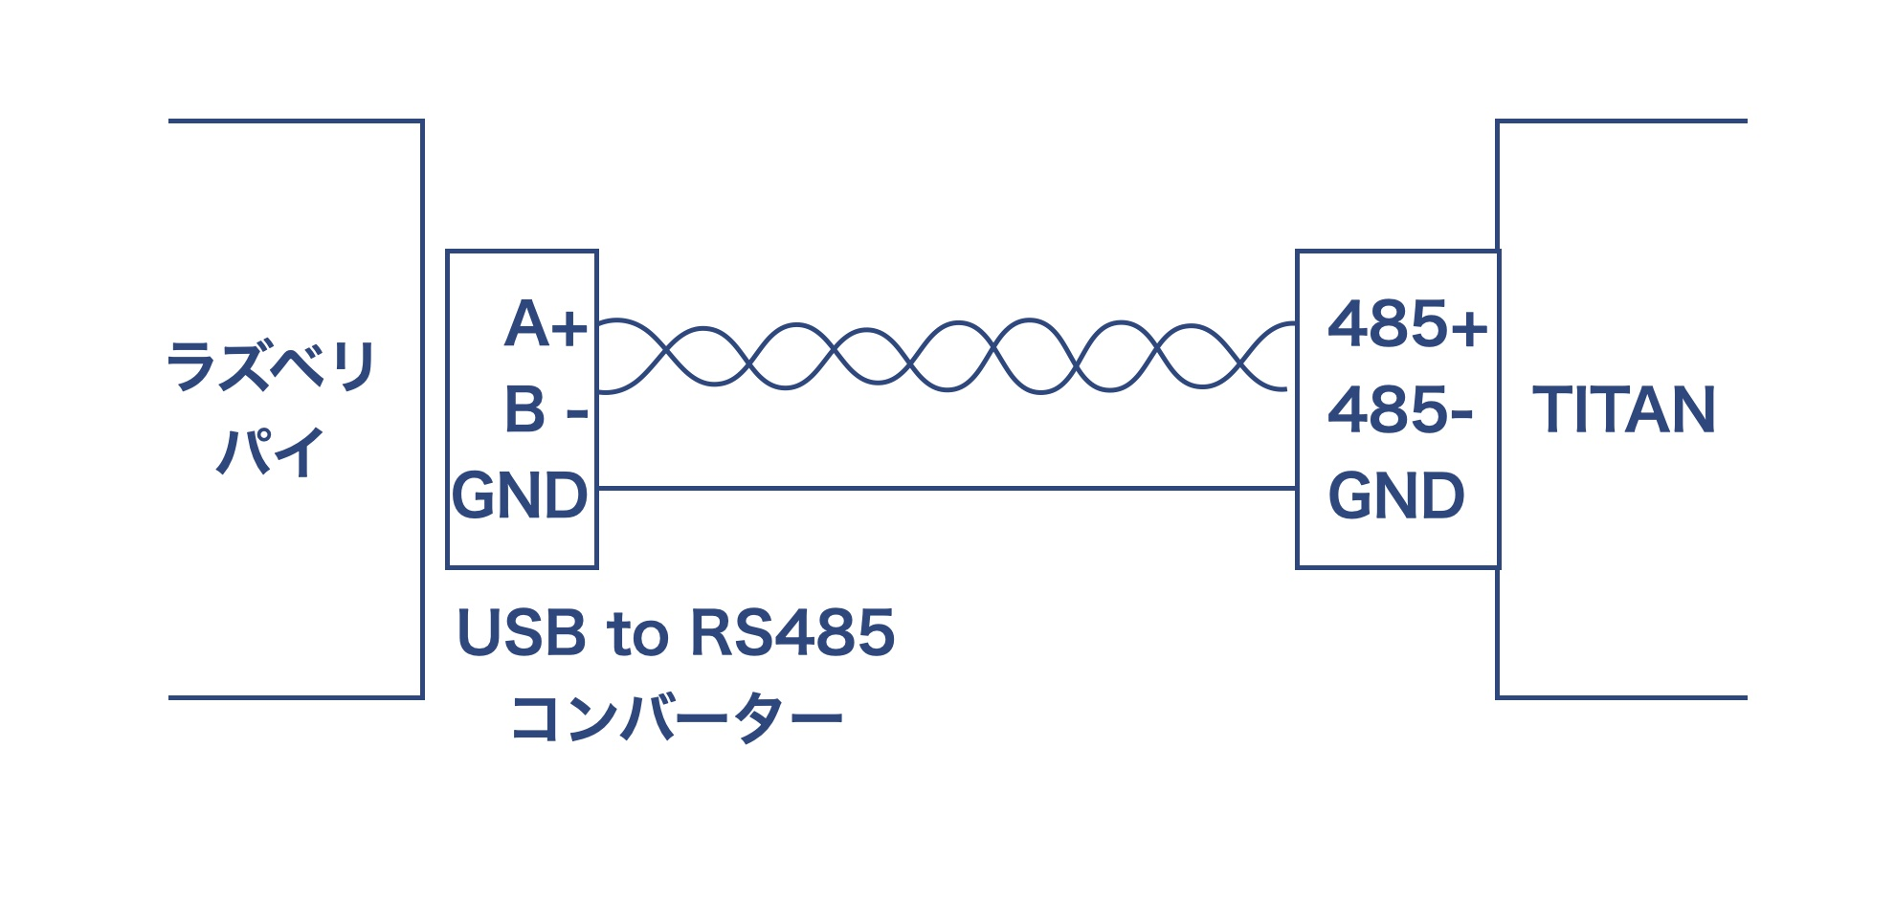

Default settings
TITANソフトウェアでTITANの初期設定をおこないます。TITANソフトウェアは次のARCUS Servo Motion社のサイトからダウンロードします。ARCUS社のサイトでもダウンロードにはユーザー登録が必要です。
- ARCUS Servo Motion社ダウンロードページ
TITANソフトウェアをインストールして起動すると、次のような画面が表示されます。

Follow the "TITAN Startup Guide" to set up TITAN.It is roughly the following flow.
- Setting up USB Communication
Click the Communication icon to set up the COM port connected to the USB cable and test the communication.
- Setting motor parameters
Click the Motor icon and select the motor type.It starts the motor without any connection to the motor and automatically recognizes the characteristics of the motor.
- Tuning
Click the Tuning icon, connect the object (mechanism) to be moved by the motor, start the motor, and automatically recognize the characteristics including the mechanismIt is also possible to use the following methods:Since there is no object this time, I did the tuning without connecting anything.
- Setting operation mode
Click the Configuration icon, set the operation mode, etc., and finally download the configuration information to TITAN, and write it to TITAN's memoryIt will be.

Operation check
Now that the initial setup is done, I will try to move the motor with TITAN.First of all, I try to rotate the motor in 1 minute 33 revolutions.
Click the Test Drive icon of TITAN software, ① Turn on servo control with "SVON", ② set "SPEED" to 33, ③ Click "JV+"And the motor starts to turn.④ Click "STOP" to stop the motor.Even if you try to rotate by pinching the shaft of the motor in this state, it will not rotate because servo control is effective.⑤ When the servo control is turned off with "SVOFF", the motor can be turned with a finger.

By the way, if you click "JV+" without turning servo control ON, "Motor not enabled." Enable first.The motor does not move.

Control servo motor with script program
TITAN has a scripting language called "A-Script" to read information such as servo control ON/OFF, motor speed and acceleration settings, and motor currentYou can control conditions such as IF and WHILE.You can also specify the position and control specific to servo motors, such as "Move the motor to position 0".
I wrote a simple program using "A-Script".
PRG 0
HSPD = 800 ; 速度を800に設定
ACC = 800 ; 加速度を800に設定
SVON ; サーボ制御をON
DELAY = 1000 ; 1000ミリ秒（1秒）待つ
WHILE TRUE
X80000 ; モーターを位置80000に移動させる
WAITX ; 動作の完了を待つ
DELAY = 1000 ; 1秒待つ
X0 ; モーターを位置0に移動させる
WAITX ; 動作の完了を待つ
DELAY = 1000 ; 1秒待つ
ENDWHILE
END
Right from ";" is a comment.I can't actually use comments with full-width characters, but I wrote a comment in Japanese for explanation.When you try to download a program that contains a full-width character, you receive an error message "An application component has an unhandled exception."It has occurred.You will see an error that says, "No, no, no, no, no, no, no, no, no, no."If you see this error somewhere in the program contains full-width characters, look for it and delete it.Be careful because it is difficult to find full-width spaces such as " ".
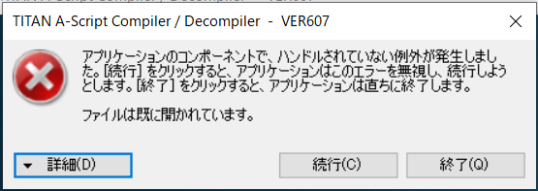
The program, after setting the speed and acceleration, turn on the servo control, move the motor position to 80000, wait 1 second when the movement is complete, the positionMove it to 0, wait 1 second when the move is complete, and move it to position 80000, and repeat the operation.
Write this program to ① program area on the right side of the TestDrive screen of TITAN software, download it to ②TITAN, and write it to ③ memory.④ When you click "RUN", the state of "Prog0" in⑤ changes from IDLE to RUNNING, and the motor starts to move.If you look at⑥ in the lower left corner of the TestDrive screen, the position of the motor is displayed, move from 0 to 80000, stop for 1 second, return from 80000 to 0, stop for 1 second, repeatI was able to confirm that it is.

Stand-alone operation
If you download the A-script program to TITAN and write it to memory, the program will be saved even if you turn off TITAN.Write the program to the memory, select ① "Misc" tab on the right side of the TITAN software Configuration screen, ② "Servo On" in "Power Up State" and ③ "Autorun" in "0"If you check "", download the settings, write to④ memory, program 0 will be automatically executed when TITAN's power is turned ON.It will be.With this, I was able to operate the motor according to the program only with TITAN and the motor without connecting the computer.

Get the operation status of the motor with Raspberry Pi
Now that you have a standalone operation, connect TITAN and Raspberry Pi with RS485 and try to get the operating state of the motor.TITAN's RS485 communication is available in 2 ways:
- TITAN-ASCII Command Communication
- Modbus communication

ASCIIコマンドで動作データ取得
まずWindowsパソコンのTITANソフトウェアでTITANの通信モードを①RS485 TITAN-ASCIIモードに設定し、②設定をダウンロードして、③メモリに書き込みます。
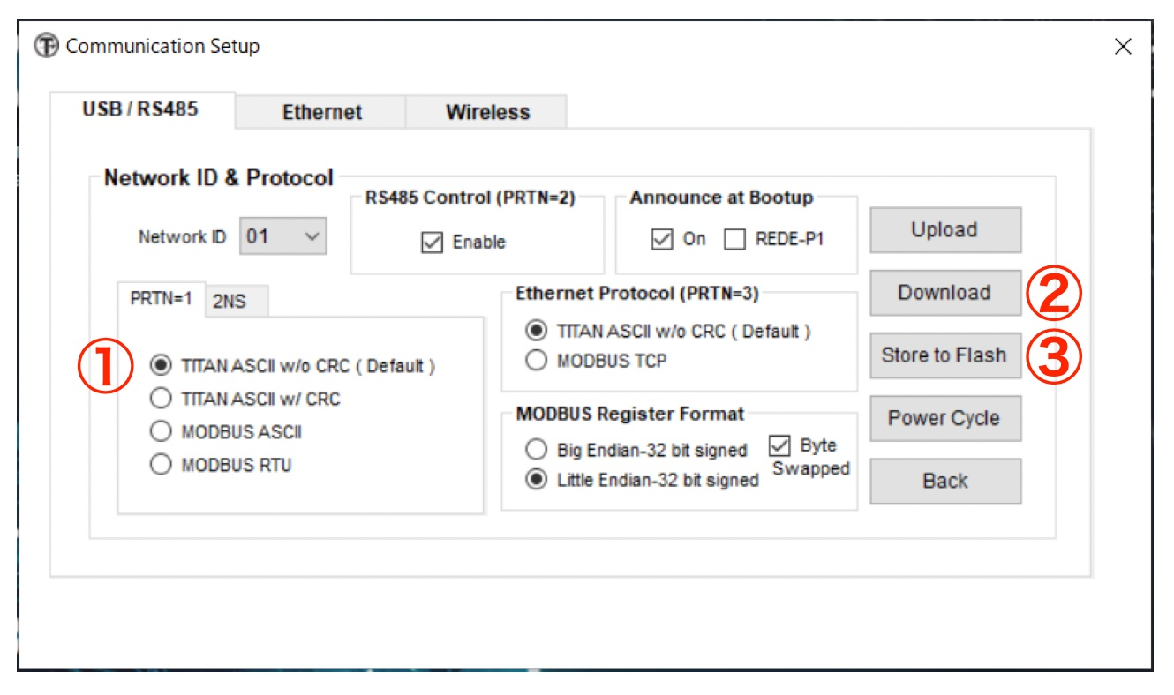
パソコンを外し、RS485ケーブルでTITANとラズベリパイを接続します。今回使っているUSB to RS485コンバーター（以下、RS485コンバーター）はCP2102という通信チップを使っています。ラズベリパイのOSが出すメッセージから「cp21」に関係するものを見ると、RS485コンバーターが /dev/ttyUSB0 でアクセスできることが分かります。
$ dmesg | grep cp21
[ 438.379957] usbcore: registered new interface driver cp210x
[ 438.380014] usbserial: USB Serial support registered for cp210x
[ 438.380141] cp210x 1-1.5:1.0: cp210x converter detected
[ 438.386169] usb 1-1.5: cp210x converter now attached to ttyUSB0
PythonプログラムでRS485コンバーターにアクセスしてみます。TITANとラズベリパイはRS485で通信していますが、USB to RS485コンバーターを介するとシリアル回線としてアクセスできます。Pythonでシリアル回線にアクセスするには pyserial というライブラリを使うので、まず pyserial をインストールします。
$ python3 -m pip install pyserial
TITANのRS485の通信パラメーターは次の通りです。
ボーレート | 115,200
バイトサイズ | 8ビット
パリティ | なし
フロー制御 | なし
ストップ ビット | 1
ボーレート以外は pyserial のデフォルト値なので、ボーレートだけ設定すれば次のようにRS485コンバーターにアクセスできます。データがないときや通信エラーの時に早くタイムアウトさせるために0.1秒に設定しています。
ser = serial.Serial('/dev/ttyUSB0', 115200, timeout=0.1)
The format of TITAN-ASCII command communication is as follows.
Command | Start character "@" | Titan's NetID | Delimiter ":" | Command Column | \r\n
Response | Start character "#" | Titan's NetID | Delimiter ":" | Response column | \r\n
TITAN's NetID is the TITAN's ID, which you set in the Communication settings of the TITAN software, and the default is 1.The command column is a sequence of commands connected by ";", such as "Command 1; Command 2".The response column is the response to a command with ";", such as "Command 1=value 1; Command 2=value 2".The last \r and \n are not the scattered 4 characters of "\""r""\""n", but the 2 characters of "\r" "\n".
For example, the command to get the state and position of the motor for TITAN of ID1 and its response is as follows.
コマンド @01:MST;EX\r\n
応答 #01:MST=03;EX=1234\r\n
I connected to TITAN in Python and tried to get error information, motor status, position, speed and motor current value.
# -*- coding: utf-8 -*-
import serial
import time

%matplotlib inline
import matplotlib.pyplot as plt
import numpy as np

ser = serial.Serial('/dev/ttyUSB0', 115200, timeout=0.1)

if ser.is_open:
print('RS485 to TITAN is open')

data = []
startT = time.perf_counter()
while (time.perf_counter() - startT) < 20.0:
loopT = time.perf_counter()
ser.write(b'@01:FLT;MST;EX;VX;CURQA;CURDA\r\n') # エンコーダ位置取得
line = ser.readline()
# b'FLT=0x0;MST=0x3;EX=9999;CURQA=-0.0379776;CURDA=0.0160128\r\n'
line.decode()[4:-2].split(';')
# ['FLT=0x0', 'MST=0x3', 'EX=9999', 'CURQA=-0.0379776', 'CURDA=0.0160128']
d = {'time': time.perf_counter() - startT}
for x in line.decode()[4:-2].split(';'):
k, v = x.split('=')
try:
d[k] = int(v, 0)
except ValueError:
d[k] = float(v)
data.append(d)
time.sleep(max(0.1 - (time.perf_counter() - loopT), 0)) # sleep()の値をマイナスにしないようにする
print(len(data))

t = [a['time'] for a in data]
x = [a['EX'] for a in data]
cq = [a['CURQA'] for a in data]
v = [a['VX'] for a in data]

fig = plt.figure(figsize=(9,6))
ax = fig.add_subplot(2,1,1)
ax.plot(t, x)
ax = fig.add_subplot(2,1,2)
ax.plot(t, v)

fig = plt.figure(figsize=(9,4))
ax1 = fig.add_subplot()
ax1.plot(t, v)
ax2 = ax1.twinx()
ax2.plot(t, cq, 'r')
To send commands to TITAN in Python, use the write method of the serial object.Since the argument of the write method is a byte column, the command string is enclosed in b” and sent as a byte column.
ser.write(b'@01:MST;EX\r\n')
The response from TITAN is a newline at the end, so you can read it with the readline method.
line = ser.readline()
b'#01:MST=0x5;EX=59530\r\n'
The response is also obtained in a byte column.It is useful to convert this to the dictionary form {‘Command 1’ : value 1, ‘Command 2’ : value 2}.
Convert the byte column to a string with the decode method as in line 21, remove the first 4 characters (#01:) and the last 2 characters (\r\n), and split it with ";"It converts the command to a list of strings called ’Command=value’.Then convert it to dictionary format as shown in lines 24 to 29.The value of the response from TITAN may be displayed as a 10-adic integer, a 16-adic integer, or an immobile decimal number.If it is a 10-digit or 16-digit integer, it converts it to an integer with int(v, 0), and if it is a immovable decimal, a ValueError exception is raised, so it converts it to a number with float(v).It's a good idea.
In the program every 0.1 seconds for 20 seconds, the error information, motor status, position, speed and motor current values are obtained, and the obtained values are graphed in matplotlib.We are working to improve the quality of our products and services.
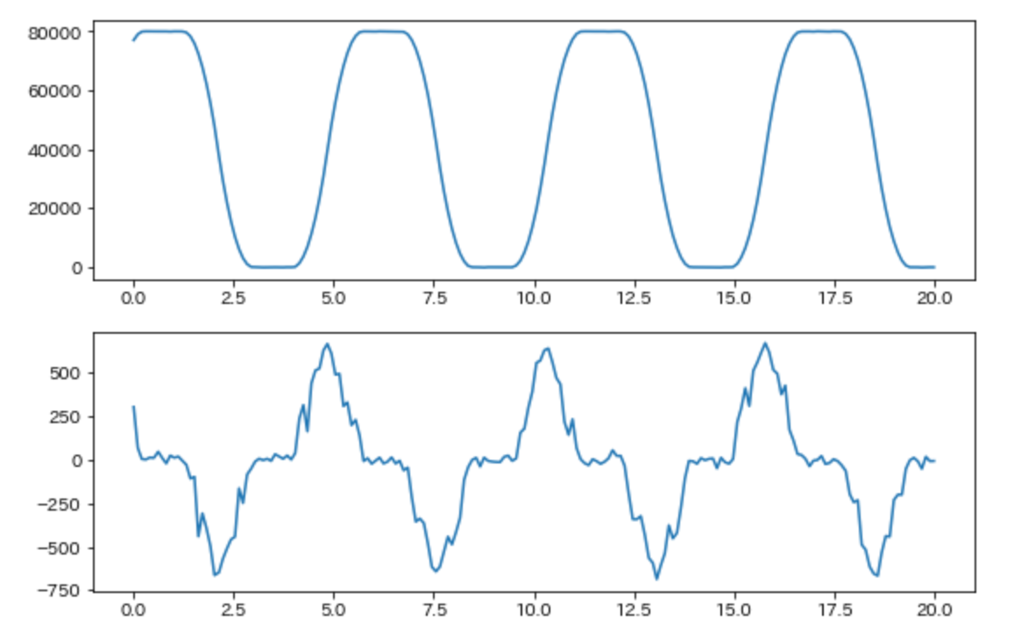
As specified in the A-Script program, the motor position moves from 0 to 80000, stops for 1 second, returns from 80000 to 0, stops for 1 second, and repeats.It will be.When moving from position 0 to 80000, the speed will accelerate from 0, the second half will slow down, and when it reaches position 80000, the speed will be 0.It was confirmed that when it returned to position 0, it accelerated and decelerated in the opposite direction, and when it returned to position 0, the speed also became 0.
In general, during acceleration and deceleration, a lot of current flows to drive the motor, and when moving at a constant speed, the current value is small.The actual data did not confirm such a relationship.Since it is a no-load state where nothing is connected to the motor, there may be no noticeable current change.

Operation data acquisition by Modbus
The RS485 communication of TITAN can communicate by Modbus in addition to communication by ASCII command.
Modbus is a communication protocol for connecting industrial electronics.When reading sensor data from a computer with a master/slave type protocol, the computer becomes the master and makes a request, and the sensor data is read from the computer.The server returns a response as a slave.As a physical network, it supports RS485 and Ethernet.TITAN is also capable of Modbus communication over both RS485 and Ethernet.This time, I will try to acquire data by Modbus communication of RS485.
Set the communication mode of TITAN to ①MODBUS RTU mode in TITAN software of Windows PC.In addition, select ② "Little Endian-32 bit signed" of "MODBUS Register Format", ③ Check "Byte Swapped", ④ Download the setting to TITAN,⑤ Write it to memoryWe will try.
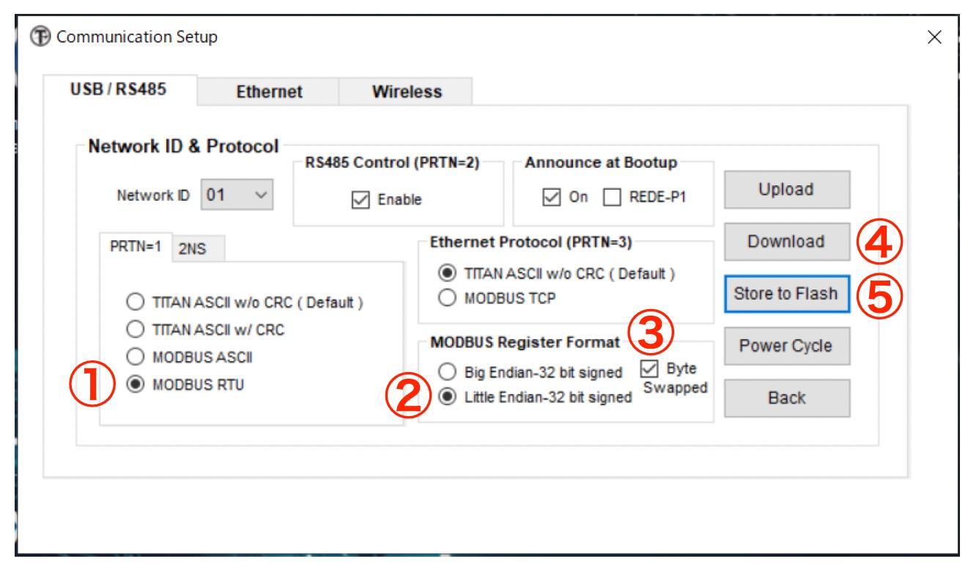
To do Modbus communication in Python, we use a library called Pymodbus, so we install Pymodbus first.
$ python3 -m pip install pymodbus
As with ASCII command communication, try to get the motor position and speed.In TITAN, this information can be read by Modbus's read_holding_registers() function.
Register address | Length | Data
0 | 2 | Encoder Real position
2 | 2 | Real speed
4 | 2 | Target position
6 | 2 | Target speed
8 | 2 | Location error
10 | 2 | Motor status
12 | 2 | Error Code
14 | 2 | Stand-alone Program Status
…
The Python program looks like this:TITAN access is organized into classes.When you generate the Titan class, you create an instance of Modbus with a device called /dev/ttyUSB0 that accesses TITAN and a baud rate, and connect to TITAN.Since Modbus will wait 3 seconds by default if no response is received from the slave device, you can specify a 0.1-second timeout and set the wait time on error.It is also possible to reduce the amount of time required for the operation.
# -*- coding: utf-8 -*-
from pymodbus.client.sync import ModbusSerialClient
from pymodbus import exceptions
import time
import struct
import binascii

%matplotlib inline
import matplotlib.pyplot as plt
import numpy as np

def hex_to_float(s):
if s.startswith('0x'):
s = s[2:]
return struct.unpack('>f', binascii.unhexlify(s))[0]

def twosComplement_hex(hexval):
bits = 32
val = int(hexval, 16)
if val & (1 << (bits-1)):
val -= 1 << bits
return val

class Titan:
def __init__(self):
self.client = ModbusSerialClient(port="/dev/ttyUSB0", method="rtu", baudrate=115200, timeout= 0.1)
self.client.connect()

def readHRegs(self, addr, count, unit=1):
while True:
try:
res = self.client.read_holding_registers(address=addr, count=count, unit=unit)
except Exception as e:
print('Exceptio in read_holding_registers')
print(e, flush=True)
res = None

if res == None or isinstance(res, exceptions.ModbusIOException):
pass
else:
regs = [x + y * 0x10000 for (x, y) in zip(res.registers[::2], res.registers[1::2])]
break
return regs

titan = Titan()

data = []
startT = time.perf_counter()
while (time.perf_counter() - startT) < 20.0:
loopT = time.perf_counter()

regs = titan.readHRegs(0, 16)
d = {'time': time.perf_counter() - startT}
d['EX'] = twosComplement_hex('{:x}'.format(regs[0]))
d['VX'] = twosComplement_hex('{:x}'.format(regs[1]))
d['ex'] = regs[0]
d['vx'] = regs[1]

data.append(d)
time.sleep(max(0.1 - (time.perf_counter() - loopT), 0)) # sleep()の値をマイナスにしないようにする

t = [a['time'] for a in data]
x = [a['EX'] for a in data]
v = [a['VX'] for a in data]

fig = plt.figure(figsize=(9,6))
ax = fig.add_subplot(2,1,1)
ax.plot(t, x)
ax = fig.add_subplot(2,1,2)
ax.plot(t, v)
TITAN returns an object called ModbusIOException if there is a communication error in read_holding_registers().The readHRegs() function of the Titan class rerun the read when an exception or ModbusIOException object is returned, so that a successful response is obtained.
In Modbus, you can specify the number of 16-bit registers to read, while in TITAN, 2 registers represent 1 data, and an even number of registers can be read.Only reads with the specified registers are supported.2 Register (1 data) can be read by specifying the address, or multiple consecutive data can be read by 1 read.The sample program contains 16 registers (8 data) from address 0 (encoder real position) to standalone program status.It is read continuously (data).
Each data is represented in base 16, position, speed, etc. are signed in base 10, motor status, etc. are in bit pattern, and data is represented in base 10, etc. are represented in base 10, etc. are represented in base 10, etc. are represented in base 10, etc. are represented in base 1, etc. are represented in base 1, etc. are represented in base 1, etc. are represented in base 1, etc. are represented in base 1, etc. are represented in baseIt is necessary to be careful because the treatment differs depending on the data.
Every 0.1 seconds in Modbus also for 20 seconds, I got the motor position and speed and graphed the values in matplotlib to check.I was able to confirm that the motor position is coming and going from 0 to 80000.

Summary
IoT Servo Controller TITAN is a servo controller that has the functions of servo amplifier and servo controller and can control multiple types of servo motors.It is a computer controller.In addition to controlling the motor, TITAN allows you to control the position, speed, current, and other data of the motor you are controlling relatively easily in programs such as Python.You can get it.It is an easy-to-use servo controller for configuring IoT systems, such as management of equipment operation performance using servo motors.

