Ambient is an IoT data visualization service.
Sensor data sent from microcontrollers, etc. is received, accumulated, and visualized (graphed).
This is a useful help on use of ambient with raspberry pi

Easy, even powerful graphing function
Ambient can help you prototype your IoT ideas as easily as possible.You can graph the sent data in real time without having to make detailed initial settings.For example, even if the temperature and humidity data obtained from the sensor are sent without the initial setting, the graph is displayed as follows.
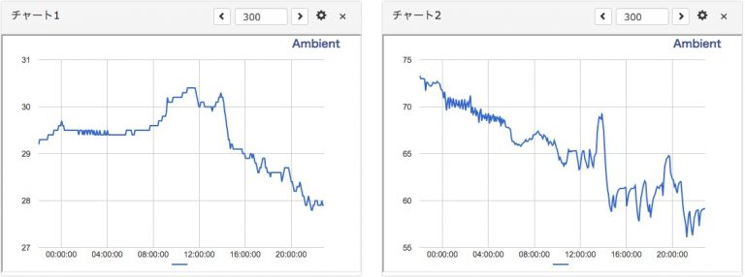
With more settings, you can name your chart or data in a way that is easy to understand, change the type of chart, or merge multiple data into one chart.You can customize it with powerful features such as superposition and display on top of each other.If you add settings to the example above, you can make a graph like the following.For more information, see Customizing Channels and Charts.
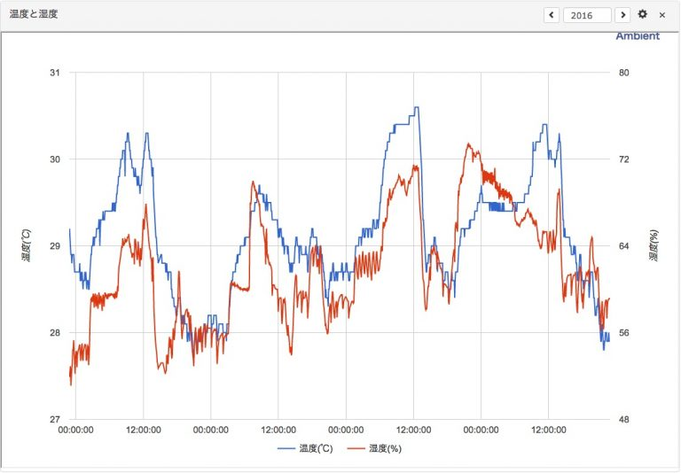

Easy to use
To use Ambient, you must first register as a user (free of charge).If your microcomputer is Arduino, mbed, Raspberry Pi there is a library and sample program, so it is best to copy it and customize itIt's easy.See "Using Ambient" for instructions.

Measure temperature and humidity with Raspberry Pi3 and visualize it with Ambient
I measured temperature and humidity with a sensor called Raspberry Pi3 and HDC1000, and sent it to Ambient for visualization (graphing).I wrote the program in Python.

How to access HDC3 from Raspberry Pi 1000 in Python

Connecting Raspberry Pi3 and HDC1000
The HDC1000 is a sensor chip that measures temperature and humidity.It can be accessed via an interface called I2C.This time, I used the "HDC1000 temperature and humidity sensor module" of Akizuki Electronics, which contained this HDC1000.
Connect the Raspberry Pi3 to the HDC1000 as follows.
Raspberry Pi | HDC1000
01(3.3v) | 1(+V)
03(GPIO02) | 2(SDA)
05(GPIO03) | 3(SCL)
07(GPIO04) | 4(RDY)
06(Ground) | 5(GND)
+V, SDA, SCL, and GND are signal lines defined by I2C, and the HDC1000 also has a pin called RDY.The HDC1000 takes about 2.5m seconds to 6.5 m seconds to measure temperature and humidity.Time depends on resolution.Since the RDY pin goes HIGH during the measurement and LOW after the measurement is completed, I connected it to Pin7 (GPIO04) of Raspberry Pi to confirm the measurement completion.

Raspberry Pi3の準備
Buy Raspberry Pi 3 and connect Raspberry Pi 3 to WiFi using Mac to connect WiFi connection and SSH connection etc.
Next, refer to how to activate I2C on Raspberry Pi (2015 version) and so on to activate I2C.HDC 0x40 was detected at address 1000 as follows:
pi$ sudo i2cdetect -y 1
0 1 2 3 4 5 6 7 8 9 a b c d e f
00: -- -- -- -- -- -- -- -- -- -- -- -- --
10: -- -- -- -- -- -- -- -- -- -- -- -- -- -- -- --
20: -- -- -- -- -- -- -- -- -- -- -- -- -- -- -- --
30: -- -- -- -- -- -- -- -- -- -- -- -- -- -- -- --
40: 40 -- -- -- -- -- -- -- -- -- -- -- -- -- -- --
50: -- -- -- -- -- -- -- -- -- -- -- -- -- -- -- --
60: -- -- -- -- -- -- -- -- -- -- -- -- -- -- -- --
70: -- -- -- -- -- -- -- --
I decided to write the program in Python, so I installed a module called WiringPi for Python that accesses I2C in Python.
pi$ sudo apt-get install python-dev python-setuptools swig

pi$ git clone --recursive https://github.com/WiringPi/WiringPi-Python.git
pi$ cd WiringPi-Python
pi$ ./build.sh

pi$ pip freeze | grep wir
wiringpi==2.32.1
This will build and install Python.The version I built was 2.32.1.

Python HDC1000 Module
I wrote a module to access the HDC1000._The _init__ method looks like this:
import wiringpi
import os
import struct

class Hdc1000:
def __init__(self, addr, rdyPin):
wiringpi.wiringPiSetup() #setup wiringpi

self.i2c = wiringpi.I2C() #get I2C
self.dev = self.i2c.setup(addr) #setup I2C device
self.rdy = rdyPin

wiringpi.pinMode(self.rdy, 0) # set ready pin to INPUT

self.i2c.writeReg16(self.dev, 0x02, 0x0000)
# Config Set reg MODE=0 Read temperature and humidity separately
Setting the Mode bit of the configuration register (0x02) to 0 reads the temperature and humidity 16 bits individually, and setting it to 1 reads the temperature and humidity 32 bits individually.If you do not want to read the data, you will need to read the data at once as a set of data.This time I tried to load it individually.By the way, in the I2C library of wiringpi, it seems that the high byte and the low byte are read and written by turning over.The Mode bit of the HDC1000 is bit 12 if the least significant bit is 0, and 1 if the least significant bit is 16, it is 0x1000, but when written in the I2C library, the Mode bit of the HDC1000 is the same as the Mode bit of the HDC1000.It writes 0x0010 when it is used.
The method to get the temperature is like this.
def getTemp(self):
self.i2c.writeReg8(self.dev, 0x00, 0x00)

while wiringpi.digitalRead(self.rdy) == 1:
pass

data = struct.unpack('BB', os.read(self.dev, 2))
temp = (data[0] << 8) | data[1]
temp = temp * 165.0 / 65536.0 - 40.0
return temp
When the HDC1000 writes something to register 0x00, it starts measuring the temperature, the RDY pin goes HIGH(1), and when the measurement is complete, it goes LOW(0).In Python, writeReg8() writes 0x00 to register 0x00 and waits until the RDY pin is 0 in the next while statement.When the RDY pin goes to 0, I read register 0x00, but I can't read the data with readReg8() and readReg16() in the I2C library of wiringpi, and I can't read the data from the os instead..When I read 2 bytes with the read() function, I was able to read the data.
How to use it is like this.Create an instance by specifying the HDC1000 I2C address (0x40) and the pin number of the RDY pin (7), and read the temperature and humidity with getTemp() and getHumid().
import hdc1000

hdc1000 = hdc1000.Hdc1000(0x40, 7)

temp = hdc1000.getTemp()
humid = hdc1000.getHumid()
print 'temp: %.1f, humid: %.1f' % (temp, humid)

Send and visualize data from Raspberry Pi3 to Ambient
C library for Arduino, C library for mbed, and node as SDKs to send data to Ambient.I have a js library, Node-RED node, but I made a Python library in addition to this.

Installing the Ambient Python Library
Ambient's Python library has been published on Github.From Github, you can install the library as follows:The example was run on Raspberry Pi3, but you can install and use it in Python on Mac as well.
pi$ sudo pip install git+https://github.com/AmbientDataInc/ambient-python-lib.git

pi$ pip freeze | grep ambient
ambient==0.1.0

How to use it in Python
import ambient

ambi = ambient.Ambient(100, "your_writeKey") # Replace your channel ID with the light key

r = ambi.send({"d1": temp, "d2": humid})
First, we import the ambient library, create an instance with the channel Id and light key to send data, and send the data with the send() method.It's a great way to make your life easier.You pass the data in a dictionary format like the one above.The key can be either "d1" to "d8".
When Ambient receives data, it stores the data with a time stamp when it is received, and graphs it in real time.For example, if you send temperature and humidity at 5-minute intervals, you can check the time-series transition of temperature and humidity in the graph as follows.
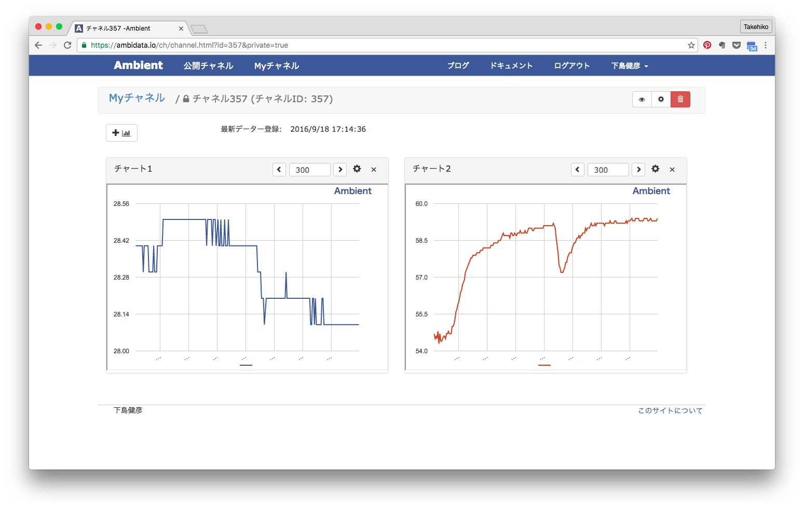

Summary
We have published a Python library to send data to Ambient and a sample program to measure temperature and humidity in the HDC1000 on Github

Python/MicroPython module in Ambient

Ambient
Ambient is an IoT data visualization service that receives, accumulates, and visualizes (graphs) sensor data.

When user registration (free) to Ambient and send data from the microcomputer, you can display a graph like this.
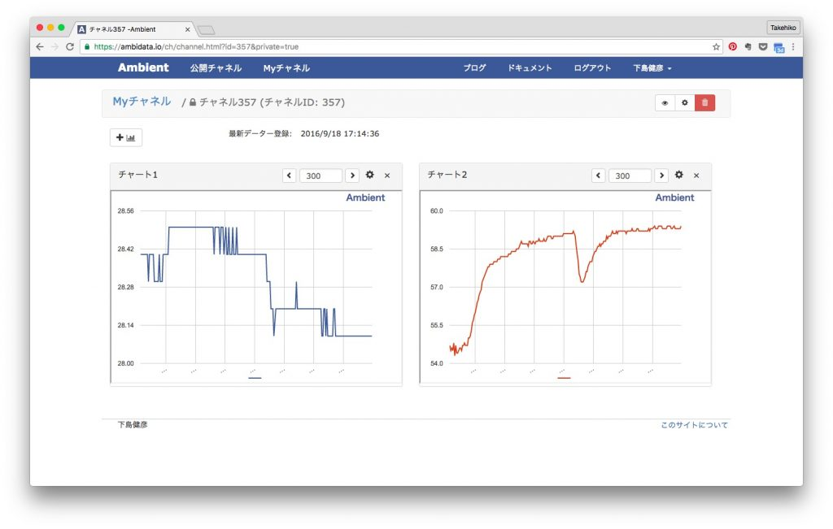
ambient-python-lib is the Python/MicroPython library for Ambient. There is a function to send data to Ambient and a function to read the data accumulated in Ambient. It also works with MicroPython.

Install the module
$ sudo pip install git+https://github.com/AmbientDataInc/ambient-python-lib.git

Importing a Module
import ambient

Sending Data to Ambient
We first create an instance of Ambient with the channel Id and light key, and then send the data with the send() method.You pass the data in a dictionary format like this:The key can be one of 'd1' to 'd8'.
ambient = am.Ambient (Channel Id, Light key [, Read key [, User key]])
r = am.send({'d1': 数値, 'd2': 数値}[, timeout = timeout])

Parameters
Please pass the data in dictionary format like above.Please specify one of the keys from "d1" to "d8".
If you send data in this format, Ambient records the time when the data was received. You can also specify the time when the data was measured as follows:
am = r.send({'created': 'YYYY-MM-DD HH:mm:ss.sss', 'd1': 1.1, 'd2': 2.2})
You can also send multiple data in bulk as follows:
= data [
{'created': '2017-02-18 12:00:00', 'd1': 1.1, 'd2': 2.1},
{'created': '2017-02-18 12:01:00', 'd1': 1.5, 'd2': 3.8},
{'created': '2017-02-18 12:02:00', 'd1': 1.0, 'd2': 0.8}
]
r = am.send(data)
timeout specifies the timeout value for the server connection.The default is 30.0 seconds.

Return value
It returns the same as the return value of Python Requests.In particular
r.status_code
The result (status code) when data is sent to the server is set.If the transmission is successful, 200 will be set.

Reading Data from Ambient
As with data transmission, the instance is created by specifying the channel Id, the write key, and the read key first. If you do not read, the write key is ok to specify ".
ambient = am.Ambient (Channel Id, Light key [, Read key [, User key]])
There are several ways to load data: to specify the number of data, to specify the date, and to specify the time period.

Load data by specifying the number of times
am = d.read(n=件数[, skip=スキップ件数[, timeout = timeout]])

Parameters
- n: Specify the number of data to read.The latest n data is loaded.
- skip: The number of skips.Skip data from the latest, and then n data is read.
- timeout: The timeout value (in seconds) for the server connection.The default time is 30.0 seconds.

Return value
- It returns an array of dictionary formats (in JSON format), such as:
[
{'created': '2017-02-25T15:01:48.000Z', 'd1': 数値, 'd2': 数値, 'd3': 数値},
{'created': '2017-02-25T15:06:47.000Z', 'd1': 数値, 'd2': 数値, 'd3': 数値},
...
]
The data generation time 'created' is displayed in Coordinated Universal Time (UTC).The data is ordered in ascending order of generation time (from old to new).

Load data with a specified date
am = d.read(date='YYYY-mm-dd'[, timeout = timeout])

Parameters
- date='YYYY-mm-dd': Reads the data for the specified date.
- timeout: The timeout value (in seconds) for the server connection.The default time is 30.0 seconds.

Return value
Returns an array of the same dictionary format as if you specified the number of items.

Load data with specified duration
am = d.read(start='YYYY-mm-dd HH:MM:SS', end='YYYY-mm-dd HH:MM:SS'[, timeout = timeout])

Parameters
- start='YYYY-mm-dd HH:MM:SS':
- end='YYYY-mm-dd HH:MM:SS': Read data from start to end.
- timeout: The timeout value (in seconds) for the server connection.The default time is 30.0 seconds.

Return value
Returns an array of the same dictionary format as if you specified the number of items.

Get Channel Information
Gets the channel information specified in Ambient, such as data name and channel location information.
am = prop.getprop([, timeout = timeout])

Parameters
- timeout: The timeout value (in seconds) for the server connection.The default time is 30.0 seconds.

Return value
The channel information is returned in dictionary form.The name I set for the data from d1 to d8 is
prop['d1']['name']
You can refer to it in .

How to use it with MicroPython
"ambient.py Download "" to the development environment, and then copy it to the local file system of the microcomputer using a tool such as mpfshell. For more information about mpfshell, see Introducing MicroPython (Mac) shell with ESP-WROOM-02. You can now "import ambient" from MicroPython's interpreter or program.

Case studies
I put an example under the examples directory.

hdc1000
It is an example of measuring temperature and humidity every 5 minutes with a sensor called hdc1000 in Python of Raspberry Pi, and sending it to Ambient to graph it. For more information, see Measuring Temperature and Humidity with Raspberry Pi3 and Visualizing it with Ambient.

uenv
Here is an example of measuring temperature, humidity, illuminance, and vibration in MicroPython of ESP8266 and recording it in Ambient. For more information, see Measuring Temperature, humidity, illuminance, and Vibration with MicroPython (ESP8266) and Recording and Visualizing it with Ambient.

M5_BME280
This is an example of connecting the M5Stack to the BME280 temperature, humidity, and pressure sensor, measuring temperature, humidity, and pressure, and sending it to Ambient. See "M5Stack (Micropython edition)" for details.

M5_BME680
This is an example of connecting M5Stack to the BME680 temperature, humidity, and air quality sensor, measuring temperature, humidity, and air pressure, and sending it to Ambient. See "M5Stack (Micropython edition)" for details.
https://github.com/AmbientDataInc/ambient-python-lib

