1. [6] Beta-reduce these lambda expressions. Show your work at each step.

1a. [1] (λx.x) y

//replace all instances of x with y

= y

1b. [2] (λz.z) ((λb.b) a)

//replace all instances of z with ((λb.b) a)

= (λb.b) a

//replace all instances of b with a

= a

1c. [3] (λx.λy.x y y) (λa.a) b

//replace all instances of x with (λa.a)

= λy. λa.a y y b

//replace all instances of y with b

= λa.a b b

//replace a instances of a with b

= b b

2a. [2] Give a Huffman Encoding for the following:

Load=25%, Move=24%, Add=23%, Subt=16%, Mult=12%

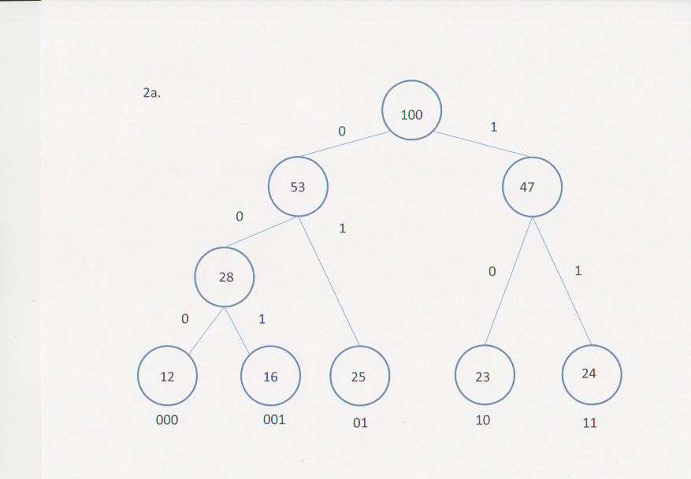

2b. [3] Draw a FSA with a start Point S and Final States Load, Move, Add, Subt and Mult that

will recognize what sort of operation is being decoded.

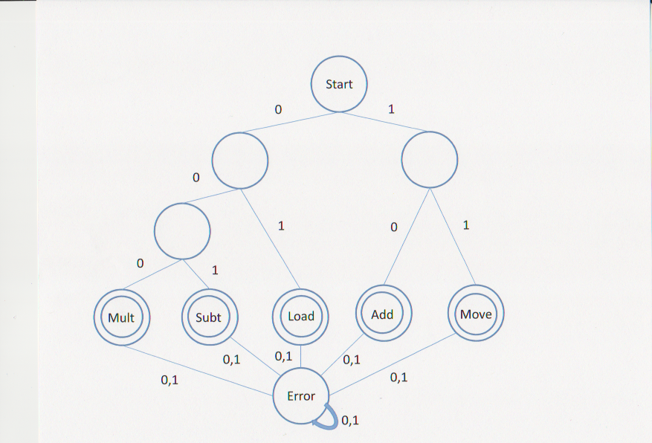

3. [3] Abstract data types.

3a. [1] What is an abstract Data type?

* An ADT is a mathematical model which may be used to capture the essentials of a problem domain in order to translate it into a computer program achieved through encapsulation.

3b. [1] What are the defining operations of a stack? What do they do?

* The defining operations of a stack are:
* Push – puts an object onto the top of the stack
* Pop – pulls the top object off the stack
* IsEmpty – returns true if the stack is empty
* Top – returns the top object in the stack

3c. [1] How is a queue different from a stack?

A queue uses first in – first out, whereas a stack uses last in – first out

and a queue would use Front versus Top to return the next object.

4. [6] Examine this function:

1 Int Plus(int A, int B) {

2 If (A==0)

3 Return(B);

4 Else

5 Return(Plus(A-1, B+1));

6 }

4a. [1] Is this a recursive function? How can you tell?

Yes, this is a recursive function because in line 5, the function is called with (A-1, B+1) as the arguements

4b. [1] What will Plus(3,5) return?

The function will return 8.

4c. [1] What will happen with this function if A is negative? How about if only B is

negative?

If A is negative, the function will continue infinitely.

If B is negative, the function will perform correctly.

4d. [3] What will the contents of the stack be when line 3 is executed if Plus(3,5) is

executed?

8

7

6

5

david@david-EP121:~/CSCI162/Asn3$ gprolog

GNU Prolog 1.3.0

By Daniel Diaz

Copyright (C) 1999-2007 Daniel Diaz

| ?- [sudoku].

compiling /home/david/CSCI162/Asn3/sudoku.pl for byte code...

/home/david/CSCI162/Asn3/sudoku.pl compiled, 46 lines read - 4765 bytes written, 20 ms

(4 ms) yes

| ?- solve([_,_,4,_,_,2,_,3,2,_,_,_,_,4,_,1],Solution).

Solution = [1,3,4,2,4,2,1,3,2,1,3,4,3,4,2,1]

yes

| ?- solve([_,_,3,_,_,4,_,2,2,_,_,_,_,3,_,1],Solution).

Solution = [1,2,3,4,3,4,1,2,2,1,4,3,4,3,2,1]

yes

| ?-

Prolog interruption (h for help) ? e

david@david-EP121:~/CSCI162/Asn3$