SIM. Assignment 2: Telco Customer Churn

Adrià Casanova, Víctor Garcia, Zhengyong Ji

2024-01-05

Table of Contents

0. Introduction 2

1. Data preparation 4

2. Exploratory Data Analysis (EDA) 8

3. Data Quality Report 12

3.1 In depth analysis of missing values 15

3.2 Multivariate outliers 18

4. Profiling of the target and feature selection 19

Numeric variables’ correlations 19

Profiling of the target 19

Feature Selection 20

Profiling of the target with the selected categorical features 21

5. Modeling 24

Data splitting 24

Modeling only with numerical variables 24

Residual analysis only with numerical variables 25

Adding factor main effects to the model 26

Residual analysis with categorical variables 27

Adding interactions to the model 27

Trying link function probit 29

Final residual analysis 30

6. Goodness of fit 33

Model prediction 35

7. Model interpretation 38

8. Conclusions 39

Annex 41

Expanded profiling of the target with the “profiling()” method 41

Complete EDA 88

# 0. Introduction

In this project, we will study the data set “Telco Customer Churn”, which can be found at <https://www.kaggle.com/datasets/blastchar/telco-customer-churn>. Our goal is to analyze the correlation between the amount of customers who left within the last month (Churn) and different features that describe the customer and the services he/she/they has signed up for. Then, we will build a logistic model that will allow us to predict the variable Churn.

All members have contributed equally to all parts of the project.

We start by taking a first general look at the dataset.

head(df)

## customerID gender SeniorCitizen Partner Dependents tenure PhoneService  
## 1 7590-VHVEG Female 0 Yes No 1 No  
## 2 5575-GNVDE Male 0 No No 34 Yes  
## 3 3668-QPYBK Male 0 No No 2 Yes  
## 4 7795-CFOCW Male 0 No No 45 No  
## 5 9237-HQITU Female 0 No No 2 Yes  
## 6 9305-CDSKC Female 0 No No 8 Yes  
## MultipleLines InternetService OnlineSecurity OnlineBackup DeviceProtection  
## 1 No phone service DSL No Yes No  
## 2 No DSL Yes No Yes  
## 3 No DSL Yes Yes No  
## 4 No phone service DSL Yes No Yes  
## 5 No Fiber optic No No No  
## 6 Yes Fiber optic No No Yes  
## TechSupport StreamingTV StreamingMovies Contract PaperlessBilling  
## 1 No No No Month-to-month Yes  
## 2 No No No One year No  
## 3 No No No Month-to-month Yes  
## 4 Yes No No One year No  
## 5 No No No Month-to-month Yes  
## 6 No Yes Yes Month-to-month Yes  
## PaymentMethod MonthlyCharges TotalCharges Churn  
## 1 Electronic check 29.85 29.85 No  
## 2 Mailed check 56.95 1889.50 No  
## 3 Mailed check 53.85 108.15 Yes  
## 4 Bank transfer (automatic) 42.30 1840.75 No  
## 5 Electronic check 70.70 151.65 Yes  
## 6 Electronic check 99.65 820.50 Yes

dim(df)

## [1] 7043 21

summary(df)

## customerID gender SeniorCitizen Partner Dependents  
## 0002-ORFBO: 1 Female:3488 Min. :0.0000 No :3641 No :4933   
## 0003-MKNFE: 1 Male :3555 1st Qu.:0.0000 Yes:3402 Yes:2110   
## 0004-TLHLJ: 1 Median :0.0000   
## 0011-IGKFF: 1 Mean :0.1621   
## 0013-EXCHZ: 1 3rd Qu.:0.0000   
## 0013-MHZWF: 1 Max. :1.0000   
## (Other) :7037   
## tenure PhoneService MultipleLines InternetService  
## Min. : 0.00 No : 682 No :3390 DSL :2421   
## 1st Qu.: 9.00 Yes:6361 No phone service: 682 Fiber optic:3096   
## Median :29.00 Yes :2971 No :1526   
## Mean :32.37   
## 3rd Qu.:55.00   
## Max. :72.00   
## OnlineSecurity OnlineBackup   
## No :3498 No :3088   
## No internet service:1526 No internet service:1526   
## Yes :2019 Yes :2429   
##   
## DeviceProtection TechSupport   
## No :3095 No :3473   
## No internet service:1526 No internet service:1526   
## Yes :2422 Yes :2044   
##   
## StreamingTV StreamingMovies Contract   
## No :2810 No :2785 Month-to-month:3875   
## No internet service:1526 No internet service:1526 One year :1473   
## Yes :2707 Yes :2732 Two year :1695   
##   
## PaperlessBilling PaymentMethod MonthlyCharges   
## No :2872 Bank transfer (automatic):1544 Min. : 18.25   
## Yes:4171 Credit card (automatic) :1522 1st Qu.: 35.50   
## Electronic check :2365 Median : 70.35   
## Mailed check :1612 Mean : 64.76   
## 3rd Qu.: 89.85   
## Max. :118.75   
##   
## TotalCharges Churn   
## Min. : 18.8 No :5174   
## 1st Qu.: 401.4 Yes:1869   
## Median :1397.5   
## Mean :2283.3   
## 3rd Qu.:3794.7   
## Max. :8684.8   
## NA's :11

The data set contains 7043 observations of 21 variables.

# 1. Data preparation

The first part of the project consisted on doing some basic data preparation to ensure that data is ready for the next sections.

Firstly, we checked that all datatypes were consistent with the metadata and declared “SeniorCitizen” as a factor, as it represented a qualitative concept.

df$SeniorCitizen <- factor(df$SeniorCitizen, labels = c("Yes", "No"))

Secondly, we discretized all numeric variables by splitting data into 4 categories. Their boundaries were obtained simply by dividing the total range in 4 equal intervals and the distribution was checked using histograms to ensure that they were similar to the original variables.

df$c.tenure <- df$tenure # Create a new variable called Categorical.tenure  
m.tenure <- max(df$tenure, na.rm = TRUE)  
df$c.tenure <- replace(df$c.tenure, df$tenure <= m.tenure/4,  
 m.tenure/4)  
for (i in 1:3) {  
 idx <- (m.tenure * i/4 < df$tenure) & (df$tenure <= m.tenure *  
 (i + 1)/4)  
 df$c.tenure <- replace(df$c.tenure, idx, m.tenure * (i +  
 1)/4)}  
min(df$tenure, na.rm = TRUE)

## [1] 0

breakpts <- seq(m.tenure/4, m.tenure, m.tenure/4); breakpts

## [1] 18 36 54 72

df$c.tenure <- factor(df$c.tenure, labels = c("(-1,18]", "(18,36]",  
 "(36,54]", "(54,72]"))  
summary(df$c.tenure)

## (-1,18] (18,36] (36,54] (54,72]   
## 2734 1308 1182 1819

par(mfrow = c(1, 2))  
plot(df$c.tenure, main = "Barplot of df$c.tenure")  
hist(df$tenure)

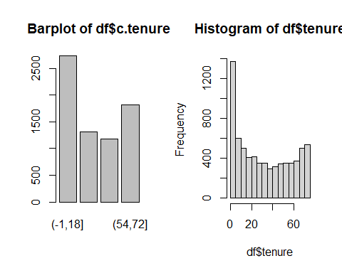

df$c.TotalCharges <- df$TotalCharges  
m.TotalCharges <- max(df$TotalCharges, na.rm = TRUE)  
df$c.TotalCharges <- replace(df$c.TotalCharges, df$TotalCharges <=  
 m.TotalCharges/4, m.TotalCharges/4)  
for (i in 1:3) {  
 idx <- (m.TotalCharges * i/4 < df$TotalCharges) & (df$TotalCharges <=  
 m.TotalCharges * (i + 1)/4)  
 df$c.TotalCharges <- replace(df$c.TotalCharges, idx, m.TotalCharges *(i + 1)/4)}  
breakpts <- seq(m.TotalCharges/4, m.TotalCharges, m.TotalCharges/4); breakpts

## [1] 2171.2 4342.4 6513.6 8684.8

df$c.TotalCharges <- factor(df$c.TotalCharges, labels = c("(-1,2171]",  
 "(2171,4342]", "(4342,6514]", "(6514,8685]"))  
summary(df$c.TotalCharges)

## (-1,2171] (2171,4342] (4342,6514] (6514,8685] NA's   
## 4295 1270 975 492 11

par(mfrow = c(1, 2))  
plot(df$c.TotalCharges, main = "Barplot of df$c.TotalCharges")  
hist(df$TotalCharges)

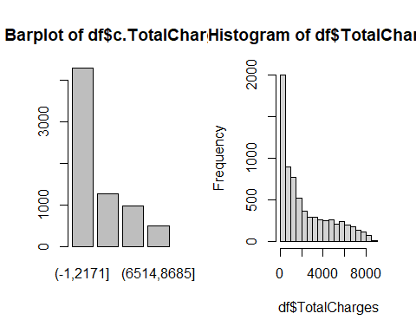

df$c.MonthlyCharges <- df$MonthlyCharges  
m.MonthlyCharges <- max(df$MonthlyCharges, na.rm = TRUE)  
df$c.MonthlyCharges <- replace(df$c.MonthlyCharges, df$MonthlyCharges <=  
 m.MonthlyCharges/4, m.MonthlyCharges/4)  
for (i in 1:3) {  
 idx <- (m.MonthlyCharges * i/4 < df$MonthlyCharges) & (df$MonthlyCharges <=  
 m.MonthlyCharges * (i + 1)/4)  
 df$c.MonthlyCharges <- replace(df$c.MonthlyCharges, idx,  
 m.MonthlyCharges * (i + 1)/4)}  
min(df$MonthlyCharges, na.rm = TRUE)

## [1] 18.25

breakpts <- seq(m.MonthlyCharges/4, m.MonthlyCharges, m.MonthlyCharges/4); breakpts

## [1] 29.6875 59.3750 89.0625 118.7500

df$c.MonthlyCharges <- factor(df$c.MonthlyCharges, labels = c("(18,30.69]", "(30.69,59.38]", "(59.38,89.06]", "(89.06,118.75]"))  
summary(df$c.MonthlyCharges)

## (18,30.69] (30.69,59.38] (59.38,89.06] (89.06,118.75]   
## 1634 1208 2317 1884

par(mfrow = c(1, 2))  
plot(df$c.MonthlyCharges, main = "Barplot of df$c.MonthlyCharges")  
hist(df$MonthlyCharges)

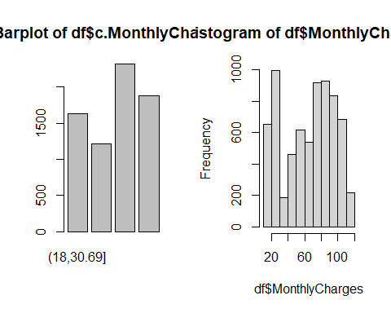

par(mfrow = c(1, 1))

Lastly, we identified categorical and numerical variables for later use.

numeric_val_idx = which(sapply(df, is.numeric))  
numeric_val = names(df)[numeric_val_idx]  
# The only numerical features that we have are tenure,  
# MonthlyCharges and TotalChages.  
  
# So the remaining will be categorical features.  
categoric_val_idx = which(sapply(df, is.factor))  
categoric_val = names(df)[categoric_val_idx]

# 2. Exploratory Data Analysis (EDA)

EDA was done mainly automatically using the “DataExplorer” library. It plots, for each variable, the distribution of numeric variables, the proportion of individuals in each category and the amount of missing values, among other metadata.

The main conclusions of this section are: 1- Using the QQ plots and distribution plots we see that no numerical variable is normally distributed. This was also checked visually and with Kolmogorov-Smirnov tests, a more suitable approach than Shappiro-Wilk for large samples.

2- Our database is not balanced in some categories, like PhoneService (10% of “No”) or SeniorCitizen(16% of “No”). This is specially relevant for the target, “Churn”, that has 73% of cases of “No”, so individuals that churned will be more difficult to predict.

3- Qualitative variables have a maximum of 4 levels, so all of them may be suitable for modeling without any aggregation.

5- Some categories, like “OnlineSecurity” or “OnlineBackup”, are not applicable if the client does not have an internet connection. Consequently, there is a special level for those cases that contains around 22% of the clients.

# Basic EDA  
summary(df)

## customerID gender SeniorCitizen Partner Dependents  
## 0002-ORFBO: 1 Female:3488 Yes:5901 No :3641 No :4933   
## 0003-MKNFE: 1 Male :3555 No :1142 Yes:3402 Yes:2110   
## 0004-TLHLJ: 1   
## 0011-IGKFF: 1   
## 0013-EXCHZ: 1   
## 0013-MHZWF: 1   
## (Other) :7037   
## tenure PhoneService MultipleLines InternetService  
## Min. : 0.00 No : 682 No :3390 DSL :2421   
## 1st Qu.: 9.00 Yes:6361 No phone service: 682 Fiber optic:3096   
## Median :29.00 Yes :2971 No :1526   
## Mean :32.37   
## 3rd Qu.:55.00   
## Max. :72.00   
##   
## OnlineSecurity OnlineBackup   
## No :3498 No :3088   
## No internet service:1526 No internet service:1526   
## Yes :2019 Yes :2429   
##   
## DeviceProtection TechSupport   
## No :3095 No :3473   
## No internet service:1526 No internet service:1526   
## Yes :2422 Yes :2044   
##   
## StreamingTV StreamingMovies Contract   
## No :2810 No :2785 Month-to-month:3875   
## No internet service:1526 No internet service:1526 One year :1473   
## Yes :2707 Yes :2732 Two year :1695   
##   
## PaperlessBilling PaymentMethod MonthlyCharges   
## No :2872 Bank transfer (automatic):1544 Min. : 18.25   
## Yes:4171 Credit card (automatic) :1522 1st Qu.: 35.50   
## Electronic check :2365 Median : 70.35   
## Mailed check :1612 Mean : 64.76   
## 3rd Qu.: 89.85   
## Max. :118.75   
##   
## TotalCharges Churn c.tenure c.TotalCharges  
## Min. : 18.8 No :5174 (-1,18]:2734 (-1,2171] :4295   
## 1st Qu.: 401.4 Yes:1869 (18,36]:1308 (2171,4342]:1270   
## Median :1397.5 (36,54]:1182 (4342,6514]: 975   
## Mean :2283.3 (54,72]:1819 (6514,8685]: 492   
## 3rd Qu.:3794.7 NA's : 11   
## Max. :8684.8   
## NA's :11   
## c.MonthlyCharges  
## (18,30.69] :1634   
## (30.69,59.38] :1208   
## (59.38,89.06] :2317   
## (89.06,118.75]:1884   
##   
##   
##

# Complete EDA create_report(df, output_format = 'pdf_document', output_file = 'Telco.pdf')

# tests  
ks.test(df$TotalCharges, "pnorm")

##   
## Asymptotic one-sample Kolmogorov-Smirnov test  
##   
## data: df$TotalCharges  
## D = 1, p-value < 2.2e-16  
## alternative hypothesis: two-sided

ks.test(df$MonthlyCharges, "pnorm")  
## Asymptotic one-sample Kolmogorov-Smirnov test  
##   
## data: df$MonthlyCharges  
## D = 1, p-value < 2.2e-16  
## alternative hypothesis: two-sided

ks.test(df$tenure, "pnorm")

##   
## Asymptotic one-sample Kolmogorov-Smirnov test  
##   
## data: df$tenure  
## D = 0.88865, p-value < 2.2e-16  
## alternative hypothesis: two-sided

# plots  
par(mfrow = c(1, 2))  
hist(df$tenure, prob = TRUE, breaks = 10, main = "Histogram of tenure   
 vs normal distribution", xlab = "tenure")  
x <- seq(min(df$tenure), max(df$tenure), by = 0.1)  
y <- dnorm(x, mean = mean(df$tenure), sd = sd(df$tenure))  
plot(x, y, xlab = "tenuere", ylab = "")

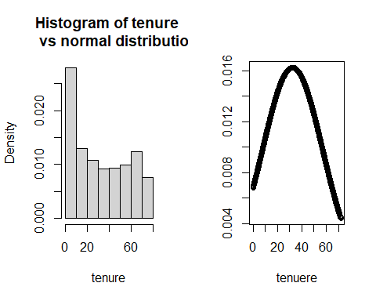

hist(df$TotalCharges, prob = TRUE, breaks = 10, main = "Hist totalCharges vs normal distribution", xlab = "TotalCharges")  
x <- seq(min(df$TotalCharges, na.rm = TRUE), max(df$TotalCharges,  
 na.rm = TRUE), by = 10)  
y <- dnorm(x, mean = mean(df$TotalCharges, na.rm = TRUE), sd = sd(df$TotalCharges, na.rm = TRUE))  
plot(x, y, xlab = "TotalCharges", ylab = "")

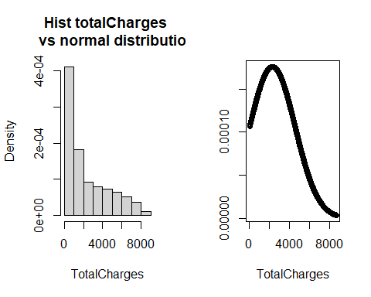

hist(df$MonthlyCharges, prob = TRUE, breaks = 10, main = "Hist MonthlyCharges vs normal distribution", xlab = "df$MonthlyCharges")  
x <- seq(min(df$MonthlyCharges, na.rm = TRUE), max(df$MonthlyCharges,  
 na.rm = TRUE), by = 0.1)  
y <- dnorm(x, mean = mean(df$MonthlyCharges, na.rm = TRUE), sd = sd(df$MonthlyCharges, na.rm = TRUE))  
plot(x, y, xlab = "df$MonthlyCharges", ylab = "")

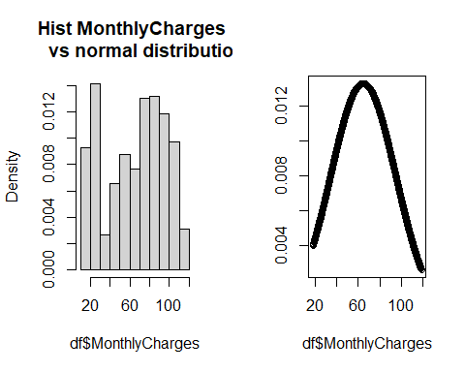

par(mfrow = c(1, 1))

# 3. Data Quality Report

In this section we analysed the missing values, outliers and errors of numeric variables to increase the quality of data before modeling.

To start with, we detected that only “TotalCharges”, and hence “c.TotalCharges”, has a total of 22 missing observations. However, all of them correspond to new clients who have not receive their first invoice yet, so “TotalCharges” can not have a value. In other words, they are “not applicable cases”. We naturally impute this observations with 0.

# Distribution of missings in df per variable  
apply(sapply(df, is.na), 2, sum)

## customerID gender SeniorCitizen Partner   
## 0 0 0 0   
## Dependents tenure PhoneService MultipleLines   
## 0 0 0 0   
## InternetService OnlineSecurity OnlineBackup DeviceProtection   
## 0 0 0 0   
## TechSupport StreamingTV StreamingMovies Contract   
## 0 0 0 0   
## PaperlessBilling PaymentMethod MonthlyCharges TotalCharges   
## 0 0 0 11   
## Churn c.tenure c.TotalCharges c.MonthlyCharges   
## 0 0 11 0

# Distribution of missings in df per individual  
table(apply(sapply(df, is.na), 1, sum))

##   
## 0 2   
## 7032 11

# Check that all missings in 'TotalCharges' correspond to individuals tenure = 0  
TotalCharges.na <- which(is.na(df$TotalCharges))  
sum(TotalCharges.na == which(df$tenure == 0)) == length(TotalCharges.na)

## [1] TRUE

# So we transform them after creating a new numeric variable with all the missings of the database  
df$n.na <- apply(sapply(df, is.na), 1, sum)  
  
df$TotalCharges[TotalCharges.na] = 0  
df$c.TotalCharges[TotalCharges.na] = "(-1,2171]"

Secondly, we detected data inconsistencies. For categorical values, we checked the EDA automatic reports and the summaries to ensure that all qualitative variables categories were meaningful and that there was not any misspelling errors. We also checked that all values of numeric variables were positive and reasonable.

Additionally, for “TotalCharges” we ensured that all the values were correct by manually calculating the value and comparing it to the actual total charge.

# Expected total charges as the product of monthly charges and tenure  
expected_total_charges = df$MonthlyCharges * df$tenure  
  
# Plot them against the actual total charges  
plot(expected_total_charges, df$TotalCharges)

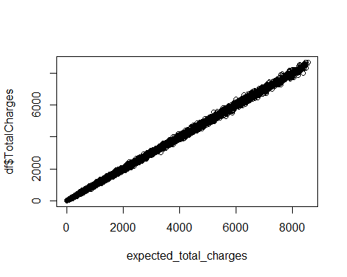

# There are no outliers, so TotalCharges is consistent.

Thirdly, we analysed univariate outliers in numeric variables using Boxplots and the typical thresholds: 1.5 * IQR(interquartile range) for mild outliers and 3 * IQR for severe outliers. As there were not any we considered that all points were suitable for our models.

par(mfrow = c(1, length(numeric_val_idx)))  
for (var in as.numeric(numeric_val_idx)) {  
 Boxplot(df[, var], ylab = names(df)[var], main = "Boxplot")}

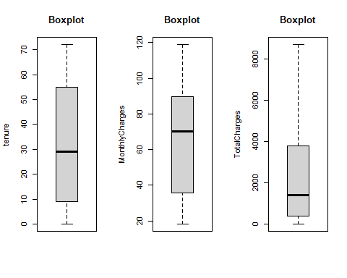

par(mfrow = c(1, 1))

## 3.1 In depth analysis of missing values

Next, we will compute for every group of individuals the mean of missing values. Then we will rank the groups according to the computed mean.

# c.TotalCharges has missings, so it doesn't make sense to  
# compute the mean of missings in its categories  
  
interesting_cat_idx <- categoric_val_idx[-c(1, 20)]  
k = 0  
for (i in interesting_cat_idx) {  
 k <- k + length(levels(df[, i]))}  
groups.na <- matrix(0, k, 2)  
l = 1  
for (idx in interesting_cat_idx) {  
 categories.na <- tapply(df$n.na, df[, idx], mean)  
 for (j in seq(length(categories.na))) {  
 groups.na[l + j - 1, ] <- c(categories.na[j], paste(names(df)[idx],  
 levels(df[, idx])[j], sep = "."))}  
 l <- l + j}  
groups.na.df <- data.frame(na.perc = groups.na[, 1], group = groups.na[,2])  
groups.na.df[order(groups.na.df$na.perc, decreasing = TRUE),]

## na.perc group  
## 37 0.0117994100294985 Contract.Two year  
## 8 0.0104265402843602 Dependents.Yes  
## 43 0.00992555831265509 PaymentMethod.Mailed check  
## 46 0.00804681784930505 c.tenure.(-1,18]  
## 16 0.00786369593709043 InternetService.No  
## 18 0.00786369593709043 OnlineSecurity.No internet service  
## 21 0.00786369593709043 OnlineBackup.No internet service  
## 24 0.00786369593709043 DeviceProtection.No internet service  
## 27 0.00786369593709043 TechSupport.No internet service  
## 30 0.00786369593709043 StreamingTV.No internet service  
## 33 0.00786369593709043 StreamingMovies.No internet service  
## 50 0.00734394124847001 c.MonthlyCharges.(18,30.69]  
## 9 0.00586510263929619 PhoneService.No  
## 12 0.00586510263929619 MultipleLines.No phone service  
## 38 0.00557103064066852 PaperlessBilling.No  
## 6 0.00529100529100529 Partner.Yes  
## 44 0.00425202937765752 Churn.No  
## 14 0.00413052457662123 InternetService.DSL  
## 19 0.00396235760277365 OnlineSecurity.Yes  
## 28 0.00391389432485323 TechSupport.Yes  
## 3 0.00372818166412472 SeniorCitizen.Yes  
## 2 0.00337552742616034 gender.Male  
## 51 0.0033112582781457 c.MonthlyCharges.(30.69,59.38]  
## 25 0.00330305532617671 DeviceProtection.Yes  
## 22 0.00329353643474681 OnlineBackup.Yes  
## 31 0.00295530107129664 StreamingTV.Yes  
## 11 0.00294985250737463 MultipleLines.No  
## 32 0.00287253141831239 StreamingMovies.No  
## 1 0.00286697247706422 gender.Female  
## 10 0.00282974375098255 PhoneService.Yes  
## 13 0.00269269606193201 MultipleLines.Yes  
## 40 0.00259067357512953 PaymentMethod.Bank transfer (automatic)  
## 52 0.00258955545964609 c.MonthlyCharges.(59.38,89.06]  
## 39 0.00143850395588588 PaperlessBilling.Yes  
## 36 0.00135777325186694 Contract.One year  
## 41 0.00131406044678055 PaymentMethod.Credit card (automatic)  
## 5 0.00109859928591046 Partner.No  
## 34 0.000732064421669107 StreamingMovies.Yes  
## 29 0.000711743772241993 StreamingTV.No  
## 20 0.000647668393782383 OnlineBackup.No  
## 23 0.000646203554119548 DeviceProtection.No  
## 26 0.000575871004894904 TechSupport.No  
## 17 0.000571755288736421 OnlineSecurity.No  
## 4 0 SeniorCitizen.No  
## 7 0 Dependents.No  
## 15 0 InternetService.Fiber optic  
## 35 0 Contract.Month-to-month  
## 42 0 PaymentMethod.Electronic check  
## 45 0 Churn.Yes  
## 47 0 c.tenure.(18,36]  
## 48 0 c.tenure.(36,54]  
## 49 0 c.tenure.(54,72]  
## 53 0 c.MonthlyCharges.(89.06,118.75]

The groups with the highest proportion of missing data are made of those individuals who:

* Have a two-year contract
* Have dependents
* Pay with a mailed check

Since the set of individuals with missing data is exactly that of the new clients, we conclude that recently incorporated clients tend to: sign a two-year contract, have dependents and pay with a mailed check.

We can compute as well the pearson correlation coefficient between “n.na” and the numerical variables.

# Creation of the correlation matrix  
corr_mat <- cor(df[, c(numeric_val_idx, 25)], ); corr_mat

## tenure MonthlyCharges TotalCharges n.na  
## tenure 1.00000000 0.24789986 0.82617840 -0.05213467  
## MonthlyCharges 0.24789986 1.00000000 0.65117383 -0.03068535  
## TotalCharges 0.82617840 0.65117383 1.00000000 -0.03977955  
## n.na -0.05213467 -0.03068535 -0.03977955 1.00000000

corrplot(corr_mat, order = "hclust", tl.cex = 0.9)

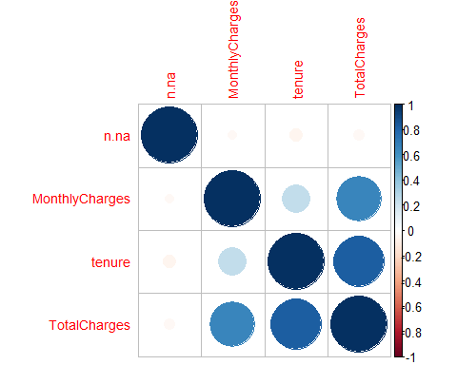

n.na is independent to the rest of numerical variables, probably because it evaluates to 0 in most observations.

## 3.2 Multivariate outliers

In this section we focused on detecting the multivariate outliers using “Moutlier”. We discovered 344 multivariate outliers, about 5% of the individuals, as it was expected. We decided to maintain them and only remove them in the modeling step if they turned out to be influential points.

set.seed(123)  
res.mout <- Moutlier(df[, numeric_val_idx], quantile = 0.95, plot = FALSE)  
  
# Visual representation  
par(mfrow = c(1, 2), cex.main = 0.8)  
plot(res.mout$md, col = "lightblue", pch = 19, main = "Detection of multivariable outliers",  
 xlab = "Observation", ylab = "Traditional Mahalanobis distance ")  
abline(h = res.mout$cutoff, col = "red", lwd = 5, lty = 2)  
  
plot(res.mout$rd, col = "lightblue", pch = 19, xlab = "Observation",  
 ylab = "Robust Mahalanobis distance ")  
abline(h = res.mout$cutoff, col = "red", lwd = 5, lty = 2)

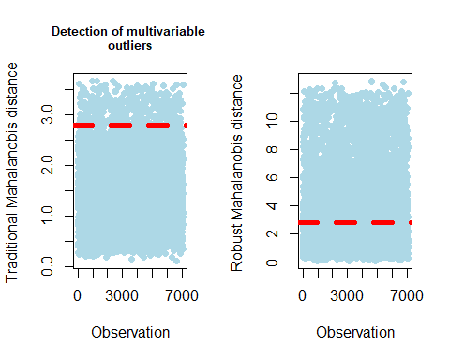

par(mfrow = c(1, 1), cex.main = 1)  
  
# Identification of the outliers  
outliers = which(res.mout$md > res.mout$cutoff & res.mout$rd >  
 res.mout$cutoff)  
length(outliers)

## [1] 344

length(outliers)/dim(df)[1] * 100

## [1] 4.884282

# 4. Profiling of the target and feature selection

## Numeric variables’ correlations

We analysed the pearson correlation coefficient to detect variables that were highly related and not include them all in the model. In the correlation plot of section 3.1 we see that “TotalCharges” is highly correlated with “MonthlyCharges” and “tenure” as the first one is calculated as the product of the others.

## Profiling of the target

Later on, we profiled the target Churn using a custom function “profiling()” created in the Multivariate Analysis subject of the Master’s degree. This method expands “catdes()” and performs many plots and tests according to the type of each variable. We will focus on plots and the given tests’ results: Chi^2, ANOVA and Kruskal-Wallis, which can be found in the annex.

# Analysis of all variables except the ID  
profiling(df[-c(grep("customerID", names(df)), grep("Churn",  
 names(df)))], df$Churn, "Churn")

The most relevant conclusions are: - Some variables are not significant, like Gender (Chi^2 p-value=0.4866) or Phone service (Chi^2 p-value=0.3388). Consequently, we state that churn is independent of the client’s gender and whether he/she/they has a phone service contracted.

profiling(df[c(grep("gender", names(df)), grep("PhoneService",  
 names(df)))], df$Churn, "Churn")

* There are variables like “MultipleLines” that even being significant (Chi^2 p-value=0.003464) the difference among levels is small, as we can see in the plots

profiling(df[grep("MultipleLines", names(df))], df$Churn, "Churn")

* The rest of variables, including the discretized, have a small p-value (< 2.2e-16) in the Chi^2, ANOVA or Kruskal-Wallis test, according to their type, and have at least one level where the target’s distribution is different than in the rest. For example, 40% of people that did not have an online backup churned, while only 22% of customers having the backup did.

profiling(df[grep("OnlineBackup", names(df))], df$Churn, "Churn")

## Feature Selection

Finally, we decided which variables were suitable to be included in the model.

The id was removed, since it will not give us any knowledge nor be useful to predict the target.

df$customerID <- NULL

We then computed the relationship between all the variables and the target with the “catdes()” method and chose the most relevant of them for the target’s explanation.

All p-values of the Chi-squared test for categorical variables are very low, less than 0.001. The 6 variables with the lowest p-value are Contract, OnlineSecurity, TechSupport, c.tenure, InternetService, PaymentMethod. Note that the list includes a discretized numerical variable.

# Correlation between all variables and our qualitative target Churn.  
res.cat = catdes(df, grep("Churn", names(df)))  
  
# Most important categorical variables, sorted by p value  
res.cat$test.chi2

## p.value df  
## Contract 5.863038e-258 2  
## OnlineSecurity 2.661150e-185 2  
## TechSupport 1.443084e-180 2  
## c.tenure 4.192004e-178 3  
## InternetService 9.571788e-160 2  
## PaymentMethod 3.682355e-140 3  
## OnlineBackup 2.079759e-131 2  
## DeviceProtection 5.505219e-122 2  
## StreamingMovies 2.667757e-82 2  
## StreamingTV 5.528994e-82 2  
## c.MonthlyCharges 8.977393e-72 3  
## PaperlessBilling 2.614597e-58 1  
## Dependents 3.276083e-43 1  
## c.TotalCharges 3.057813e-39 3  
## SeniorCitizen 9.477904e-37 1  
## Partner 1.519037e-36 1  
## MultipleLines 3.464383e-03 2

As for numeric variables, “tenure” has the smallest p-value in the F-test, much lower than those of discrete variables. As we have already seen, there is a high correlation between “MonthlyCharges”, “tenure” and “TotalCharges” so we will only include in the models “TotalCharges” or “MonthlyCharges” together with “tenure”.

res.cat$quanti.var

## Eta2 P-value  
## tenure 0.12406504 7.999058e-205  
## TotalCharges 0.03933251 2.127212e-63  
## MonthlyCharges 0.03738671 2.706646e-60

## Profiling of the target with the selected categorical features

Lastly, we decided to make an extensive profiling of the six categorical variables that we could use in the model in order to understand them better. The main conclusions for each variable were:

* Contract: The probability of churning is decreased when the contract term increases. For example, if a costumer has a month contract and changes it to an annual the probability of not churning increases from 0.58 to 0.89.
* InternetService: People that do not have an internet service do not usually churn (7%). However, if they had a Fiber optic connection, the probability to churn increases (42%). This could be explained by the fact that users with a fast internet connection try to get the best offer for the service, but it would be necessary to make a market analysis to validate this hypothesis.
* OnlineSecurity: The probability of churning is small when the customer has online security. However, having an internet connection or not seems a more interesting feature than the variable itself, as the “No internet service” level has the smallest p-value.
* TechSupport: Having tech support increases the probability of not churning from 60% to 84% (when compared with not having it, although having internet service). Having internet service or not is, again, a more relevant feature.
* c.tenure: Loyalty is important, since people tend to churn less when they have spent longer with the service. For example, people who have spent less than 1.5 years has churned 44% of times, but only 8% of those who have stayed for more than 4.5 years have churned.
* PaymentMethod: The proportion of people that churned is very similar in all types of payment except for “Electronic check”. In this level, the proportion of churns is 45%, 18% higher than the global average.

# Global proportions of Churn categories  
proportions(table(df$Churn))

##   
## No Yes   
## 0.7346301 0.2653699

# Calculate the indexes of the variables to investigate  
names = c("Contract", "OnlineSecurity", "TechSupport", "c.tenure",  
 "InternetService", "PaymentMethod")  
index = NULL  
  
for (i in 1:length(names)) {  
 ind = grep(names[i], colnames(df))  
 index = append(index, ind)}  
index = append(index, grep("Churn", names(df)))  
  
# Profiling of only those variables  
res.cat2 = catdes(df[, index], length(index))  
  
res.cat2$category

## $No  
## Cla/Mod Mod/Cla Global  
## Contract=Two year 97.16814 31.83224 24.06645  
## c.tenure=(54,72] 92.02859 32.35408 25.82706  
## InternetService=No 92.59502 27.30963 21.66690  
## TechSupport=No internet service 92.59502 27.30963 21.66690  
## OnlineSecurity=No internet service 92.59502 27.30963 21.66690  
## Contract=One year 88.73048 25.26092 20.91438  
## OnlineSecurity=Yes 85.38881 33.32045 28.66676  
## TechSupport=Yes 84.83366 33.51372 29.02172  
## PaymentMethod=Credit card (automatic) 84.75690 24.93235 21.61011  
## InternetService=DSL 81.04089 37.92037 34.37456  
## PaymentMethod=Bank transfer (automatic) 83.29016 24.85504 21.92248  
## PaymentMethod=Mailed check 80.89330 25.20294 22.88797  
## c.tenure=(36,54] 81.97970 18.72826 16.78262  
## c.tenure=(18,36] 77.29358 19.54001 18.57163  
## PaymentMethod=Electronic check 54.71459 25.00966 33.57944  
## InternetService=Fiber optic 58.10724 34.77000 43.95854  
## c.tenure=(-1,18] 55.59620 29.37766 38.81869  
## TechSupport=No 58.36453 39.17665 49.31137  
## OnlineSecurity=No 58.23328 39.36993 49.66634  
## Contract=Month-to-month 57.29032 42.90684 55.01917  
## p.value v.test  
## Contract=Two year 3.588830e-187 29.178937  
## c.tenure=(54,72] 2.745248e-113 22.620153  
## InternetService=No 6.584621e-98 20.999812  
## TechSupport=No internet service 6.584621e-98 20.999812  
## OnlineSecurity=No internet service 6.584621e-98 20.999812  
## Contract=One year 3.593041e-57 15.935502  
## OnlineSecurity=Yes 1.606459e-50 14.947938  
## TechSupport=Yes 1.323174e-46 14.334963  
## PaymentMethod=Credit card (automatic) 6.408166e-32 11.758206  
## InternetService=DSL 2.545367e-26 10.614727  
## PaymentMethod=Bank transfer (automatic) 1.180908e-24 10.250207  
## PaymentMethod=Mailed check 3.226893e-15 7.881803  
## c.tenure=(36,54] 6.217772e-14 7.503412  
## c.tenure=(18,36] 4.375264e-04 3.516348  
## PaymentMethod=Electronic check 1.790860e-136 -24.864755  
## InternetService=Fiber optic 2.289126e-148 -25.941138  
## c.tenure=(-1,18] 7.876341e-159 -26.852547  
## TechSupport=No 1.899538e-183 -28.883947  
## OnlineSecurity=No 6.171504e-190 -29.396034  
## Contract=Month-to-month 3.620915e-283 -35.959308  
##   
## $Yes  
## Cla/Mod Mod/Cla Global  
## Contract=Month-to-month 42.709677 88.550027 55.01917  
## OnlineSecurity=No 41.766724 78.170144 49.66634  
## TechSupport=No 41.635474 77.367576 49.31137  
## c.tenure=(-1,18] 44.403804 64.954521 38.81869  
## InternetService=Fiber optic 41.892765 69.395399 43.95854  
## PaymentMethod=Electronic check 45.285412 57.303371 33.57944  
## c.tenure=(18,36] 22.706422 15.890851 18.57163  
## c.tenure=(36,54] 18.020305 11.396469 16.78262  
## PaymentMethod=Mailed check 19.106700 16.479401 22.88797  
## PaymentMethod=Bank transfer (automatic) 16.709845 13.804173 21.92248  
## InternetService=DSL 18.959108 24.558587 34.37456  
## PaymentMethod=Credit card (automatic) 15.243101 12.413055 21.61011  
## TechSupport=Yes 15.166341 16.586410 29.02172  
## OnlineSecurity=Yes 14.611194 15.783842 28.66676  
## Contract=One year 11.269518 8.881755 20.91438  
## InternetService=No 7.404980 6.046014 21.66690  
## TechSupport=No internet service 7.404980 6.046014 21.66690  
## OnlineSecurity=No internet service 7.404980 6.046014 21.66690  
## c.tenure=(54,72] 7.971413 7.758159 25.82706  
## Contract=Two year 2.831858 2.568218 24.06645  
## p.value v.test  
## Contract=Month-to-month 3.620915e-283 35.959308  
## OnlineSecurity=No 6.171504e-190 29.396034  
## TechSupport=No 1.899538e-183 28.883947  
## c.tenure=(-1,18] 7.876341e-159 26.852547  
## InternetService=Fiber optic 2.289126e-148 25.941138  
## PaymentMethod=Electronic check 1.790860e-136 24.864755  
## c.tenure=(18,36] 4.375264e-04 -3.516348  
## c.tenure=(36,54] 6.217772e-14 -7.503412  
## PaymentMethod=Mailed check 3.226893e-15 -7.881803  
## PaymentMethod=Bank transfer (automatic) 1.180908e-24 -10.250207  
## InternetService=DSL 2.545367e-26 -10.614727  
## PaymentMethod=Credit card (automatic) 6.408166e-32 -11.758206  
## TechSupport=Yes 1.323174e-46 -14.334963  
## OnlineSecurity=Yes 1.606459e-50 -14.947938  
## Contract=One year 3.593041e-57 -15.935502  
## InternetService=No 6.584621e-98 -20.999812  
## TechSupport=No internet service 6.584621e-98 -20.999812  
## OnlineSecurity=No internet service 6.584621e-98 -20.999812  
## c.tenure=(54,72] 2.745248e-113 -22.620153  
## Contract=Two year 3.588830e-187 -29.178937

# Another visualization of the profiling  
# profiling(df[,index], df$Churn, 'Churn')

# 5. Modeling

## Data splitting

First, let’s split the dataset into training and testing set. We have decided that 70% of the data will be used for training.

set.seed(123)  
  
sampling = sample.split(df$Churn, SplitRatio = 0.7)  
train = subset(df, sampling == TRUE)  
test = subset(df, sampling == FALSE)

## Modeling only with numerical variables

As we mentioned, there is a strong correlation between {tenure, MonthlyCharges} and TotalCharges, as the second one is simply the product of the variables in the first set. Hence, we will build two models, one for each set of variables, and keep the best one.

m0.set1 = glm(Churn ~ tenure + MonthlyCharges, data = train,  
 family = binomial)  
# Checking the Anova test, both variables are significant to our model. Hence, we won't remove any of them.  
Anova(m0.set1, test = "LR")

## Analysis of Deviance Table (Type II tests)  
##   
## Response: Churn  
## LR Chisq Df Pr(>Chisq)   
## tenure 1071.50 1 < 2.2e-16 ***  
## MonthlyCharges 583.55 1 < 2.2e-16 ***  
## ---  
## Signif. codes: 0 '***' 0.001 '**' 0.01 '*' 0.05 '.' 0.1 ' ' 1

m0.set2 = glm(Churn ~ TotalCharges, data = train, family = binomial)  
  
BIC(m0.set1, m0.set2)

## df BIC  
## m0.set1 3 4444.286  
## m0.set2 2 5504.792

Checking the Bayesian criterion, the set {tenure, MonthlyCharges} has a much lower value and its variables are significant. Hence, we’ll choose this set of variables for further analysis.

We also check possible transformation for our model m0.set1.

m0.log = glm(Churn ~ tenure + log(MonthlyCharges), data = train,  
 family = binomial)  
m0.sqrt = glm(Churn ~ sqrt(tenure) + MonthlyCharges, data = train,  
 family = binomial)  
  
BIC(m0.set1, m0.log, m0.sqrt)

## df BIC  
## m0.set1 3 4444.286  
## m0.log 3 4465.685  
## m0.sqrt 3 4397.700

We have tried several transformations for both variables (sqrt, log, exp, etc), but BIC shows that the best model is the one with sqrt on tenure.

Discretized variables might create a better model, so we study this possibility.

m1 = glm(Churn ~ c.tenure + MonthlyCharges, data = train, family = binomial)  
  
BIC(m1, m0.sqrt)

## df BIC  
## m1 5 4585.287  
## m0.sqrt 3 4397.700

Checking the AIC and BIC parameters, we decided to keep the numerical version of tenure. We have checked as well the model with MonthlyCharges discretized, but the AIC is worse once more.

## Residual analysis only with numerical variables

It is important to look for influential points in the model that could worsen it. “influencePlot()” computes the Cook’s distance of each point, so that we can compare them with the threshold studied in the course.

# Check influential points  
influent = influencePlot(m0.sqrt)[3]

influent

## CookD  
## 269 0.0059784386  
## 431 0.0061523136  
## 3827 0.0005332286  
## 4381 0.0004744407

# Calculate D's threshold  
D_thresh <- 2/sqrt(dim(train)[1])  
D_thresh

## [1] 0.02848436

The Cook’s distances obtained from “influencePlot()” are smaller than our threshold, so we will not remove any point.

## Adding factor main effects to the model

After being satisfied with our final model based on numerical variables, we add categorical variables to it in decreasing relevance order.

m2 = glm(Churn ~ sqrt(tenure) + MonthlyCharges + Contract, data = train, family = binomial)  
  
# Adding {contract} indeed reduces the BIC of our model.  
BIC(m0.sqrt, m2)

## df BIC  
## m0.sqrt 3 4397.700  
## m2 5 4217.893

m3 = glm(Churn ~ sqrt(tenure) + MonthlyCharges + Contract + InternetService, data = train, family = binomial)  
  
# Adding {InternetService} indeed reduces the BIC of our model.  
BIC(m2, m3)

## df BIC  
## m2 5 4217.893  
## m3 7 4190.321

We have figured out in the profiling section that {InternetService} and {OnlineSecurity, TechSupport} have some levels that are strongly correlated. Specifically, when “InternetService” = “No”, “OnlineSecurity and”TechSupport” can’t be given a value, so they are declared as “No intervet service”.

To avoid multicollinearity and NA’s, we need to decide which variable to keep.

m4 = glm(Churn ~ sqrt(tenure) + MonthlyCharges + Contract +   
 OnlineSecurity + TechSupport, data = train, family = binomial)  
  
BIC(m3, m4)

## df BIC  
## m3 7 4190.321  
## m4 8 4153.715

The BIC criterion for m4 is smaller, but taking into account that “InternetService” is more correlated with the target variable and the difference in the BIC is not that significant, we decided to keep m3, with “InternetService”.

m5 = glm(Churn ~ sqrt(tenure) + MonthlyCharges + Contract +   
 InternetService + PaymentMethod, data = train, family = binomial)  
  
# Adding {PaymentMethod} indeed reduces the BIC of our model.  
BIC(m3, m5)

## df BIC  
## m3 7 4190.321  
## m5 10 4174.603

## Residual analysis with categorical variables

We repeat the residual analysis performed earlier with our current model.

influent = influencePlot(m5)[3]

influent

## CookD  
## 269 0.0055072625  
## 937 0.0002690920  
## 4273 0.0054160023  
## 6755 0.0002337059

# Calculate D's threshold  
D_thresh <- 2/sqrt(dim(train)[1]); D_thresh

## [1] 0.02848436

As before, the Cook’s distances obtained from “influencePlot()” are smaller than our threshold, so we will not remove any point.

## Adding interactions to the model

Sometimes interactions between dependent variables improve a model, so let us see how they work in our case. To start with, we check all possible interactions and execute “step()” to end up with the most relevant ones.

m6 = glm(Churn ~ (sqrt(tenure) + MonthlyCharges + Contract +  
 InternetService + PaymentMethod)^2, data = train, family = binomial)  
  
# Use step function to find the combination that minimizes the AIC.  
step(m6)

Out of the interaction “step()” recommends to add, we see how the ones with the smallest AIC perform. That is, we add the interactions between “sqrt(tenure)” and “PaymentMethod” or “Contract”.

m7 = glm(Churn ~ sqrt(tenure) * PaymentMethod + sqrt(tenure) *  
 Contract + MonthlyCharges + InternetService + PaymentMethod,  
 data = train, family = binomial)  
  
BIC(m5, m7)

## df BIC  
## m5 10 4174.603  
## m7 15 4194.054

According to the BIC criterion, no improvement is obtained.

Now we will add the interaction with the highest AIC instead, “MonthlyCharges:InternetService”.

m8 = glm(Churn ~ sqrt(tenure) + Contract + MonthlyCharges *   
 InternetService + PaymentMethod, data = train, family = binomial)  
  
BIC(m5, m8)

## df BIC  
## m5 10 4174.603  
## m8 12 4164.660

summary(m8)

##   
## Call:  
## glm(formula = Churn ~ sqrt(tenure) + Contract + MonthlyCharges *   
## InternetService + PaymentMethod, family = binomial, data = train)  
##   
## Coefficients:  
## Estimate Std. Error z value Pr(>|z|)  
## (Intercept) 0.750286 0.297440 2.522 0.01165  
## sqrt(tenure) -0.348759 0.023305 -14.965 < 2e-16  
## ContractOne year -0.841360 0.128380 -6.554 5.61e-11  
## ContractTwo year -1.728150 0.203049 -8.511 < 2e-16  
## MonthlyCharges -0.009692 0.005254 -1.845 0.06507  
## InternetServiceFiber optic -1.504022 0.481191 -3.126 0.00177  
## InternetServiceNo -2.268409 1.568535 -1.446 0.14812  
## PaymentMethodCredit card (automatic) 0.011553 0.136266 0.085 0.93243  
## PaymentMethodElectronic check 0.453998 0.113412 4.003 6.25e-05  
## PaymentMethodMailed check -0.154366 0.138451 -1.115 0.26487  
## MonthlyCharges:InternetServiceFiber optic 0.034298 0.006722 5.103 3.35e-07  
## MonthlyCharges:InternetServiceNo 0.049096 0.075285 0.652 0.51431  
##   
## (Intercept) *   
## sqrt(tenure) ***  
## ContractOne year ***  
## ContractTwo year ***  
## MonthlyCharges .   
## InternetServiceFiber optic **   
## InternetServiceNo   
## PaymentMethodCredit card (automatic)   
## PaymentMethodElectronic check ***  
## PaymentMethodMailed check   
## MonthlyCharges:InternetServiceFiber optic ***  
## MonthlyCharges:InternetServiceNo   
## ---  
## Signif. codes: 0 '***' 0.001 '**' 0.01 '*' 0.05 '.' 0.1 ' ' 1  
##   
## (Dispersion parameter for binomial family taken to be 1)  
##   
## Null deviance: 5704.4 on 4929 degrees of freedom  
## Residual deviance: 4062.6 on 4918 degrees of freedom  
## AIC: 4086.6  
##   
## Number of Fisher Scoring iterations: 6

The BIC improved from 4174 to 4164, but with the cost of 2 degrees of freedom. Adding the interaction between “MonthlyCharges” and “InternetService” is a trade-off between simplicity and accuracy. At this point, after having added many variables, we value more simplicity, so we will not add this interaction.

## Trying link function probit

We are interested in the effect of changing the link function of the logistic regression to “probit”.

m9 = glm(Churn ~ sqrt(tenure) + MonthlyCharges + Contract + InternetService +  
 PaymentMethod, data = train, family = binomial(link = "probit"))  
  
BIC(m5, m9)

## df BIC  
## m5 10 4174.603  
## m9 10 4177.774

Sadly, based on the BIC criterion, no improvement is obtained.

## Final residual analysis

We will perform now a final residual analysis.

# Check influential points  
influent = influencePlot(m9)[3]

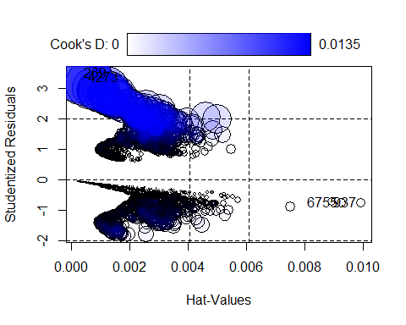

influent

## CookD  
## 269 0.0134537052  
## 937 0.0003234289  
## 4273 0.0119056685  
## 6755 0.0002981121

# Calculate D's threshold  
D_thresh <- 2/sqrt(dim(train)[1])  
D_thresh

## [1] 0.02848436

# The most influential observations are the 269 and 4273, which are theones with the biggest Cook's distance. Nonetheless, any of them is a multivariate outlier.  
sum(outliers == 269)

## [1] 0

sum(outliers == 4273)

## [1] 0

df$Churn[269]

## [1] Yes  
## Levels: No Yes

df$Churn[4273]

## [1] Yes  
## Levels: No Yes

# Neither is a univariate outlier in tenure and TotalCharges when analyzed inside their target's category.  
sum(Boxplot(df$tenure[df$Churn == "Yes"]) == 269)

## [1] 0

sum(Boxplot(df$tenure[df$Churn == "Yes"]) == 4273)

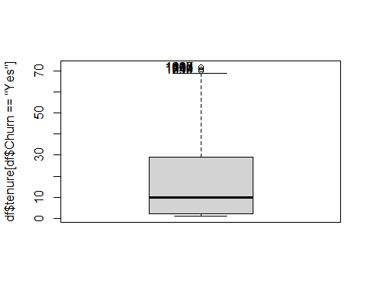

## [1] 0

sum(Boxplot(df$MonthlyCharges[df$Churn == "Yes"]) == 269)

## [1] 0

sum(Boxplot(df$MonthlyCharges[df$Churn == "Yes"]) == 4273)

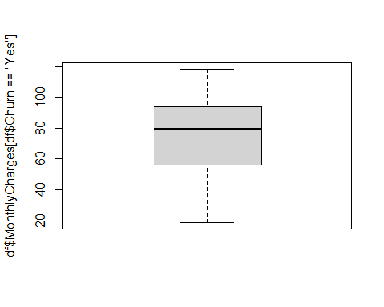

## [1] 0

sum(Boxplot(df$TotalCharges[df$Churn == "Yes"]) == 269)

## [1] 0

sum(Boxplot(df$TotalCharges[df$Churn == "Yes"]) == 4273)

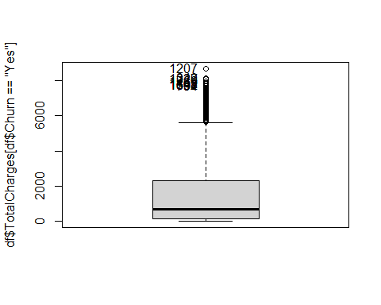

## [1] 0

Observations 269 and 4273 may be influential points, but both of them are smaller than the threshold. Any of these are multivariate outliers or severe outliers of a numerical variable when looked in their category of Churn. They are not neither globally, since we saw in the preprocessing that there were no severe outliers. Hence, we won’t remove any of them.

# 6. Goodness of fit

PseudoR2(m5, which = "McFadden")

## McFadden   
## 0.2830884

The R2 of McFadden is not excellent, but at least it is acceptable. Let us check the residual plots.

residualPlots(m5)

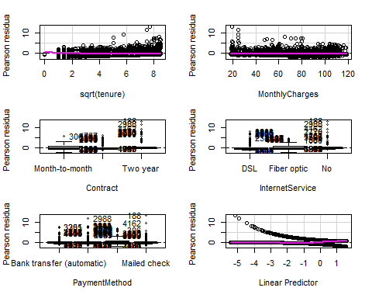

## Test stat Pr(>|Test stat|)   
## sqrt(tenure) 21.586 3.384e-06 ***  
## MonthlyCharges 21.877 2.907e-06 ***  
## Contract   
## InternetService   
## PaymentMethod   
## ---  
## Signif. codes: 0 '***' 0.001 '**' 0.01 '*' 0.05 '.' 0.1 ' ' 1

# Outliers in the residual plots might be caused, in part,  
# by unbalanced data  
prop.table(table(df$Contract))

##   
## Month-to-month One year Two year   
## 0.5501917 0.2091438 0.2406645

prop.table(table(df$InternetService))

##   
## DSL Fiber optic No   
## 0.3437456 0.4395854 0.2166690

prop.table(table(df$PaymentMethod))

##   
## Bank transfer (automatic) Credit card (automatic) Electronic check   
## 0.2192248 0.2161011 0.3357944   
## Mailed check   
## 0.2288797

In the residual plots we see that all levels in the model contain severe outliers, except for “Month-to-month” (there is only 1 outlier). However, those points do not seem to affect the Pearson residuals distributions, which are all close to zero as expected. Moreover, they might be caused by unbalanced data.

m5.mout = glm(Churn ~ sqrt(tenure) + MonthlyCharges + Contract +  
 InternetService + PaymentMethod, data = train[-outliers,  
 ], family = binomial)  
residualPlots(m5.mout)

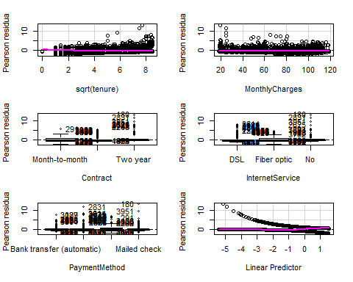

## Test stat Pr(>|Test stat|)   
## sqrt(tenure) 20.256 6.775e-06 ***  
## MonthlyCharges 19.519 9.959e-06 ***  
## Contract   
## InternetService   
## PaymentMethod   
## ---  
## Signif. codes: 0 '***' 0.001 '**' 0.01 '*' 0.05 '.' 0.1 ' ' 1

To try to remove those outliers from the categorical variables we remove all multivariate outliers. This gives us an alternative model (m5.mout) that we cannot compare using BIC or other measure of fitness as the models do not have the same cardinality. However, the new model still contains outliers in the residual plot, so we consider that it is better not to remove the multivariate outliers. This backs up the hypothesis of unbalanced data causing outliers in the Pearson residuals.

## Model prediction

Once we have our final model m5 we can predict the values of Churn on the test dataset.

# First, we compute the probability of Churn for each  
# observation (from test) with predict function.  
predictions = predict(m5, test[-20], type = "response")  
  
# Then, for those that have a probability higher than 0.5,  
# we can consider Churn == 'Yes'  
probability = factor(as.character(ifelse(predictions >= 0.5,  
 "Yes", "No")))  
  
# Finally, compute the Confusion Matrix of predicted result  
confusion.mat <- confusionMatrix(probability, test$Churn, mode = "everything", positive = "Yes"); confusion.mat

## Confusion Matrix and Statistics  
##   
## Reference  
## Prediction No Yes  
## No 1395 279  
## Yes 157 282  
##   
## Accuracy : 0.7937   
## 95% CI : (0.7758, 0.8107)  
## No Information Rate : 0.7345   
## P-Value [Acc > NIR] : 1.548e-10   
##   
## Kappa : 0.4315   
##   
## Mcnemar's Test P-Value : 6.838e-09   
##   
## Sensitivity : 0.5027   
## Specificity : 0.8988   
## Pos Pred Value : 0.6424   
## Neg Pred Value : 0.8333   
## Precision : 0.6424   
## Recall : 0.5027   
## F1 : 0.5640   
## Prevalence : 0.2655   
## Detection Rate : 0.1335   
## Detection Prevalence : 0.2078   
## Balanced Accuracy : 0.7008   
##   
## 'Positive' Class : Yes   
##

roc.curve(test$Churn, probability)

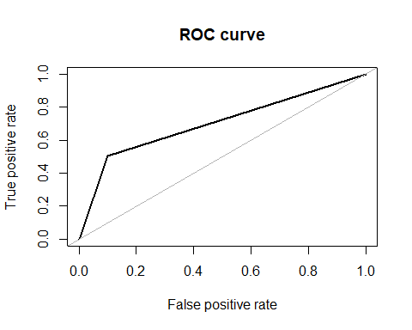

## Area under the curve (AUC): 0.701

With the predicted values of the target, we can also study the goodness of fit of the model m5 through the confusion matrix. The most typical measure obtained from this matrix is the accuracy, but in our case it is not reliable because we have unbalanced data. Hence, we resort to the F1-score, a harmonic mean that is less influenced by unbalanced data. We got a value of 56%, which is not great, but it is not a worthless model. This is confirmed by the ROC curve plotted above, with AUC = 0.70.

Finally, we compare m5 with the null model to see the improvement we have obtained.

m.null = glm(Churn ~ 1, data = train, family = binomial)  
  
BIC(m5, m.null)

## df BIC  
## m5 10 4174.603  
## m.null 1 5712.933

BIC coefficient decreased from 5712 to 4174. So we improve the predictive capability.

# 7. Model interpretation

Finally, let’s summarize and interpret our final model.

m5 = glm(Churn ~ sqrt(tenure) + MonthlyCharges + Contract +   
 InternetService + PaymentMethod, data = train, family = binomial)  
  
summary(m5)

##   
## Call:  
## glm(formula = Churn ~ sqrt(tenure) + MonthlyCharges + Contract +   
## InternetService + PaymentMethod, family = binomial, data = train)  
##   
## Coefficients:  
## Estimate Std. Error z value Pr(>|z|)   
## (Intercept) -0.302267 0.213978 -1.413 0.157771   
## sqrt(tenure) -0.328520 0.022733 -14.451 < 2e-16 ***  
## MonthlyCharges 0.008831 0.003666 2.409 0.015984 *   
## ContractOne year -0.831241 0.127318 -6.529 6.63e-11 ***  
## ContractTwo year -1.707955 0.201971 -8.456 < 2e-16 ***  
## InternetServiceFiber optic 0.843216 0.155490 5.423 5.86e-08 ***  
## InternetServiceNo -0.674397 0.185458 -3.636 0.000276 ***  
## PaymentMethodCredit card (automatic) 0.016257 0.135680 0.120 0.904625   
## PaymentMethodElectronic check 0.482651 0.112957 4.273 1.93e-05 ***  
## PaymentMethodMailed check -0.116088 0.137387 -0.845 0.398128   
## ---  
## Signif. codes: 0 '***' 0.001 '**' 0.01 '*' 0.05 '.' 0.1 ' ' 1  
##   
## (Dispersion parameter for binomial family taken to be 1)  
##   
## Null deviance: 5704.4 on 4929 degrees of freedom  
## Residual deviance: 4089.6 on 4920 degrees of freedom  
## AIC: 4109.6  
##   
## Number of Fisher Scoring iterations: 6

sort(exp(m5$coefficients), decreasing = TRUE)

## InternetServiceFiber optic PaymentMethodElectronic check   
## 2.3238275 1.6203637   
## PaymentMethodCredit card (automatic) MonthlyCharges   
## 1.0163902 1.0088706   
## PaymentMethodMailed check (Intercept)   
## 0.8903972 0.7391410   
## sqrt(tenure) InternetServiceNo   
## 0.7199885 0.5094636   
## ContractOne year ContractTwo year   
## 0.4355085 0.1812361

The model is composed by the tenure of the customer, the bill they pay monthly, the contract period that they have with the company, the internet service they own and the payment method.

Bear in mind that 1 denotes “client churned” and 0 denotes “client did not churn”, where clients with a lower linear predictor are less likely to leave the company.

As a consequence, loyalty (more tenure), reduces the odds to churn while MonthlyCharges increases it. Also, with categorical variables we see that costumers with a Fiber optic double the odds to churn with respect to costumers with a DSL service (reference category for “InternetService”) all else being equal.

Additionally, paying with Electronic check, instead of a “bank transfer” increases by 62% the odds to churn, all else being equal. Other payment methods do not have a big impact on the Churn.

More importantly, it seems that having long contract periods is very important to reduce the odds to churn, as clients that have a biannual contract have approximately 99% less odds of not to churn compared to the ones that have a monthly contract, all else being equal.

Additionally, not having internet is also important, as those clients have 50% less odds to churn with respect to the ones that have a DSL service all else being equal. This may indicate that this group of individuals prefer a more basic service but are more stable.

# 8. Conclusions

In this project we have created a generalized linear model that predicts the probability to churn using {tenure, MonthlyCharges, Contract, InternetService, PaymentMethod}, all these predictors are explained with detail in the previous chapter. In total, our model predictors are composed of 2 numerical features and 3 categorical variables, with tenure transformed and no interactions.

The indicator of performance of this model shows a F1 score of 0.5640, and Area under the Curve (AUC) of 0.701. Accuracy is not considered because of the dataset’s imbalance, indeed many people churned. As a consequence our confusion matrix, found below, contain more errors than True Positives.

## Reference  
## Prediction No Yes  
## No 1395 279  
## Yes 157 282

Although our model is not perfect, we are searching a balance between simplicity and accuracy, considering the trade-off associated with adding more variables and interactions. Indeed that would improve the fitness, but with the cost of increasing the parameters and complexity of the model, which lately make it harder to be interpreted.

As future work, we can try to study different methods to balance the data set, either undersampling the category of people who did not churn or uppersampling the complementary category.

# Annex

## Expanded profiling of the target with the “profiling()” method

# Analysis of all variables except the ID  
profiling(df[-c(grep("customerID", names(df)), grep("Churn",  
 names(df)))], df$Churn, "Churn")

## [1] "Variable gender"  
## [1] "Categories=" "Female" "Male"

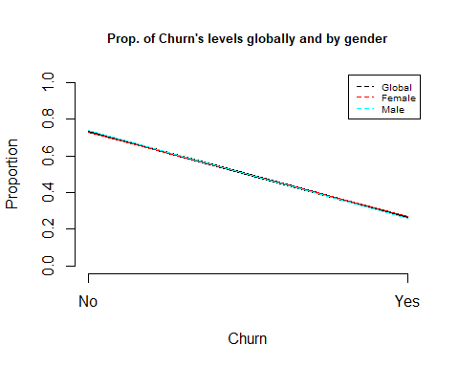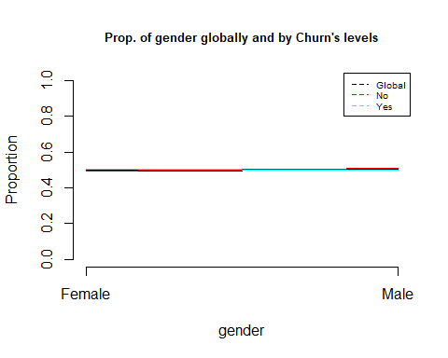

## [1] "Cross Table:"  
## P  
## No Yes  
## Female 2549 939  
## Male 2625 930  
## [1] "Distributions by columns:"  
##   
## P Female Male  
## No 0.7307913 0.7383966  
## Yes 0.2692087 0.2616034  
## [1] "Chi^2 test: "  
##   
## Pearson's Chi-squared test with Yates' continuity correction  
##   
## data: dades[, k] and as.factor(P)  
## X-squared = 0.48408, df = 1, p-value = 0.4866  
##   
## [1] "ValorTestXquali:"  
## $rowpf  
## Xquali  
## P Female Male  
## No 0.4926556 0.5073444  
## Yes 0.5024077 0.4975923  
##   
## $vtest  
## Xquali  
## P Female Male  
## No -0.7227493 0.7227493  
## Yes 0.7227493 -0.7227493  
##   
## $pval  
## Xquali  
## P Female Male  
## No 0.234917 0.234917  
## Yes 0.234917 0.234917  
##   
## [1] "Variable SeniorCitizen"  
## [1] "Categories=" "Yes" "No"

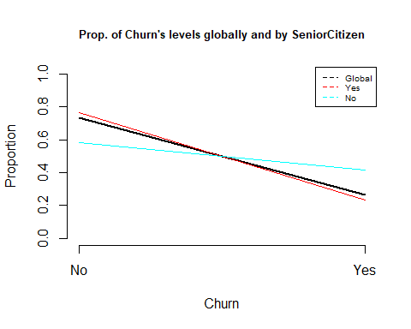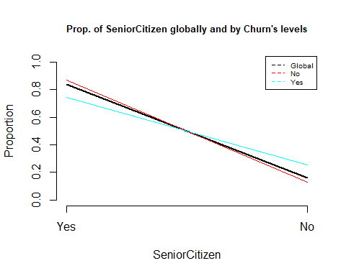

## [1] "Cross Table:"  
## P  
## No Yes  
## Yes 4508 1393  
## No 666 476  
## [1] "Distributions by columns:"  
##   
## P Yes No  
## No 0.7639383 0.5831874  
## Yes 0.2360617 0.4168126  
## [1] "Chi^2 test: "  
##   
## Pearson's Chi-squared test with Yates' continuity correction  
##   
## data: dades[, k] and as.factor(P)  
## X-squared = 159.43, df = 1, p-value < 2.2e-16  
##   
## [1] "ValorTestXquali:"  
## $rowpf  
## Xquali  
## P Yes No  
## No 0.8712795 0.1287205  
## Yes 0.7453184 0.2546816  
##   
## $vtest  
## Xquali  
## P Yes No  
## No 12.66302 -12.66302  
## Yes -12.66302 12.66302  
##   
## $pval  
## Xquali  
## P Yes No  
## No 4.738952e-37 0.000000e+00  
## Yes 0.000000e+00 4.738952e-37  
##   
## [1] "Variable Partner"  
## [1] "Categories=" "No" "Yes"

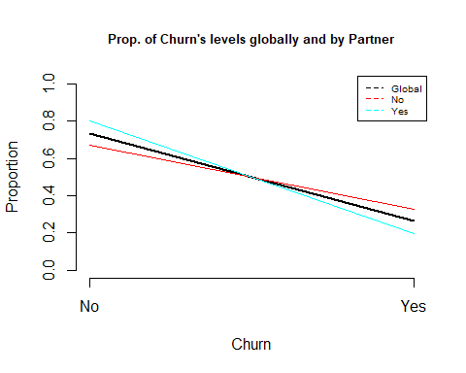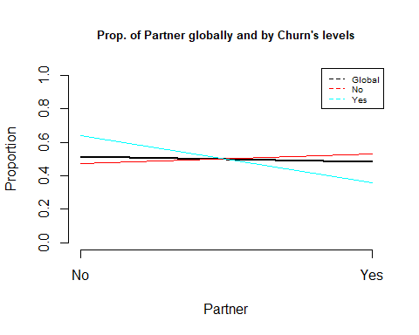

## [1] "Cross Table:"  
## P  
## No Yes  
## No 2441 1200  
## Yes 2733 669  
## [1] "Distributions by columns:"  
##   
## P No Yes  
## No 0.6704202 0.8033510  
## Yes 0.3295798 0.1966490  
## [1] "Chi^2 test: "  
##   
## Pearson's Chi-squared test with Yates' continuity correction  
##   
## data: dades[, k] and as.factor(P)  
## X-squared = 158.73, df = 1, p-value < 2.2e-16  
##   
## [1] "ValorTestXquali:"  
## $rowpf  
## Xquali  
## P No Yes  
## No 0.4717820 0.5282180  
## Yes 0.6420546 0.3579454  
##   
## $vtest  
## Xquali  
## P No Yes  
## No -12.62595 12.62595  
## Yes 12.62595 -12.62595  
##   
## $pval  
## Xquali  
## P No Yes  
## No 0.000000e+00 7.595183e-37  
## Yes 7.595183e-37 0.000000e+00  
##   
## [1] "Variable Dependents"  
## [1] "Categories=" "No" "Yes"

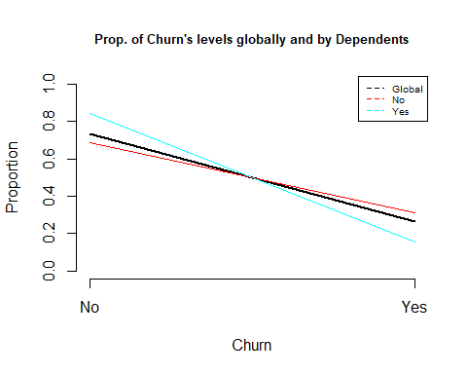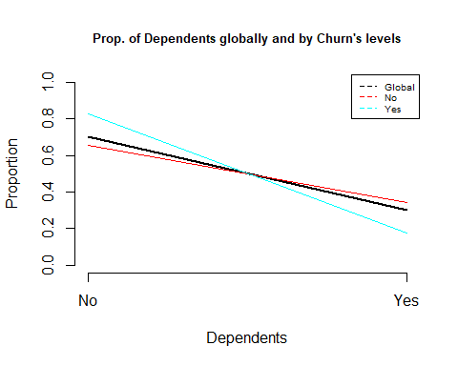

## [1] "Cross Table:"  
## P  
## No Yes  
## No 3390 1543  
## Yes 1784 326  
## [1] "Distributions by columns:"  
##   
## P No Yes  
## No 0.6872086 0.8454976  
## Yes 0.3127914 0.1545024  
## [1] "Chi^2 test: "  
##   
## Pearson's Chi-squared test with Yates' continuity correction  
##   
## data: dades[, k] and as.factor(P)  
## X-squared = 189.13, df = 1, p-value < 2.2e-16  
##   
## [1] "ValorTestXquali:"  
## $rowpf  
## Xquali  
## P No Yes  
## No 0.6551991 0.3448009  
## Yes 0.8255752 0.1744248  
##   
## $vtest  
## Xquali  
## P No Yes  
## No -13.78188 13.78188  
## Yes 13.78188 -13.78188  
##   
## $pval  
## Xquali  
## P No Yes  
## No 0.000000e+00 1.638041e-43  
## Yes 1.638041e-43 0.000000e+00  
##   
## [1] "Analysis by level of : tenure"

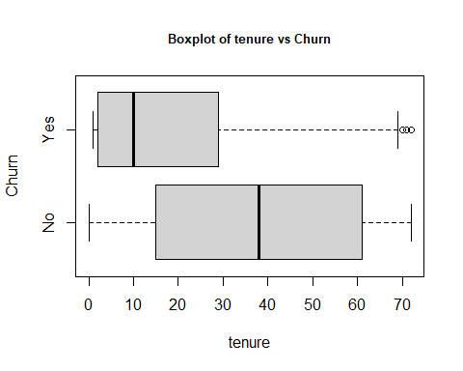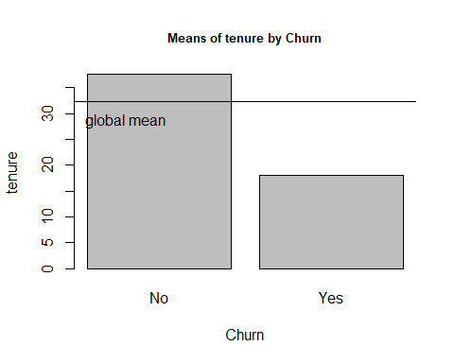

## [1] "Statistics by group:"  
## Min. 1st Qu. Median Mean 3rd Qu. Max.   
## 0.00 15.00 38.00 37.57 61.00 72.00   
## Min. 1st Qu. Median Mean 3rd Qu. Max.   
## 1.00 2.00 10.00 17.98 29.00 72.00   
## [1] "p-valueANOVA: 1.19549454726051e-232"  
## [1] "p-value Kruskal-Wallis: 2.41914018186156e-208"  
## [1] "p-values ValorsTest: "  
## No Yes   
## 2.081921e-181 0.000000e+00   
## [1] "Variable PhoneService"  
## [1] "Categories=" "No" "Yes"

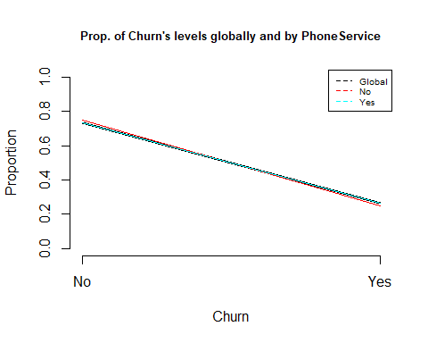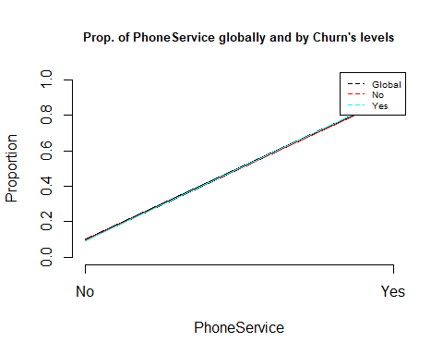

## [1] "Cross Table:"  
## P  
## No Yes  
## No 512 170  
## Yes 4662 1699  
## [1] "Distributions by columns:"  
##   
## P No Yes  
## No 0.7507331 0.7329036  
## Yes 0.2492669 0.2670964  
## [1] "Chi^2 test: "  
##   
## Pearson's Chi-squared test with Yates' continuity correction  
##   
## data: dades[, k] and as.factor(P)  
## X-squared = 0.91503, df = 1, p-value = 0.3388  
##   
## [1] "ValorTestXquali:"  
## $rowpf  
## Xquali  
## P No Yes  
## No 0.09895632 0.90104368  
## Yes 0.09095773 0.90904227  
##   
## $vtest  
## Xquali  
## P No Yes  
## No 1.002202 -1.002202  
## Yes -1.002202 1.002202  
##   
## $pval  
## Xquali  
## P No Yes  
## No 0.1581231 0.1581231  
## Yes 0.1581231 0.1581231  
##   
## [1] "Variable MultipleLines"  
## [1] "Categories=" "No" "No phone service" "Yes"

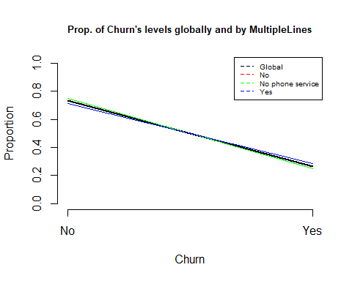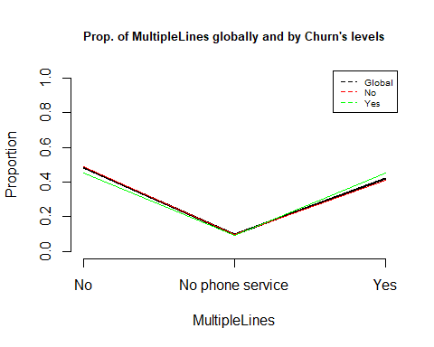

## [1] "Cross Table:"  
## P  
## No Yes  
## No 2541 849  
## No phone service 512 170  
## Yes 2121 850  
## [1] "Distributions by columns:"  
##   
## P No No phone service Yes  
## No 0.7495575 0.7507331 0.7139010  
## Yes 0.2504425 0.2492669 0.2860990  
## [1] "Chi^2 test: "  
##   
## Pearson's Chi-squared test  
##   
## data: dades[, k] and as.factor(P)  
## X-squared = 11.33, df = 2, p-value = 0.003464  
##   
## [1] "ValorTestXquali:"  
## $rowpf  
## Xquali  
## P No No phone service Yes  
## No 0.49110939 0.09895632 0.40993429  
## Yes 0.45425361 0.09095773 0.45478866  
##   
## $vtest  
## Xquali  
## P No No phone service Yes  
## No 2.733239 1.002202 -3.365474  
## Yes -2.733239 -1.002202 3.365474  
##   
## $pval  
## Xquali  
## P No No phone service Yes  
## No 0.0031357380 0.1581230658 0.0003820611  
## Yes 0.0031357380 0.1581230658 0.0003820611  
##   
## [1] "Variable InternetService"  
## [1] "Categories=" "DSL" "Fiber optic" "No"

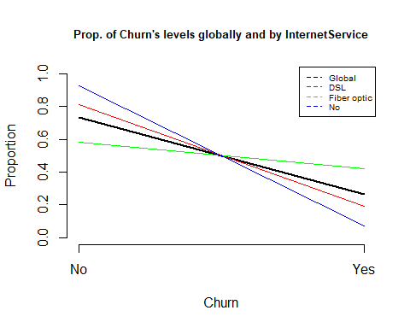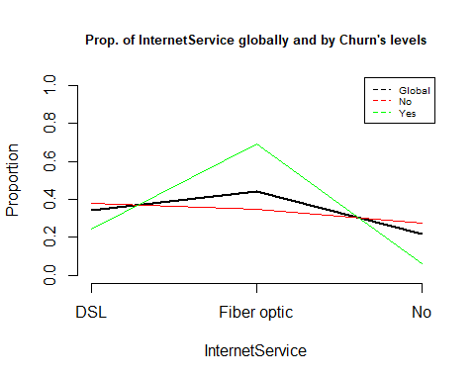

## [1] "Cross Table:"  
## P  
## No Yes  
## DSL 1962 459  
## Fiber optic 1799 1297  
## No 1413 113  
## [1] "Distributions by columns:"  
##   
## P DSL Fiber optic No  
## No 0.8104089 0.5810724 0.9259502  
## Yes 0.1895911 0.4189276 0.0740498  
## [1] "Chi^2 test: "  
##   
## Pearson's Chi-squared test  
##   
## data: dades[, k] and as.factor(P)  
## X-squared = 732.31, df = 2, p-value < 2.2e-16  
##   
## [1] "ValorTestXquali:"  
## $rowpf  
## Xquali  
## P DSL Fiber optic No  
## No 0.37920371 0.34770004 0.27309625  
## Yes 0.24558587 0.69395399 0.06046014  
##   
## $vtest  
## Xquali  
## P DSL Fiber optic No  
## No 10.42434 -25.84981 19.12516  
## Yes -10.42434 25.84981 -19.12516  
##   
## $pval  
## Xquali  
## P DSL Fiber optic No  
## No 9.598875e-26 0.000000e+00 7.795425e-82  
## Yes 0.000000e+00 1.222462e-147 0.000000e+00  
##   
## [1] "Variable OnlineSecurity"  
## [1] "Categories=" "No" "No internet service"  
## [4] "Yes"

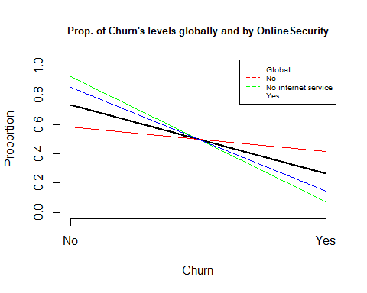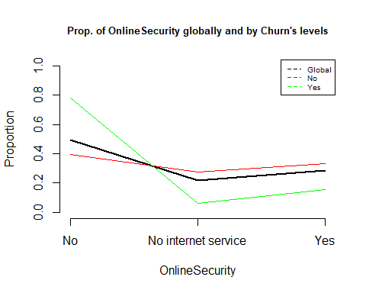

## [1] "Cross Table:"  
## P  
## No Yes  
## No 2037 1461  
## No internet service 1413 113  
## Yes 1724 295  
## [1] "Distributions by columns:"  
##   
## P No No internet service Yes  
## No 0.5823328 0.9259502 0.8538881  
## Yes 0.4176672 0.0740498 0.1461119  
## [1] "Chi^2 test: "  
##   
## Pearson's Chi-squared test  
##   
## data: dades[, k] and as.factor(P)  
## X-squared = 850, df = 2, p-value < 2.2e-16  
##   
## [1] "ValorTestXquali:"  
## $rowpf  
## Xquali  
## P No No internet service Yes  
## No 0.39369927 0.27309625 0.33320448  
## Yes 0.78170144 0.06046014 0.15783842  
##   
## $vtest  
## Xquali  
## P No No internet service Yes  
## No -28.75497 19.12516 14.36975  
## Yes 28.75497 -19.12516 -14.36975  
##   
## $pval  
## Xquali  
## P No No internet service Yes  
## No 0.000000e+00 7.795425e-82 4.005837e-47  
## Yes 3.925582e-182 0.000000e+00 0.000000e+00  
##   
## [1] "Variable OnlineBackup"  
## [1] "Categories=" "No" "No internet service"  
## [4] "Yes"

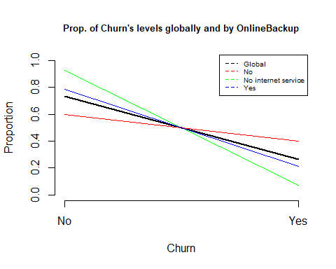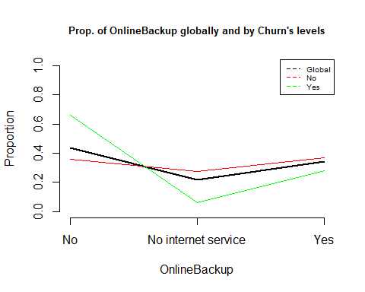

## [1] "Cross Table:"  
## P  
## No Yes  
## No 1855 1233  
## No internet service 1413 113  
## Yes 1906 523  
## [1] "Distributions by columns:"  
##   
## P No No internet service Yes  
## No 0.6007124 0.9259502 0.7846851  
## Yes 0.3992876 0.0740498 0.2153149  
## [1] "Chi^2 test: "  
##   
## Pearson's Chi-squared test  
##   
## data: dades[, k] and as.factor(P)  
## X-squared = 601.81, df = 2, p-value < 2.2e-16  
##   
## [1] "ValorTestXquali:"  
## $rowpf  
## Xquali  
## P No No internet service Yes  
## No 0.35852339 0.27309625 0.36838036  
## Yes 0.65971108 0.06046014 0.27982879  
##   
## $vtest  
## Xquali  
## P No No internet service Yes  
## No -22.491687 19.125155 6.903041  
## Yes 22.491687 -19.125155 -6.903041  
##   
## $pval  
## Xquali  
## P No No internet service Yes  
## No 0.000000e+00 7.795425e-82 2.545045e-12  
## Yes 2.502984e-112 0.000000e+00 2.545075e-12  
##   
## [1] "Variable DeviceProtection"  
## [1] "Categories=" "No" "No internet service"  
## [4] "Yes"

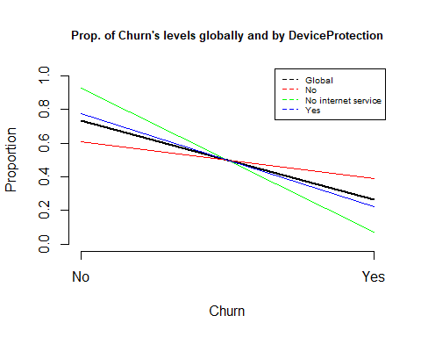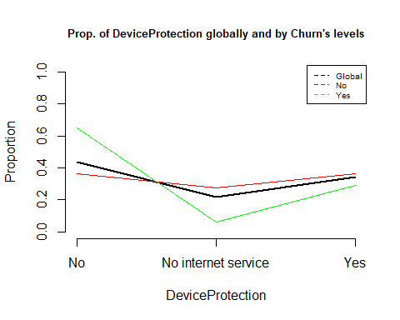

## [1] "Cross Table:"  
## P  
## No Yes  
## No 1884 1211  
## No internet service 1413 113  
## Yes 1877 545  
## [1] "Distributions by columns:"  
##   
## P No No internet service Yes  
## No 0.6087237 0.9259502 0.7749794  
## Yes 0.3912763 0.0740498 0.2250206  
## [1] "Chi^2 test: "  
##   
## Pearson's Chi-squared test  
##   
## data: dades[, k] and as.factor(P)  
## X-squared = 558.42, df = 2, p-value < 2.2e-16  
##   
## [1] "ValorTestXquali:"  
## $rowpf  
## Xquali  
## P No No internet service Yes  
## No 0.36412833 0.27309625 0.36277542  
## Yes 0.64794007 0.06046014 0.29159979  
##   
## $vtest  
## Xquali  
## P No No internet service Yes  
## No -21.188888 19.125155 5.552301  
## Yes 21.188888 -19.125155 -5.552301  
##   
## $pval  
## Xquali  
## P No No internet service Yes  
## No 0.000000e+00 7.795425e-82 1.409671e-08  
## Yes 6.045963e-100 0.000000e+00 1.409671e-08  
##   
## [1] "Variable TechSupport"  
## [1] "Categories=" "No" "No internet service"  
## [4] "Yes"

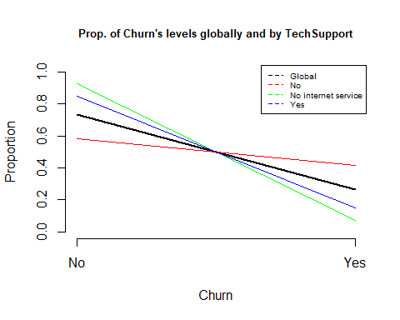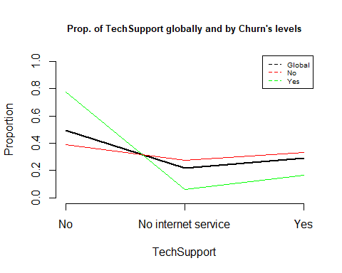

## [1] "Cross Table:"  
## P  
## No Yes  
## No 2027 1446  
## No internet service 1413 113  
## Yes 1734 310  
## [1] "Distributions by columns:"  
##   
## P No No internet service Yes  
## No 0.5836453 0.9259502 0.8483366  
## Yes 0.4163547 0.0740498 0.1516634  
## [1] "Chi^2 test: "  
##   
## Pearson's Chi-squared test  
##   
## data: dades[, k] and as.factor(P)  
## X-squared = 828.2, df = 2, p-value < 2.2e-16  
##   
## [1] "ValorTestXquali:"  
## $rowpf  
## Xquali  
## P No No internet service Yes  
## No 0.39176652 0.27309625 0.33513722  
## Yes 0.77367576 0.06046014 0.16586410  
##   
## $vtest  
## Xquali  
## P No No internet service Yes  
## No -28.30547 19.12516 13.81983  
## Yes 28.30547 -19.12516 -13.81983  
##   
## $pval  
## Xquali  
## P No No internet service Yes  
## No 0.000000e+00 7.795425e-82 9.676286e-44  
## Yes 1.479823e-176 0.000000e+00 0.000000e+00  
##   
## [1] "Variable StreamingTV"  
## [1] "Categories=" "No" "No internet service"  
## [4] "Yes"

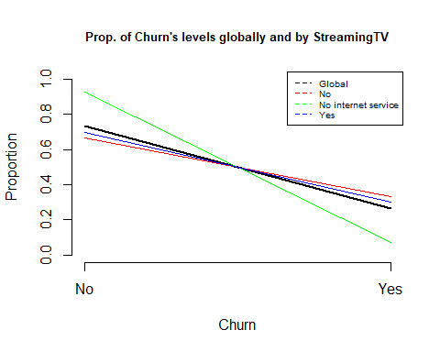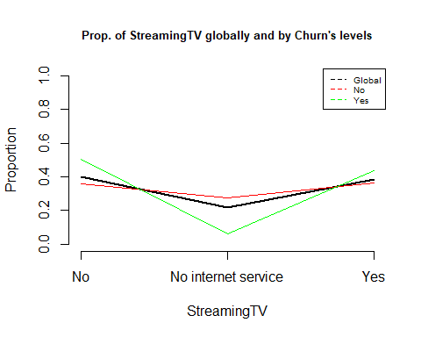

## [1] "Cross Table:"  
## P  
## No Yes  
## No 1868 942  
## No internet service 1413 113  
## Yes 1893 814  
## [1] "Distributions by columns:"  
##   
## P No No internet service Yes  
## No 0.6647687 0.9259502 0.6992981  
## Yes 0.3352313 0.0740498 0.3007019  
## [1] "Chi^2 test: "  
##   
## Pearson's Chi-squared test  
##   
## data: dades[, k] and as.factor(P)  
## X-squared = 374.2, df = 2, p-value < 2.2e-16  
##   
## [1] "ValorTestXquali:"  
## $rowpf  
## Xquali  
## P No No internet service Yes  
## No 0.36103595 0.27309625 0.36586780  
## Yes 0.50401284 0.06046014 0.43552702  
##   
## $vtest  
## Xquali  
## P No No internet service Yes  
## No -10.818954 19.125155 -5.306236  
## Yes 10.818954 -19.125155 5.306236  
##   
## $pval  
## Xquali  
## P No No internet service Yes  
## No 0.000000e+00 7.795425e-82 5.595609e-08  
## Yes 1.399774e-27 0.000000e+00 5.595609e-08  
##   
## [1] "Variable StreamingMovies"  
## [1] "Categories=" "No" "No internet service"  
## [4] "Yes"

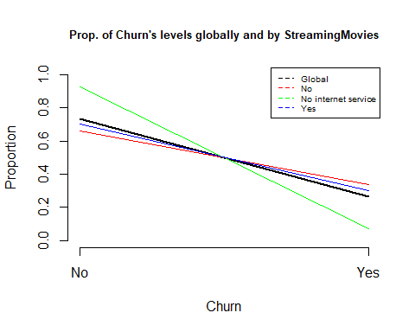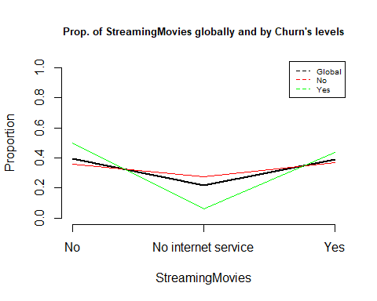

## [1] "Cross Table:"  
## P  
## No Yes  
## No 1847 938  
## No internet service 1413 113  
## Yes 1914 818  
## [1] "Distributions by columns:"  
##   
## P No No internet service Yes  
## No 0.6631957 0.9259502 0.7005857  
## Yes 0.3368043 0.0740498 0.2994143  
## [1] "Chi^2 test: "  
##   
## Pearson's Chi-squared test  
##   
## data: dades[, k] and as.factor(P)  
## X-squared = 375.66, df = 2, p-value < 2.2e-16  
##   
## [1] "ValorTestXquali:"  
## $rowpf  
## Xquali  
## P No No internet service Yes  
## No 0.35697719 0.27309625 0.36992656  
## Yes 0.50187266 0.06046014 0.43766720  
##   
## $vtest  
## Xquali  
## P No No internet service Yes  
## No -10.980853 19.125155 -5.151298  
## Yes 10.980853 -19.125155 5.151298  
##   
## $pval  
## Xquali  
## P No No internet service Yes  
## No 0.000000e+00 7.795425e-82 1.293448e-07  
## Yes 2.362211e-28 0.000000e+00 1.293448e-07  
##   
## [1] "Variable Contract"  
## [1] "Categories=" "Month-to-month" "One year" "Two year"

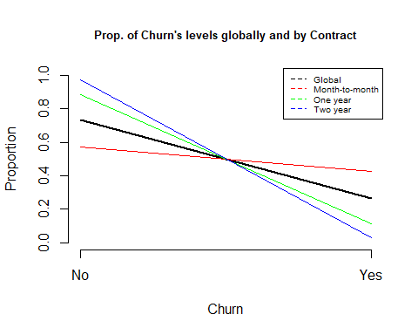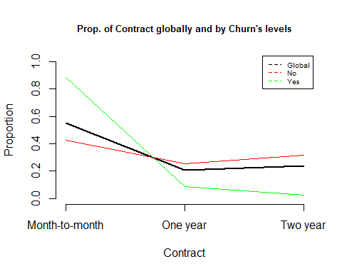

## [1] "Cross Table:"  
## P  
## No Yes  
## Month-to-month 2220 1655  
## One year 1307 166  
## Two year 1647 48  
## [1] "Distributions by columns:"  
##   
## P Month-to-month One year Two year  
## No 0.57290323 0.88730482 0.97168142  
## Yes 0.42709677 0.11269518 0.02831858  
## [1] "Chi^2 test: "  
##   
## Pearson's Chi-squared test  
##   
## data: dades[, k] and as.factor(P)  
## X-squared = 1184.6, df = 2, p-value < 2.2e-16  
##   
## [1] "ValorTestXquali:"  
## $rowpf  
## Xquali  
## P Month-to-month One year Two year  
## No 0.42906842 0.25260920 0.31832238  
## Yes 0.88550027 0.08881755 0.02568218  
##   
## $vtest  
## Xquali  
## P Month-to-month One year Two year  
## No -33.99728 14.92312 25.36589  
## Yes 33.99728 -14.92312 -25.36589  
##   
## $pval  
## Xquali  
## P Month-to-month One year Two year  
## No 0.000000e+00 1.165649e-50 3.001022e-142  
## Yes 1.221803e-253 0.000000e+00 0.000000e+00  
##   
## [1] "Variable PaperlessBilling"  
## [1] "Categories=" "No" "Yes"

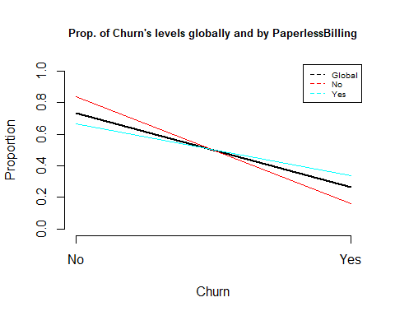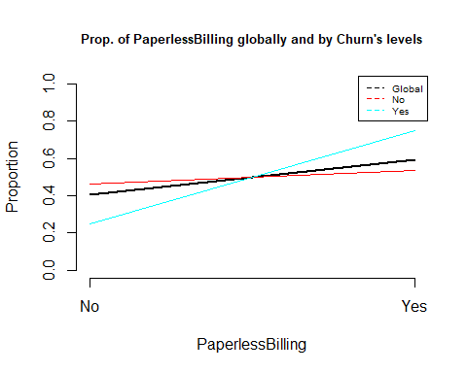

## [1] "Cross Table:"  
## P  
## No Yes  
## No 2403 469  
## Yes 2771 1400  
## [1] "Distributions by columns:"  
##   
## P No Yes  
## No 0.8366992 0.6643491  
## Yes 0.1633008 0.3356509  
## [1] "Chi^2 test: "  
##   
## Pearson's Chi-squared test with Yates' continuity correction  
##   
## data: dades[, k] and as.factor(P)  
## X-squared = 258.28, df = 1, p-value < 2.2e-16  
##   
## [1] "ValorTestXquali:"  
## $rowpf  
## Xquali  
## P No Yes  
## No 0.4644376 0.5355624  
## Yes 0.2509363 0.7490637  
##   
## $vtest  
## Xquali  
## P No Yes  
## No 16.09848 -16.09848  
## Yes -16.09848 16.09848  
##   
## $pval  
## Xquali  
## P No Yes  
## No 1.307299e-58 0.000000e+00  
## Yes 0.000000e+00 1.307299e-58  
##   
## [1] "Variable PaymentMethod"  
## [1] "Categories=" "Bank transfer (automatic)"  
## [3] "Credit card (automatic)" "Electronic check"   
## [5] "Mailed check"

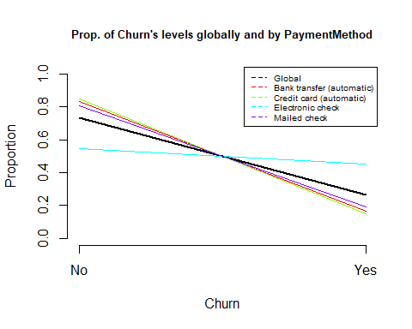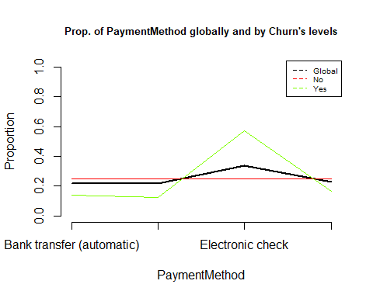

## [1] "Cross Table:"  
## P  
## No Yes  
## Bank transfer (automatic) 1286 258  
## Credit card (automatic) 1290 232  
## Electronic check 1294 1071  
## Mailed check 1304 308  
## [1] "Distributions by columns:"  
##   
## P Bank transfer (automatic) Credit card (automatic) Electronic check  
## No 0.8329016 0.8475690 0.5471459  
## Yes 0.1670984 0.1524310 0.4528541  
##   
## P Mailed check  
## No 0.8089330  
## Yes 0.1910670  
## [1] "Chi^2 test: "  
##   
## Pearson's Chi-squared test  
##   
## data: dades[, k] and as.factor(P)  
## X-squared = 648.14, df = 3, p-value < 2.2e-16  
##   
## [1] "ValorTestXquali:"  
## $rowpf  
## Xquali  
## P Bank transfer (automatic) Credit card (automatic) Electronic check  
## No 0.2485504 0.2493235 0.2500966  
## Yes 0.1380417 0.1241306 0.5730337  
## Xquali  
## P Mailed check  
## No 0.2520294  
## Yes 0.1647940  
##   
## $vtest  
## Xquali  
## P Bank transfer (automatic) Credit card (automatic) Electronic check  
## No 9.897550 11.270950 -25.337801  
## Yes -9.897550 -11.270950 25.337801  
## Xquali  
## P Mailed check  
## No 7.694261  
## Yes -7.694261  
##   
## $pval  
## Xquali  
## P Bank transfer (automatic) Credit card (automatic) Electronic check  
## No 2.132984e-23 9.129469e-30 0.000000e+00  
## Yes 0.000000e+00 0.000000e+00 6.123943e-142  
## Xquali  
## P Mailed check  
## No 7.115733e-15  
## Yes 7.105427e-15  
##   
## [1] "Analysis by level of : MonthlyCharges"

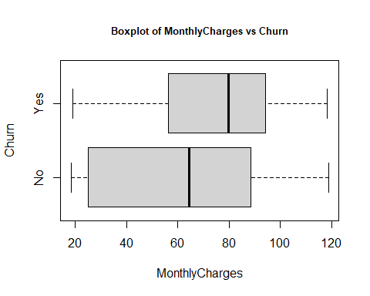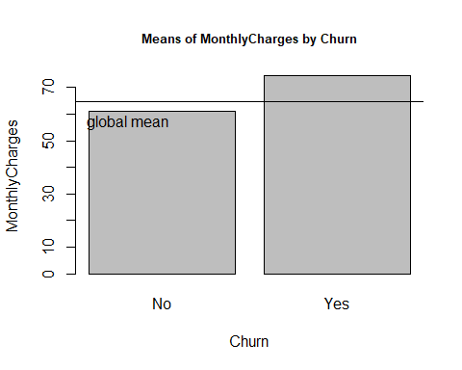

## [1] "Statistics by group:"  
## Min. 1st Qu. Median Mean 3rd Qu. Max.   
## 18.25 25.10 64.42 61.27 88.40 118.75   
## Min. 1st Qu. Median Mean 3rd Qu. Max.   
## 18.85 56.15 79.65 74.44 94.20 118.35   
## [1] "p-valueANOVA: 8.59244933154708e-73"  
## [1] "p-value Kruskal-Wallis: 3.31128554878381e-54"  
## [1] "p-values ValorsTest: "  
## No Yes   
## 0.000000e+00 1.861643e-58   
## [1] "Analysis by level of : TotalCharges"

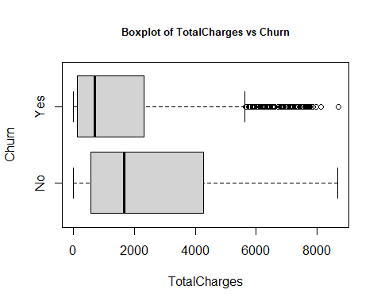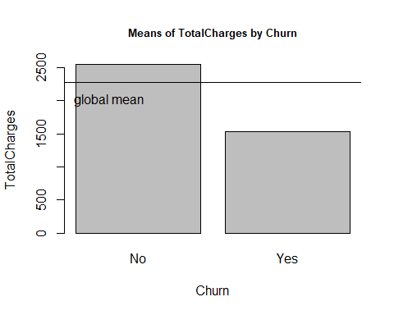

## [1] "Statistics by group:"  
## Min. 1st Qu. Median Mean 3rd Qu. Max.   
## 0.0 572.9 1679.5 2549.9 4262.9 8672.5   
## Min. 1st Qu. Median Mean 3rd Qu. Max.   
## 18.85 134.50 703.55 1531.80 2331.30 8684.80   
## [1] "p-valueANOVA: 5.90258060907269e-75"  
## [1] "p-value Kruskal-Wallis: 5.68430392462642e-83"  
## [1] "p-values ValorsTest: "  
## No Yes   
## 2.476582e-61 0.000000e+00   
## [1] "Variable c.tenure"  
## [1] "Categories=" "(-1,18]" "(18,36]" "(36,54]" "(54,72]"

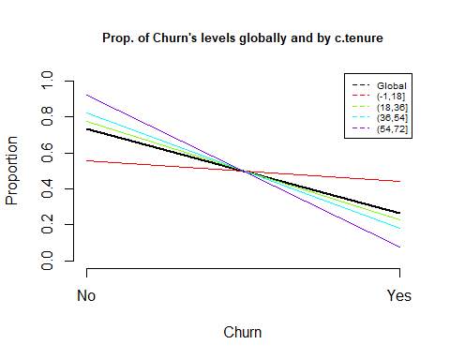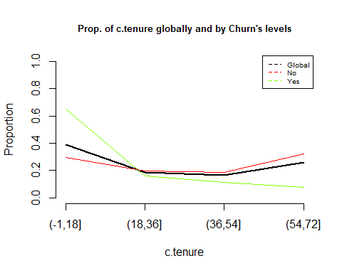

## [1] "Cross Table:"  
## P  
## No Yes  
## (-1,18] 1520 1214  
## (18,36] 1011 297  
## (36,54] 969 213  
## (54,72] 1674 145  
## [1] "Distributions by columns:"  
##   
## P (-1,18] (18,36] (36,54] (54,72]  
## No 0.55596196 0.77293578 0.81979695 0.92028587  
## Yes 0.44403804 0.22706422 0.18020305 0.07971413  
## [1] "Chi^2 test: "  
##   
## Pearson's Chi-squared test  
##   
## data: dades[, k] and as.factor(P)  
## X-squared = 823.12, df = 3, p-value < 2.2e-16  
##   
## [1] "ValorTestXquali:"  
## $rowpf  
## Xquali  
## P (-1,18] (18,36] (36,54] (54,72]  
## No 0.29377658 0.19540008 0.18728257 0.32354078  
## Yes 0.64954521 0.15890851 0.11396469 0.07758159  
##   
## $vtest  
## Xquali  
## P (-1,18] (18,36] (36,54] (54,72]  
## No -27.050598 3.477112 7.269625 20.822929  
## Yes 27.050598 -3.477112 -7.269625 -20.822929  
##   
## $pval  
## Xquali  
## P (-1,18] (18,36] (36,54] (54,72]  
## No 0.000000e+00 2.534231e-04 1.802435e-13 1.341373e-96  
## Yes 1.879067e-161 2.534231e-04 1.801892e-13 0.000000e+00  
##   
## [1] "Variable c.TotalCharges"  
## [1] "Categories=" "(-1,2171]" "(2171,4342]" "(4342,6514]" "(6514,8685]"

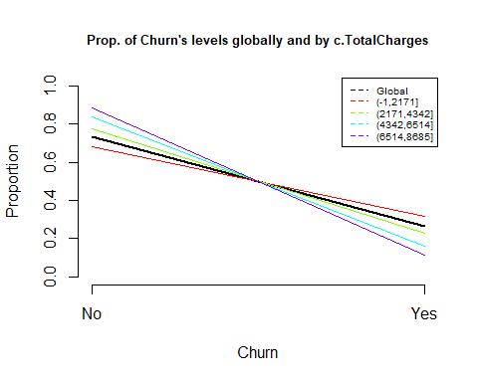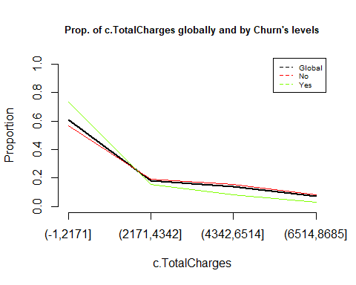

## [1] "Cross Table:"  
## P  
## No Yes  
## (-1,2171] 2938 1368  
## (2171,4342] 982 288  
## (4342,6514] 819 156  
## (6514,8685] 435 57  
## [1] "Distributions by columns:"  
##   
## P (-1,2171] (2171,4342] (4342,6514] (6514,8685]  
## No 0.6823038 0.7732283 0.8400000 0.8841463  
## Yes 0.3176962 0.2267717 0.1600000 0.1158537  
## [1] "Chi^2 test: "  
##   
## Pearson's Chi-squared test  
##   
## data: dades[, k] and as.factor(P)  
## X-squared = 182.13, df = 3, p-value < 2.2e-16  
##   
## [1] "ValorTestXquali:"  
## $rowpf  
## Xquali  
## P (-1,2171] (2171,4342] (4342,6514] (6514,8685]  
## No 0.56783920 0.18979513 0.15829146 0.08407422  
## Yes 0.73194222 0.15409310 0.08346709 0.03049759  
##   
## $vtest  
## Xquali  
## P (-1,2171] (2171,4342] (4342,6514] (6514,8685]  
## No -12.474952 3.441018 8.028134 7.788175  
## Yes 12.474952 -3.441018 -8.028134 -7.788175  
##   
## $pval  
## Xquali  
## P (-1,2171] (2171,4342] (4342,6514] (6514,8685]  
## No 0.000000e+00 2.897645e-04 4.948298e-16 3.399196e-15  
## Yes 5.113421e-36 2.897645e-04 4.440892e-16 3.441691e-15  
##   
## [1] "Variable c.MonthlyCharges"  
## [1] "Categories=" "(18,30.69]" "(30.69,59.38]" "(59.38,89.06]"   
## [5] "(89.06,118.75]"

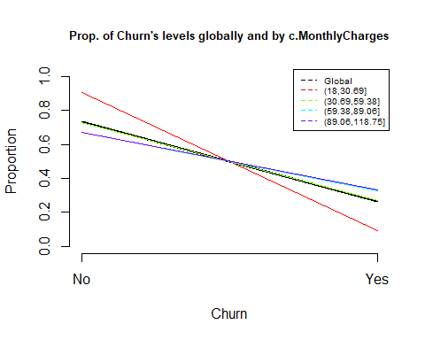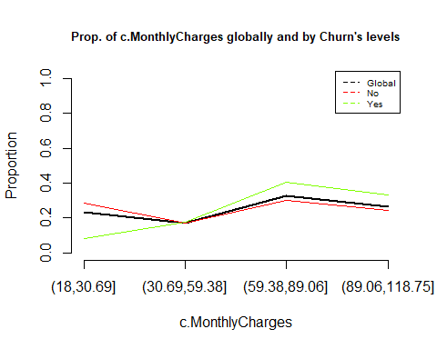

## [1] "Cross Table:"  
## P  
## No Yes  
## (18,30.69] 1478 156  
## (30.69,59.38] 882 326  
## (59.38,89.06] 1554 763  
## (89.06,118.75] 1260 624  
## [1] "Distributions by columns:"  
##   
## P (18,30.69] (30.69,59.38] (59.38,89.06] (89.06,118.75]  
## No 0.90452876 0.73013245 0.67069486 0.66878981  
## Yes 0.09547124 0.26986755 0.32930514 0.33121019  
## [1] "Chi^2 test: "  
##   
## Pearson's Chi-squared test  
##   
## data: dades[, k] and as.factor(P)  
## X-squared = 332.54, df = 3, p-value < 2.2e-16  
##   
## [1] "ValorTestXquali:"  
## $rowpf  
## Xquali  
## P (18,30.69] (30.69,59.38] (59.38,89.06] (89.06,118.75]  
## No 0.28565906 0.17046772 0.30034789 0.24352532  
## Yes 0.08346709 0.17442483 0.40823970 0.33386838  
##   
## $vtest  
## Xquali  
## P (18,30.69] (30.69,59.38] (59.38,89.06] (89.06,118.75]  
## No 17.7490901 -0.3889736 -8.5089368 -7.5625505  
## Yes -17.7490901 0.3889736 8.5089368 7.5625505  
##   
## $pval  
## Xquali  
## P (18,30.69] (30.69,59.38] (59.38,89.06] (89.06,118.75]  
## No 8.758458e-71 3.486478e-01 0.000000e+00 1.976197e-14  
## Yes 0.000000e+00 3.486478e-01 8.776773e-18 1.976207e-14  
##   
## [1] "P.values per class: No"  
## gender SeniorCitizen Partner Dependents   
## 0.00e+00 0.00e+00 0.00e+00 0.00e+00   
## PhoneService MultipleLines InternetService OnlineSecurity   
## 0.00e+00 0.00e+00 0.00e+00 0.00e+00   
## OnlineBackup DeviceProtection TechSupport StreamingTV   
## 0.00e+00 0.00e+00 0.00e+00 0.00e+00   
## StreamingMovies Contract PaperlessBilling PaymentMethod   
## 0.00e+00 0.00e+00 0.00e+00 0.00e+00   
## MonthlyCharges c.tenure c.TotalCharges c.MonthlyCharges   
## 0.00e+00 0.00e+00 0.00e+00 0.00e+00   
## tenure TotalCharges   
## 2.08e-181 2.48e-61   
## [1] "P.values per class: Yes"  
## gender SeniorCitizen Partner Dependents   
## 0.00e+00 0.00e+00 0.00e+00 0.00e+00   
## tenure PhoneService MultipleLines InternetService   
## 0.00e+00 0.00e+00 0.00e+00 0.00e+00   
## OnlineSecurity OnlineBackup DeviceProtection TechSupport   
## 0.00e+00 0.00e+00 0.00e+00 0.00e+00   
## StreamingTV StreamingMovies Contract PaperlessBilling   
## 0.00e+00 0.00e+00 0.00e+00 0.00e+00   
## PaymentMethod TotalCharges c.tenure c.TotalCharges   
## 0.00e+00 0.00e+00 0.00e+00 0.00e+00   
## c.MonthlyCharges MonthlyCharges   
## 0.00e+00 1.86e-58

## Complete EDA