Title

Subtitle

Author

Date

Abstract

# Heading 1

## Heading 2

### Heading 3

#### Heading 4

##### Heading 5

###### Heading 6

Heading 7

Heading 8

Heading 9

First Paragraph.

An image is below:

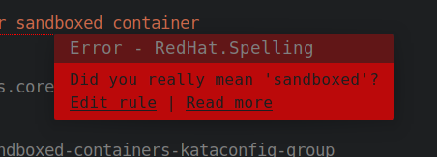Figure 1: Image caption

Body Text. Body Text Char. Verbatim Char .  [Hyperlink](http://example.com/)  . Footnote. [1]

Block Text.

Table caption.

|  |  |
| --- | --- |
| Table | Table |
| 1 | 2 |

Image Caption

DefinitionTerm

Definition

DefinitionTerm

Definition

apiVersion: ptp.openshift.io/v1

kind: PtpConfig

metadata:

name: boundary-clock-ptp-config-nic1

namespace: openshift-ptp

spec:

profile:

- name: "profile1"

ptp4lOpts: "-2 --summary_interval -4"

ptp4lConf: |

[ens5f1]

masterOnly 1

[ens5f0]

masterOnly 0

phc2sysOpts: "-a -r -m -n 24 -N 8 -R 16"

1. Footnote Text.