## QLNU-SEC-2403+于光泽+191897071@qq.com

## REVERSE+ uglyCpp

## 解题思路

1.放入ida中分析

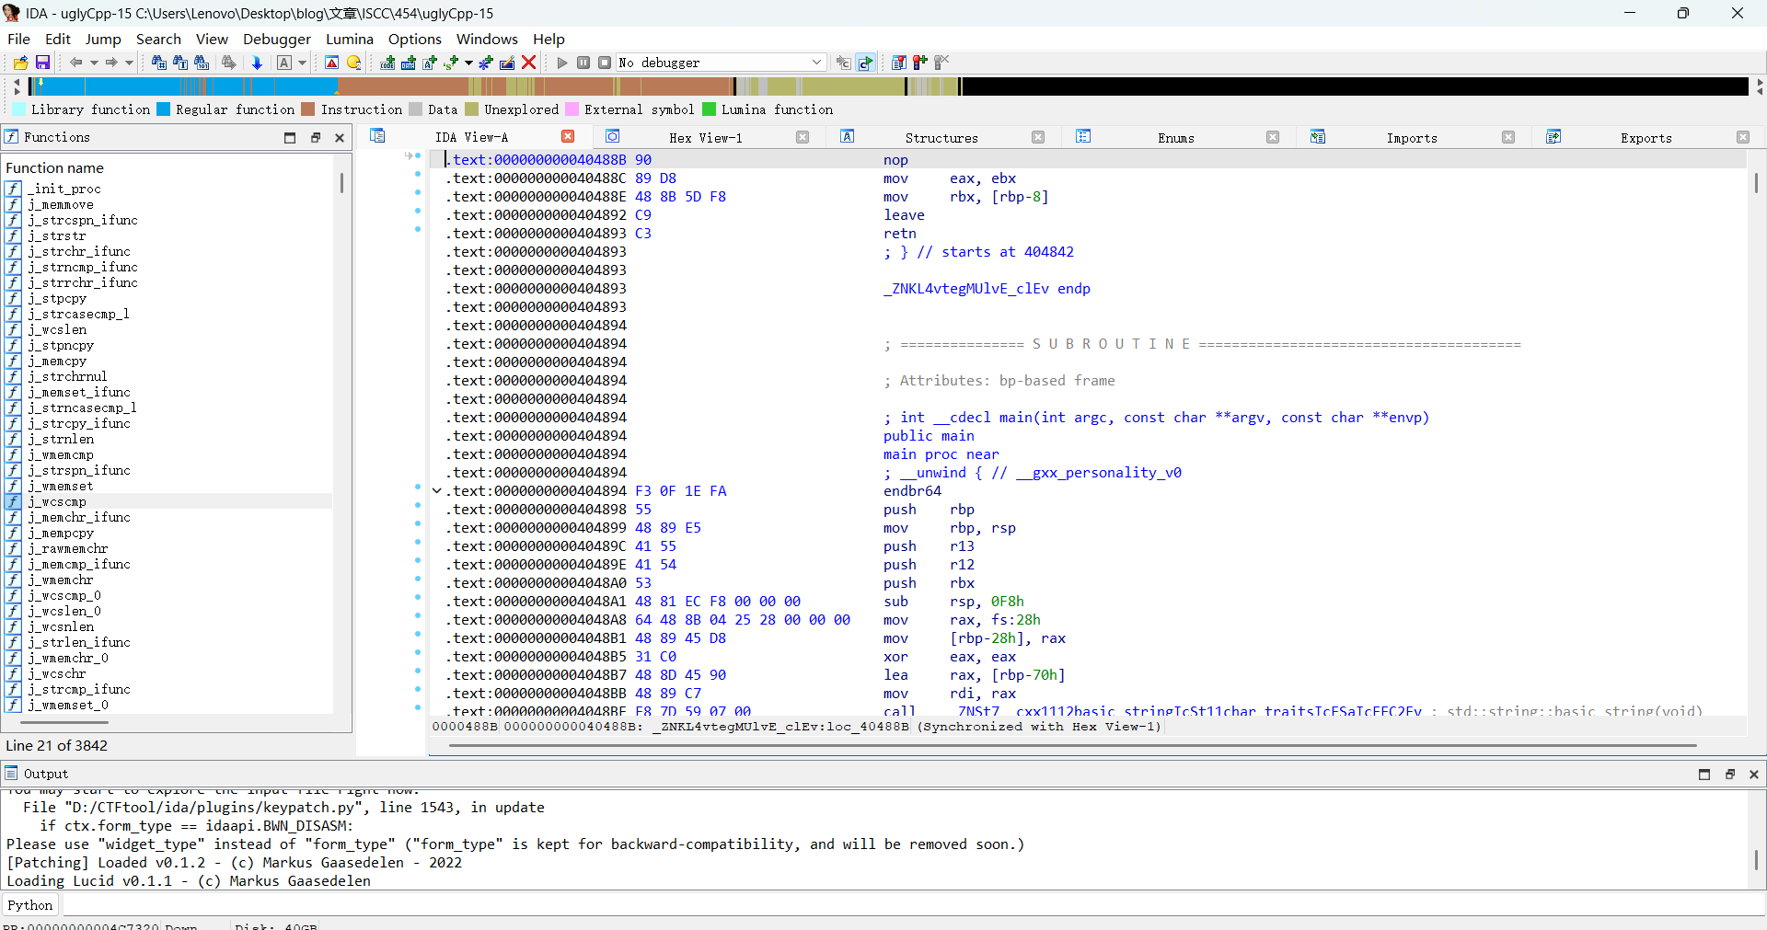

2.在j_wcscmp函数中找到其中的密文

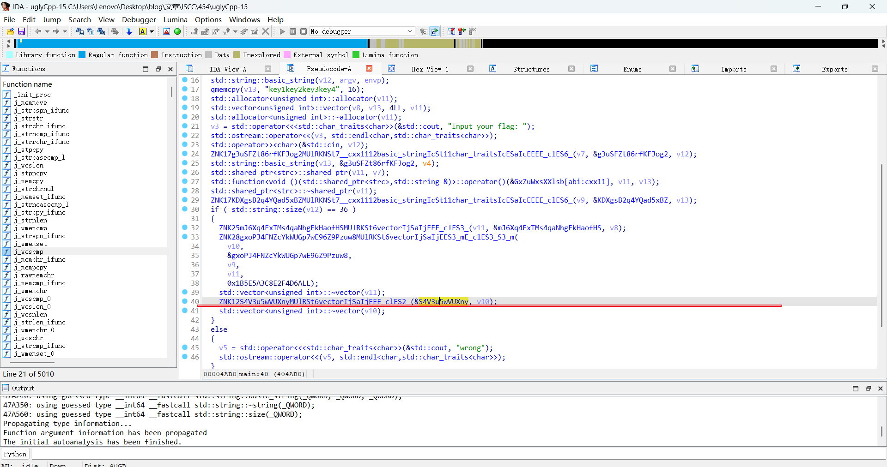

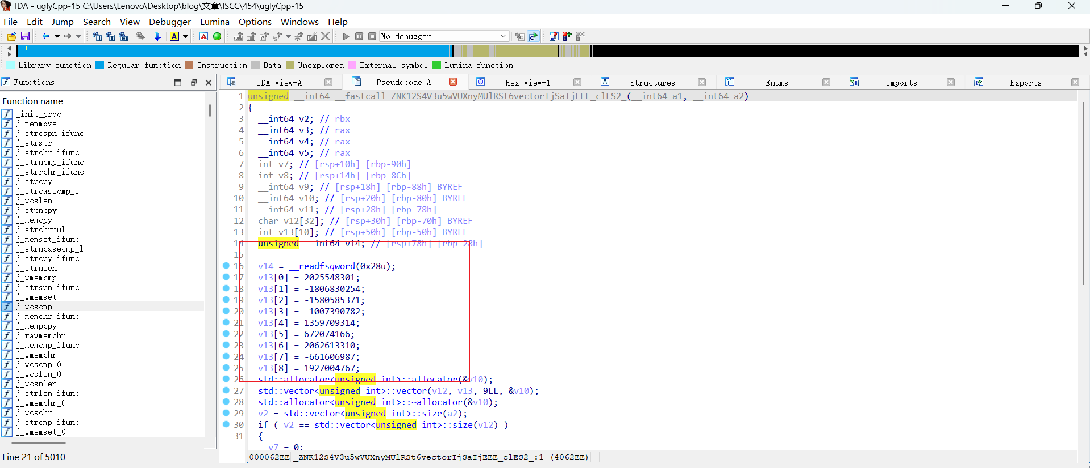

3.先异或解密，再字节解码，接着按照下面的规则映射

“5p6h7q8d9risbtjuevkwaxlyfzm0c1n2g3o4”“abcdefghijklmnopqrstuvwxyz0123456789”

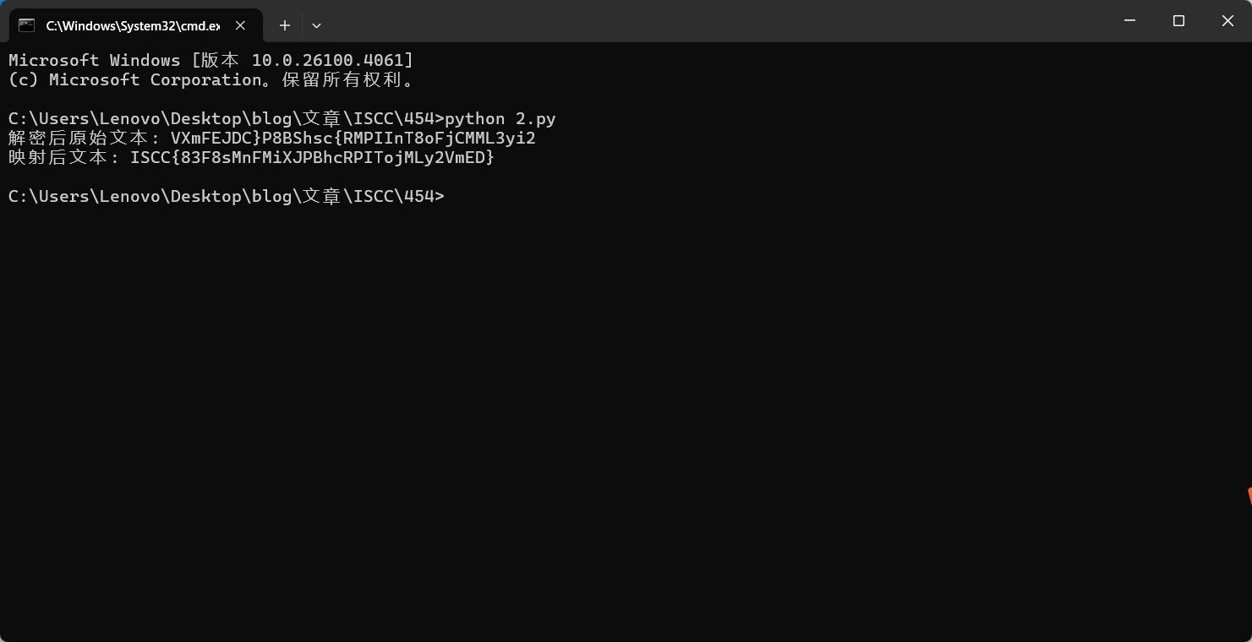

## Exp:

def decrypt_ciphertext(encrypted_values, xor_key_list):

encrypted_ints = [value & 0xffffffff for value in encrypted_values]

decrypted_ints = [encrypted_ints[i] ^ xor_key_list[i] for i in range(len(encrypted_ints))]

return decrypted_ints

def convert_ints_to_string(integer_list):

try:

return "".join([num.to_bytes(length=4, byteorder="little").decode() for num in integer_list])

except UnicodeDecodeError:

print("解码失败，可能密钥错误或数据损坏")

return ""

def apply_custom_character_mapping(input_text, source_character_table, target_character_table):

result = []

for char in target_character_table:

if char in source_character_table:

position = source_character_table.index(char)

if position < len(input_text):

result.append(input_text[position])

return ''.join(result)

def main():

encrypted_data = [

2025548301, -1806830254, -1580585371, -1007390782,

1359709314, 672074166, 2062613310, -661606987, 1927004767

]

decryption_key = [

0x3ED6325B, 0xD709BF17, 0xE3F27E18, 0xA0870791,

0x0146D6F9, 0x7C6140FF, 0x10B69406, 0x94DDE0F6, 0x40B2BB6C

]

source_mapping_table = "5p6h7q8d9risbtjuevkwaxlyfzm0c1n2g3o4"

target_mapping_table = "abcdefghijklmnopqrstuvwxyz0123456789"

decrypted_values = decrypt_ciphertext(encrypted_data, decryption_key)

original_text = convert_ints_to_string(decrypted_values)

print("解密后原始文本:", original_text)

transformed_text = apply_custom_character_mapping(original_text, source_mapping_table, target_mapping_table)

print("映射后文本:", transformed_text)

if __name__ == "__main__":

main()