**Re2 uglyCpp**

直接将附件丢进IDA工具：

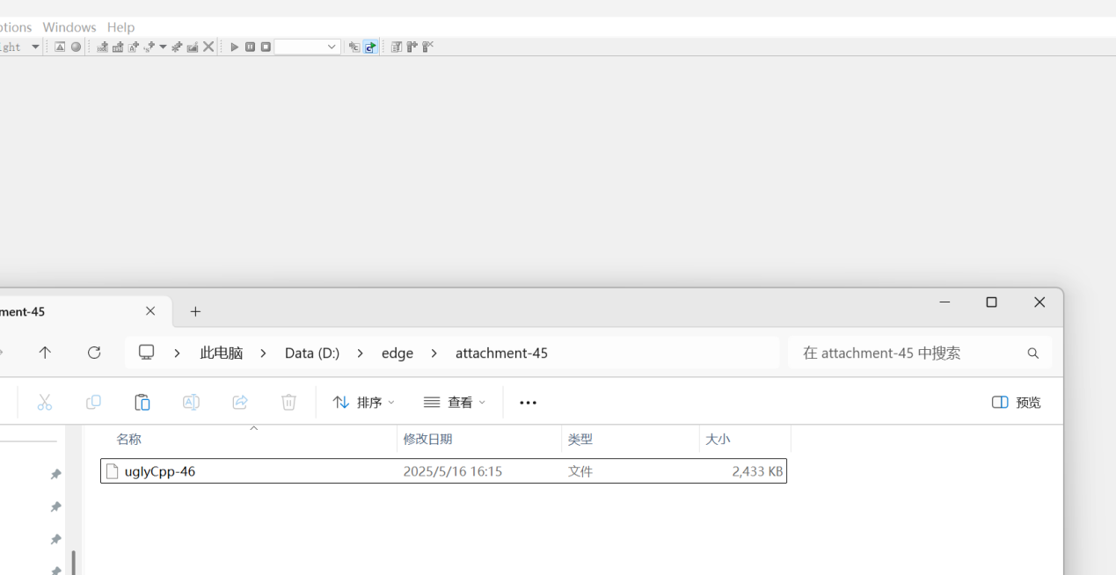

出现以下界面：

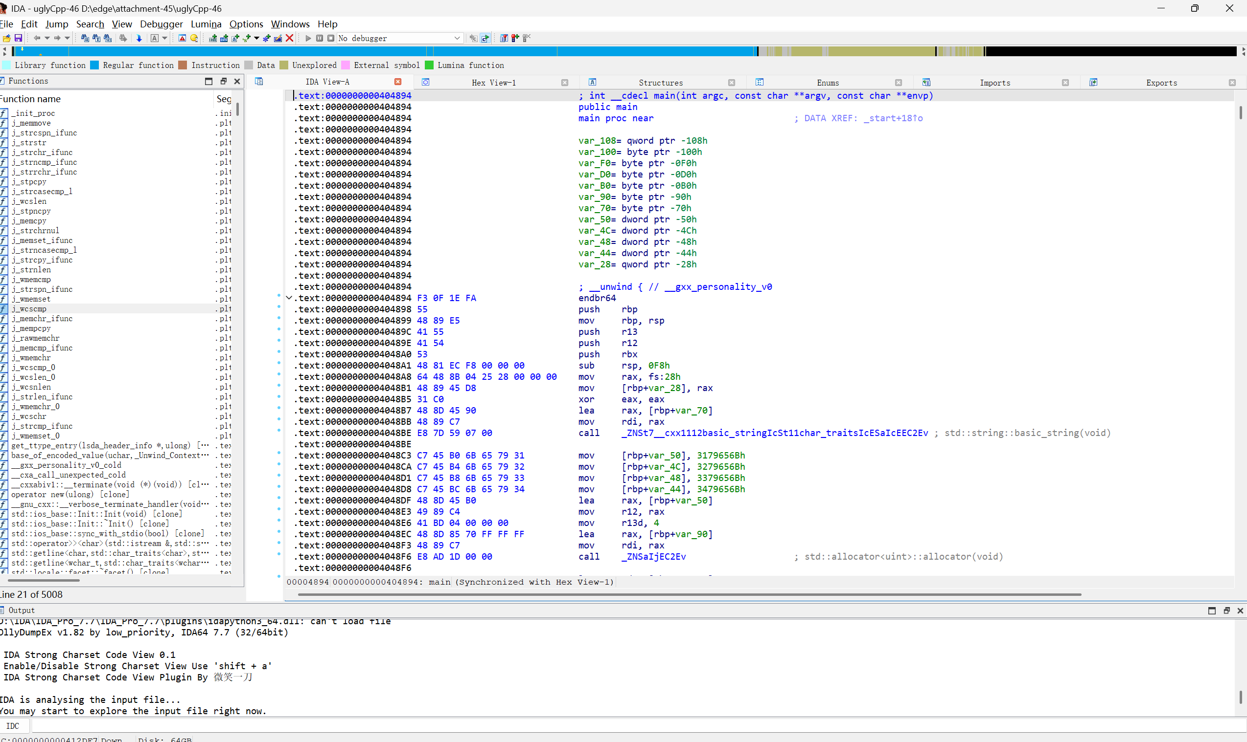

按下F5出现伪代码，找到V10列：

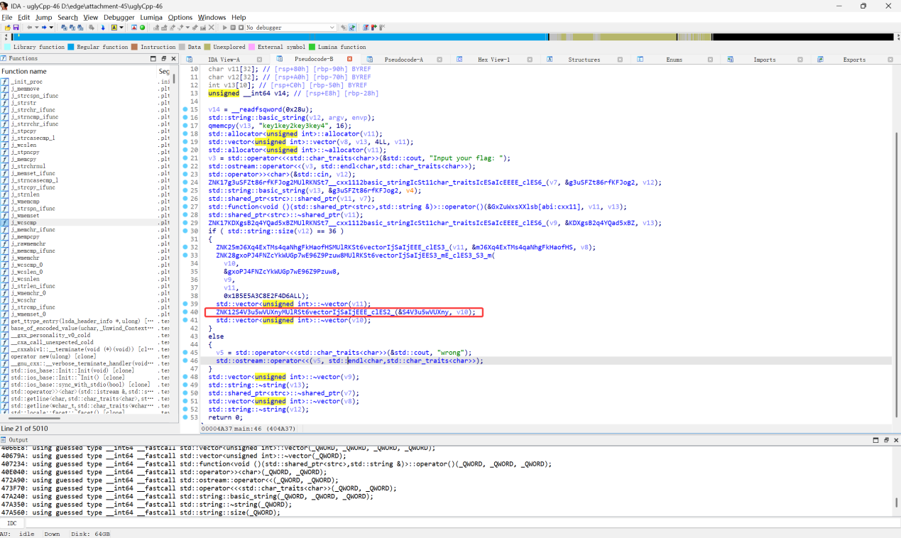

双击英文出现以下界面：

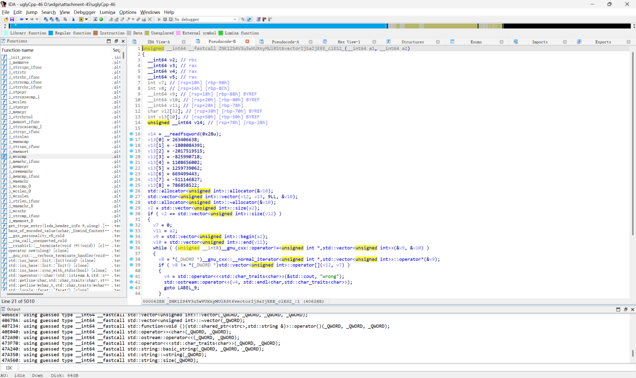

按下Tab键出现以下界面，将红线框出部分放入解密代码：

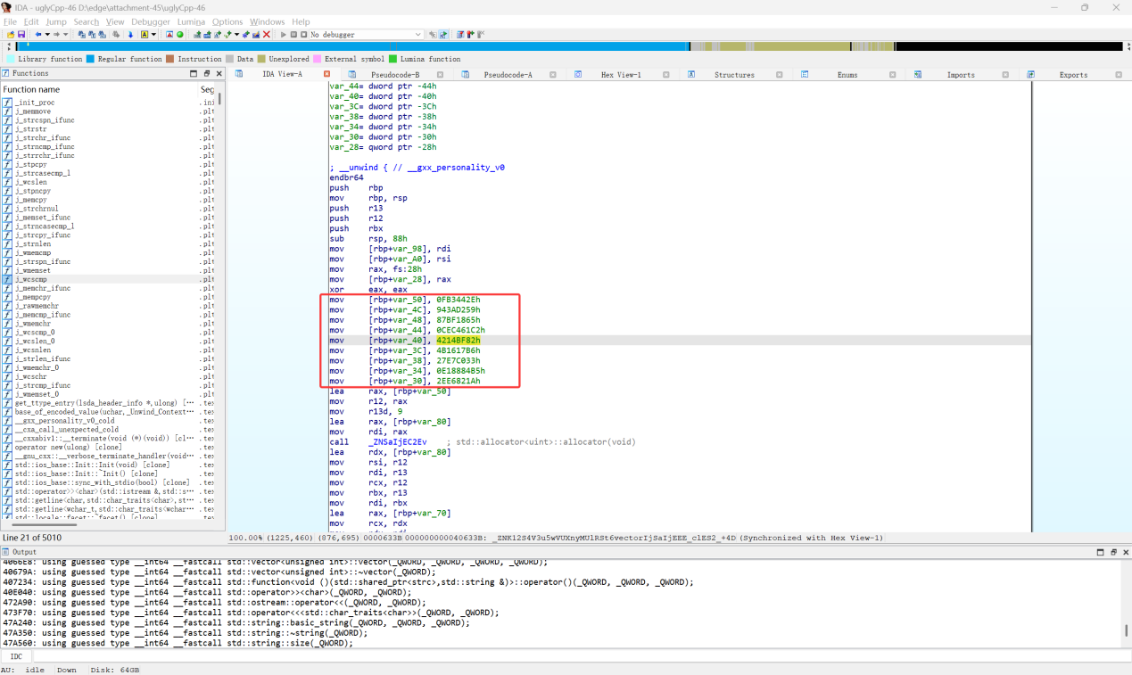

去掉h放入代码：

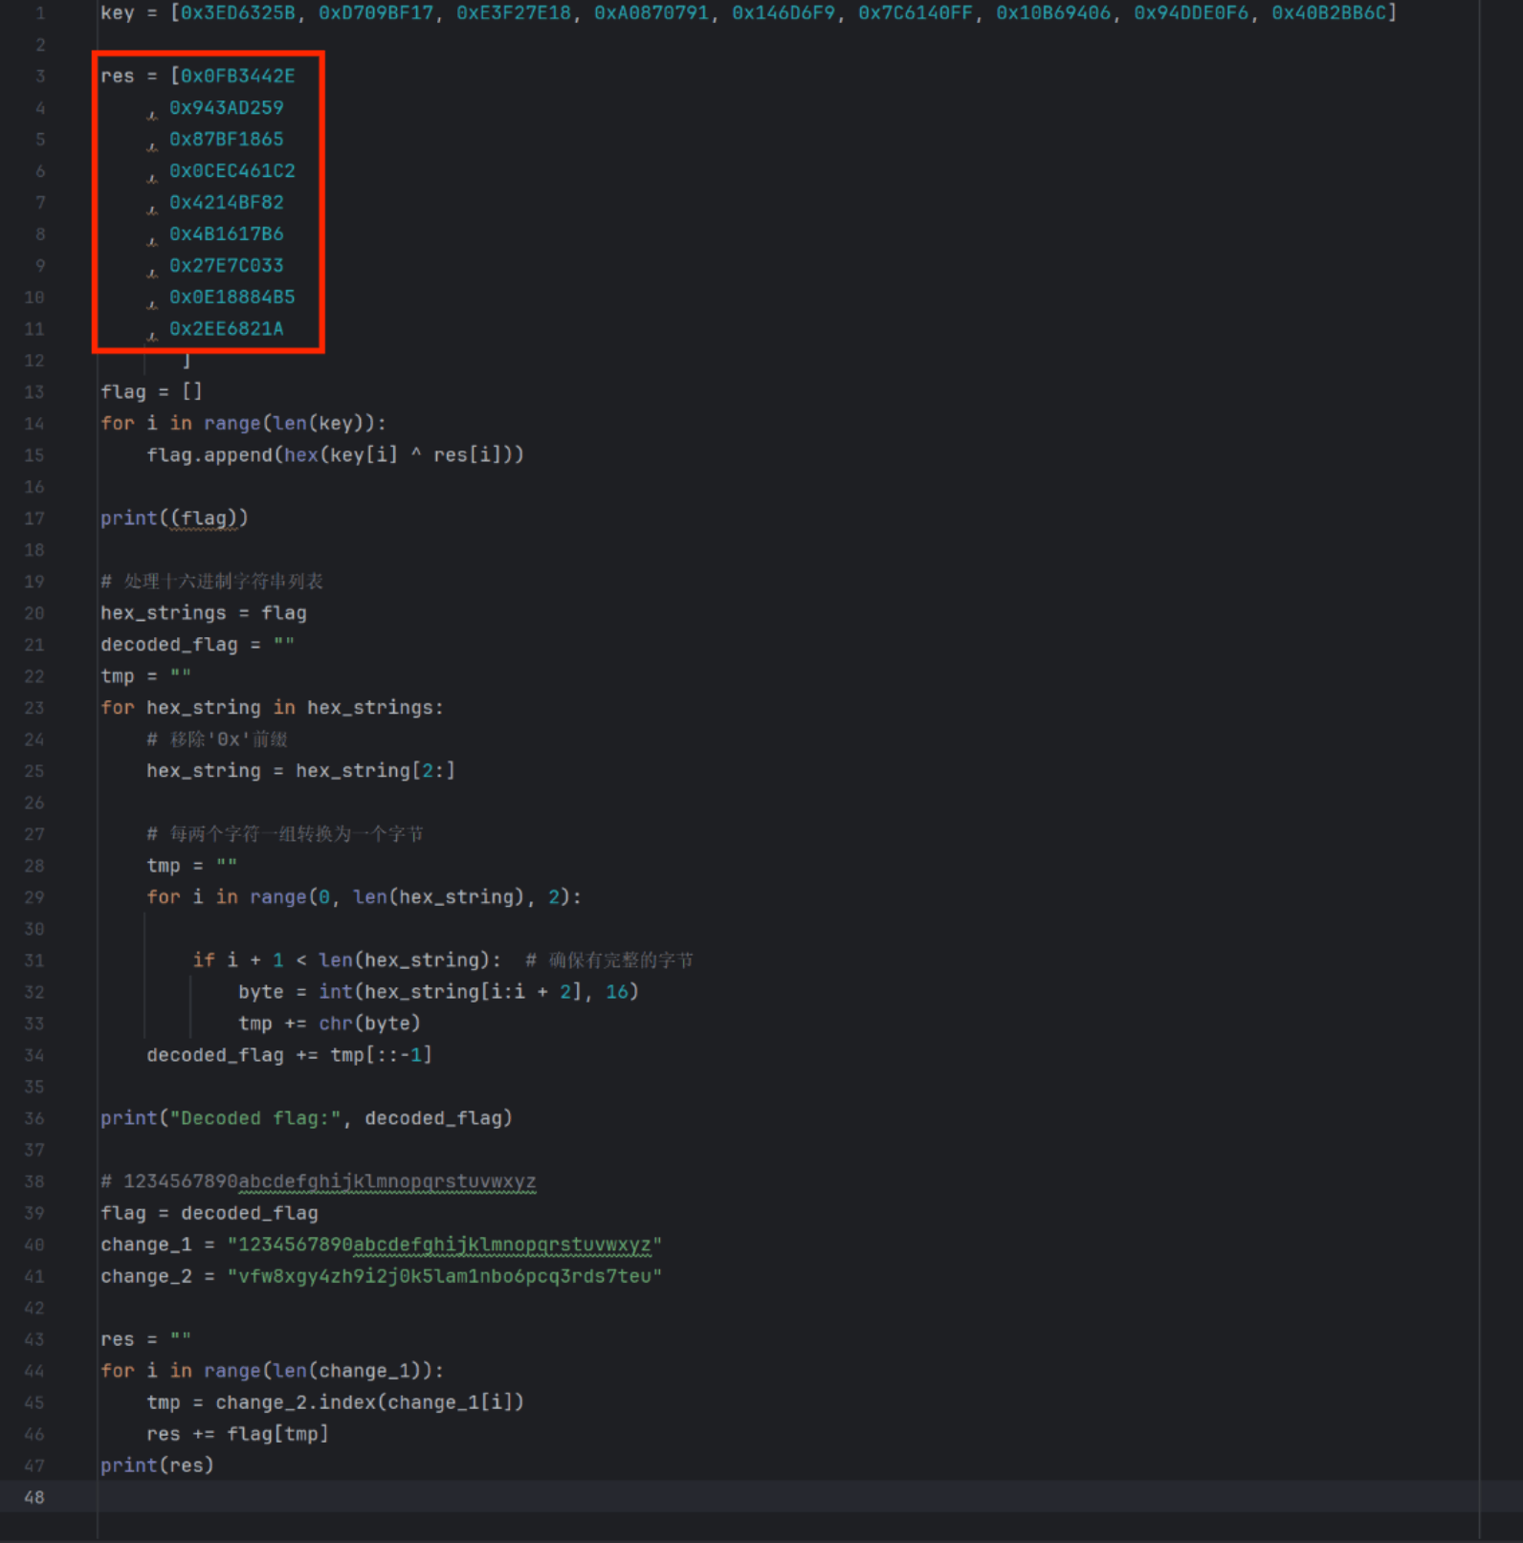

得到flag：ISCC{5v1MCRwQUTvmfdfniCW7T7du9nueN3}

解密脚本

key = [0x3ED6325B,0xD709BF17,0xE3F27E18,0xA0870791,0x146D6F9,0x7C6140FF,0x10B69406,0x94DDE0F6,0x40B2BB6C]

res = [ 0x44854502

,0x946CE85E

,0x88B54F65

,0xE9DF35C2

,0x312F8682

,0x313579B6

,0x7AD0C668

,0xED9183B5

,0x1881F30A

]

flag = []

for i in range(len(key)):

flag.append(hex(key[i]^res[i]))

print((flag))

# 处理十六进制字符串列表

hex_strings = flag

decoded_flag = ""

tmp = ""

for hex_string in hex_strings:

# 移除'0x'前缀

hex_string = hex_string[2:]

# 每两个字符一组转换为一个字节

tmp = ""

for i in range(0, len(hex_string), 2):

if i+1 < len(hex_string): # 确保有完整的字节

byte = int(hex_string[i:i+2], 16)

tmp += chr(byte)

decoded_flag += tmp[::-1]

print("Decoded flag:", decoded_flag)

# 1234567890abcdefghijklmnopqrstuvwxyz

flag = decoded_flag

change_1 = "1234567890abcdefghijklmnopqrstuvwxyz"

change_2 = "vfw8xgy4zh9i2j0k5lam1nbo6pcq3rds7teu"

res = ""

for i in range(len(change_1)):

tmp = change_2.index(change_1[i])

res +=flag[tmp]

print(res)