1.apk解压，lib x8664拿到三个so  
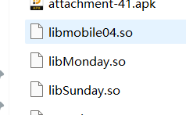  
asset x8664拿到enreal  
2.mobile04搜Java_com_example_mobile04_MainActivity_getEncryptedSegment，拿到adex的字节值填到上面脚本s里 3.monday.so搜Java_com_example_mobile04_a_checkFlag2，看异或多少替换 data[i] ^= 0x55  
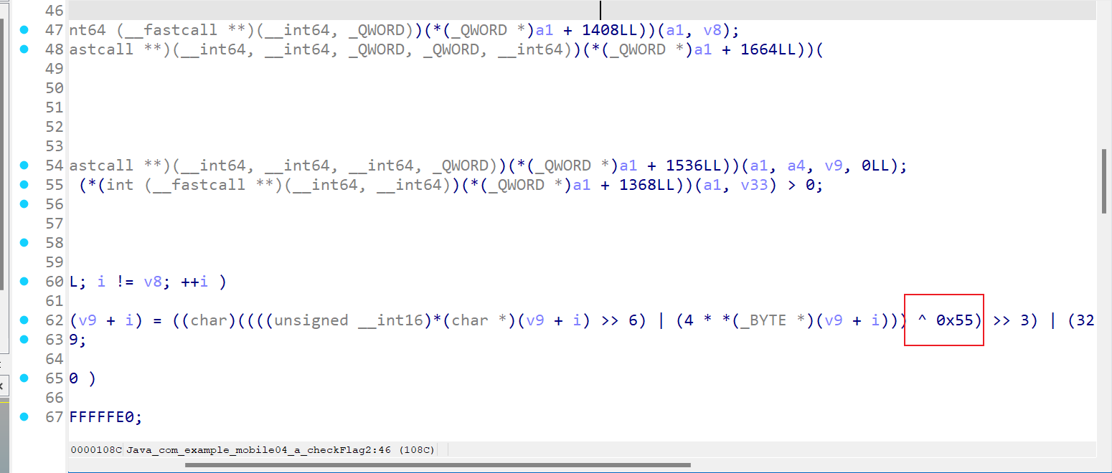  
4.拿到decrypted.dex复制里面的数值，sunday.so搜字符串  
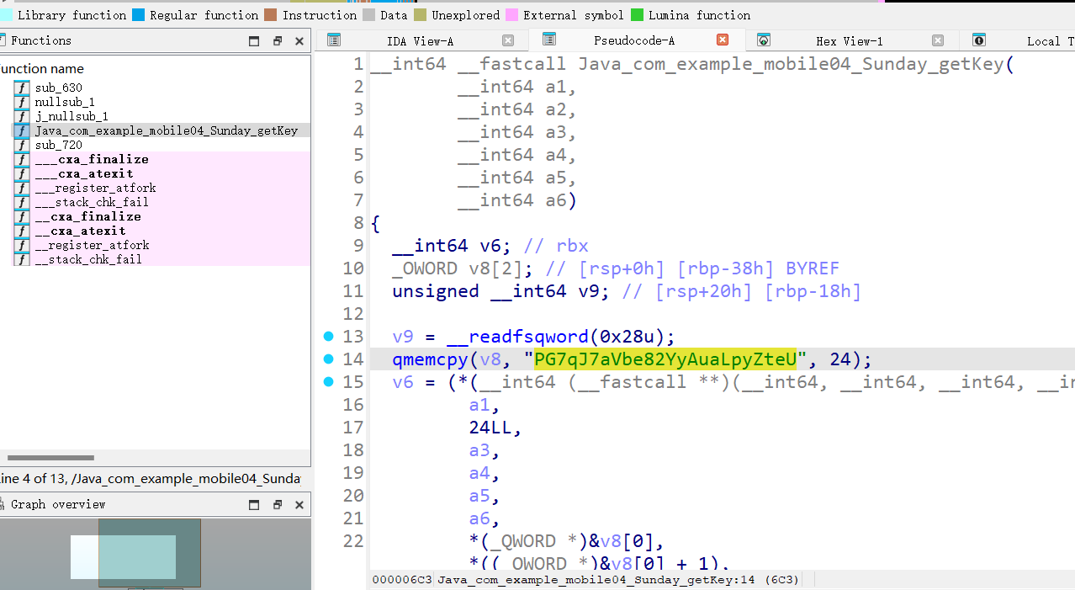  
然后去赛博厨子 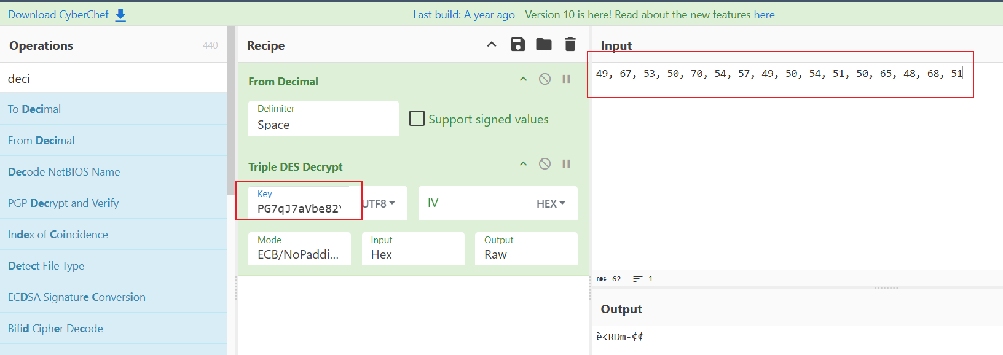  
5.decode_enreal ida反编译搜real_check，复制字符串和hex值赛博厨子 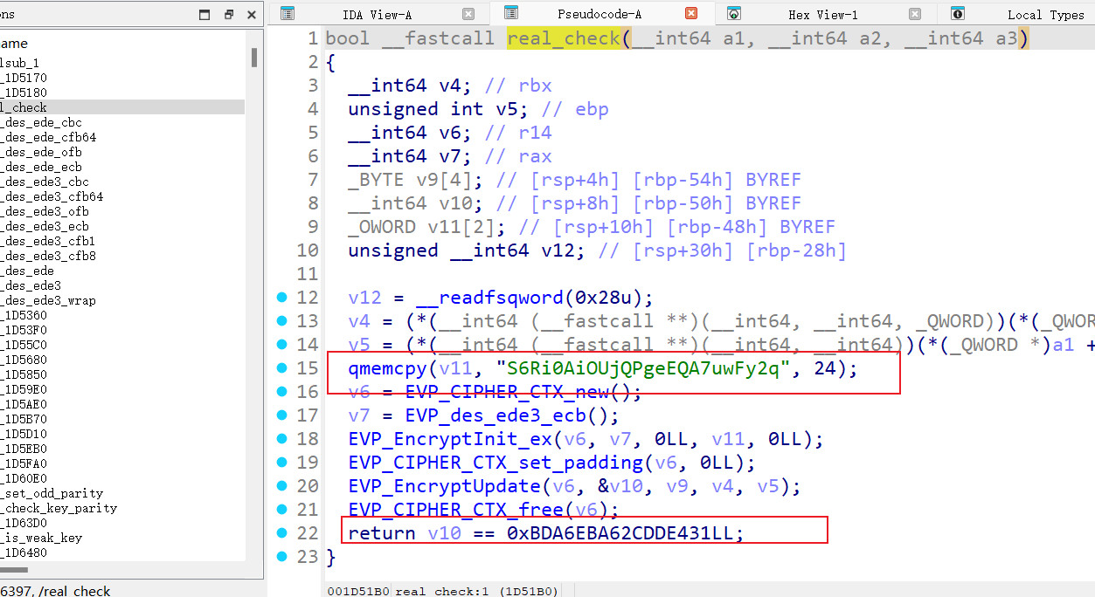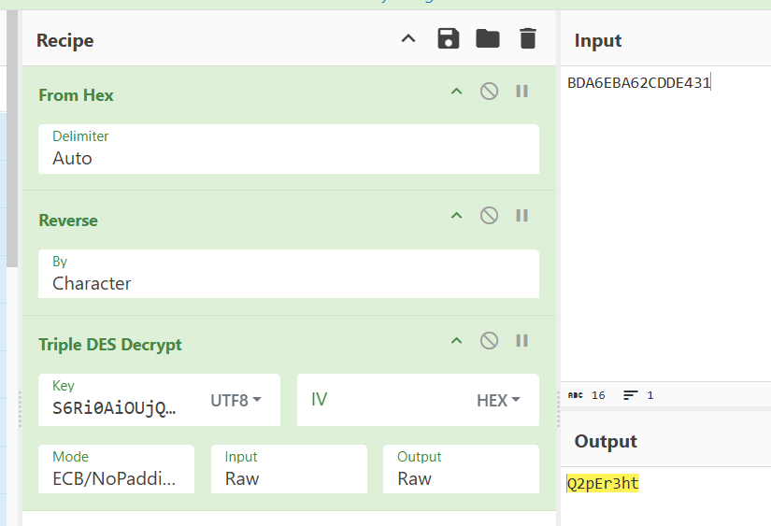  
6.拼接两个解密的字符串就是flag

s = []

with open("decrypted.dex", "wb") as f:

f.write(bytes(s))

with open("enreal", "rb") as f:

data = list(f.read())

for i in range(len(data)):

data[i] = (data[i] << 2) | (data[i] >> 6)

data[i] &= 0xff

data[i] ^= 0x55

data[i] = (data[i] >> 3) | (data[i] << 5)

data[i] &= 0xff

with open("decode_enreal", "wb") as f:

f.write(bytes(data))