Supernote .note to PDF Converter
Simple Windows guide for non-technical users
This guide explains how to convert Supernote .note files into useful PDF files without typing commands. The user will install Python once, run one setup file once, then convert notebooks by putting them into an input folder and double-clicking a conversion file.

What you will get
- A PDF copy of each Supernote notebook.
- Searchable text where the notebook contains recognised handwriting or textbox text.
- PDF bookmarks from headings, keywords, and starred pages where available.
- Internal Supernote links converted to clickable PDF links where possible.

Before you start
- A Windows computer with internet access.
- The Supernote converter files, including note_to_pdf.py.
- One or more Supernote files ending in .note.
- About 10-15 minutes the first time. After setup, conversions should be much quicker.

One-page quick version
Step | What to do | What happens
1 | Install Python from python.org. Tick Add python.exe to PATH. | Windows learns how to run the converter.
2 | Download or copy the converter folder. | You have one folder containing the converter.
3 | Double-click 1_Install_Requirements.bat. | The required Python packages are installed.
4 | Put .note files into the input folder. | The converter knows which notebooks to process.
5 | Double-click 2_Convert_Notes_to_PDF.bat. | PDFs are created in the output folder.

Step 1 - Install Python
Open a web browser and go to the official Python download page for Windows. Click the main download button. The exact version number may change over time; that is fine.
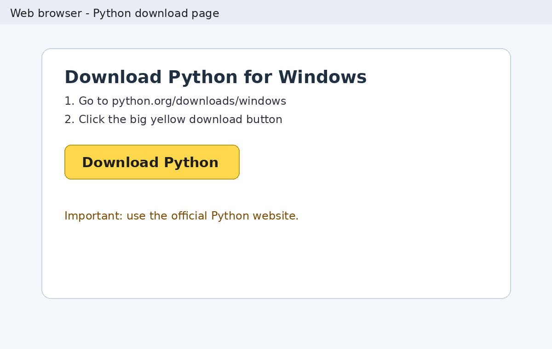
When the installer opens, tick Add python.exe to PATH first. This is the most important checkbox. Then click Install Now.
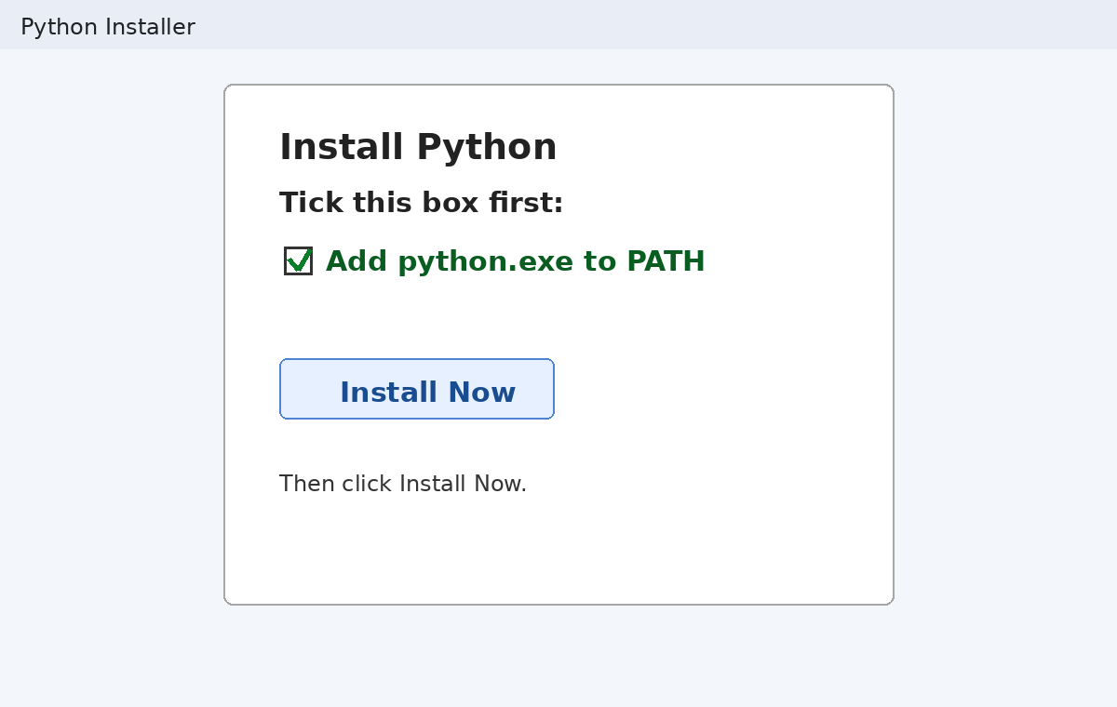
If Windows asks whether to allow changes, choose Yes. When installation finishes, close the installer.

Step 2 - Get the converter folder ready
Download the converter ZIP or copy the converter folder from whoever provided it. If it arrives as a ZIP file, right-click it and choose Extract All. Do not try to run it while it is still inside the ZIP.
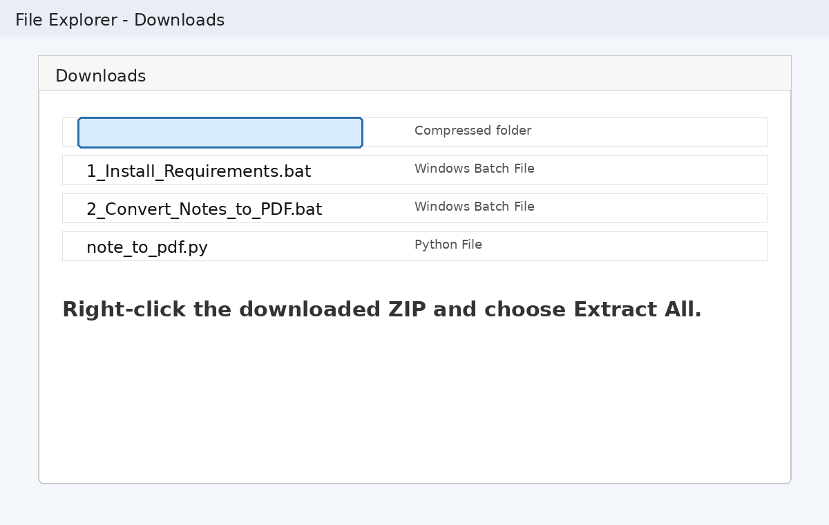
The finished folder should look roughly like this. The important file is note_to_pdf.py. The helper files are included so the user does not need to type commands.
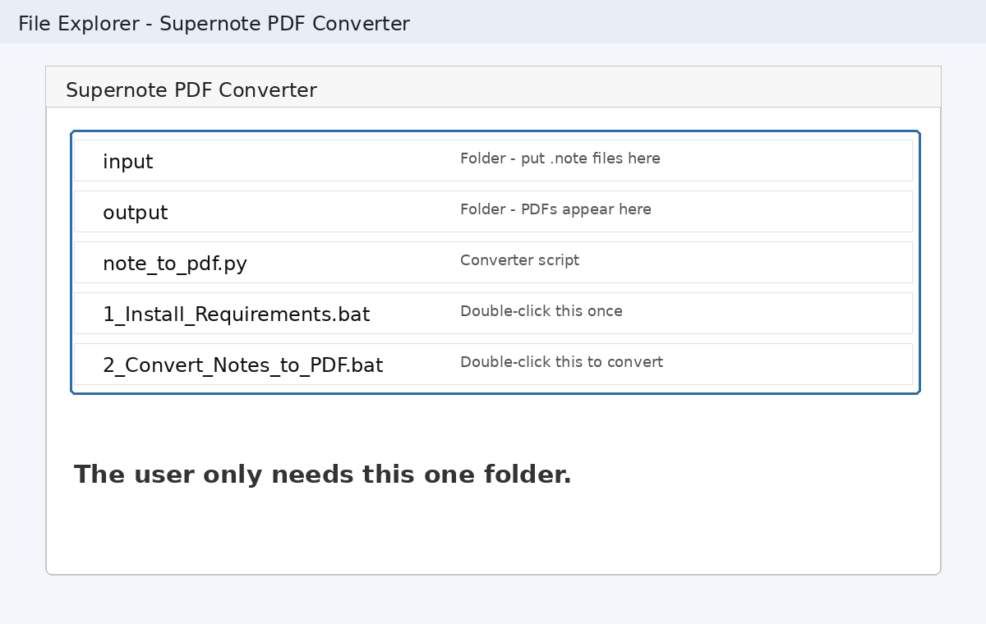

Step 3 - Run the first-time setup
Double-click 1_Install_Requirements.bat. This only needs to be done once on each computer. It installs the packages used by the converter: supernotelib, pypdf, reportlab, and pillow.
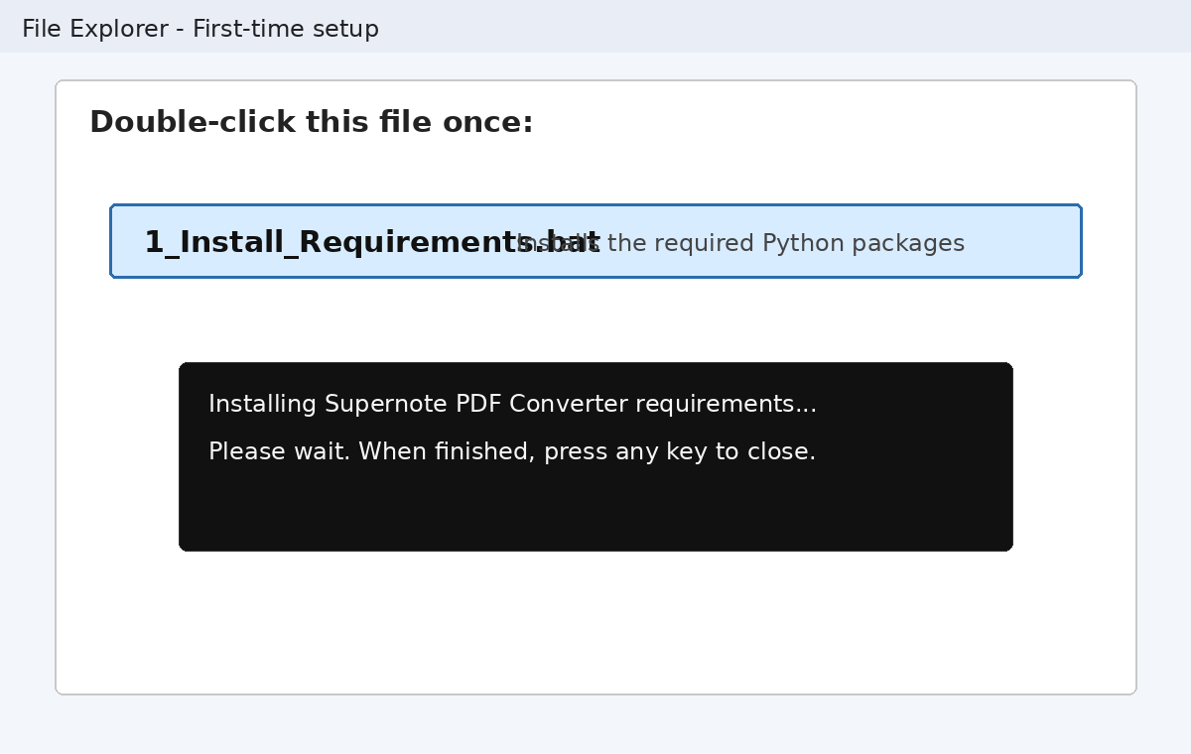
A black window may appear. That is normal. Wait until it says setup is complete, then press any key to close it.

Step 4 - Put your .note files into the input folder
Open the input folder. Copy your Supernote .note files into it. Copying is safer than moving, because it leaves the original files untouched.
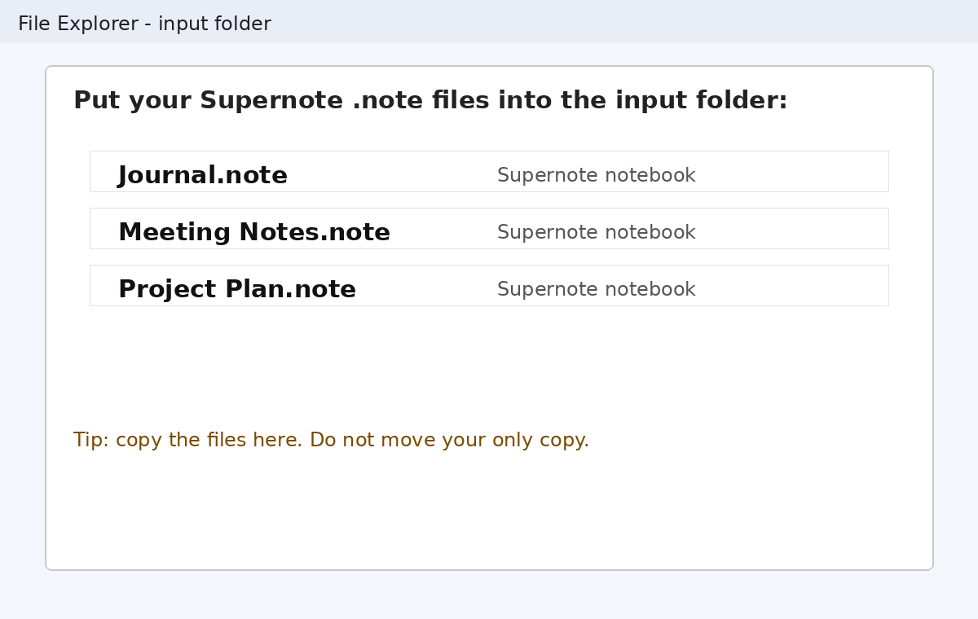

Step 5 - Convert the notes to PDF
Go back to the main converter folder and double-click 2_Convert_Notes_to_PDF.bat. The converter will process every .note file in the input folder.
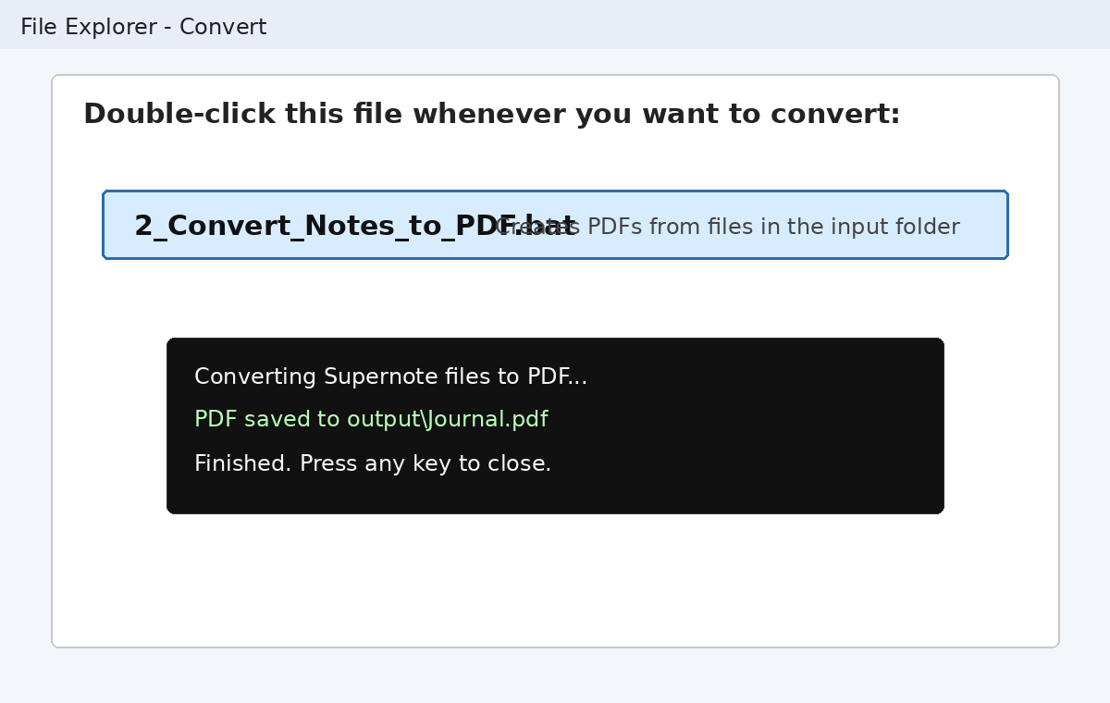
When it finishes, open the output folder. Your PDFs should be there.
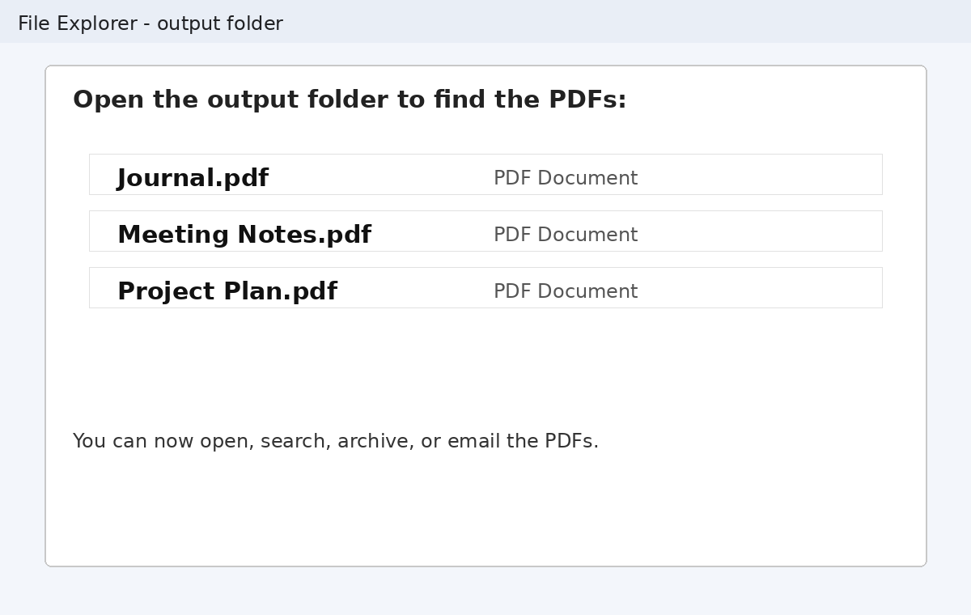

What the PDF may include
Rendered notebook pages: The visible Supernote pages are turned into PDF pages.
Searchable text: Recognised handwriting and textbox text are added as invisible searchable text where available.
Bookmarks: Supernote headings and keywords are added to the PDF outline where available.
Starred pages: Starred pages are marked using a star symbol.
Internal links: Internal Supernote page links are recreated as clickable links where possible.

Troubleshooting for non-technical users
Problem | What to try
Nothing happens when I double-click the setup file | Install Python again and make sure Add python.exe to PATH is ticked.
The setup window says Python was not found | Restart the computer, then try again. If it still fails, reinstall Python and tick Add python.exe to PATH.
No PDF is created | Check that the .note file is inside the input folder. Also check that note_to_pdf.py is in the main converter folder.
The PDF is very large | Use the Advanced Compression helper if provided, or ask a technical helper to run with quality 60.
The conversion crashes | Try converting one notebook at a time. A technical helper can reduce workers to 1.
Some headings say Heading 1 or Heading 2 | The converter found a heading marker but could not confidently read the heading text. This can happen if handwriting recognition was unavailable.

Optional advanced helpers
Most users should ignore this section. These options are useful if someone wants a smaller PDF, wants to check the table of contents only, or is testing a large notebook.
Advanced option | Plain-English meaning
--toc | Show headings, stars, and keywords without making a PDF.
--search meeting notes | Search editable textboxes inside the notebook.
--page 5 | Test one page only.
--workers 1 | Use less computer power if conversion crashes.
--quality 60 | Make a smaller PDF with more image compression.
--out converted | Save PDFs into a different folder.

Text for the README file included with the helper folder
Supernote PDF Converter - Windows Helper
1. Copy note_to_pdf.py into this folder.
2. Double-click 1_Install_Requirements.bat once.
3. Put Supernote .note files into the input folder.
4. Double-click 2_Convert_Notes_to_PDF.bat.
5. Open the output folder to find the PDFs.
Alternative: drag one or more .note files onto 3_Drag_and_Drop_Convert.bat.

Plain-English explanation
Supernote notebooks are excellent on the device, but PDF is easier to search, archive, email, open on other devices, use in document systems, and feed into AI or RAG tools. This converter turns the notebook into a more useful PDF while keeping as much structure as possible.

